Possible Grindr Feature - Promiscuity Coefficient
Sample 3
The City College of New York

NOTE: Grindr currently does not allocate its messages on a cloud database. For this document, it is assumed that Grindr has all of its messages stored in a cloud database.
Abstract
Grindr is the world’s largest social networking app for gay, bi, trans, and queer people (Grindr). Grindr currently contains a feature in which users can state what they’re “looking” for, but most users abuse the feature to appear more prominently to other men. In this paper, a data analysis utilizing gay men's previous chat history to determine what a user’s main intentions are, sexual versus social, is presented. It was hypothesized that adding a promiscuity coefficient feature could help men stick to their initial intentions and find compatible men (men with similar intentions).

This promiscuity coefficient, a number that ranked a user’s intentions, was calculated and given on a range from -1 to 1 where -1=sexual intentions and 1=strictly social intentions. To test this feature, 50 gay men were selected and given pre-experiment surveys to figure out their initial intentions, and then it was studied to see if they had more success with messaging guys with similar intentions. After monitoring the 50 test subjects, it was found that incorporating the coefficient feature generated more success in men who were chatting with men with similar intentions. The results indicated that the coefficients of the men shifted more to the side that their initial thoughts aligned with. It was concluded that adding the feature to the app would generate more success for the users on the application, in that it would help them remain true to their initial intentions.

Possible Grindr Feature - Promiscuity Coefficient
Networking applications are easily accessible, are widely used by today’s generations, and are an easy way for people to socialize with one another and connect with each other in whichever way they may choose (Finkel, Eastwick, Karney, Reis, & Sprecher, 2012). Grindr was invented in 2009 and has grown today to be one of the world’s most popular gay dating apps. (Isaac, 2016). Yet, Grindr users still find it challenging to connect with one another meaningfully. While some of the challenges come from users not being compatible, it boils down to people “wasting” one another’s time because of not knowing each other’s true intentions. Previous research by Rice, Holloway, Winetrobe, Rhoades, Barman-Adhikari, et al. found that while 65.1% of men were looking for hookups, another 64.6% were looking for real dates (2012). Through reputation, Grindr is known to be a simple hookup app by popular media sources (Isaac, 2016).
A study was conducted to determine the probability of the sexual and social actions of Grindr users based on their lexicon and messaging habits. The study was performed by surveying a small test group of 50 gay men. Then the promiscuity coefficient feature was implemented on user profiles (see Appendix Figure 2) to permit users with similar intentions to more easily find one another. The test subjects were resurveyed after a year to see how their coefficients changed and how they personally felt about the coefficient feature. It was hypothesized that adding a promiscuity coefficient to user profiles where a user’s true intentions were stated, in an un-editable form, would lead to users more successfully reaching their initial goals.
Grindr was chosen as the networking tool in this research because it allowed users to see more than one profile at a time. Applications like Tinder make their users swipe through many different profiles, and they cannot message a person until a match is found. Grindr was also chosen as the application to experiment with because it already included an “intentions” filter. Users can filter out their profile and other profiles by stating what they are looking for, such as dates, networking, friends, relationships, and right now [immediate meetup] (Grindr). Even though Grindr provided users with the opportunity to filter out their intentions in their profile, abuse of such features lead to men voiding their initial intentions, hence the reason why such a high number of males have had sexual relations on their meetups, rather than sticking to dating (Finkel et al., 2012).

Materials and Method
Materials
- 50 Gay Males who have used Grindr for over a year and have 100k messages in their total history. All gay males are from New York City and have remained in NYC for the past year and the experiment.
  - 15 men account for the initial state of nonsexual encounters
  - 35 men account for the initial state of sexual encounters
- Grindr Database (Grindr.db) Used to allocate the Data (Farnden, Martini, B., & Choo, 2015).
- Messages then inputted into a C++ readable file format
- Google Sheets - Used to generate the graphs, tables, and test subject surveys
- C++ (Virtual Machine)
  - Algorithm
- Grindr Application
  - Add new Feature and Analyze Data/Interactions
Method and Procedure
The experiment initiated with selecting 50 men to beta test the feature. The 50 men were chosen based on the following criteria:
  - Has lived in NYC for the past year, without leaving,
  - Has over 100k message history count,
  - 15 have intentions of social dates,
  - and 35 have intentions of sexual encounters.
These criteria were chosen because of the abundance of gay men in NYC, giving our test subjects an array of men to converse with during the duration of the experiment. Men who had over a year of conversation were chosen, as the more chat history present, the more accurate the coefficient.
The following questions were asked to all of our subjects.
  - What percentage of times do you look at the guy’s “looking for” profile section?
  - Do you believe this app can be improved?
  - Do you think matching a person to their chats is an accurate representation of who they are?
  - Is the application fulfilling its purpose?
The purpose of gathering these questions was to figure out how users felt about the application, in regard to messaging the “appropriate men.” The purpose was also to determine if adding the promiscuity coefficient would help them target who to initiate communication with to have more responsive outcomes to what they want.
This experiment was conducted by taking information from Grindr’s cloud databases written in SQLite and then it was parsed and made readable by C++ to allow for data manipulation. The set of users consisted of 50 NYC based men who had been in the area for over a year. This was done to prevent participants who were just in the city for a quick and fun visit and to instead study long-term user habits. These men’s chat histories over the past year were then analyzed. An analysis was performed by cross-checking chat history by names and a given list of “sexual” and “social” words (see Appendix Figure 1). The sexual words chosen were: Fuck, Lick, Ass, Eat, Sexy, Sex, Raw, Condom, Dick, and Hole. The social words chosen were Dinner, Date, Coffee, Beach, Brunch, Drinks, and Park. A count was given for both, broken down by individual words in each set and then combined into a stacked bar graph using Google Sheets to allow for graphical analysis (see Appendix Figure 3 and 4).
Using the data pulled from the parsed SQL databases, the instances of specific words were then analyzed in chart format (see Figure 5). This data was used to generate the promiscuity filter that clearly showed how users focused on sexual conversation could be easily separated from users who intended to have a more social based conversation. Then it was compared to users who used the app small amounts and to users who had similar sexual and social keyword usage meaning they were more neutral towards each side.
The range of the calculated promiscuity coefficient fell between -1 and 1 and was based on a relative scale between usage of words in each set. The closer the user was to 0, the more balance between social and sexual conversation they had. The closer that the user was to -1, the more sexual words that they’ve used. The closer the user was to 1, the more social words that the user had used. After gathering the coefficient, the rating coefficients were programmed into the Grindr app. For purposes of this short document, see Appendix Figure 2 which shows how the rating coefficient would look on the app.
Once the coefficients were uploaded, each of the 50 test subjects was told that their conversations would continue to be monitored to study the aftermath of its implementation. Each test subject was made aware of what the rating coefficient signified. After the 365-day mark, the rating coefficient was removed from all profiles, and all test subjects lost access from seeing it.
Each of the 50 men was re-surveyed at the end of the experiment and asked the following questions:
  - Did you find more men that had similar interests to you?
  - Do you believe the rating coefficient helped in regard to accessing men at a faster rate?
  - Did the rating coefficient of the men you talked to match the conversation that they were presenting?
  - Do you believe that after this year of experiment you were viewed as more of a sexual or social person?

Results
The following are the pre-experiment survey questions to the 50 test subjects.
Table 1. The percentage of times the test subjects stated they looked at the guy’s “looking for” profile section
0% | 5%
1-33% | 22%
34-67% | 32%
68-99% | 20%
100% | 21%

Table 2. Yes/No Based Pre-Survey Questions | Yes | No
The percentage of test subjects that believe the Grindr app “can be improved?” | 69% | 31%
The percentage of test subject that believe matching a person to their chats is an accurate representation of who they are | 80% | 20%
The percentage of test subjects that believe the application fulfilling its purpose | 32% | 68%

Information pulled from the pre-experiment questions (Table 2), shows only 5% of users did not pay attention to other users’ looking sections on their profiles. 68% of the test subjects claimed Grindr was not fulfilling its expectations, and 69% said it could be improved. Finally, 80% of the test subjects said they believed a user could be accurately read and understood by analyzing their intentions based on the conversations they had in private chat messages.

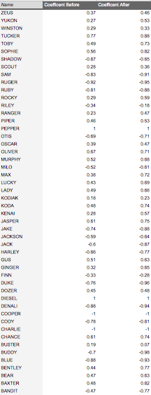
Figure 5. The 50 test subjects’ promiscuity coefficients pre and post implementation of the feature.
The following are the post-survey questions to the 50 test subjects:
Table 3. Yes/No Based Post-Survey Questions | Yes | No
The percentage of test subjects that agreed/disagreed with the coefficient helping them select which conversations to initiate with | 89% | 11%
Test subjects response to “Did you find more men that had similar interest to you?” | 68% | 32%
Test subjects response to “Do you believe the rating coefficient helped in regard to accessing men at a faster rate?” | 84% | 16%
The test subjects response to “Did the rating coefficient of than men you talked to match the conversation that they were presenting?” | 96% | 2%

Table 4. The test subjects response to “Do you believe that after this year of experiment you were viewed as more of a sexual or social person?”
More Sexual | 65%
More Social | 28%
Unsure | 7%

Post-experiment data (Table 3) shows that 89% of users agreed that this implementation made initiating conversation easier. 68% of the test subjects found users with similar interests. 84% of the test subjects agreed that the coefficient helped them access men at a faster rate. Lastly test subjects reported 96% accuracy based on the conversations they had with other members, and it helped them to understand themselves more fully and whether they truly wanted to come off as sexual or social.

Discussion
The pre- to post-implementation data showed how revealing a user’s true intentions made the magnitude of the coefficient increase for all test subjects. Users such as Zeus, Ginger, Bear, Bandit, etc. had their coefficients skew higher towards their initial intentions. Zeus increased from 0.37 to 0.46 in only a year. Additionally, 89% of the test subjects believed that the coefficient helped them find other users with similar intentions and made them get viewed as what their initial intentions were. The increase of the magnitude of the promiscuity coefficients may have been because the user’s intentions were more honest and straightforward. People knew the honest intentions of whom they were speaking to, rather than trying to assume based on possibly misleading personally editable profile information.
The results do support the hypothesis that adding a promiscuity coefficient to user profiles where a user’s true intentions were stated would lead to users more successfully reaching their initial networking goals. Based on the experiment, the increase of the test subject's promiscuity factor shows that adding the promiscuity feature to the Grindr app will have a positive outcome; more men will be likelier to stick to their initial intentions and have a better chance of finding men with similar intentions.
If provided with more time for the experiment and more data obtained from the user’s conversations, i.e., what they received and what kind of conversations they had, it could be seen if the promiscuity factor had actually been tampered with or if it produced the correct results. Some subjects, such as Rocky increased from a coefficient of .29 to .59, about .30 points. A sudden increase as this could only mean that the user was purposefully altering his words. Also, because there was no full background check of the men, there was no way to know whether they lied about their initial intentions to again just meet a variety of men. With more money, more research could be performed on the experimental group’s past encounters with Grindr men to see what the success/downfall between them was.
Conclusion
Finding the right kind of person on a networking app remains tricky today. While the thought of incompatibly comes into play, the most significant factor in the failures of such an app, like Grindr, is because users tend to lie about their intentions. An application such as Grindr provides the ability for gay men to specify their intentions, such as dates, hookups, friends, etc., but many lie about it as they want to be able to have more options of men.
To solve this problem the “promiscuity coefficient” feature that assigns a value to what kind of a man a user is based on their previous chat history, was developed. The closer the user was to -1, the greater the sexual intentions that the user had. The closer to 1, the more likely the user was just a very social person. After surveying 50 men both before and after the implementations and usage of the feature, it was found that most men had more success in communicating with men with similar intentions to them after the feature was implemented. Their coefficient stayed in the same range (negative stayed negative, positive stayed positive) but the values themselves got closer to both -1 and 1 on each side as users began to narrow down their messages and wants. These results validated the hypothesis that presenting this coefficient data on user profiles would improve user interactions and help them reach their initial goals more effectively. As the feature proved to be successful for this sample group, it is believed that adding the promiscuity coefficient as a main feature available to view for all users will allow the men on this app a higher probability of success in finding matches.

References
Farnden, J., Martini, B., & Choo, K. R. (2015). Privacy Risks in Mobile Dating Apps. CoRR.
Retrieved March 12, 2018, from https://arxiv.org/pdf/1505.02906.pdf.
Finkel EJ, Eastwick PW, Karney BR, Reis HT, Sprecher S. (2012) Online Dating: A Critical
Analysis From the Perspective of Psychological Science. Psychol Sci Public Interest. 13(1):3-66. doi: 10.1177/1529100612436522. PubMed PMID: 26173279.
Retrieved March 8th, 2018 https://www3.nd.edu/~ghaeffel/OnineDating_Aron.pdf
Galassi, J. (2017, September 17). Grindr Profile Picture -- Edited [digital image].
Retrieved March 10, 2018, from https://www.queerty.com/include-disabled-Dating-profile-20170917
Grindr. (nod). Retrieved March 13, 2018, from https://www.grindr.com/
Isaac, M. (2016, January 11). Grindr Sells Stake to Chinese Company. Retrieved March 12,
2018, from https://www.nytimes.com/2016/01/12/technology/grindr-sells-stake-to-chinese-company.html
Rice E, Holloway I, Winetrobe H, Rhoades H, Barman-Adhikari A, et al. (2012) Sex Risk among
Young Men who have Sex with Men who use Grindr, a Smartphone Geosocial Networking Application. J AIDS Clinic Res S4:005.doi:10.4172/2155-6113.S4-005

Appendix
Figure 1 (A., B., C.) Representations of the partial code of in C++ that was used to calculate the promiscuity coefficient for the users.
- 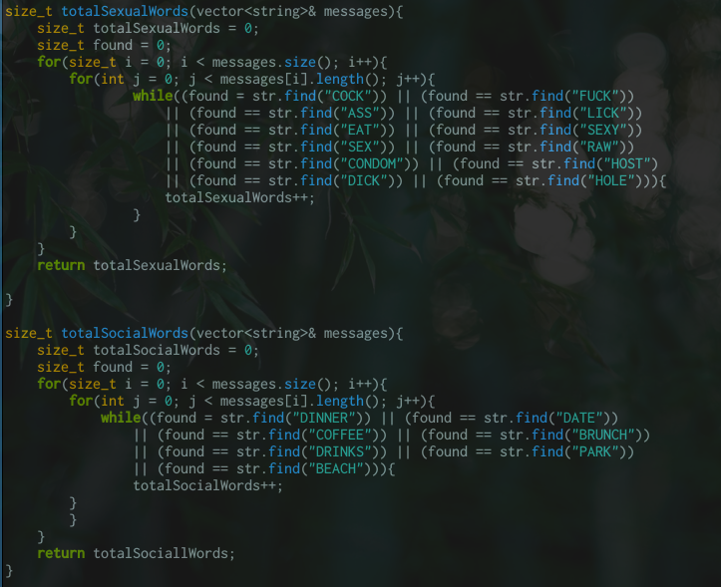
- 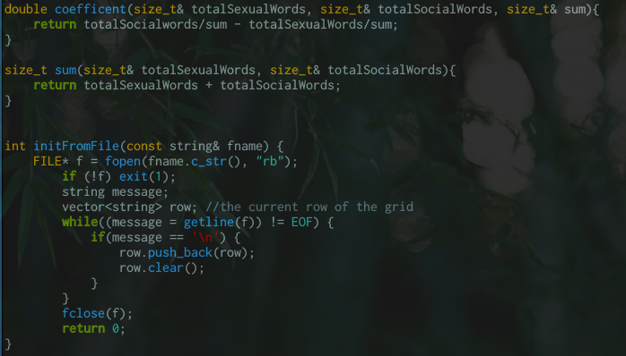

Figure 2: The promiscuity coefficient feature on a user’s profile. Labeled in Red. (Galassi, 2017).
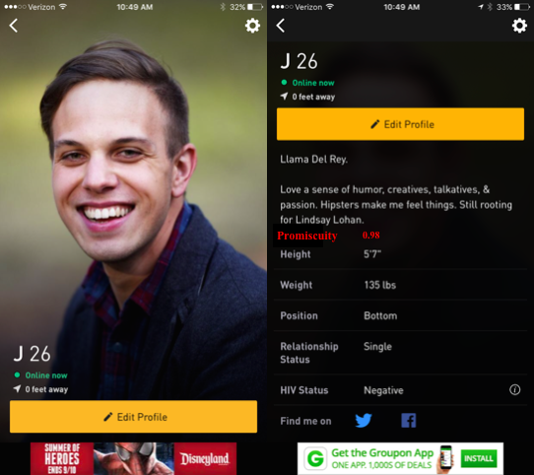

Figure 3. The number of times each test subject used the social keywords.
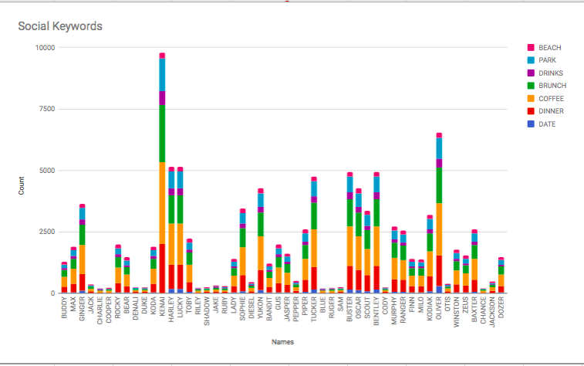
Figure 4. The number of times each test subject used the sexual keywords.
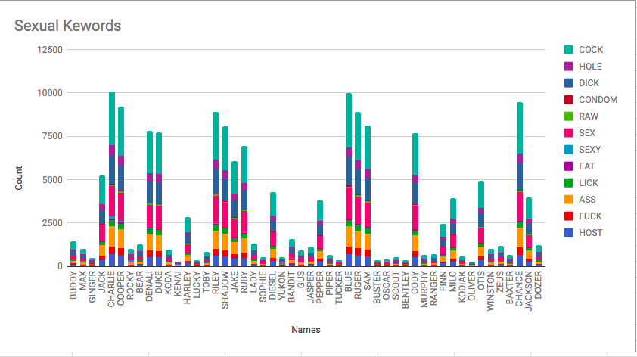

The Reflection Piece
When I was assigned this paper, I was quite torn on what I was interested in as a topic. As a freshman in computer science, I know that there are endless possibilities in computer science, but what I wanted to do with those possibilities was the challenge within itself. The second part of this assignment that stumped me was about what I could write about with the limited skills I currently possess. Computer Science isn’t understanding one program, it is understanding multiple programs, different mathematical algorithms, and knowing what you want to research. In this paper, not only did I learn how to write a lab report, I learned how to incorporate rhetorical situations into a non-narrative paper, and I gained insight into the networking culture of today's age.
Speaking of rhetorical situations, my lab report on developing a networking app feature, specifically a feature for Grindr, is intended for anyone who might use or develop a networking app. The feature is designed to help those looking to help increase the efficiency and compatibility outcomes of users on networking apps. It is also for the users of networking apps who may be searching for different methodologies that can help their them find more compatible matches. This lab report can also be for someone who is trying to learn more about the Grindr App and how users may interact with it. Lastly, this lab report can also be utilized by someone who might need help determining some psychological factors surrounding Grindr, i.e., the men’s initial uses for this app versus what they may end up doing (both pre- and post- feature).
My purpose for writing this paper was because I’ve realized that networking apps, in theory, are intended to help people find compatible persons. They are supposed to help find people with similar interests in matters of seconds, but I’ve found out that the opposite is true in reality. When I came across Grindr in my research, I realized that new features need to be added to these networking apps to help a user find “the one” as using a networking app that is statistically known for dates, has a reputation for only hookups.
The genre of this assignment is a lab report, a lab report tailored to my engineering field. The lab report experiments/researches something, in my case a feature being added to the Grindr networking app. It also analyzes both the outcome and the procedure of its implementation. My procedure involved the analysis of a small sample group and their outcomes with the added promiscuity coefficient feature. The lab report lists a brief description of the application itself, lists my methods and procedure, the results that were retrieved from the experiment, and an analysis that tied in all of the information.
My stance on this assignment is that I feel that if we as users rely on specific networking apps to find people with similar interests, we should be able to find those people and not “waste our time” on these applications. I believe that if an application is to be built, its features should be utilized to their maximum potential to increase its efficiency.
The media/design of this assignment is both digital and print. The digital component of this assignment comes from gathering the research of the Grindr application, coding the feature of the app, generating the graphs and surveys of the 50 test subjects, and submitting the final document via email. The print component of this assignment had to do editing and revising my own paper as I prefer reading print documents to digital documents.
The exigence surrounding this paper has to do with the fact that I care about how people connect with one another and how we as people spend our time. If we expect ourselves to find someone with similar interests, we should be able to do it. Applications are built to speed up processes and help connect people on a social level. Grindr, a networking app, is known for hookups even though data collected on its users show that an equal amount intends actually to date. Additionally, Grindr, unlike Tinder, allows its users to message anyone nearby and message more than one person at a time, yet the users still do not fulfill their main intentions of networking. Being able to find a solution to this before I get into the dating world, will not only help those who are soul searching, but will help myself.
This assignment meets Course Learning outcomes 1, 2, 5, 7, 8. It meets number 1: “acknowledges your and others' range of linguistic differences as resources, and draw on those resources to develop rhetorical sensibility,” because this assignment requires me to figure out which data I needed to allow my audience to understand what my experiment was about for the methods/results produced. With outcome 1, I also had to figure out what parts of Grindr’s background were relevant for my audience to understand Grindr fully. It meets outcome 2: “enhance strategies for reading, drafting, revising, editing, and self-assessment,” because the assignment requires the peer-review process and exposing myself to other lab reports. The peer review process helped me figure out what components of the lab report may be working well, or not working well.
The paper also meets outcome 5: “engage in genre analysis and multimodal composing to explore effective writing across disciplinary contexts and beyond,” because I had to review different forms of lab reports, utilize different networking applications, and review articles to piece together my experiment of the Grindr App feature. It meets outcome 7: “practice using various library resources, online databases, and the Internet to locate sources appropriate to your writing projects,” because the assignment requires finding credible sources similar lab reports and connecting it to my lab report, such as why was my lab report needed. Additionally, what my report is \ adding to the computer science community -- that being the promiscuity coefficient feature is added to an application that has many users. Lastly, it meets outcome 8: “strengthens your source use practices (including evaluating, integrating, quoting, paraphrasing, summarizing, synthesizing, analyzing, and citing sources),” as I utilized different sources in my text, anywhere from images to paraphrasing different experiments from other reports.

