Painting Roads for Benefits and Success
Sample 2
The City College of New York

Author Note
[Include any grant/funding information and a complete correspondence address.]
Abstract
Asphalt roads generally have a dark hue, which can lead to an increase in temperature causing many negative effects. Implementing light tinted asphalt roads will solve this problem and possibly decrease temperatures, which leaves a certain area cool rather than hot. Regular asphalt road should be replaced with a lighter tint road area by area. This can be done with the use of materials such as aggregate base, asphalt base layer, asphalt intermediate layer, etc. Slowly replacing the roads will help people adjust, as well as see or feel the difference the small adjustment made. The area will soon feel little to no difference regarding temperature as well as saving energy due to the decrease of electricity usage. The results show that the light tinted asphalt road does decrease the temperature or remain stagnant. It also shows the many benefits it has compared to the regular asphalt road. Overall, the light tinted asphalt road is beneficial to society compared to the regular asphalt road.
Painting Roads for Benefits and Success
In this experiment, I tested how the implementation of light tinted asphalt roads affected or benefited the society compared to the regular asphalt road. Since the regular asphalt road has a dark hue, I expect that the road will cause an increase in temperature in the area, causing negative outcomes. Since the light tinted asphalt road has a lighter hue, I expect the temperature in that area to stay stagnant or possibly decrease, which will bring many benefits into the society.

Materials
The materials and machines needed to construct a simple asphalt road are the following:
Subsoil
Aggregate base
Asphalt base layer
Asphalt Intermediate layer
Asphalt Surface
Loaders
Graders
Milling machine
Paver
Compactor
Tower cane
Tractor cane

Methods
In order to construct a road in the area desired, a milling machine is needed to remove layers of unwanted materials. Every road also needs a firm foundation, a base where it’s able to support everything above it. After the milling machine is used to remove unwanted materials from the construction site, loaders or the tractor cane will be used to dig, move and/or place loose soil on the construction site. Once the soil is in place, another machine called graders will be used to smooth, as well as level the construction surface. Once the soil is leveled, the compactor will then be used to compress and compact the soil to be able to advance (A Civil Engineering’s look.., pg. 1) (The Basics of a Good Road, pg. 1 ).
Another layer is added on top of the soil, which is called the Aggregate base. The Aggregate base is essentially made up of sand as well as rocks. The road needs to have a satisfactory base to eliminate costly maintenance or reconstruction, which will then result to quick maintenance in the future. Once the Aggregate base is added and spread out using the paver, the compactor will then compress and compact the base to improve the foundation of the road (The Basics of a Good Road, pg. 2).
Another layer will be added called Asphalt pavement base. The Asphalt pavement base will ensure the road to be fatigue resistant. It will manage strains which will prevent from cracking. Next layer would be the Asphalt Intermediate layer which essentially distributes the load as well as resist structural rutting. Lastly, the final layer of the road is the Asphalt surface. The Asphalt surface is customizable especially for, not only specific safety precautions, but as well as preservation necessities. The Asphalt will be customized to a lighter tint to avoid excess heat absorption to benefit the society. All the layers will be then compressed and compacted by the compactor to ensure the roads stability as well as ensuring it to last indeterminately. (The Basics of a Good Road, pg. 3)

Results
Tables:
Table 1
Average Temperature of The Regular Asphalt Road vs. The Light Tinted Asphalt Road
Place/area | Year | Months | Regular Road Temp (°F) | Light tinted Road Temp (°F)
California | 2018 | June-August | 93 | 90
California | 2023 | June-August | 97 | 86
California | 2028 | June-August | 95 | 84
Michigan | 2018 | June-August | 85 | 85
Michigan | 2023 | June-August | 86 | 84
Michigan | 2028 | June-August | 86 | 84
Note: As shown in table 1, the average temperature of California in the months of June through August, having the regular asphalt road, increased as time progressed. This is due to the roads dark hue. Dark hues absorb heat from the sun which can eventually cause a heat wave. California is already a hot area where many civilians live and travel. The area is overpopulated which causes an increase in temperature, and in addition the trapped heat in the road will cause the temperature to further increase. The light tinted road will decrease the temperature since the roads hue isn’t as dark as the regular road, so it will not absorb and trap heat compared to the regular road. The temperature in Michigan on the other hand stayed stagnant. Since Michigan is upstate, the area doesn’t get as hot as California. The light tinted road however, did slightly decrease the temperature as the temperature of the regular road slightly increased.

Table 2
Average Electricity Usage of an Area with Regular Asphalt or Light Tinted Asphalt Road
County | Year | Months | Electricity Used having Regular Road (Millions of kWh) | Electricity used to have Light tinted Road (Millions of kWh)
Sacramento, Cali | 2018 | June-August | 2494.7764 | 2478.9312
Sacramento, Cali | 2023 | June-August | 3002.6595 | 2206.8462
Sacramento, Cali | 2028 | June-August | 3265.5244 | 1984.1227
Macomb, Michigan | 2018 | June-August | 1873.6282 | 1867.5698
Macomb, Michigan | 2023 | June-August | 1903.0585 | 1745.6841
Macomb, Michigan | 2028 | June-August | 1936.1263 | 1663.4756
Note: As shown in table 2, the average electricity usage in Sacramento in the months of June through August, having the regular asphalt road, increased as time progressed. Since the regular asphalt road absorbs and traps heat, the temperature rises leading to a higher electricity usage. The higher the temperature, the more air conditioners used in a long period of time. The light tinted road helps maintain the temperature or possibly decrease it. If the temperature maintains or decrease, the air conditioners used in terms of time will stay stagnant. This will lead to the same usage of electricity or can possibly decrease it. Macomb, Michigan didn’t change as much because Michigan is a cooler climate than California. This means they do not have to use air conditioners as much compared to California.

Comparison between the Light Tinted Asphalt Road and the Regular Asphalt Road:
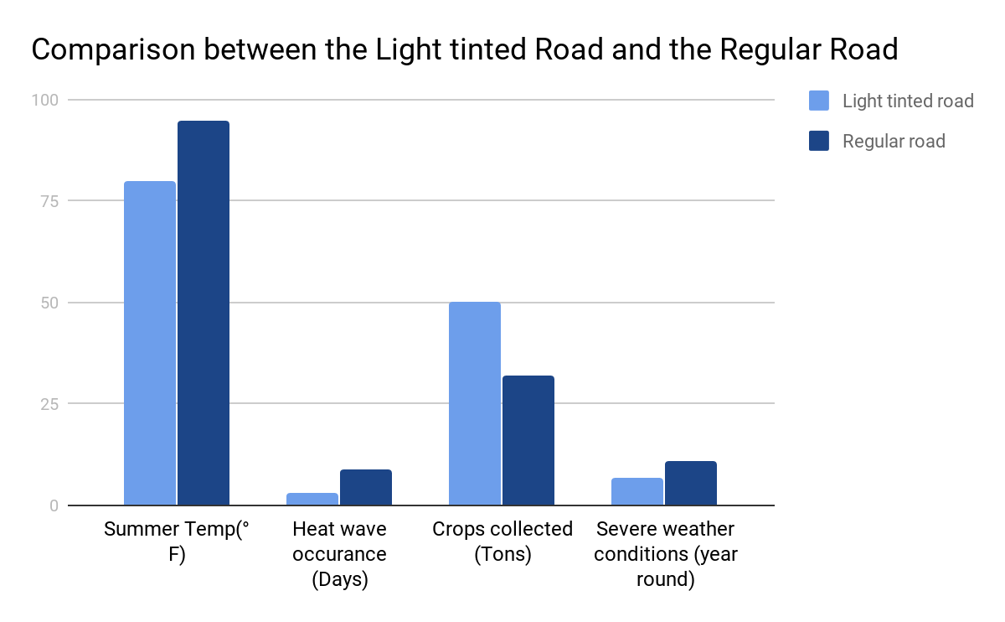
Figure 1
Figure 1. Shows the comparison between the light tinted asphalt road and regular asphalt roads results when it comes to certain scenarios.

Implementing light tinted asphalt roads overall benefits society. As data show in table 1, the light tinted asphalt road decreases or controls the temperature on that particular county or area due to the road not having a dark hue. Dark hues normally absorb and traps heat which causes an increase in temperature. An increase in temperature will lead to many negative outcome or consequences in which the society should avoid. It can affect the number of crops harvested, weather patterns, plants, animals, people, and more. When the temperature rises, the electricity or energy usage will also increase, which will lead to electric shortages adding on to the greenhouse gases in the environment. The light tinted asphalt road also has other benefits such as requiring little to none quick maintenance. If the road was constructed using concrete, it will require many costly maintenance, and possibly reconstruction. While asphalt is guaranteed to last indeterminately, if done correctly. This will reduce the budget needed for road maintenance, and the remaining funds could go to a different project that also benefits the society.

Discussion
The results supported the prediction or hypothesis I made that the regular asphalt road caused an increase in temperature in that particular area. Dark hues generally absorb and traps heat that leads to a temperature increase. Temperature increasing will affect the oceans, weather patterns, plants, animals as well as humans and cause a heat wave. To prevent this from occurring, the implementation of a light tinted road in society will decrease the temperature or stay stagnant rather than increasing it. The temperature staying stagnant or decreasing will lead to benefits (Higher Temperatures, pg. 1).
Higher temperature will cause heat waves as well as draughts which will reduce the amount of water available for irrigation. This will also cause problems with crops, unable to grow certain crops in certain weather conditions. Higher temperature will likely cause irregular weather patterns which leads to more storms and floods. Also, when the temperature is unbearably hot, people will tend to use air conditioner for long periods of time. This will lead to more electricity usage as well as a electricity shortages. Electricity shortages will spread and add greenhouse gases which is unpleasant to the environment. Preventing an increase in temperature will be better for the society.
The results supported my second prediction or hypothesis as well that the implementation of a light tinted asphalt road will cause benefits to the society. When the light tinted asphalt road is implemented, the temperature will most likely stay stagnant or decrease. If the temperature stays stagnant, the electricity usage will stay stagnant and hydropower will produce more energy as time progress. Constructing an asphalt road is also beneficial because it will hardly require frequent maintenance. Compared to a concrete road, the concrete road will need frequent costly maintenance as well as reconstruction. This will result in saving plenty of energy as well as funds.

Conclusion

Overall, the experiment succeeded in showing that the light tinted asphalt roads brought many positive outcomes. The data provided in the lab report proves that the light tinted asphalt roads enable the temperature to stay stagnant as well as decrease the temperature, which provided positive outcomes. Since the temperature didn’t increase, there was no problems with harvesting crops, no electric shortages, normal weather patterns, and the prevention of certain diseases spreading. However, these differences can be considered for experimental or human errors.
References
(2016). A Civil Engineer’s look at Roads and Highways. Ohio University Russ College of Engineering and Technology, Pages 1-3.
(2016). Higher Temperatures. A Student’s Guide to Global Climate Change, Page 1.
(1984). The Basics of a Good Road. Vermont Local Roads, Pages 1-4.

Reflection
When the assignment was assigned, I had troubles choosing a topic or experiment for my lab report. It took me two to three days to come up with a possible topic. I ended up sticking with the first topic I came up with due to shortage of time. I was required to post my topic in blackboard through discussions and comment on three other peoples topics. It was interesting to see and find out what my peers field of study was while reading through the discussion board.
The genre of this assignment is a lab report. A lab report is an analyzation as well as the description of a lab experiment where usually one makes a hypothesis which will then be tested in the experiment. My assignment followed the conventions of a lab report because my lab report conducted a hypothesis. With this hypothesis, there was an experiment that tested and proved its statements. It also contains data from the experiment as well as explanations, lists materials, methods, results, discussion, conclusions and references which follows a structure of a lab report.
The media of this assignment is that its required to be posted no later than March 14th in blackboard. This is because everyone was assigned a random group to do peer review. Peer review will take place Thursday for the hybrid class, for people to have time to download read and comprehend each other’s lab reports. It will be difficult if certain people submit their lab report at 3:00am and the other group members will have to suffer because each person is required to write three peer review sheets.
My purpose for writing this lab report is to implement ideas that may lead to different things. My hypothesis could work, or it could fail, which is why it is tested in an experiment to see if it does. Writing a lab report also helps people to see different point of views or new ideas. As well as recreating past lab reports to see if they get the same results. If they recreate the lab report, it’s possible for them to see a mistake that wasn’t detected by the previous lab conductor. There are many benefits on writing and sharing a lab report someone has done.
The exigence about this lab report about roads is because I am pursuing civil engineering. I am interested on how I can help improve the society by constructing better houses, buildings, libraries, hospitals, roads, bridges, and maybe as little as constructing a little playground.
The audience of this lab report targets people who have some, little to none knowledge about roads or at least civil engineering. There are machines as well as materials not known to an ordinary person. Those machines or materials are brought up in the methods section where it explains what a certain machine does. It also explains what a certain material does as well as how it's beneficial to the road itself. It is also mentioned and/or explained in the discussion section. The data which includes tables, and graphs are easy to understand. However, if there’s a reason someone doesn’t understand, below each table or each graph there are notes and descriptions explaining what is going on. The explanation varies from four to six sentences.
This assignment meets the necessary details about a lab report. The lab report consists of the eight basic elements of a structured lab report learned in class.

