Technical Description
  - of the Case Mate Compact Stapler

The Case Mate Stapler is a device used to secure multiple pieces of paper together through a metal fastener. While simplistic in nature, the stapler is very complex and precise in its construction. This description will examine the six main parts of the Case Mate Stapler, and how they work with each other to create a smooth and simple user experience. The figure shown below has all six main parts of the stapler that we’ll discussing labeled for ease of reference: Base, Handle, Cartridge, Pin, Crimpler, and Hammer.
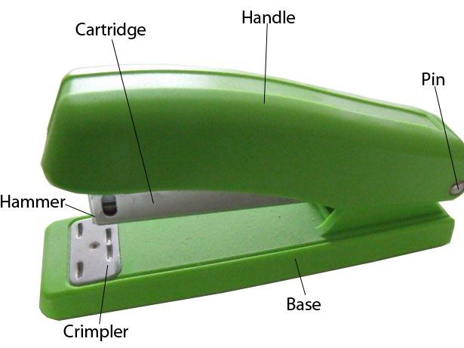

- Base
- Handle
- Cartridge
- Pin
- Crimpler
- Hammer

Base
The base of the stapler is a flat green piece of hollow plastic, measuring 4.5”x1.25”x7/16”. This rounded rectangular piece is perfectly flat on the bottom to provide a stable foundation when resting on a table or desk. The top of the base is designed to be flat, as papers will rest against it when the stapler is being utilized.

Handle
The handle of the stapler is a smooth, rounded, rectangular piece of plastic, molded to be comfortable when squeezed in the hand. This green plastic piece is 4.25”x1.25”x15/17”. All the sides, although flat, are generally rounded and smoothed, with the top having a relaxed downward slope from the front to the back.

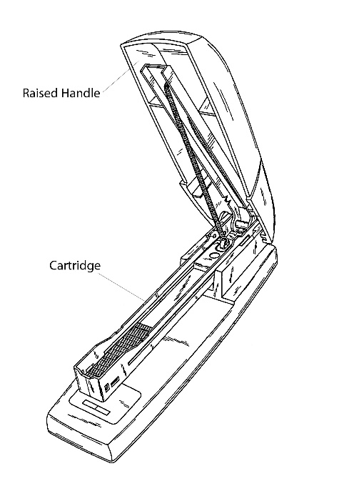
Cartridge
Housed inside the plastic handle is a metal U-beam, used to hold the staples, called the cartridge. The plastic handle clips away from this metal shaft, enabling the user to reload the staples as they see fit. Set inside the cartridge is a metal spring that, when fully extended, runs the full length of the cartridge. This spring becomes compact when staples are inserted into the cartridge, and then it eases the staples forward to the front of the stapler as staples are used.

Pin
The base, the metal shaft, and the handle are all held together on the back end of the stapler by a 1.25” metal pin. This pin allows the handle to snap away from the metal shaft, without them separating completely. It also allows the handle to clip away from the base, to widen the uses of the stapler.

Crimpler
The crimpler is a 14/16”x14/16” metal plate with a groove indented into it. It’s placed opposite of the Pin, on the front of the stapler, set into the base.

Hammer
The hammer is a solid metal plate, set in the front of the handle of the stapler. At the front of the cartridge, there’s a slit cut horizontally, just big enough to let a single staple through, when forced. The hammer is placed right above that slit, and glued into the plastic handle. When you squeeze handle and base together, the cartridge hits the base first. The cartridge is designed to slide up into handle, allowing the plastic handle to slide down and touch the base, all while the cartridge gets tucked away inside the handle. When this happens, the hammer continues downward with the handle (as it’s attached to the handle and not the cartridge) and it forces a staple out of the shaft, through the slit, where it gets force molded to the shape of the groove in the crimper.

Conclusion
The modern stapler is designed to be comfortable, and for ease of use. At a glance, it’s very easy to overlook the complexity of such a small device. With a simple squeeze of the hand, a metal fastener can provide organization in an unorganized world.
Very strong work. The writing is mostly lean and strong with no real awkward parts or over-wordiness. The attention to detail is wonderful, and I see no glaring omissions. However, as my comments suggest, there are a few descriptions that could be more precise and there are a few missing, key technical details. The intro, as mentioned, is the only part that needs some serious consideration to more closely match the genre expected outline. The grammar is also great, with just a few minor edits to make. The document design also looks clean and readable. Overall, this is strong work and I appreciate the care that went into it.

References
Dod, J. (2007). Green Stapler. Retrieved October 13, 2015, from http://www.publicdomainpictures.net/view-image.php?image=33694&picture=green-stapler

Patent US20050224554 - Stapler with device for holding stapler open. (n.d.). Retrieved October 21, 2015, from http://www.google.com/patents/US20050224554

U-Beam. (n.d.). Retrieved October 21, 2015, from http://www.perkor.hu/en/u-beam-1/

Whitney, D. (2004). 4.B. THE STAPLER. Retrieved October 13, 2015, from http://www.globalspec.com/reference/69905/203279/4-b-the-stapler

