City College of New York

Engl 21007- L2

Writing for Engineers- Hybrid Section

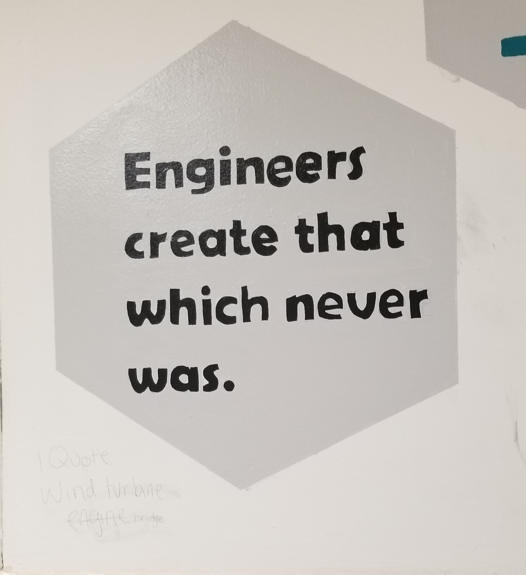 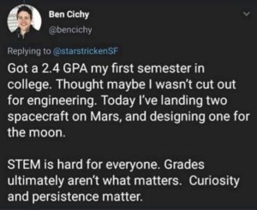

**Course:** Engl 210, Section L2

**Classroom**: SH 20

**Schedule:** Tuesdays and Thursdays, 9:30am-10:45am

**Writing Instructor:** Danielle Carr

**Office Location:** NAC 6/335a

**Office Hours:** Tuesdays and Thursdays 11am-12pm, and by appointment

**Email:** dcarr@ccny.cuny.edu

**Phone:** 914-462-7330, and office extension

Course Description:

This course will help you to hone the critical reading and thinking, research, and writing you will need to succeed in all of your writing courses and specifically your engineering courses. This course is also preparing students to write as engineers in professional environments. We will examine, analyze, and create various types of technical communication such as: memos, letters, instructions, definitions, descriptions, designs, proposals, and presentations. You will learn to synthesize information, find answers, and present ideas to some of the different audiences you will encounter. Learning to write well will enable you to present yourself in the best possible light in all situations. You will learn how to communicate your knowledge, plans, and ideas in a professional manner. Our time in this course will focus on reading and listening, essential steps in the writing process, effective writing, synthesizing material from various sources, and the ability to locate and evaluate relevant library and online research. We will also examine how writing is impacted by the elements of the rhetorical situation. By the end of the course, students should be confident in utilizing this knowledge in the construction and completion of a writing portfolio and self assessment.

How This Course Works:

This course is a hybrid course, a blend of an online classroom and a literal, face to face (f2f) traditional classroom experience. Luckily, this won’t change too much of your class experience. You will still be responsible for attending all scheduled f2f classes and handing in all work ON TIME and properly done, whether it’s due online or f2f. You will also be responsible for posting projects and presentations in specific folders and also posting responses to these projects. I will let you know when these postings are due, keep in mind they are mandatory as they are part of your homework and participation grades. The online homework will also have time sensitive deadlines. These responses can transfer to f2f discussions held in class, so they must be thought provoking and thorough. However, it is extremely important for students to attend all in person meetings as well, as this is the time when we will work on the most difficult assignments for the course.

Course Learning Outcomes:

Over the course of the semester, you will

* acknowledge your and others' range of linguistic differences as resources, and draw on those resources to develop rhetorical sensibility
* enhance strategies for reading, drafting, revising, editing, and self-assessment
* negotiate your own writing goals and audience expectations regarding conventions of genre, medium, and rhetorical situation
* develop and engage in the collaborative and social aspects of writing processes
* engage in genre analysis and multimodal composing to explore effective writing across disciplinary contexts and beyond
* formulate and articulate a stance through and in your writing
* practice using various library resources, online databases, and the Internet to locate sources appropriate to your writing projects
* strengthen your source use practices (including evaluating, integrating, quoting, paraphrasing, summarizing, synthesizing, analyzing, and citing sources)

What You’re EXACTLY Doing in This Course:

In this course you will learn to read, write, and speak thoughtfully and critically within your discipline. You will produce various written works in discipline specific genres and give presentations surrounding scientific topics of your choosing. Hopefully this rhetoric and writing practice strengthens your writing skills throughout your academic and scientific career.

Also, to simulate the engineer’s “experience,” you will spend much of the semester in pre-determined (by me) groups, in which you will consider the topic, direction, and composition of your projects together. However, MOST of the time, you will compose and submit individual assignments.

Required Textbook(s): *Technical Communication* by Mike Martel, 12th edition, Bedford/Saint Martin’s

* Supplemental Readings will be made available on Blackboard, CUNY Commons course site, or as handouts and distributed in class.
* Complementary textbooks (which, from time to time we might reference), include <https://digitalcommons.kennesaw.edu/opentc/>

<https://open.umn.edu/opentextbooks/textbooks/412>

CUNY Commons Course Website- <https://engl210ccny.commons.gc.cuny.edu/>

Which will house various documents/files necessary for coursework

Semester Calendar

Tuesday, January 28- First Day of Class

Thursday, January 30

Tuesday, February 4

Thursday, February 6

Tuesday, February 11

Thursday, February 13

Tuesday, February 18

Thursday, February 20

Tuesday, February 25

Thursday, February 27

Tuesday, March 3

Thursday, March 5

Tuesday, March 10

Thursday, March 12

Tuesday, March 17

Thursday, March 19

Tuesday, March 24

Thursday, March 26

Tuesday, March 31

Thursday, April 2

Tuesday, April 7- **No class- Classes follow a Wednesday Schedule!**

Thursday, April 9- **No class- Spring Break!**

Tuesday, April 14- **No class- Spring Break!**

Thursday, April 16- **No class- Spring Break!**

Tuesday, April 21

Thursday, April 23

Tuesday, April 28

Thursday, April 30

Tuesday, May 5

Thursday, May 7

Tuesday, May 12

Thursday, May 14- **Last Day of Classes!**

**Class Policies**

Lateness and Absences

* According to the CUNY CCNY Undergraduate Bulletin: http://www.ccny.cuny.edu/registrar/upload/2013-2015-Undergraduate-Bulletin.pdf (page 215)

Students are expected to attend every class session of each course in which they are enrolled and to be on time. An instructor has the right to drop a student from a course for excessive absence. Students are advised to determine the instructor’s policy at the first class session. They should note that an instructor may treat lateness as equivalent to absence. No distinction is made between excused and unexcused absences. ***Each instructor*** retains the right to establish his or her own policy, but students should be guided by the following general College policy: **In courses designated as clinical, performance, laboratory or field work courses, the limit on absences is established by the individual instructor. For all other courses, the number of hours absent may not exceed twice the number of contact hours the course meets per week. When a student is dropped for excessive absence, the Registrar will enter the grade of "WU".**

In other words: each student can miss up to THREE classes. FOUR absences results in a failure of the course. Students are expected to be in class ON TIME and remain for the duration of class. IF there is an unavoidable issue which prevents the student for remaining in the class for the entire period (as in necessity for lateness or early departure) please let the instructor know prior to arrival via email. If attendance/lateness is going to be a problem, consider switching from this section, it’s an early section and if I can arrive to school on time, ready to work, then so can everyone else.

Food and Drink 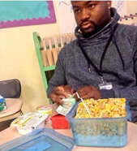 🡨----------------- Don’t let this be you!!!

Eating/Drinking is allowed in class but do not let it be a distraction to you or your classmates. Also, **clean up after yourselves!** Classrooms are communal spaces and NOT your personal bedrooms, hotel rooms, or kitchens. They need to be kept clean by ALL who use them.

Electronic Devices 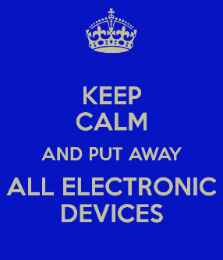

If it beeps, vibrates, rings, plays music, or has a screen, mute it before you enter class. Cell phone use is prohibited during class. Silence your cell phone, put it away before you enter the room and keep it away for the duration of class. If there is an emergency, quietly step out of the room to handle it. Tablets and computers can be used as note-taking devices or E-book readers if that is how students wish to transcribe information or read text. However, those devices can only be used SOLELY for that purpose, no web surfing, social media, or any other recreational use during class time. When those devices are not needed, they should be “sleeping,” face down, and out of reach.

“Don’t Yuck My Yum” 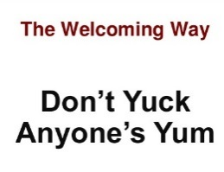

Each and every one of us, including myself, comes from a diverse background, environment, and has a unique life experience and skill set which contributes to our worldview and opinion. As members of a classroom community, school community, and society, etc., it is our duty to remember this and respect all viewpoints, even if we don’t agree with them. Remember, there are constructive ways to criticize.

Assignments and Due Dates 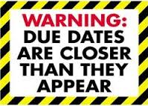

Assignments are due on the due date both in print and on blackboard unless previously arranged with the instructor. The campus is full of computer and print labs, save your work, get a cloud or a thumb drive and plan for all possible technological failures. In the case that any student will be absent on a due date, plan to submit work early! I prefer not to read on screen, so emailed work is frowned upon unless given prior permission If you are submitting print work AFTER class and I’m not there for you to put it in my hands, you MUST put it in my mailbox across from the English department and MAKE SURE someone **signs** and **dates** your submission. Work **without** a time and date stamp will be considered late. Work submitted after the due date will be deducted by half a letter grade every day that it’s late. First draft due dates are listed on the weekly assignment schedule, final draft due dates are due **1-2** class meetings after you receive your essays back with either my or peer comments. The exact dates will be announced in class. Various assignments will be required to be posted on Blackboard. You will receive advanced notice for this and there will be a section on Blackboard for the submission. In these cases, submission both on paper and online is required and one without the other can and will affect your grade.

Academic Integrity

Plagiarism is the unacknowledged use of another person's words or ideas. You can use other people’s ideas as much as you want and/or need to. Just make sure to **properly** give credit where credit is due. Words copied verbatim from another source must be quoted and the source must be cited. When you paraphrase words/ideas from another source, you must acknowledge the original author unless the ideas are common knowledge (information found in three or more different places). If you collaborate with another author to produce written work, you must acknowledge that person's contribution. “Borrowed” material must be *properly* cited in APA format, as is the preferred citation for the sciences. Anything incorrectly cited is considered plagiarism and is graded as an F. If there is any further question about the parameters of academic dishonesty reference page 230 of the CUNY Policy on Academic Integrity appears on page 230 of the City College of New York Undergraduate Bulletin 2013-2015.

* http://www.ccny.cuny.edu/registrar/upload/2013-2015-Undergraduate-Bulletin.pdf

All writing submitted for this course is expected to be your own. If a student’s submission contains any forms of plagiarism, he/she is at minimum subject to a failing grade for the project and/or course, and worst case scenario, academic suspension or expulsion. Part of the function for this course is to teach students how maintain academic integrity and to cite sources **properly** according to the standards of the American Psychological Association (APA)in order to avoid cases of inadvertent plagiarism, As part of this course, we will discuss strategies for adhering to standard conventions for responsible source use and for maintaining academic integrity and how to avoid inadvertently plagiarizing someone else’s work.

You can learn more about plagiarism at the following link: www.wwnorton.com/college/english/write/writesite/research/plagiarism_tutorial.aspx

Here are five practices defined as plagiarism in the CUNY Policy on Academic Integrity:

* Copying another person’s actual words without the use of quotation marks and footnotes attributing the words to their source.
* Presenting another person’s ideas or theories in your own words without acknowledging the source.
* Using information that is not common knowledge without acknowledging the source.
* Failing to acknowledge collaborators on homework and laboratory assignments. Submitting downloaded term papers or parts of term papers, paraphrasing, or copying information from the internet without citing the source, and “cutting and pasting” from various sources without proper attribution.

If you need ANY help at all *outside* of the classroom pertaining to anything at all, from writing issues and tutoring, to feeling overwhelmed, or *anything* in between, utilize these resources…

**The Writing Center**

<http://www.ccny.cuny.edu/writing/>

The CCNY Writing Center offers a supportive learning environment where students can have one-on-one tutoring sessions with writing consultants. It is a great resource for you to obtain extra help as you write and revise your papers. They DO NOT proofread your papers, but offer assistance on improving certain aspects of them. They also offer ESL tutoring. To set up an appointment or semester-long sessions, contact them in person at the Writing Center, which is located in the NAC, 3rd floor plaza or call (212) 650-8104. They will be partially open starting 9/8, and fully operational starting 9/15. I strongly advise you contact them as soon as possible, even if you don’t have anything specific you need assistance with yet.

**Gateway Advising Center**, NAC 1/220

<http://www.ccny.cuny.edu/gateway/>

Students without a declared major can receive academic advising, especially if you have questions about your course of study, core requirements, etc.

**AccessAbility Center Tutoring Services,** NAC 1/218

<http://www.ccny.cuny.edu/accessability/>

Provides one-on-one tutoring and workshops to all registered students with learning or physical disabilities.

**SEEK Peer Academic Learning Center,** NAC 4/224

Phone: 212-650-5786**;** Email: seekpals@ccny.cuny.edu

Offers counseling and peer tutoring for students in need of academic and financial support who have registered for the SEEK Program.

**Campus Counseling Center,** Marshak J-15

Phone: 212-650-8222, Email: [counseling@ccny.cuny.edu](mailto:counseling@ccny.cuny.edu)

<http://www.ccny.cuny.edu/counseling/>

The Counseling Center offers short term individual and group counseling to help students deal with their personal and adjustment issues that may interfere with their ability to progress academically to their fullest potential.

**Instructor, see front page for contact information and location**

If there’s something you feel I can’t help you with during class time, please do NOT hesitate to reach out and contact me. I frequently answer email and I love hard working students.

Grading Breakdown

Students will be assigned a grade for the writing section based on their completion of their assignments, participation, and attendance according to the following breakdown:

**Attendance and Participation, (online and f2f),**

**Coursework and in class writing 10% 94%-100% A 70%-72% C-**

**Diagnostic Essay (letter to professor) 5% 90%-93% A- 66%-69% D+**

**Lab Report 15% 86%-89% B+ 60%-65% D**

**Technical Description 20% 85%-83% B 0%-59% F**

**Group Project 20% 80%-82% B-**

**--Proposal 10% 76%-79% C+**

**--Presentation 10% 73%-75% C**

**Self Assessment/Portfolio 15%**

**Memo- 10%**

Required Assignments

In addition to smaller assignments that will be assigned throughout the course of the semester, the bulk of the coursework will focus on 3 major assignments given with the goals of reinforcing lessons, meeting learning outcomes, and increasing writing, analytical, and rhetorical skills. These will be done in a series of drafts with scaffolding assignments in order to both lead up to the assignments and provide students opportunities for revision.

* Diagnostic Writing Assignment- **500 word minimum- two fold assignment, read in entirety!!**
  + Write a professional letter to me about your life, your experiences, your achievements, your talents. What is your major in college and how does your major connects to your professional goal(s)? Include where you are from and how you want me to see you. Write about your challenges as well as your successes. How do you imagine your future place in the world of engineering? What are some of the engineering challenges you would like to be involved with? How do you plan to impact change in your world with your degree? Must include at least ONE page on an “artifact,” an item that is most important to your area/concentration. For example, computer engineers could discuss a mouse, keyboard, etc. Must describe the item in detail and discuss the significance of the item. You will (eventually) bring in this item (or a photo) and stand up and present it to the class. you and why. This item CANNOT be your cellphone or computer unless you are/have built the Iphone 12 or Samsung S12.
    - This is a formal letter, addressed to me (use the school address), and signed at the end by you. Type in 12 point New Times Roman font, normal margins. See the Kennesaw website, chapter 2.1 for letter templates). My address

Danielle Carr

City College of New York- English Department

1. nvent Ave

New York, NY 10031

* Memo- You will write a memo to the interim president of the City College of New York, addressing a problem on campus. This problem can be related to renovating or improving areas of the campus (cafeterias, dorms, classrooms, parking etc.). Be creative. The idea is to define a problem and offer a specific solution to address this problem. Remember, the president does not know about this specific problem so you will have to provide the context. Important details can be bulleted for easy reading. No cost estimates are required for this memo. Basically, it will be a memo that requires a follow-up meeting for further discussion.
  + - Format: 12 pt. New Times Roman, 1 inch margins. Paragraphs are single spaced and left justified. Skip a line between paragraphs. Sections should have heading titles that are in bold face.
    - Length: 1-2 pages (500 words), 1 page reflection paper
* Lab Report- min 4-5 pages of text, min 2 pages reflection paper
  + Students will compose a lab report based on a lab experiment specific to their chosen area/concentration of engineering. The lab report must have all of the elements of the lab report listed from the discussion/powerpoint from class (the appendix/acknowledgements are not mandatory, but the other elements are). The lab report also requires a bit of research, a minimum of three sources must be cited both in text and listed on the reference page according to APA standards.
* Technical Description (20%), minimum of 5 pages of text, 2 page for reflection.
  + You will write a description of a simple technological item, more than likely, the item you selected and included in your letter to the instructor assignment.
  + Or, choose one that you are particularly interested in and explain its purpose, as it relates to your concentration. Think carefully about your choice. Descriptions of objects, mechanisms, and processes appear in virtually every kind of technical communication. In addition, instructions are also frequently used.
  + Research and APA citations will be required for this assignment.
* Engineering Proposal + Presentation - Proposal Minimum 5 pages. Self-Reflection 1-2 pages. Presentation, minimum 10 minutes. Each person will write his or her own reflection paper which must include their role in the project (exactly WHAT they did), how they liked (or disliked) working in teams, analysis of the rhetorical elements and how the project met specific course learning outcomes. You will also grade each other’s performance with templates.
  + The assignment is a group/oral report of a proposal for a creative engineering innovation. The following areas of the United States (USVI, Puerto Rico, parts of Florida, and Houston), not to mention islands such as Dominica, islands of the BVI, St Maarten, Barbuda, Cuba, etc were drastically affected by hurricanes Maria and Irma. Most recently the Bahamas was affected by hurricane destruction and Puerto Rico is suffering from massive, random earthquakes. These areas are undergoing massive rebuilding projects, changing infrastructure, and considering ways to update aspects of the islands so that such immense damage does not occur in the wake of other hurricanes. Power grids, computer systems, roads, bridges, buildings, to name a few things, have been destroyed. Hospitals, airports, etc are being severely impacted. Despite the amount of human suffering that has occurred in the wake of these natural disasters, these natural disasters actually make for an engineer’s dream: how can you positively impact these areas in their times of great need? Rebuilding and upgrading to better than once was will take years, especially if hurricanes of such magnitude return to the Caribbean.
    - You are not limited to this part of the world. If you find a recent natural disaster in another part of the world where your team’s expertise could be of service, clear it with the instructor first.
  + Your task is to consider this in light of your engineering concentration (civil, electrical, computer, mechanical, chemical, etc) and develop a thing/idea that is designed to assist the rebuilding process in some way. Your design might have something to do with infrastructure: bridges, roads, sidewalks, etc. Your idea might have to do with solar panels and electrical grids, water collection (as islands are notoriously yet ironically always short on water), anything, there is no limit to idea but money must be considered (you need a budget, hurricane repair is ALREADY expensive). These are just some ideas you are not required to use them.
  + You will need to do some research to see what problems have surfaced where (as far as issue/island/location) on your own, which you will incorporate into your project (that’s going to be the history/background part).
  + The project requires a brief technical description of your thing/idea, a brief literature review, the proposal, powerpoint, resumés, job postings, and an audience analysis- who are you presenting this to? Who are you impacting/helping with your idea/thing? How will this impact your content?
    - Project objectives:
      * Innovation
      * Process
      * Group work
      * Oral presentation
      * Overall thoroughness and logic of proposal structure
* Reflection paper- typically 1-2 pages, but depends on the assignment.
  + Students must make use of the terms introduced in the rhetorical situation and describe how each assignment has helped them to achieve the course learning project. These must be attached to the final draft of all assignments.
* Final portfolio and self reflection
  + A rhetorical analysis of the student’s work that should include references to elements of the rhetorical situation: genre, audience, purpose, exigence, stance, and media/design, in digital format, on the CUNY Commons.
    - \*\*\***This semester, Researchers at CCNY will be collecting all assignments from all sections of Engl210 Writing for Engineers including portfolios and self-assessments. Because of this study, you will be asked to submit your final work following specific formatting conventions.**

** All major writing assignments will require a written self reflection component, which we will discuss in class.

On draft work:

“Almost all good writing begins with terrible first efforts. You need to start somewhere. Start by getting something -- anything -- down on paper. A friend of mine says that the first draft is the down draft -- you just *get it down*. The second draft is the up draft -- you *fix it up*. You try to say what you have to say more accurately. And the third draft is the dental draft, where you check every tooth, to see if it's loose or cramped or decayed, or even, God help us, healthy.”

– Anne Lammott, *Bird by Bird: Some Instructions on Writing and Life*

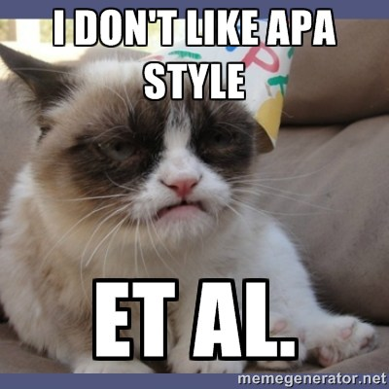 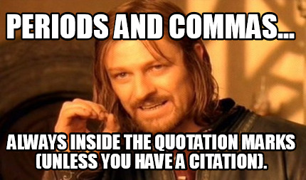

*** All written assignments must be typed using Microsoft Word in 12 point, Times New Roman font, double spaced, with one inch margins, as per APA guidelines. For this course we will be referring to the Purdue OWL website to learn and practice using the APA format. <https://owl.english.purdue.edu/owl/resource/653/01/>

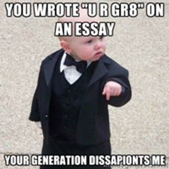 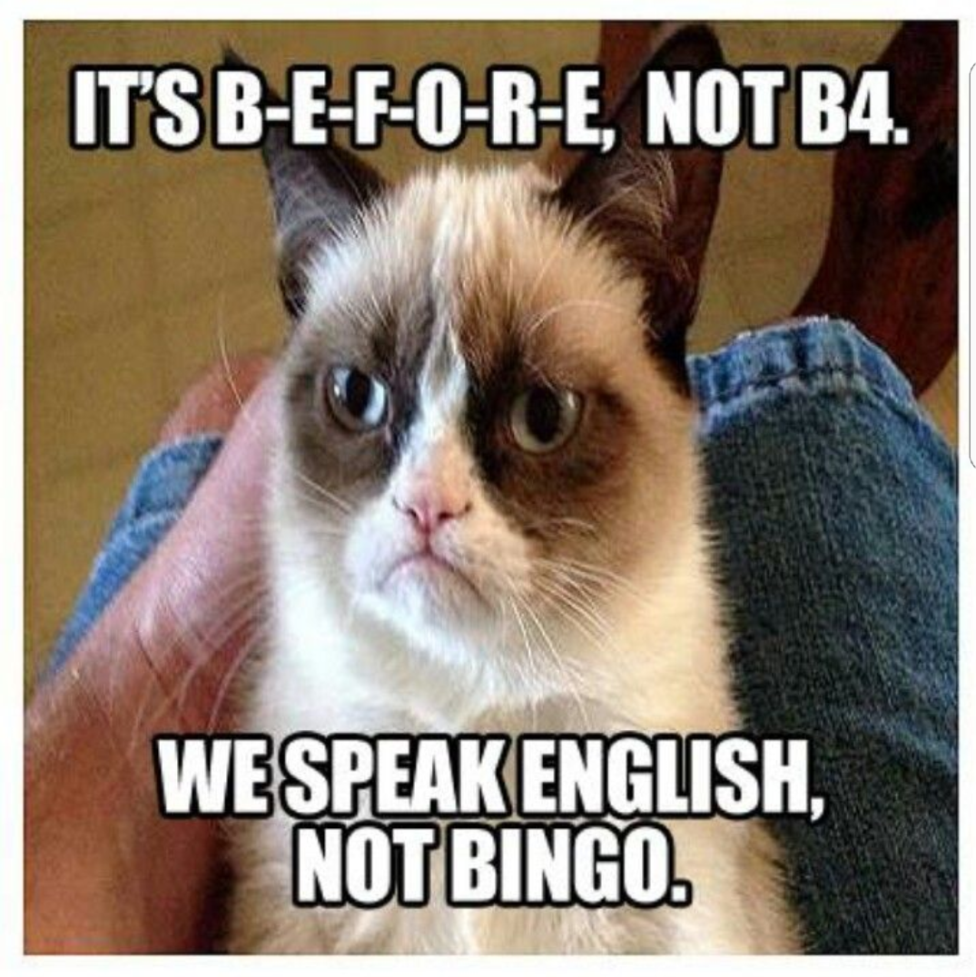*** Also, while the course objectives do not state that I am trying to create professional grammarians, ***ALL*** writing for this course ***MUST*** be written in Standard English and not in text slang or colloquial spelling.

Weekly Assignment Schedule

|  |  |  |
| --- | --- | --- |
| **Date** | **In Class** | **Assignment** |
| **Week 1** |  |  |
| Tuesday 1/28 | Review syllabus, ice breaker, assign and explain diagnostic essay assignment, discuss “Theme for English B.” | Read Markel Ch 5. Complete introduction letter, due 2/4. |
| Thursday 1/30 | Discuss elements of Rhetorical situations, genre, stance, exigence, purpose, media/design, and audience. In class writing assignment on rhetorical situation and audience analysis. | Essay due 2/4. Based on the groups posted on BB, determine a team/company name and post on BB under the discussions page. Read Markel Ch 3, 8, 9, 10. |
| **Week 2** |  |  |
| Tuesday 2/4 | Essay due. How do engineers communicate? Discussion on assignment #1- memo, reflection papers, audience analysis. | Memo due 2/11, one draft. |
| Thursday 2/6 | Continue discussion. | Markel ch 20. Memo due 2/11 |
| **Week 3** |  |  |
| Tuesday 2/11 | Memo due. In class assignment and discussion on descriptions and instructions. | Read Markel Ch 6. BB post on technical description item due 2/12, 8pm. draft work due 2/20 |
| Thursday 2/13 | Discuss assignment #2- technical description and APA citations and quotations. | Draft work due 2/22, bring 4 paper copies for peer review. READ: Markel Ch 2 |
| **Week 4** |  |  |
| Tuesday 2/18 | **NO F2F class! Hybrid class. See post for directions** | Draft work due, 2/20, bring 4 copies for peer review |
| Thursday 2/20 | **Instructor sick- hybrid class, online peer review** | Final draft due 2/25, read Markel Ch 19 |
| **Week 5** |  |  |
| Tuesday 2/25 | Final draft due. Discuss lab reports, in class exercise and assessment | Complete the genre analysis on the lab report handouts |
| Thursday 2/27 | Discuss lab report project and reflection papers |  |
| **Week 6** |  |  |
| Tuesday 3/3 | **Hybrid day, no f2f class meeting!** |  |
| Thursday 3/5 | **\*\* library class** | Post lab report decisions on bb, comment on other groups |
| **Week 7** |  |  |
| Tuesday 3/10 | **Hybrid day, no f2f class** | Draft work due online, 3/12 |
| Thursday 3/12 | **\*\*hybrid meeting, no formal class, online peer review** | Final draft due 3/17 |
| **Week 8** |  |  |
| Tuesday 3/17 | **Final lab report due. Prep day, no class meeting** |  |
| Thursday 3/19 | Set up CUNY Commons websites, discuss group project on technical description | Read Markel 10, 15, 16, material on Job Postings, begin to consider possible topics for project |
| **Week 9** |  |  |
| Tuesday 3/24 | Discussion- job posting, resumé, genre of technical proposal | Read student samples- genre analysis, post resumé Continue research |
| Thursday 3/26 | Discussion of genre analysis, instructor meetings in “breakout rooms” on project topics/decision | Compose brief abstract on projects, post on bb, comment on other groups. Due 3/30 by 10pm.  Read Markel Ch 21 |
| **Week 10** |  |  |
| Tuesday 3/31 | Review Progress of Projects. Meeting with instructor | develop a job posting for your team/project, post it on bb, then pick from the “pool of applicants” on BB in the resume area.  Continue working on projects, |
| Thursday 4/2 | In class peer review session, work on projects, comments, etc |  |
| **Week 11** |  |  |
| Tuesday 4/7 | **No class! Follow a Wednesday Schedule** |  |
| Thursday 4/9 | **No class! Spring Break!** |  |
| **Week 12** |  |  |
| Tuesday 4/14 | **No class, spring Break!** |  |
| Thursday 4/16 | **No class, spring break!** |  |
| **Week 13** |  |  |
| Tuesday 4/21 | In class presentations, |  |
| Thursday 4/23 | In class presentations |  |
| **Week 14** |  |  |
| Tuesday 4/28 | In class presentations/ discussion of final project (return to CUNY commons sites) |  |
| Thursday 4/30 | **Hybrid day, composition of content** |  |
| **Week 15** |  |  |
| Tuesday 5/5 | Composition of content | Online peer review |
| Thursday 5/7 | **Hybrid day-**Online peer review | Final due 5/14 |
| **Week 16** |  |  |
| Tuesday 5/14 | **Last Day of Classes!**  Self reflection and final portfolio final due |  |