Rapid Response Communications Recovery with C.O.W.s
Proposal to be presented on November 21, 2018

David Geiger, Yang He, Frank Orefice, Hanane Sobhi
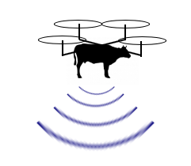
The Flying COW, LLC
(212)-590-2721
160 Convent Ave, New York, NY 10031
FlyingCow@citymail.cuny.edu

Table of Contents
- Introduction 3
  - Problem Statement 4
  - Background 4
  - Needs Statement 5
  - Objective 5
- Proposed Technical Approach 6
  - Requirements 7
  - Architecture Design 7
  - Implementation Design 8
  - Quality Assurance Plan 10
- Expected Project Results 10
  - Measure of Success 10
  - Costs of Flying COWS 11
- Project Schedule 14
- About Us 14
References 17

- Introduction
Communication is a vital part of our society. Due to technological advances, communications through devices like cell phones and computers are assuming a more vital role in our day to day interactions. Smartphones are now ubiquitous, and allow us to communicate with friends, family and coworkers at anytime and anywhere. These devices are also essential for receiving and sending important information, connection to navigation, and even access to emergency services. While this technology has made vast improvements to quality of life for millions of people around the world, this reliance on our mobile devices makes us more and more vulnerable if key infrastructure in the networks is lost or damaged.
During natural disasters like hurricanes, tornadoes and storms, cell phone towers are susceptible to damage and loss of power. More than a minor inconvenience, disruptions to communications with others during an emergency can have serious consequences. A lack of communication could mean life or death. It not only may affect citizen’s abilities to communicate, but also emergency response coordination by local governments and first responders. Though mobile providers make attempts at lessening the impact of the storms by fixing the cell towers in a timely manner, depending on the damage done by the storms, it may take some time.
Our team plans to improve and develop Cell On Wings (COW) drones, to provide cell service to those in areas where cell towers were destroyed. By using COW drones, we’ll be able to reach many mobile users and won’t be limited like Cell On Wheels, which are mobile cell stations, that must traverse roads that are either damaged or destroyed by the storms. We plan to first test our drone in Ponce, Puerto Rico, one of the many coastal areas of Puerto Rico devastated by Hurricane Maria, to ascertain its scalable capabilities. After successfully producing and testing the system, we plan to provide our COW drones to mobile providers, the Federal and local governments, and disaster relief organizations. We believe our innovative system for rapid deployment will help bring communication back to those in need within hours of a natural disaster and provide service while critical hardware is repaired.
1.1 Problem Statement
Due to the devastation caused by Hurricane Maria, cellular communications infrastructure in Puerto Rico was crippled. Either due to the lack of electricity or the physical destruction of cell phone towers, residents, local governments and even emergency responders were left without the ability to communicate for long periods of time. The damage left approximately 91% of Puerto Rico without cell phone coverage (Weise, 2017). Despite being a commonwealth of the United States, Puerto Rico’s recovery after the storm was delayed. 90% of the Puerto Rico’s citizens still had no mobile phone service seven days after the storm. Mobile carriers such as T-Mobile, Sprint and AT&T, despite being competitors, worked together “to provide communication to people in despair” (Rogers, 2017). To lessen the impact, carriers sent emergency mobile units and supplies such as VSATS (Very Small Aperture Terminal) and Cell On Wheels (COW), to provide cellular service to those who need it.
Though mobile carriers made attempts to fix damaged cell phone towers, VSATs and ground-based COWs faced many challenges that slowed their deployment and reduced their immediate impact on restoring communications. The hurricane destroyed and flooded roads, making traveling the island difficult. Cumbersome Cell on Wheels units as well as the VSATs could not be deployed where damaged roads made travel impossible. This disproportionately affected those who lived in rural areas or on mountaintops, and who weren’t given priority when it came to repair of nearby cell towers (Rogers, 2017).
Instead of using a truck, the Cell On Wings utilizes a drone to cover more areas to provide people with coverage. Though AT&T has proven that this new technology works, it hasn’t used it in Puerto Rico since it was first unveiled (Wamsley, 2017). If more mobile providers were able to utilize this technology in conjunction with existing methods of providing coverage to areas affected by natural disasters, it will lessen the effects of the storm and the recovery after natural disasters.
1.2 Background
The Flying COWs design will be based on the ones tested by AT&T for limited use after Hurricane Maria in Puerto Rico. Due to the usefulness of the device and the number of users it could reach, it would be able to greatly help those who were impacted by natural disasters. However, current drone technology is limited by drone battery life. Other mobile providers have instead chosen to use VSATS and COWS (Cell On Wheels) to help those who lost mobile service during the storms (Rogers, 2017). Though these devices can help those in need, are not limited by batteries, but are slow and have limited deployment ranges.
We believe our system will not only augment existing emergency response to a loss of communications but surpass the existing methods for restoring communications more quickly and thoroughly. Furthermore, it can be integrated to work with existing non-damaged communications infrastructure or stand alone for up to 5 days of continuous service. This is will be due to improvements in drone technology, battery life, and the ability to connect to a small, compact ground-based power unit. The drone and power unit are small enough to be airlifted to remote locations, or even driven in a standard 4x4 SUV, Jeep, or van when applicable.
1.3 Needs Statement
The aftermath of a natural disaster can take a toll on those who were affected by it. These events ultimately lead to the destruction of property, such as homes and businesses, but may even lead to the loss of life. When mobile service is lost as a result of the storm, people are desperate to know if their loved ones are safe. Mobile providers may make attempts to quickly restore mobile service to those affected, but such a task may take longer than expected. However, using Flying COWs, people will be able to at least contact their loved ones and let them know that they are safe.
1.4 Objective
In implementing this project, our team aims to develop efficient and cost-effective Flying COWS for the government, mobile providers and humanitarian organization to help areas affected by the loss of cellular towers during natural disasters. These Flying COWs will be deployed and allow those in the affected area to have mobile access to communicate with their loved ones and to get information that would otherwise be blocked by the lack of electricity, internet and cellular service. In doing this, the team hopes to help those in need by connecting them with others when they need it the most.
Our plan involves improving on current heavy-lifting drone, battery, and telecommunications technology. Research and development will be carried out in a shared incubator space in New York. This allows access to all the personal, machinery and materials at a lower cost than building out a facility from scratch. All development of the drones, battery and power units, as well as software and electronic hardware will be done under one roof, allowing for more efficient and productive manufacturing.
As a proof of concept test, we plan to test the system in Ponce Puerto Rico. This site has been selected as an ideal area because it has a population size that can be covered with 5-10 drones, which represent a reasonable scale for manufacturing at this stage. In addition to its size, Ponce presents a variety of geographical challenges typical of areas prone to hurricanes, mudslides, etc. It has a coastal area, a flat urban section, and is abutted by steep mountains. These present ample testing opportunities to fine tune mechanical and electronic components and to test the effectiveness of communication at a reasonable scale.
Once we complete our testing, we plan to provide our COW drones to mobile providers, the U.S. government and disaster relief organizations, as to maximize the effectiveness of our drones.
2. Proposed Technical Approach
Our team consists of chemical, mechanical and electrical engineers, as well as a computer scientist that will be working on the project. The engineers will be working on the design of the drone, and the computer scientist will work on the software used by the drone. The chemical engineers will work on developing the drone’s power source, which will either be designed into the drone or tethered to the drone. Our electrical engineers will develop the electronics to be used in the drone and the mechanical engineers will make designs for the drone. Our computer scientist will use C++ to develop the software that will be used by the drone.
2.1 Requirements
Personnel Requirements
- Mechanical and Chemical Engineering team, Computer Engineering team and Electrical Engineering team
- A designer with a background in designing drones
- Technical/ Project management staff for manufacturing
- Temporary deployment team (Ponce, PR)
Other Requirements
- Office and Manufacturing space
- Materials
- Transportation and logistics
2.2 Architecture Design
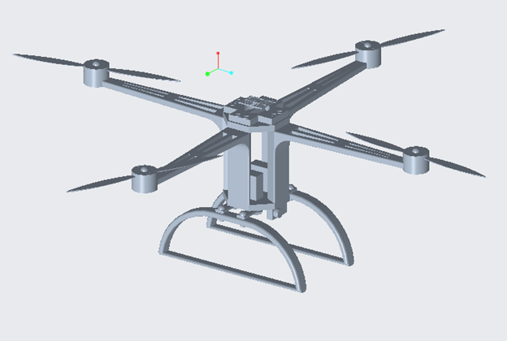
Figure 1. Body overview
The four-axis aircraft, also known as the four-rotor and four-rotor, is a multi-axis aircraft with four rotors to hover, maintain posture and level flight. Unlike a fixed-wing aircraft, it lifts the aircraft through the thrust provided by the rotor. Its four rotors are the same size and their distribution is close to symmetry. For a simple design, the thrust can be adjusted at different positions by adjusting the relative speed between the different rotors, and the counter-torque between each rotor can be overcome to control the aircraft to maintain the altitude or complete various maneuvers.
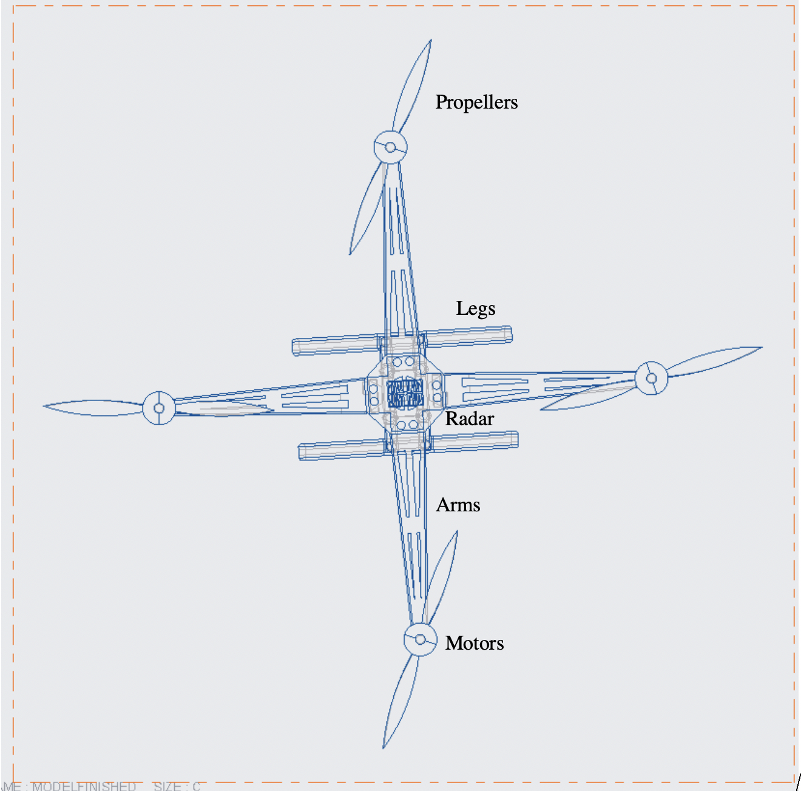
Figure 2. Drone top overview
With the development of smart phones, the development of electronic gyroscopes, GPS, fly-by-wire flight control systems, and motors with fast throttle response speeds have been used as power systems to overcome the main shortcomings of quad-rotor aircraft. Because the quadcopter is small, light in weight, and easy to carry, it can easily enter various harsh environments where people cannot easily enter. Often used to make models, but also used to perform aerial film framing, real-time monitoring, terrain exploration and other missions.
2.3 Power and Base Station Design
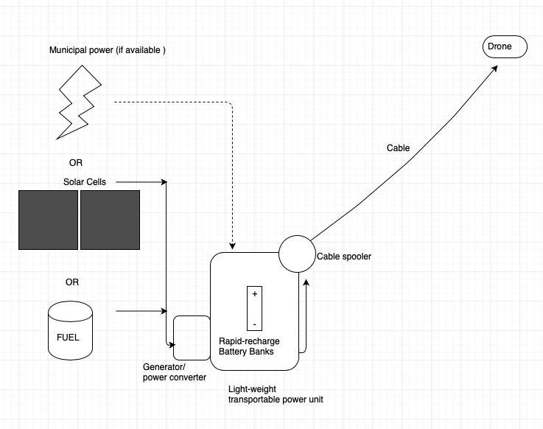
Figure 3. Base station with multiple power sources
The base station will serve to provide power to the drone, as onboard batteries are heavy and limit the drone’s time in the air. Relying on a light, portable base station for power gives the drone much longer flight times. The base station will be compact, approximately 3 feet by 4 ft by 4ft. It can be dropped into remote locations by helicopter, or even travel over land via regular pick-up truck, van or other utility vehicle. It has three different power options: Solar arrays, liquid fuel (gasoline), or municipal power (if available). Each of these could charge an extensive battery bank designed by the Flying COW’s team of engineers for fast recharge and high-power output.
- We will install the small cell antenna to the drone and verify the connection via the scanning receiver software.
- The drone will be powered using a tether and a ground power source.
- GPS radar is setup on the top of the drone; Geo-investigation camera will be attached at the bottom of the drone body.
- Base station and drone are operated by only two technicians and can operate continuously for up to 5 days before maintenance.
2.4 Quality Assurance Plan
I. Outline goals
A. Develop a proof of concept for a rapidly deployable drone cellular network.
B. Develop a more efficient version of the drone that can remain active for a minimum 3-5 days.
II. Personnel
- Have experience working in teams comprised of engineers with different engineering backgrounds.
- Provide skilled technical staff for the manufacture of all hardware and software, as well as train on-site technicians in operation of COW network.
III. Funding
- Preventing developmental delays
- Creating a project schedule and deadlines
  - Creating goals to complete and show progress of the project.

3. Expected Project Results
- We expect to build upon existing COW and drone technology to make smaller, more efficient, and robust drones, both in manufacture and usage.
- We expect mobile providers like AT&T, T-Mobile and others to use our drones to help wider areas that have lost cell connect due to a natural disaster.
- We expect to organizations like the Red Cross to use our devices in conjunction with mobile providers to help those affected by natural disasters.
3.1 Measure of Success
- Our drones can provide mobile service to those in the immediate area.
- Our drones can continue to provide mobile service at high altitudes and in mountainous areas.
- During the recovery period, people can communicate with their loved ones and get information about the disaster and the recovery efforts.
3.2 Project Costs
The research and development costs associated with this project include the salaries for 5 principal engineers as well as 10 staff and technicians for 17 months. The development and production will take place in a technology incubator space located in the Brooklyn Navy Yard, New York, which offers start-up companies low-cost development space. The incubator includes all office equipment, tools and machinery needed for production for the Proof-of-Concept, saving time and money in set-up costs.
The table below is a breakdown of the estimated research and development costs for the project.

Research + Development Costs
Description | Unit Cost | Yearly Cost | Total Project Cost
Office/Manufacturing Space | $5500/month | $66,000 | 93,500
Utilities | $1200/month | $14,400 | $20,400
Insurance | $800 | $9600 | $13,600
Engineer Salaries (5) | $75,000 | $375,000 | $531,250
Technicians/ Staff (10) | $55,000 | $550,000 | $779,166
R+D Sub-Total |  |  | $1,437,916

The production costs associated with this project are detailed in the table below.
The drone cost includes the materials, like carbon fiber, propellers, electronics, and communication hardware, as well as all the miscellaneous hardware needed to construct the drone. It also includes the labor to manufacture them. The electronics and networking hardware consist of the base station and drone communications equipment. Each mobile base station can supply up to 5 days of power via gas generators and solar panels. They contain network transmitters/receivers for signal processing to and from the drone. They are enclosed in a polycarbonate/ aluminum severe weather resistant case. The transmission cable connects the base station to the drone to supply power and communications.
A total of 10 drones are built for the proof of concept test, even though it is estimated that 5 will provide ample coverage. This will provide back up if there is damage during shipment, deployment, etc. to not delay testing.

Production Costs
Description | Unit Cost | Number of Units | Total Project Cost
Drone Manufacture  (Labor and Materials) | $25,000 each | 10 | $250,000
Electronics and networking | $1000 | 10 | $5000
Mobile Power Unit | $9,500 | 5 | $47,500
Transmitter/Receiver Manufacture | $1,450 | 10 | $14,500
Transmission Cable | $5 / lin ft | 1,500 lin ft | $7,500
Production Sub-Total |  |  | $324,500

Logistical costs include the transport of hardware from New York to Ponce, Puerto Rico.
It also includes the cost of local temporary technical staff to deploy and monitor the drones and base stations. A budget of $200 per day is allocated for each staff member on site (not including salaried staff). A total test time of 2 weeks is estimated. Generator fuel is estimated at $3.50 per gallon. To avoid shipping costs, the transmission cable will be sourced in Puerto Rico, and a budget of $5.00 per linear foot is allocated to it.
There is currently no allocation for permits and fees, as we believe these will be waived by the local government.
The table below details the estimated logistical costs.
Logistical Costs
Description | Unit Cost Estimate |  | Total Cost
Transport New York to Ponce | $700 per Drone/base station |  | $7,000
Fuel | 3-5 days @ 25 gal/day @$3.50/gal |  | $263 - $438
Deployment Team (Ponce) | 2 weeks per test (10 persons @ $200 per diem) |  | $20,000
Permits | TBD |  | TBD
Misc. Hardware, tools, additional transport, meals, etc |  |  | $7,000
Logistical Sub-Total |  |  | $34,438

Total Estimated Expenditures: $1,796,854.00
4. Project Schedule
Date | Task
1/01/2019 | Meet with the mayor of Ponce, Puerto Rico, Maria Meléndez to discuss the project, what needs to be done and when we plan to test our device.
2/01/2019 - 6/23/2019 | Receive equipment needed for the device and begin designing the drone.
6/24/2019 -  8/30/2019 | Work on any issues with the software and the hardware. Also, attempt any small-scale trial runs of the drone.
9/30/2019 | First official flight of the drone
9/30/2019-6/14/2020 | Work on any bugs that appeared during the first official flight and prepare for second official flight.
6/15/2020 | Second official flight of the drone
7/14/2020 | Meet with the mayor and discuss the following steps for the project

5. About Us
Our Company
The Flying COW, LLC. is a New York based company that is comprised of engineers from different backgrounds. Using our different skill sets, our goal is to develop efficient and cost-effective Flying COWS for the government, mobile providers and humanitarian organization to help areas affected by natural disasters and the loss of cell service.
Our Team
Frank Orefice
Frank serves as Flying COW’s computer scientist responsible with developing the software to be used by the Flying COWs. He received an associate degree for computer science from Kingsborough Community College and is currently pursuing his bachelor’s degree in computer science from the City College of New York. Despite being a student, Frank has developed software for research and competitions. He has had research experience as the lead Computational Analyst of a Biology Research group, where he developed software using Python to analyze biological data-sets and automate the process of their research.
Frank enjoys programming and has participate in many hackathons to hone his skills and to gain experience working in a team of developers. Despite being from different backgrounds, during his first hackathon, his team was able to win a prize in the competition for their application. With his problem solving and teamwork skills, as well as his passion for programming, Frank is a capable member of Flying COW, who is willing to go the extra mile to produce a product that would not only benefit the company but would benefit those affected by natural disasters.
David Geiger
Serves as Flying COW’s chemical engineer for battery development and power supply innovations. He received a BE in Chemical Engineering from the City College of New York. David had 5 years’ experience in working on a diverse set of battery and energy optimization projects for the National Renewable Energy Lab and has consulted for the City of New York on renewable energy policy and implementation.
David honed his project management and budgeting skills as the president of a small design and fabrication company, where he led and managed teams of employees and subcontractors and learned to think on his feet. He not only brings his chemical engineering skills to Flying COW, but is also a skilled machinist, welder and all-around problem solver. In addition, his hands on and management experience makes for good communication with other members of the engineering and production teams.
Hanane Sobhi
Serves as Flying Cow’s electrical engineer for EScs ( electronic speed controller) and sensors.
Hanane received her first bachelor in Sciences Physics Of Engineer from The University of Sciences and Technologies in Morocco and her second bachelor in Electrical Engineering from The City College of New York. She a member of Society Women Engineers (SWE) and a member of The National Society of Collegiate Scholars (NSCS).
She had a lot of experience in data analysis and programming, but her work as a Chief Financial Officer (CFO) in Khamiss company helps her to develop performance measures that support the company’s strategic direction, oversee the company's transaction processing systems and bring new partnership to the company.
Yang He
Serves as Flying COW’s mechanical engineer for drone designs. He is a member of American Institute of Aeronautics and Astronautics (AIAA) who had two years’ experience in small scale aircraft design. He received a BE degree from the City College of New York. He was a participant of NASA Space Weather Research Group and research interested in power grid protection from the damage of solar activities. These experiences lead him had a good expectations in natural disaster recovering projects.

References
FCC. (2018). Human Exposure to Radio Frequency Fields: Guidelines for Cellular Antenna Sites. Retrieved from https://www.fcc.gov/consumers/guides/human-exposure-radio-frequency-fields-guidelines-cellular-and-pcs-sites
Rogers, A. (2017). In Puerto Rico, no power means no telecommunications. Retrieved from https://www.wired.com/story/in-puerto-rico-no-power-means-no-telecommunications/
Wamsley, L. (2017). FAA Approves Drone As ‘Cell Phone Tower In The Sky’ For Puerto Rico. Retrieved from https://www.npr.org/sections/thetwo-way/2017/11/17/564879549/faa-approves-drone-as-cell-phone-tower-in-the-sky-for-puerto-rico
Weise, E. (2017). Puerto Rico is nearly entirely cut off from cellphone service, leading to low tech solutions. Retrieved from https://www.usatoday.com/story/tech/2017/09/28/puerto-rico-cell-phone-service-tmobile-att-hurricane/710775001/

The Reflection Papers
Frank Orefice
My role in the project was to work on the proposal’s outline and most of its sections. I also provided the information I found while researching the topic, such as the technology and how Hurricane Maria disrupted communication in Puerto Rico. Since this was the first time most of us had worked on a group proposal, it was a challenge for us to decide on what to write about. When I was researching Hurricane Maria and how it impacted Puerto Rico, one issue that was predominant in my search was the destruction of cell towers and the lack of cell service. I found this issue very interesting and decided to research further into the issue. After gathering enough information, I proposed the idea to my group which led to us basing our proposal on the topic.
When we were given the assignment, I was kind of worried. Personally, I don’t enjoy doing group projects since I like to have full control of my writing. However, as we began working on the proposal, we were able to get more work done than if had worked alone. Also, since I’m a computer science major, there is a limitation to my knowledge, especially when it comes to hardware and design for the drone. Since my group has a mechanical engineer, he was able to provide the models needed for the drone. I learned through this assignment that teamwork and collaborating is a necessity in engineering as engineers come from different backgrounds with different knowledge sets. By collaborating, you can effectively cover topics and issues that would otherwise be outside your understanding.
The genre of this assignment is a proposal. A proposal is a document used to persuade the reader to consider, fund or support an idea that the writer wants to pursue. Our project follows the workings of a proposal because it describes an issue of cell phone towers being destroyed by natural disasters and proposes a fix the issue using drones with built-in cell towers. Our proposal also explains how much the project would cost and how long it would take to design and implement the drones.
The audience for this proposal is primarily Maria Melendez, William Long and Martin Burvill. In our proposal, we state that we plan to test our drones in Ponce, Puerto Rico and Maria Melendez in the current mayor of Ponce. With her help, we hope to test our drone in a coastal area that was damaged by Hurricane Maria. William Long is the current Administrator of the Federal Emergency Management Agency (FEMA). With his help, we hope to make our drones available for other areas in the United States affected by natural disasters. Finally, Martin Burvill is the current Senior Vice President and Group President of Verizon Business Markets. With his help we hope to make our drones available to mobile providers, whose cell phone towers were destroyed by natural disasters. Others who may read our proposal are those who are interested in the technology and equipment that is being used by organizations that help during natural disasters, as well as new technology that is being implemented to quicken the recovery time of areas affected by these natural disasters.
The purpose of this proposal is to inform the reader about the experimental technology that is Cell On Wings and persuade them to fund our project to design more efficient versions of the technology. My stance on the subject is that Puerto Rico, despite being a commonwealth of the United States, has had a longer recovery period than it should have. Understandably, infrastructure is usually badly damaged during these types of storms, however, the loss of an essential means of communication such as cell service can exacerbate the damage done by these storms. Despite the prevalence of drones, COWS have yet to be massed produced. I believe such a technology is essential to lessening the recovery time and helping those who need assistance.
The media that is used for this assignment is multimodal since we must give in a copy of our proposal using print and digital resources. The proposal is digital, since we must post our drafts online so that our classmates could peer review it for our final draft. It's in print since we must give in our draft and our final draft in print. We also had to post our idea for our proposal on Blackboard before starting our assignment. Also, our project has a PowerPoint component that is used to effectively inform the class what our proposal is about, how we plan to implement it and how much it would cost.
The exigence of this assignment is communication, specifically using cell phones. Almost everyone owns a cell phone and consider it as an essential part of their daily lives. We use our cell phones to talk to our loved ones, friends, coworkers or to search for information. If we were in an emergency which led to the loss of cell service, we’d be at a major disadvantage. We would not only have information on the situation, but we would also be unable to communicate with our loved ones to inform them about our safety.
This assignment follows learning outcomes 4, 5, and 7. The assignment meets outcome number 4 since over the course of the assignment, we’ve worked as a group to come up with the topic of our proposal and the purpose of our proposal. The assignment meets outcome number 5 since its genre is a project proposal and uses a multimodal form using print and digital media. Finally, the assignment meets outcome number 7, since we used campus library and internet resources to get information for our proposal.
David Geiger
I learn a lot from doing group project work. As a senior, I’ve taken part in almost a dozen different group design projects and I always learn much more than I do when working on solo tasks. This, however, is the first time I’ve worked with so many different engineers from different fields and experiences. Even though I think I floated the telecommunications idea initially, it was interesting to watch the idea change form around something I had never heard about (COWs). It was especially interesting to take part in discussions where each of the group members would start to organically fill in tasks or supply ideas based on what they thought they could bring to the project. While there would not typically be much for a chemical engineer to do on a telecom project in the real world, I felt like I contributed by using my experience with cost estimation. I also supplied ideas for the base station and did general editing for the proposal. I also forwarded the selection of the location in PR, assisted with the PP, and provided the diagram for the base station. However, my main task was to come up with far-fetched ideas (mostly about filling the drone with helium) and then recanting them via text or email almost immediately. The logo design is also my doing. I couldn’t resist. It’s a testament to the tolerance of my group mates that they let it remain.
This project fits the genre requirements for a proposal. It is broken up into sections that: Introduce the project, provide background on the problem, suggest a solution. The proposal also has a technical section that gives a brief overview of the technology used in the solution, and a break-down of the costs associated. It also outlines a metric used to judge the successful completion of the project as well as a timeline for completion that includes intermediate deliverables.
The media is multimodal. It includes a written hardcopy to be presented, an electronic submission, a PowerPoint document and an oral group presentation in front of the class.
The purpose of the document is to both inform and persuade. It should serve to give the reader enough technical information that they understand the concepts, the challenges and the costs of the project, but not be burdened with details that obscure the larger scope of work. It also needs to inform the reader about who we are as a group and provide our backgrounds relevant to completing the task. It should try to persuade the reader that this is a solution that is feasible and worth undertaking. It should also communicate that the group contains the right people to do it.
The audience we identified as being most interested in our idea would be the governor of Ponce, PR. where we would undertake the proof of concept trial, the head of FEMA, and the vice-president of Verizon, who would be necessary to partner with to achieve a good outcome.
The stance we’ve taken is that we believe that this is a viable solution to help communities recover quicker from natural disasters and that our group has the qualifications to implement it.
The exigence around this project is that there is a very real need to provide ways to restore vital services when natural disasters occur.
The learning outcomes met by this project, are 4,5 and 7, involving working as a group, working within the proposal genre in various modes (print, digital, presentation), and using online and library resources.
Hanane Sobhi
When I saw this assignment, It remind me of my last internship that I did as a project for my last year of college in Morocco, where I had to look for a specific a problem, find a solution and do it. After my internship is done I had to write a rapport or a “proposal”. I knew that this assignment it’s not really an easy work, because it demands a lot of research, a lot of thinking to find solutions, and a lot of work solve the problem. But I was so lucky to work with a team that know how to work in group, communicate a good feedbacks and maintain a harmonic process to the end.
Our team has different concentrations. We have David, a chemical engineer student, Yang, a mechanical engineer student me, an electrical engineer student and Frank, a computer science student who always brings a bright idea to the table. And using a drones as solution to one of the main problems that Hurricane caused to people in Puerto Rico which is “the lack of communication”, was his idea. Just after, Yang came up with a nice and easy design of the drone since he had a background knowledge about it. And Once the subject of our proposal was set up, we want to be more specific. So, me and David had to do some research about the most cities that can benefit from our project. Then we decided that Ponce city will be a good target for our project, but the most part that I worked on it was the audience analysis, where I had to do some research on each person that we aimed that they can help us.
Our audience is : María Eloisa Meléndez, the current mayor of Ponce city in Puerto Rico. María Eloisa Meléndez has a science background, she will understand even the technical aspect of our proposal. And since she was born and grow up in Ponce city, she will push other persons to help us in our project, because she always cares about her city, her people and community.
William B. “Brock” Long, the Administrator of the Federal Emergency Management Agency ( FEMA) works a lot in Hurricane and evacuation liaison emergency. He will help us a lot. Because he know what hurricane can cause to people.
Martin Burvill , the Senior Vice President and Group President of Verizon Business Markets. Since Verizon group is the one who provide Puerto Rico with phones and network, we hope that Martin Burvill will help us to make our drone available in other places and cities, and in corporation with them use them to provide network in places destroyed by natural disasters.
Other person who may read our proposal are student engineer who like innovation and have the same patient. Also people who are interested by the drone technology and the use behind it.
The genre of this assignment is Proposal. A proposal is usually used to show a solution to a problem in details. And I believe our assignment follows the conventions of a proposal because we follow the plan associated to a proposal as it said.
The purpose of our proposal is to explain to the other companies that we are a new and young engineers who like innovation and challenges, we want to persuade them to help us to promote our project by fund it.
My stance is to push the government or other people to help Puerto Rico, because she always suffer from hurricane and natural disasters.
The media that I used for this assignment is multimodal, both print and digital. The first part of this assignment was posted and shared online in Blackboard. So we had to explain our proposal not in detail and respond other groups and get feedback as well on Blackboard. In our first peer review session we had to bring one print copy for our instructor who gave a good feedback as well and got 2 other feedback from 2 groups. Also, when reading the proposal of other students, it gave us some ideas and we tried to fix our mistakes. Our final drafts will be handed in and print as well as on Blackboard. Also a presentation in powerpoint should be done by Monday, because we have to present our proposal.
The exigence surrounding this proposal is the lack of communication that can be caused by natural disasters, In my last project I did a lot of research about phones and I know how people do a lot of things by . However, if a natural disaster happened we lose network and communication. That’s why our team came up with this new idea of using drones to help people, especially in Puerto Rico, where Hurricane take place every time.
This assignment meets Course learning outcomes 4, 5 and 7. It meets number 7, because we used resources from internet to look for information about history or design or coast of the drone. And Since the assignment requires a proposal genre and we used multimodal form as digital and print media, it meets number 5. This assignment meet also number 4, because we did discussion to choose the subject of our proposal and we used comments and feedbacks in blackboard and email as well.
Yang He
This is the first time I have been written an engineering proposal, and it was never done by me. It is a more-than-twenty pages paper, which I haven’t written that long before. Before the courses, I didn’t know how to write a proposal, and I have no idea about the structures that an engineering proposal should have. However, after the classes with decent explanations, I got basic ideas of how to write a good engineering proposal.
This is a group project. Our group has four students, they are in different concentrations. They are in electrical engineering, chemical engineering and computer science. Our group is the best fit to the project! My major is Mechanical engineering, and our proposal is about cell phone signal transmission drones, so I was assigned to do the drone designing part. Our drone was really a new design, which came from my another course, and it is not an item that we can purchase in the market. Since the drone was designed by us, we are familiar with all the components it has, and we understand the performance and advantages of the drone. We are very confidence with our project.
Since it is a very long project, we split the paper into different parts. Each group member will be assigned to parts that related to his/her major. I am very happy that I am a part of this amazing team. Frank is majoring in computer science, he gave us many brilliant ideas on software parts; David is majoring in chemical engineering, he is a senior in our tram. He had many experiences doing a project, and we glad to hear his opinions. Hanane is majoring in electrical engineering, and she is also very cool. She always has some creative ideas. In my view, our group is unique and the best, ever.
The audience for this proposal is: Maria Melendez, Martin Burvill, and William Long. Maria Melendez in the mayor of Ponce. Her may provide help for our drone testing in a coastal area that was damaged by Hurricane Maria. We plan to test our drones in Ponce, Puerto Rico, so her help is necessary. William Long is the Administrator of the Federal Emergency Management Agency. We hope to make our drones available for other areas that had natural disasters from his help. Martin Burvill is the Vice President and of Verizon. we hope to make our drones available to conduct to Verizon signals, where cell phone towers were destroyed and couldn’t provide services. Other technicians, engineers, geeks could also be the audience. Our project proposal provided a great solution for emergency communication recover, but it is not limit to communication recover. It is also a useful solution for goods and materials delivery, since our drones have a huge payload area. It can deliver food, water, and medicines to any area that destroyed by natural distracters. Internet/telephone service providers could be the audience as well. They may need a good solution for any type of recovering emergency communication.
The media of this assignment is multimodal, including both print and digital. The first part of this assignment which is the description, was posted online in Blackboard. We also had to respond to three different group posts on Blackboard. In addition, job posting, technical description (which was the first paper), and writing a resume is also include in this project, and they are consider minor parts on the proposal.
The assignment meets the course learning outcome 4 and 5. I was in a group that discussed and designed the drone of the engineering proposal. We did a peer review for the first draft of the report. I had some ideas about how to improve my writing skills, especially writing a better engineering proposal. My group mates helped me a lot. In this report, I used multimodal composing through digital and print to explain out project.

Audience Analysis 1
Reader’s Name: María Eloisa Meléndez Altieri also known as Mayita.
Reader’s Job Title: The current mayor
Education: Bachelor of Science , a degree in dental medicine from the University of Puerto Rico School of Dental Medicine
Professional Experiences: Politicien, Dentiste.
Job Responsibilities:
Personal Characteristics:
Cultural Characteristics: Spanish, Born in Ponce, Puerto Rico
Attitude Toward the Writer: Business women and politician.
Attitude Toward the Subject: Will help her city, her community
Expectations About the Subject: Helpful, we know about her city,
Expectations About the Document: Informative, descriptive, detailed
Reasons for Reading the Document: Help her city and her community
Ways of Reading the Document:
Skim it** Study It Read a portion of it **
Which portion? Technical, budget and the purpose, also the problem where we are talking about her city.
Use it to perform a task or carry out a procedure of autorisation.
Use it to create another document to get help.
Reading Skills: Very high
Reader’s Physical Environment: Office government

Audience Analysis 2
Reader’s Name: William B. “Brock” Long
Reader’s Job Title: the Administrator of the Federal Emergency Management Agency (FEMA)
Education: Bachelor of Science degree
Master of Public Health degree
Executive Leadership Program.
Professional Experience: 18 years of experience assisting and supporting local, state, and Federal Governments with building robust emergency management and public health
2011, he had worked as Executive Vice President at Hagerty Consulting.
2008-2011, Mr. Long served as Director of Alabama’s Emergency Management Agency (AEMA)
Executive Vice President at Hagerty Consulting
Mr. Long also served as the private sector chairman for the National Emergency Management Association (NEMA)
Long was a FEMA Regional Hurricane Program Manager, FEMA Hurricane and Evacuation Liaison Team Leader, and statewide school safety coordinator for the Georgia Emergency Management Agency.
Job Responsibilities: provided strategic direction and leadership to the firm’s full complement of emergency management programs and professionals.
Personal Characteristics: leadership, multi task person, nice, work on team
Attitude Toward the Writer: make the purpose clear and very persuasive
Attitude Toward the Subject: convince or persuade
Expectations About the Subject: New Innovation, helpful
Expectations About the Document: Informative, descriptive, detailed
Reasons for Reading the Document: He knows what are we talking about and about Hurricane
Ways of Reading the Document:
Skim it ** Study It Read a portion of it ___ Which portion?
Use it to perform a task or carry out a procedure of permission
Reading Skills: Hight
Reader’s Physical Environment: Office government

Audience Analysis 3

Reader’s Name: Martin Burvill

Reader’s Job Title: Senior Vice President and Group President Verizon Business Markets
Education: Honors degree in electronic, computing and systems engineering
Professional Experience: More than 35 years of global sales, marketing, operations, finance.
Vice president - global sales and Marketing at S.I.T.A, vice president - EMEA for Global Crossing
General manager - Outsourcing Services at BT Global Solutions, and senior consultant with Logica PLC.
Worked at board level with global multinationals and government accounts
Job Responsibilities: Design, negotiate and deliver global communications services and solutions.
Develop major enterprise network service integration and professional services business in EMEA
Cultural Characteristics: Speaks French and Spanish
Attitude Toward the Writer: persuade to collaborate because they will benefit more
Attitude Toward the Subject: Understand the process of the work of the drone that might be helpful for people and also for Verizon.
Expectations About the Subject: attractive and come with a new innovation
Expectations About the Document: Technical, clear planning and professional
Reasons for Reading the Document: Collaboration
Ways of Reading the Document:
Skim it ** Study It Read a portion of it Which portion?
Use it to perform a task or carry out a procedure of collaboration
Reading Skills: good reading
Reader’s Physical Environment: Office

A Computer Engineer position job

Job Description:

Flying COW is working to create flying mobile sites called Cell On Wings to provide coverage in areas damaged during natural disasters. You’ll be working alongside a team of engineers to develop these devices as well as collaborating on problems that may present themselves when deploying these devices in areas impacted by disasters. Our team has an immediate opening for an experienced Software designer and network programming.

Duties:

- Software Design.
- Dealing with networking issues.
- Planning and coordination.
- Working with Seahawk scanning software.
- Developing drone technology.

Qualifications:

- Bachelor’s degree in an engineering field
- 2+ years of experience
- CCNP (Cisco Certification Network Professional certification)

Skills:

- Experience developing in C++.
- Multitasking skills.
- Team Working skills.
- Secondary language is a plus.

Benefits:
- Starting salary $70,000 per year.
- All travels and trips are covered.
- Medical insurance.

We are an equal opportunity employer, we are different, we have lives too, but we work hard, and we respect each other. If you are interested send a resume with a cover letter to FlyingCowHR@gmail.com. Please respond with an email with a subject “Computer Engineer Position”

