Technical Description
of the Apple Magic Keyboard

The Apple Magic Keyboard is a modern rendition of the classic keyboard which has been around as long as computers have. The Magic Keyboard made its debut in October 2015 and was one of the few products part of their Magic line including their Magic Mouse and Magic Trackpad. This description will discuss six components of the Apple Magic Keyboard. The figure shown below displays the Apple Magic Keyboard.
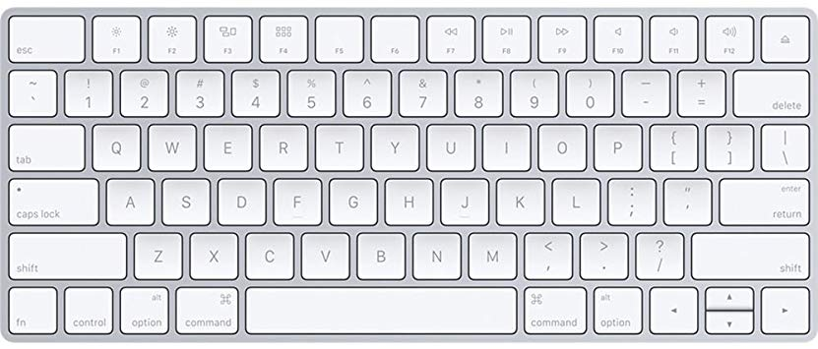
Contents
- Keyboard Layout
- Battery Life
- Size and Portability
- Bluetooth Connectivity
- Key Switches
- Special Functions
Keyboard Layout
The Keyboard uses the classic QWERTY layout which is common among many keyboards available. The main component that really makes this keyboard standout among the many wireless keyboards is its rechargeability.

Battery Life
The Magic Keyboard can be recharged using the iconic lightning cable used among many apple products. Charging takes approximately 2 hours for a full charge and can last approximately 2 months of use. Personally, I have used this Keyboard for longer than 2 months without the need to charge it which says something about the battery life of this device.
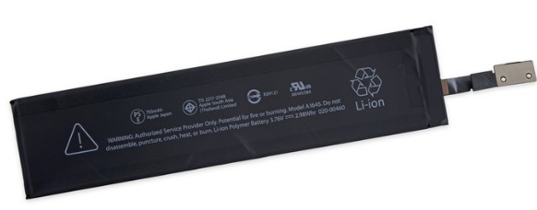

Size and Portability
The dimensions for this device have a height of 0.16-0.43 inches since it has a gradient from the bottom half of the keyboard to the top. This gives the keyboard a great ergonomic slanted feature making it even more comfortable to type on. The width of this keyboard is 10.98 inches which is almost half of the usual keyboard. This gives the keyboard a very small compact minimalistic.
Bluetooth Connectivity
The Apple Magic Keyboard has the capability to pair with any Apple device through Bluetooth pairing. The Magic Keyboard uses Bluetooth 3.0 which is common among most Bluetooth devices. 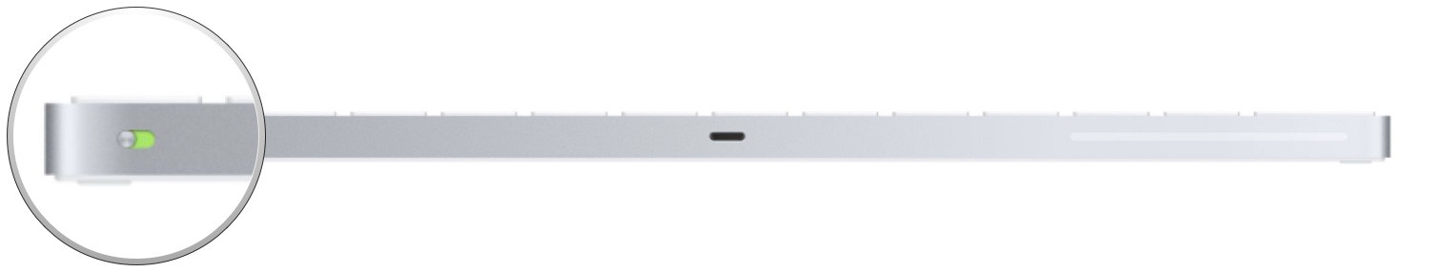
To connect your device, you simply turn on the switch at the top right of the Magic Keyboard, go to the Bluetooth section in your settings and wait for “Magic Keyboard” to pop up. Once you select the option your devices are successfully paired. It’s that easy!

Key Switches
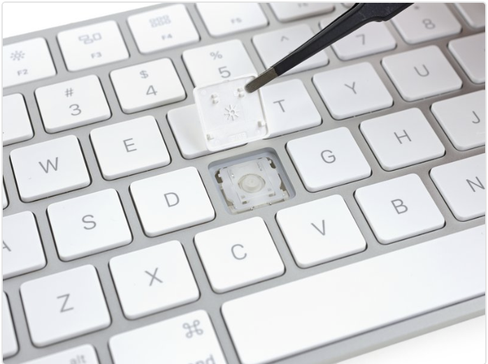
The keys used on the keyboard use a scissor switch which is the mechanism used under the keys to make the keys pop out of the keyboard. This Mechanism is a favorite of many users who use this device because of the feel it gives which is very satisfying. This mechanism also makes this keyboard very quiet and doesn’t make obnoxious clicking sounds while typing.

Special Functions
The Magic Keyboard has the ability to perform special functions with the push of a couple buttons simultaneously. For example, if you push “Command + C” you can copy whatever text you highlight. This maximizes productivity by saving time since you can do this operation in less than a second as it would take a few seconds with a mouse.
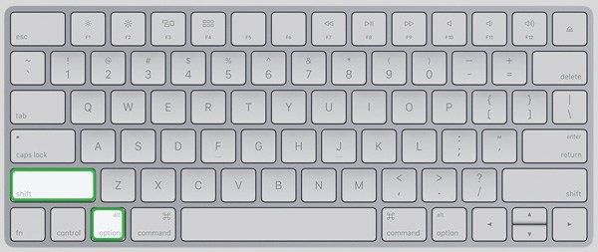

References

Magic Keyboard Teardown. (2019, June 18). Retrieved from
https://www.ifixit.com/Teardown/Magic Keyboard Teardown/50995

Lomas, N. (2018, September 1). An ode to Apple's awful MacBook keyboard.
Retrieved from https://techcrunch.com/2018/09/01/an-ode-to-apples-awful-
mac-keyboard/

Reflection

As soon as I heard about this topic, I knew that I wanted to do a keyboard because of house significant it is for us Computer Science majors. Everyone that writes lines of code to perform a program needs a keyboard to type whatever they want. Without a Keyboard a computer is sort of useless because you can’t even input anything for the computer to do. I specifically chose the Apple Magic Keyboard, because it is my personal favorite when it comes to keyboards because of the feel it has while typing. I also chose this particular keyboard because I had a feeling that some people may have not heard of this keyboard since it is fairly new. After doing a bit of research on the keyboard I learned more about the components that make up the Magic Keyboard as well as some features it has that many keyboards lacked for some time. I wrote this technical description in a very friendly manner that would be easily understood by people of all levels when it comes to using a keyboard.

With this technical description one can learn more about the history of the Magic Keyboard, as well as the components of the keyboard such as the special types of keys, height and width etc. You can also learn about the distinct features this keyboard has that many keyboards did not have for a long time which is blue tooth compatibility. For my description I decided to use very basic language common among most people who use a keyboard so that it could be used by people of all levels as I have mentioned before. I began my description by giving a brief overview of the Apple Magic Keyboard with some history behind it, this was to give certain people who had no idea what a Magic Keyboard was to get an idea and also spark some interest in them to read more about it. I also included a contents section which could be used to skip to a certain portion of the description relevant to the reader. I used multiple images to display what I was referring to in my paragraphs, this way the reader can get an understanding of what I was talking about through text and then use the image as a reference to reinforce what they just read. The sources I used for this technical description were really helpful because they broke down certain components of the keyboard which I referred to in my description.

With this assignment, I have met course learning outcomes such as “acknowledge your and others' range of linguistic differences as resources, and draw on those resources to develop rhetorical sensibility”, because I had to consider who was actually reading my description, which in this case was a wide range of people so I kept it very simple that could be understood by everyone. I also used the course learning outcome “develop and engage in the collaborative and social aspects of writing processes” this was done during our peer review where we had a chance to comment on one another’s work to help each other with our writing. And last but certainly not the least I used “strengthen your source use practices (including evaluating, integrating, quoting, paraphrasing, summarizing, synthesizing, analyzing, and citing sources)”. I used this one all throughout my description from summarizing to analyzing, to citing sources.

