The Technical Description of an apple magic keyboard

The City College of New York
ENGL 21007: Writing for Engineers
Professor Danielle Carr
February 20, 2020

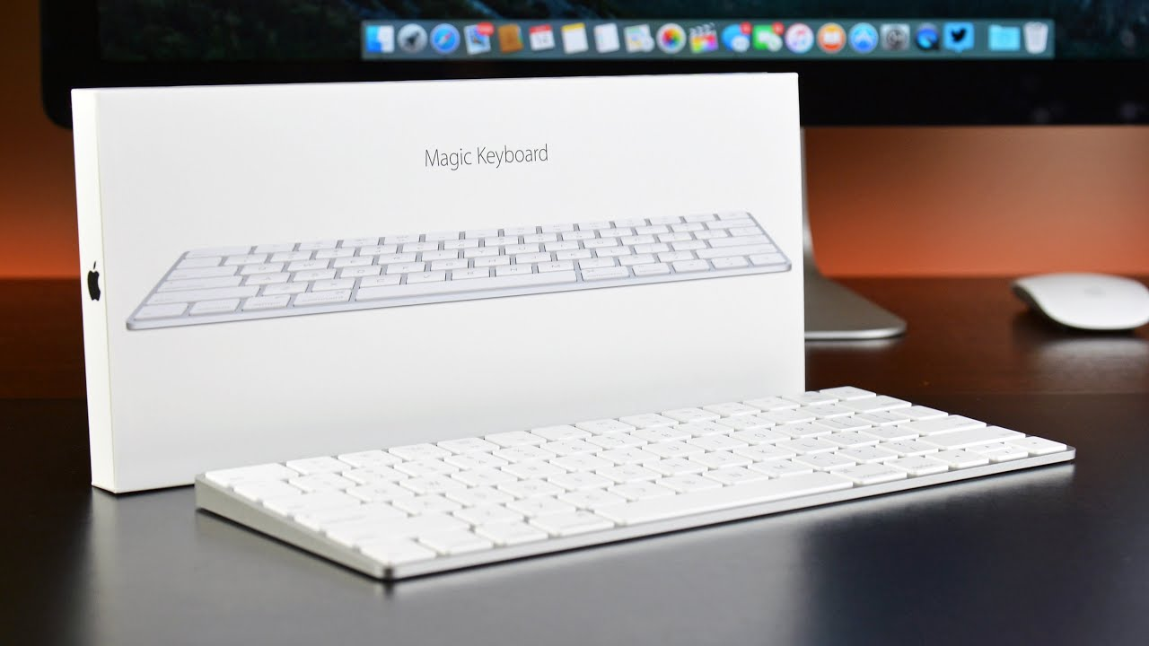

Table of Contents

Introduction 3
About the Apple Company 4
Magic Keyboard 4
Technical Description 5
Summary 5
References 7
Reflection 8

Introduction
Technology is improving as the years go by. Regardless of whether it is at home, work, school, strolling down the road, or tuning in to music, innovation has enabled individuals to improve, quicker, and all the more effectively. Whether its students using some sort of technology in the classroom or workers using it to be able to do their work in their office space. The manifestations of new computers and tablets; the simple access to as good as ever telephones have driven more. Technology comes in many different forms though also such as; Radio, TV, Computers, the Internet, Electronic Dictionary, Email, Blogs, and Audio Cassettes, PowerPoint, Videos, DVDs or VCD's and many more.

A large number of people in this world have used some sort of computer either it has been a PC or as a Mac. With any computers a keyboard comes with the product. A keyboard is considered to be the most used device when it comes to operating a computer. The keyboard consist of a set of alphabetical keys. A keyboard also consists of the numbers one to nice and other keys that do various functions. The most common format of the keyboard is considered to be a QWERTY keyboard. Of course, the reason behind the name of this keyboard is due to the way the keys on the keyboard are set up on the first row of letters. This type is totally different from the way the original layout was made.

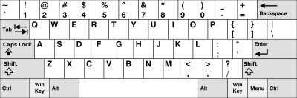

History

Apple was founded by the name of Steve Jobs, Ronald Wayne and also Steve Wozniak in 1976. In four years, the company was able to start the production of Apple I and Apple II computers. Of course, as the years go by manufactures always find a way to find new ways to improve their product from the one the previously released. As a founder of the company, they needed to find to improve their company and become a better computing platform. So, the company decided for the benefit of the company they would partner up with two companies that are known as Motorola and IBM.

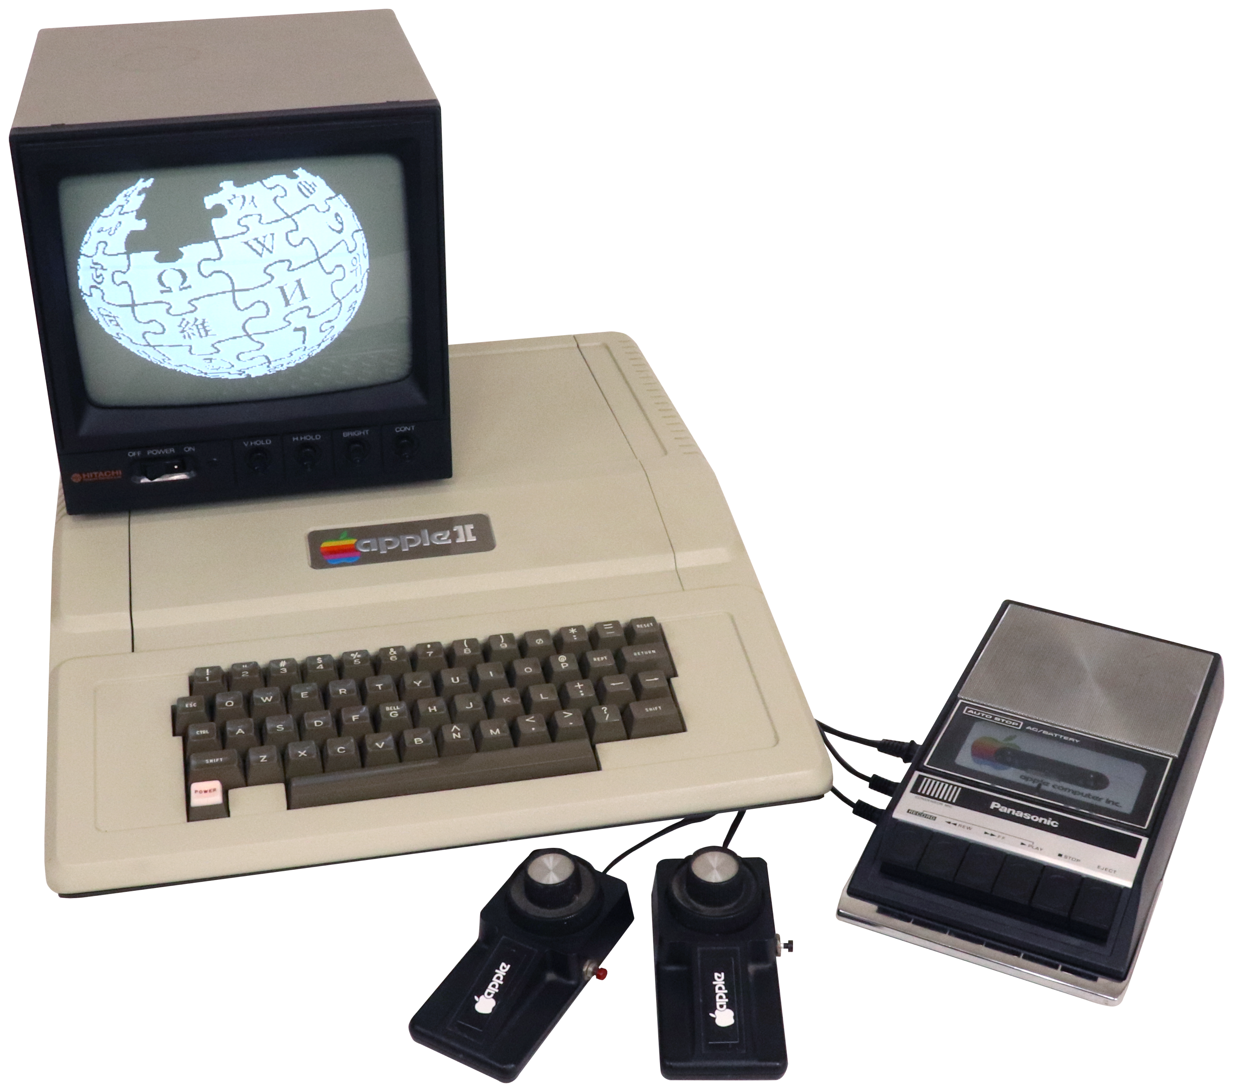
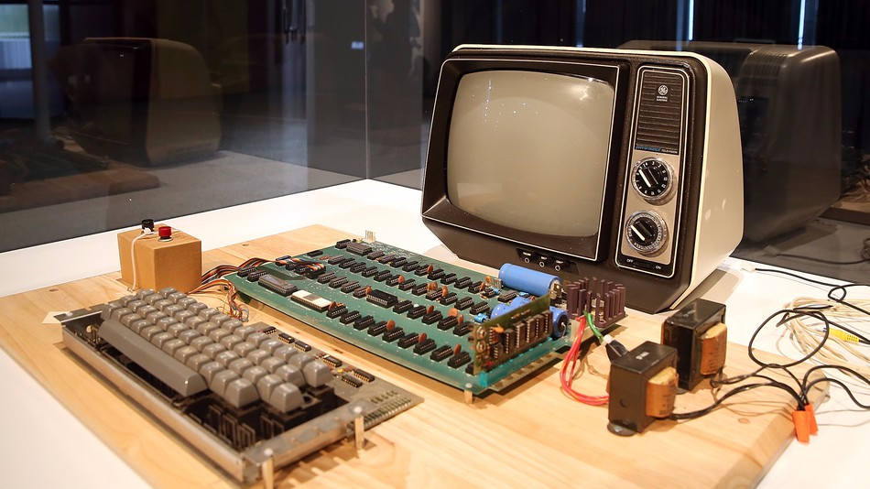

Magic keyboard
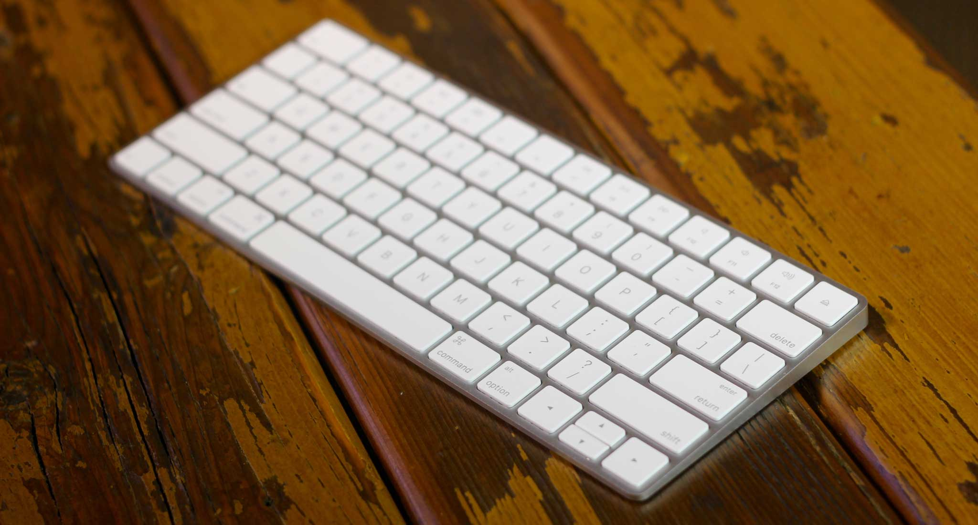
Magic Keyboard is an apple product that was released to improve their computers. The magic keyboard combines a smooth structure with a built-in rechargeable battery and improved key highlights. With a stable scissor instrument underneath each key as well as optimized key travel and a low profile, Magic Keyboard gives an astoundingly agreeable and exact composing experience. A every helpful component of the magic keyboard is that the battery is extraordinarily durable.

Technical Description:
Exterior parts

Nearly all of the company’s products are composed of aluminum. The Apple magic keyboard wouldn’t be any different. Each keyboard has a power button, and keys of the keyboard. The main function of a keyboard is for you could type your words instead of needing to handwrite it. This keyboard gets the work done while being light and easy to move around. One of the best features of an apple magic keyboard is that it's wireless. A magic keyboard could work up to 33 feet. My personal experience when I type on an apple product it feels 100 times better than a PC. The keys feel smoother and it’s just more comfortable. On the keyboard, you got the alphabet on the keys in a QWERTY format. Then you also got the number one to nine on top of the keyboard. Over the numbers, you got different keys that could do different functions such as turn up and down the brightness. You could also raise and lower the volume of your computer.
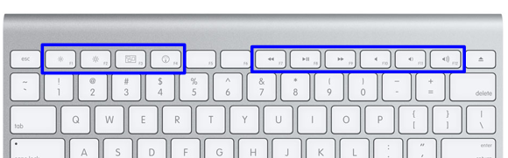

The keyboard requires 2 AA batteries which you would have to insert in the battery compartment. The cover might look different to you but its made for you to easily open to battery compartment with any size coin.

Details on the keyboard

The keyboard is made up of aluminum with the keys made of plastic for comfort. The magic keyboard comes in measuring 4.52 inches in length, 10.98 inches in width and only 0.16 inches in height. The keyboard is also not as heavy as you would think. It only weighs 0.51 oz.

Interior

Apple have created a newly design key which gives off the butterfly affect. Underneath the keys, there is a butterfly-like instrument utilized for the keys to be pushed down. This component takes into consideration the console to be flimsy, little and minimized. Underneath the keys of the console, the system glances as appeared in the picture beneath.
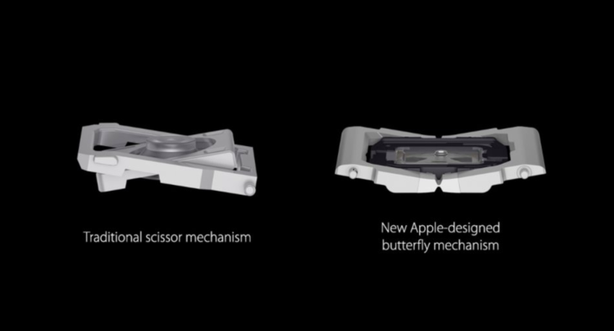

Summary:

Thank You for Purchasing the Apple Magic Keyboard. Don’t forget computer products are improving as the years go by so why fall back out of date. Interface your console to Bluetooth and start utilizing it immediately. Make a point to utilize this console with Mac OS to get a full understanding of its highlights. The flimsy, light and conservative type of this console will effortlessly fit around your work area and you can chip away at it with comfort. If you ever need more help simply just go to https://www.apple.com.

References
"Magic Keyboard - US English". Apple, 2020,
https://www.apple.com/shop/product/MLA22LL/A/magic-keyboard-us-english.

Starr, Michelle. "A Brief History Of The QWERTY Keyboard". CNET, 2020,

https://www.cnet.com/news/a-brief-history-of-the-qwerty-keyboard/.

"Apple Computers: This Month In Business History (Business Reference Services, Library Of Congress)". Loc.Gov, 2020,

https://www.loc.gov/rr/business/businesshistory/April/apple.html.

Technical Description Reflection : Apple Magic keyboard

For this assignment, I have used a technical description as a method of informing the public on the components of a magic keyboard as well as their functions. With this technical description, the audience will obtain knowledge on the technical aspects of a Magic Keyboard. My genre is a technical description, which is a message with intentions of concisely describing the structure and use of a Magic Keyboard. Also, this topic is used to address the presumably the owner of a product, the product is clearly stated, background information is given, the components are described in an organized manner, there are a conclusion and a reference page. The necessity of my assignment is to educate people about the benefits of the Magic Keyboard. My target audience are the purchaser of an apple product or any other computer product. My stance, about the topic, is that an individual may not have the necessary knowledge regarding keyboards to make their usage easier. I just provided a way to show how the apple product might help in any environment. My purpose, why I’m writing this technical description, is because my daily routine is surrounded by a computer. Technology keeps on improving and so would the products that come with it. This task meets Course Learning Outcomes 3, 4, and 5; It meets number 3 by including the reflection segment to comprehend what bits of the logical circumstance were met inside the specialized depiction and how they may have been utilized, for example, with the passage on the class of this task incorporates a sentence portraying how type is affected by the portrayal of the showcase on the iPod. It meets number 4 by the cooperation of the online conversation gathering and online companion audit. This is intended to get input on work to improve for the last draft. It meets number 5 by utilizing two unique sorts of writing in a multimodal type of media utilizing print and computerized. As talked about in media passage of the reflection area, the specialized portrayal is print when utilized as printed versions of first and only drafts and computerized while examining themes online in the conversation board on Blackboard and while turning in the last draft on the web.

