The Technical Description of a BiC Cristal Ballpoint Pen Xtra-Smooth

City College of New York

ENGL 21007

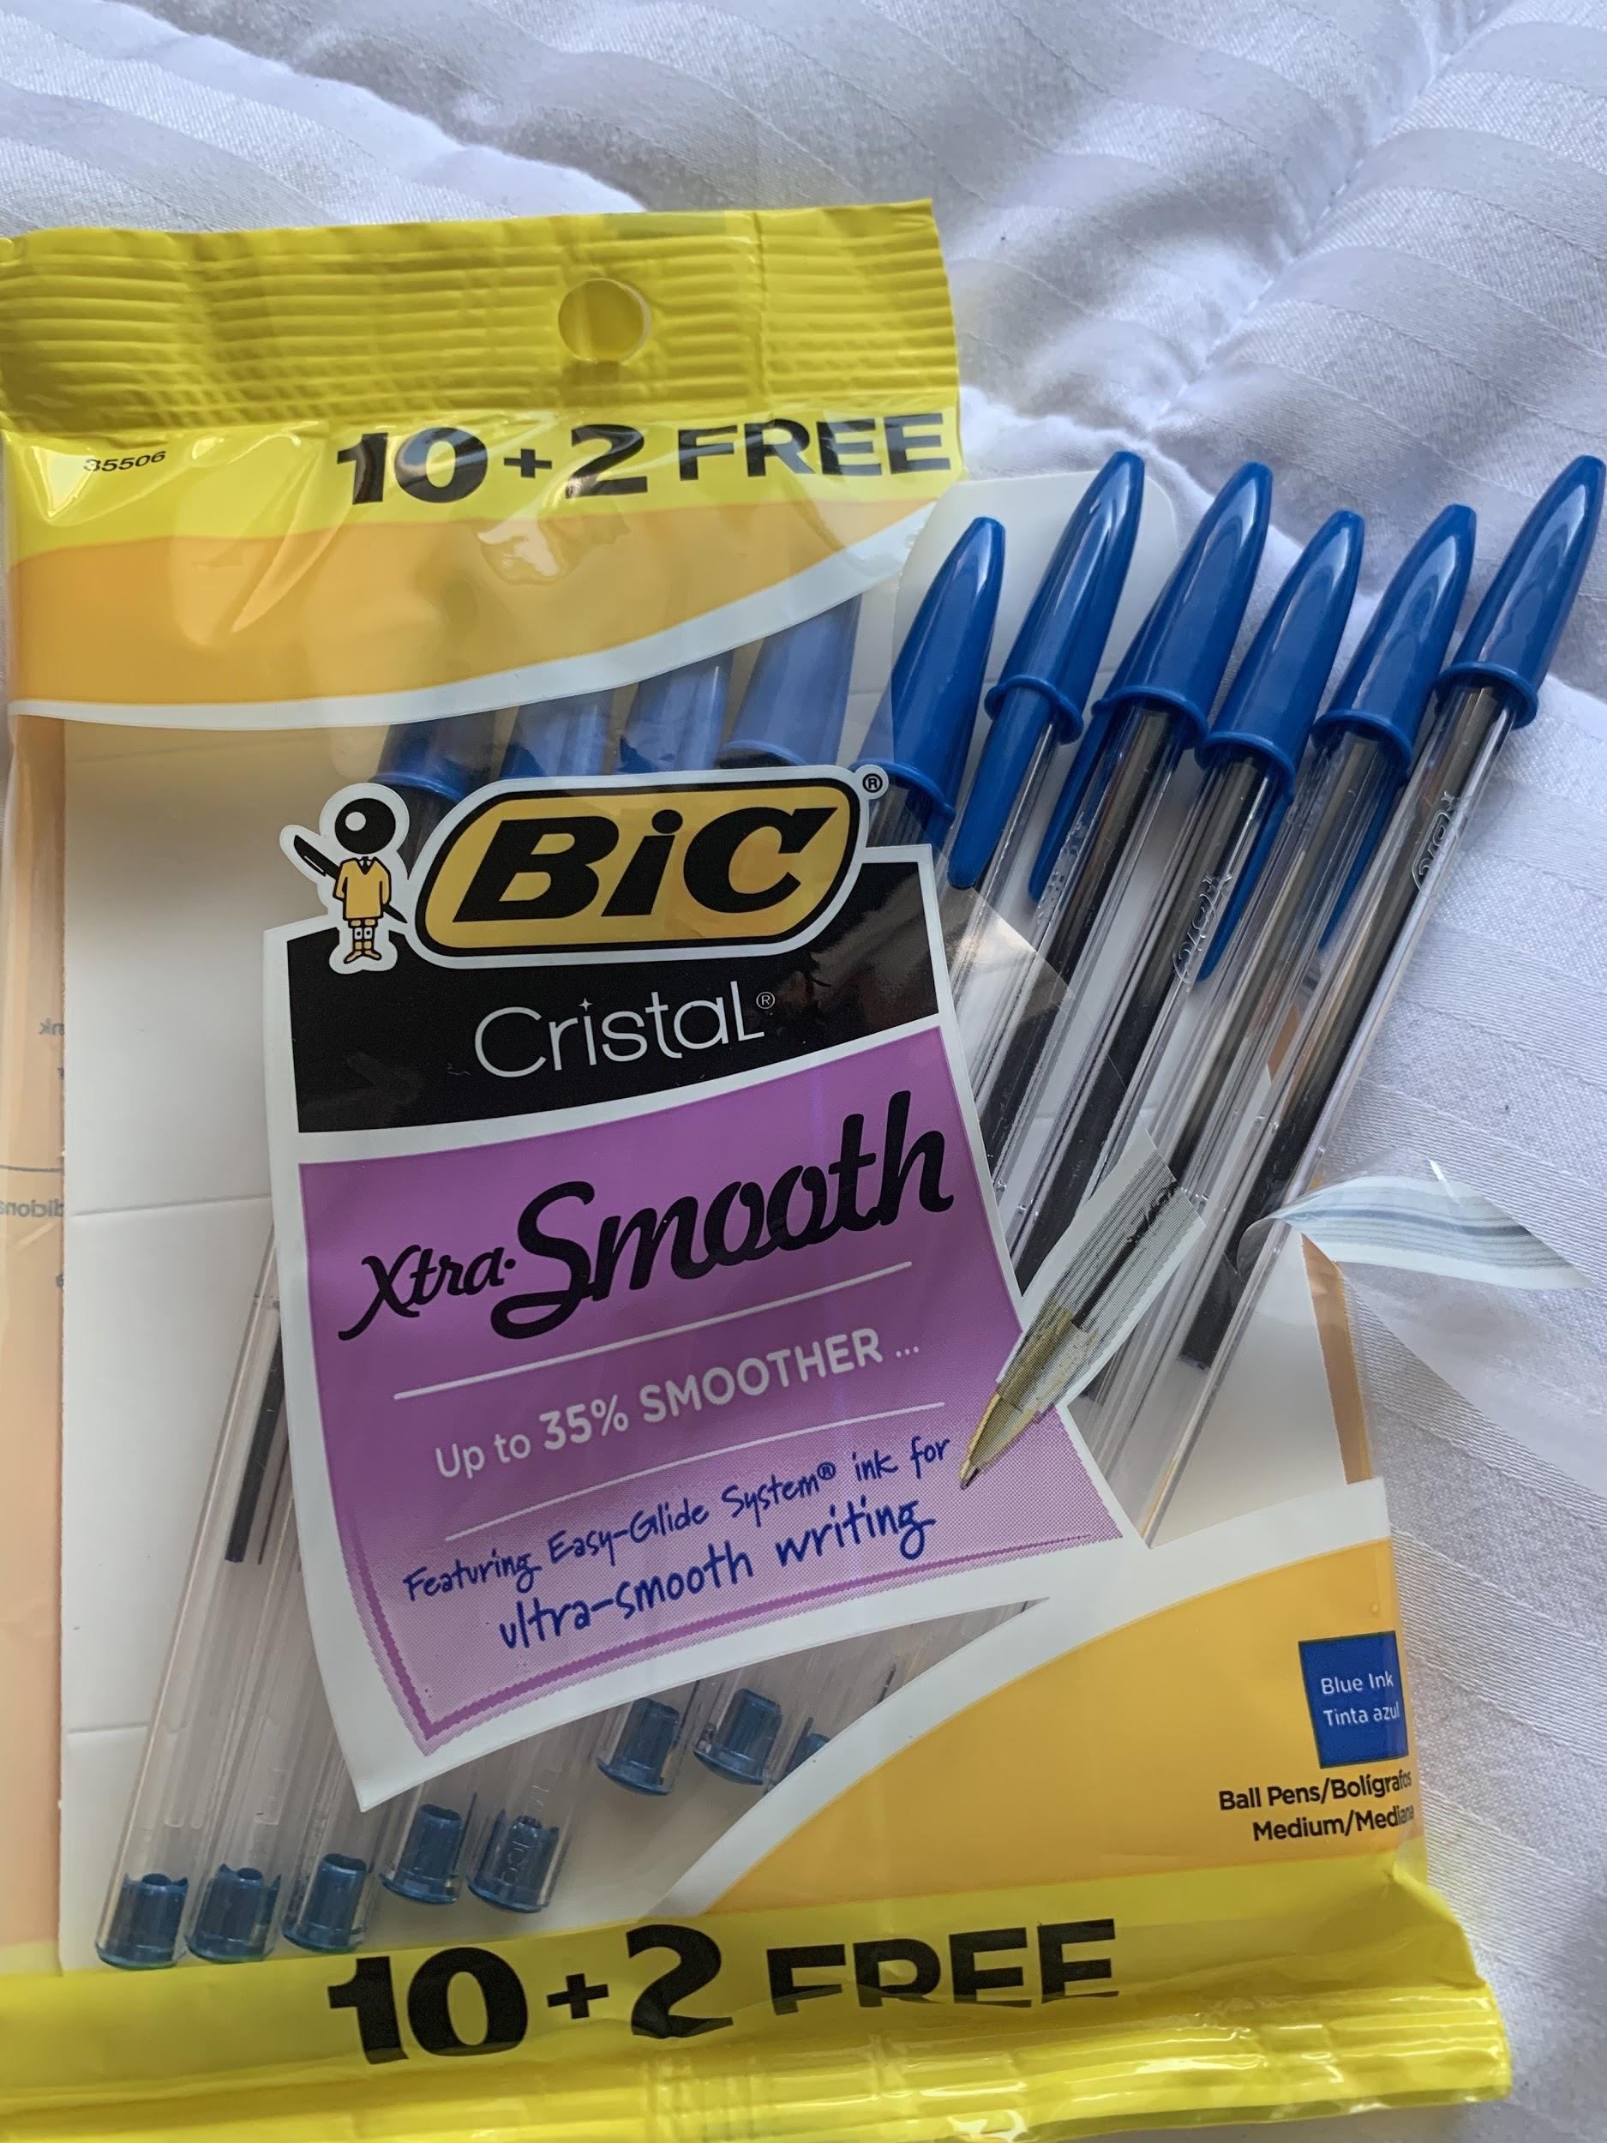

Written by: Leslie Paredes

Table of Contents

Introduction to the BiC Cristal Ballpoint Pen Xtra-Smooth 3
About the BiC Company 3
The BiC Cristal Ballpoint Pen Xtra-Smooth Innovation 4
BiC Cristal Pen Makeup 5
Exterior parts 5
Interior of the BiC Pen 7
How to use the BiC Pen 9
Summary 10
Conclusion 10
More Information on the BiC Pen 10
References 11

Introduction to the BiC Cristal Ballpoint Pen Xtra-Smooth
Historical background on Pens
The creation of the pen has facilitated the basis of our civilization. Pens have made it possible to communicate knowledge and information and create many works of art. The first to invent a pen as a way to write were the ancient Egyptians. They were the first to create a tool that allowed them to create marks on papyrus which was their form of paper. They created what's called the reed pen. They were made from reed straw with a pointy end and with a slit that was filled with a writing fluid that would flow down to the point and mark the papyrus. Then came the Quill pen, which was the pen that was used the most in the past. It was made up of bird feathers from swans and geese. The Europeans shaped the feathers with a knife and then dipped the feather into an inkwell and used it to write. Quill pens were very durable and were very smooth. Steel-point pens were then created which functioned the same way as the quill pen. (Karpret, 2018). After this came the fountain pen which had many flaws because the ink would often overflow. Then in the 19th century came the ballpoint pens, which was a turning point in evolution. Ballpoint pens take us up to modern day (Rolger, 2009). It is a much durable pen compared to the ones listed before. This pen can be used on many different surfaces such as cardboard and wood. This was the pen that ended ink writing and having to dip your pen in ink in order to get it to create a mark.
About the BiC Company
The BiC company was founded in 1945 by Marcel Bich along with his business partner Edouard Buffard in Clichy, France. BiC is a family-owned company. It all started when Marcel Bich launched his own ballpoint pen in France in the year 1950, which was when the company got its name ''BiC”, BiC is a shortened version of his name. After his launch, these pens were quickly adopted by many people and the number of consumers increased. In 1958, “BiC came to the U.S. market acquiring the Waterman Pen organization” (Karpret, 2018). BiC then began to establish its presence in places outside of France. It continued to expand and become known in many other places such as in Africa, MiddleEast, Scandinavia, and Japan. Pens aren’t the only thing BiC manufactures, they also produce pocket lighters and razors. They are known for their modern design and for creating products that are long-lasting. With over 13,664 employees, they sell about 11.5 billion items per year! (BicWorld, 2003). The BiC company also owns other brands such as, Tipp-Ex, BiC Kids, BiC Graphics and many more. Some of their major stationary inventions are the gel pens, extra fine pens, extra bold, golden pen and many more, but the best pens they have is the Xtra-Smooth one which is what you will be learning about today!. This company has been successful for 75 years, and still is till this day. BiC continues to offer it's iconic products that are used by thousands of people around the world.

The BiC Cristal Ballpoint Pen Xtra-Smooth Innovation
The BiC Cristal Ballpoint Pen is a writing instrument that can be easily used by anyone. It is an instrument that is very easy to write with, anyone who has the ability to hold a pen in between their fingers is most likely able to use a BiC Cristal Ballpoint Pen. This ballpoint pen was designed to be able to distribute fast-drying thick ink, without having the ink dry out of the pen. The ball in this pen is what lets this happen. BiC has many different types of pens, but in this project I will be talking about the Xtra-Smooth pen, the most comfortable one. The purpose of this pen is to be able to write on a piece of paper, piece of cardboard, wall, any type of material. It is also used to create works of art in many ways. The BiC Cristal Ballpoint Pen has a mechanism by which the ink is made to flow through the tip of the pen and scribbled into a surface. It is used in many different places. For example, it is good for school, office use, to have at home, in your car and to carry in your purse, anyone can use this pen!. The BiC Cristal Ballpoint Pen has many components to it which makes it function the way it does. This description will examine the exterior and interior parts of this pen as well as how each piece works together to make this pen work. This pen is 5 ⅞ by ½ inches and weighs 5.8 grams. It has a transparent barrel that is hexagonal, with the ink being visible. It has no particular smell, but when the cap is off you can smell the ink which has a strong smell. The cap of the pen is made up of plastic as well as the barrel and ink tube. The tip and the ballpoint are made up of metal. All of these are important components to this pen. Here you will be learning about the anatomy of a BiC Cristal Pen Xtra-Smooth, which is the best pen this company manufactures.

BiC Cristal Pen Makeup
Main Components of the BiC pen
There are two major parts to the BiC pen. It is the interior and the exterior parts. Each part is made up of many different pieces and have their own functions and ways of working together.
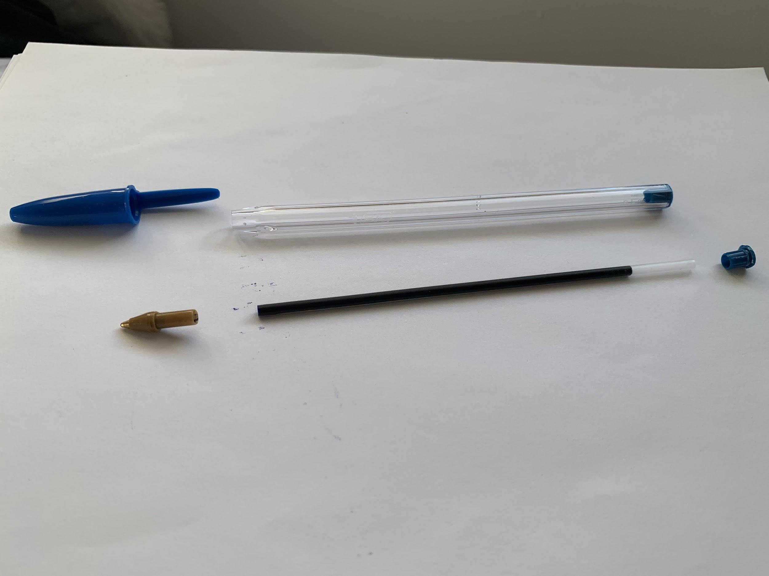
Figure 1: Exterior of the BiC Pen
Exterior part of the BiC Pen
The exterior of this pen is composed of the following:
- The barrel
- The cap
- The stopper

The Barrel:
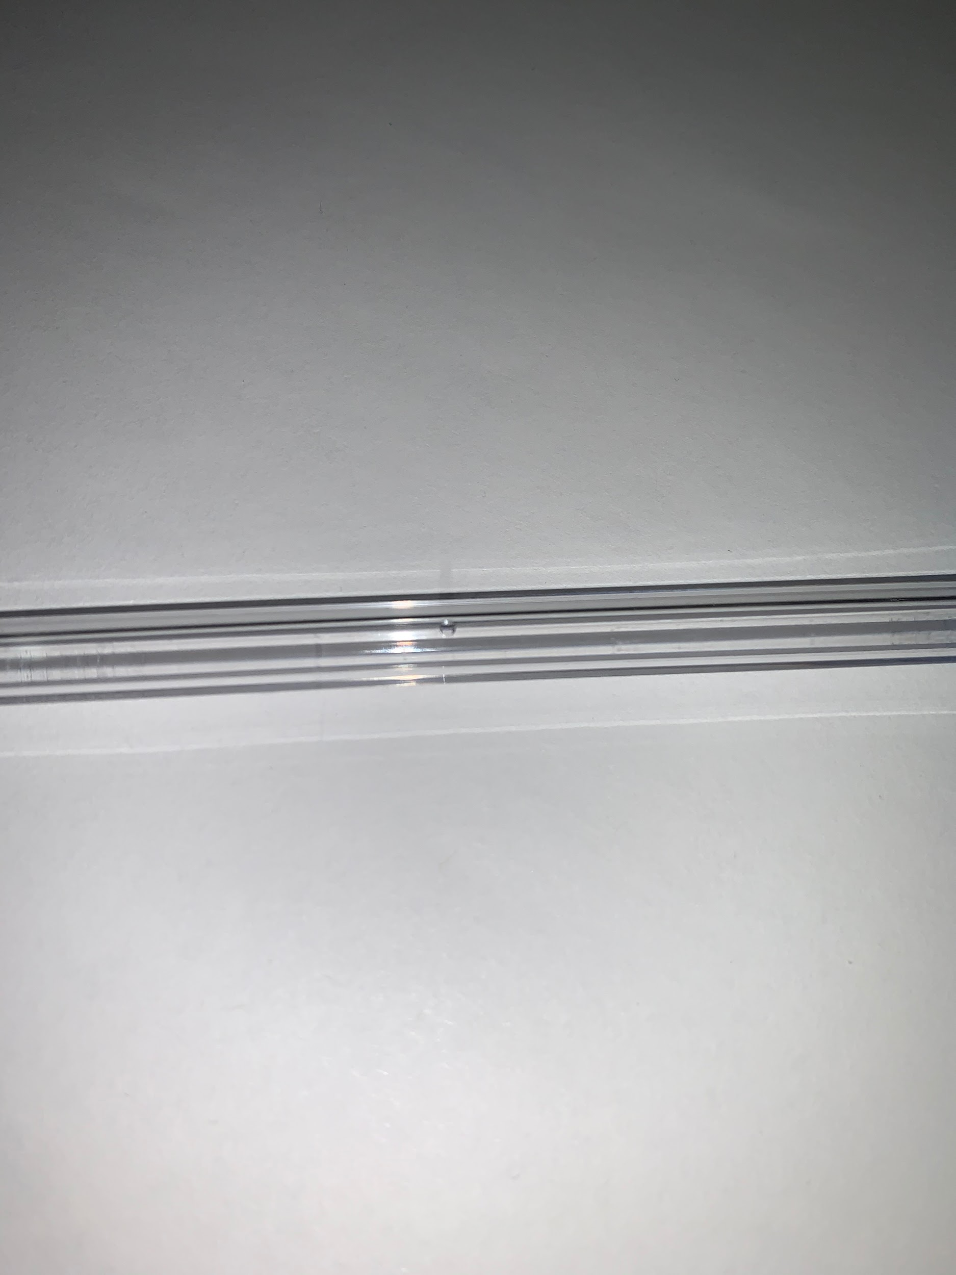
The Barrel is the part where people grip the pen when using it as you can see in figure 1. It has a length of 5 ¼ inches and a width of ⅜ of an inch. This piece is made out of polystyrene plastic, it is like the shape of a cylinder but has a hexagonal shape, the purpose for this so that the pen won't be able to roll around in uneven surfaces. It is very light and has a smooth texture. This barrel is transparent (just like a plastic straw), meant for one to see the ink cartridge and the amount of ink that is left. This barrel has a very tiny hole that is ⅛ of an inch wide located in the middle because so it balances the pressure inside and outside the pen as you can see in figure 2. It is meant to help push the ink towards the tip and prevents leakage, it does this by creating the same air pressure both inside and out the pen. The barrel is what connects the ballpoint and ink cartridge together. It is the main component of the pen in order for someone to be able to use it properly without it Figure 2 The Barrel
bothering their fingers, the reason why it's very comfortable. The bottom of the barrel is where the stopper goes and the top of the barrel is where the ball holder goes, the barrel holds all the pieces together.
The cap:
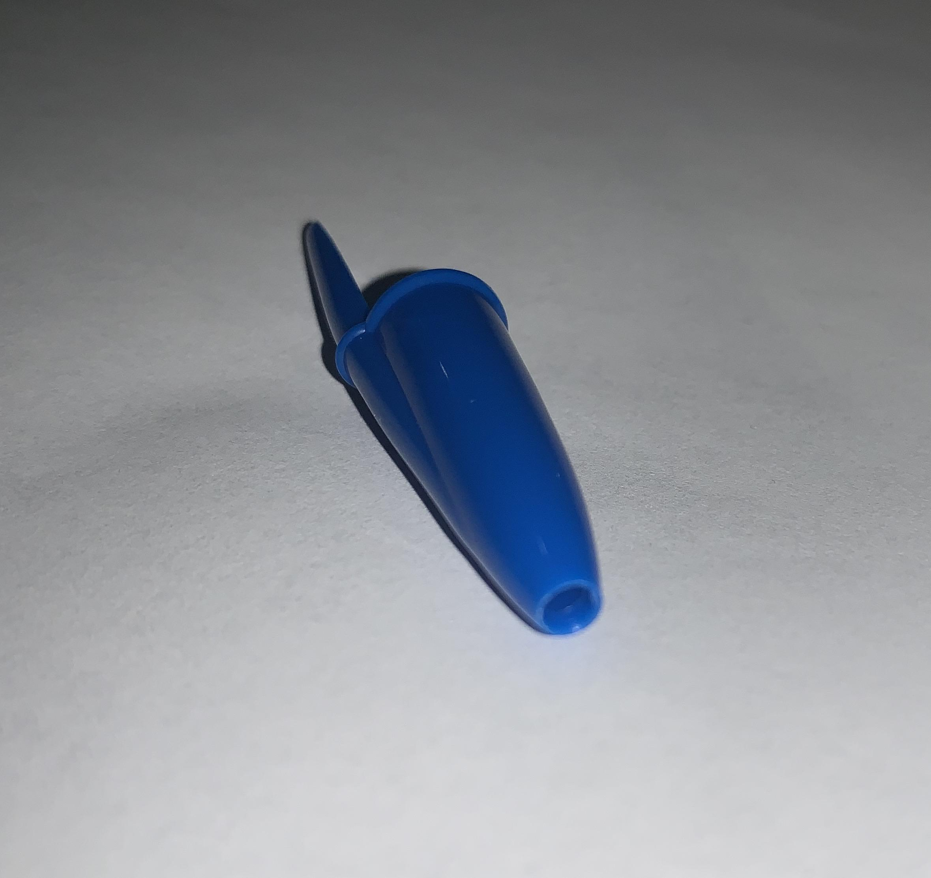
The cap of this pen is also made up of polystyrene plastic due to its durability, in this case it is blue because the ink of this pen is blue but the color of the cap depends on the color of the ink. It has a hollow conic shape with a length of 2 ¼ inches and a very smooth texture. The cap is a removable plastic piece that covers the plastic barrel, ballpoint and ball holder. It is meant to cover the tip of the pen when it is not being used so that the ink won't dry out and escaping the pen leading to anything around it getting stained. (Giesbrecht, 2016). As you can see in figure 3 the cap has a hole on the top, it is also meant for the air pressure to be the same inside and outside the pen and also makes it easier to open and close the cap, like a lid. Figure 3: The Cap
According to the BiC Pen company, the reason why some of their pen caps have holes is to prevent the cap from completely obstructing someone's airway if accidently inhaled. Some other functions of the cap is to allow its user to clip their pen to objects such as books, folders and pockets. It is also one of the reasons why the pen won’t roll off in uneven surfaces.

The Stopper:
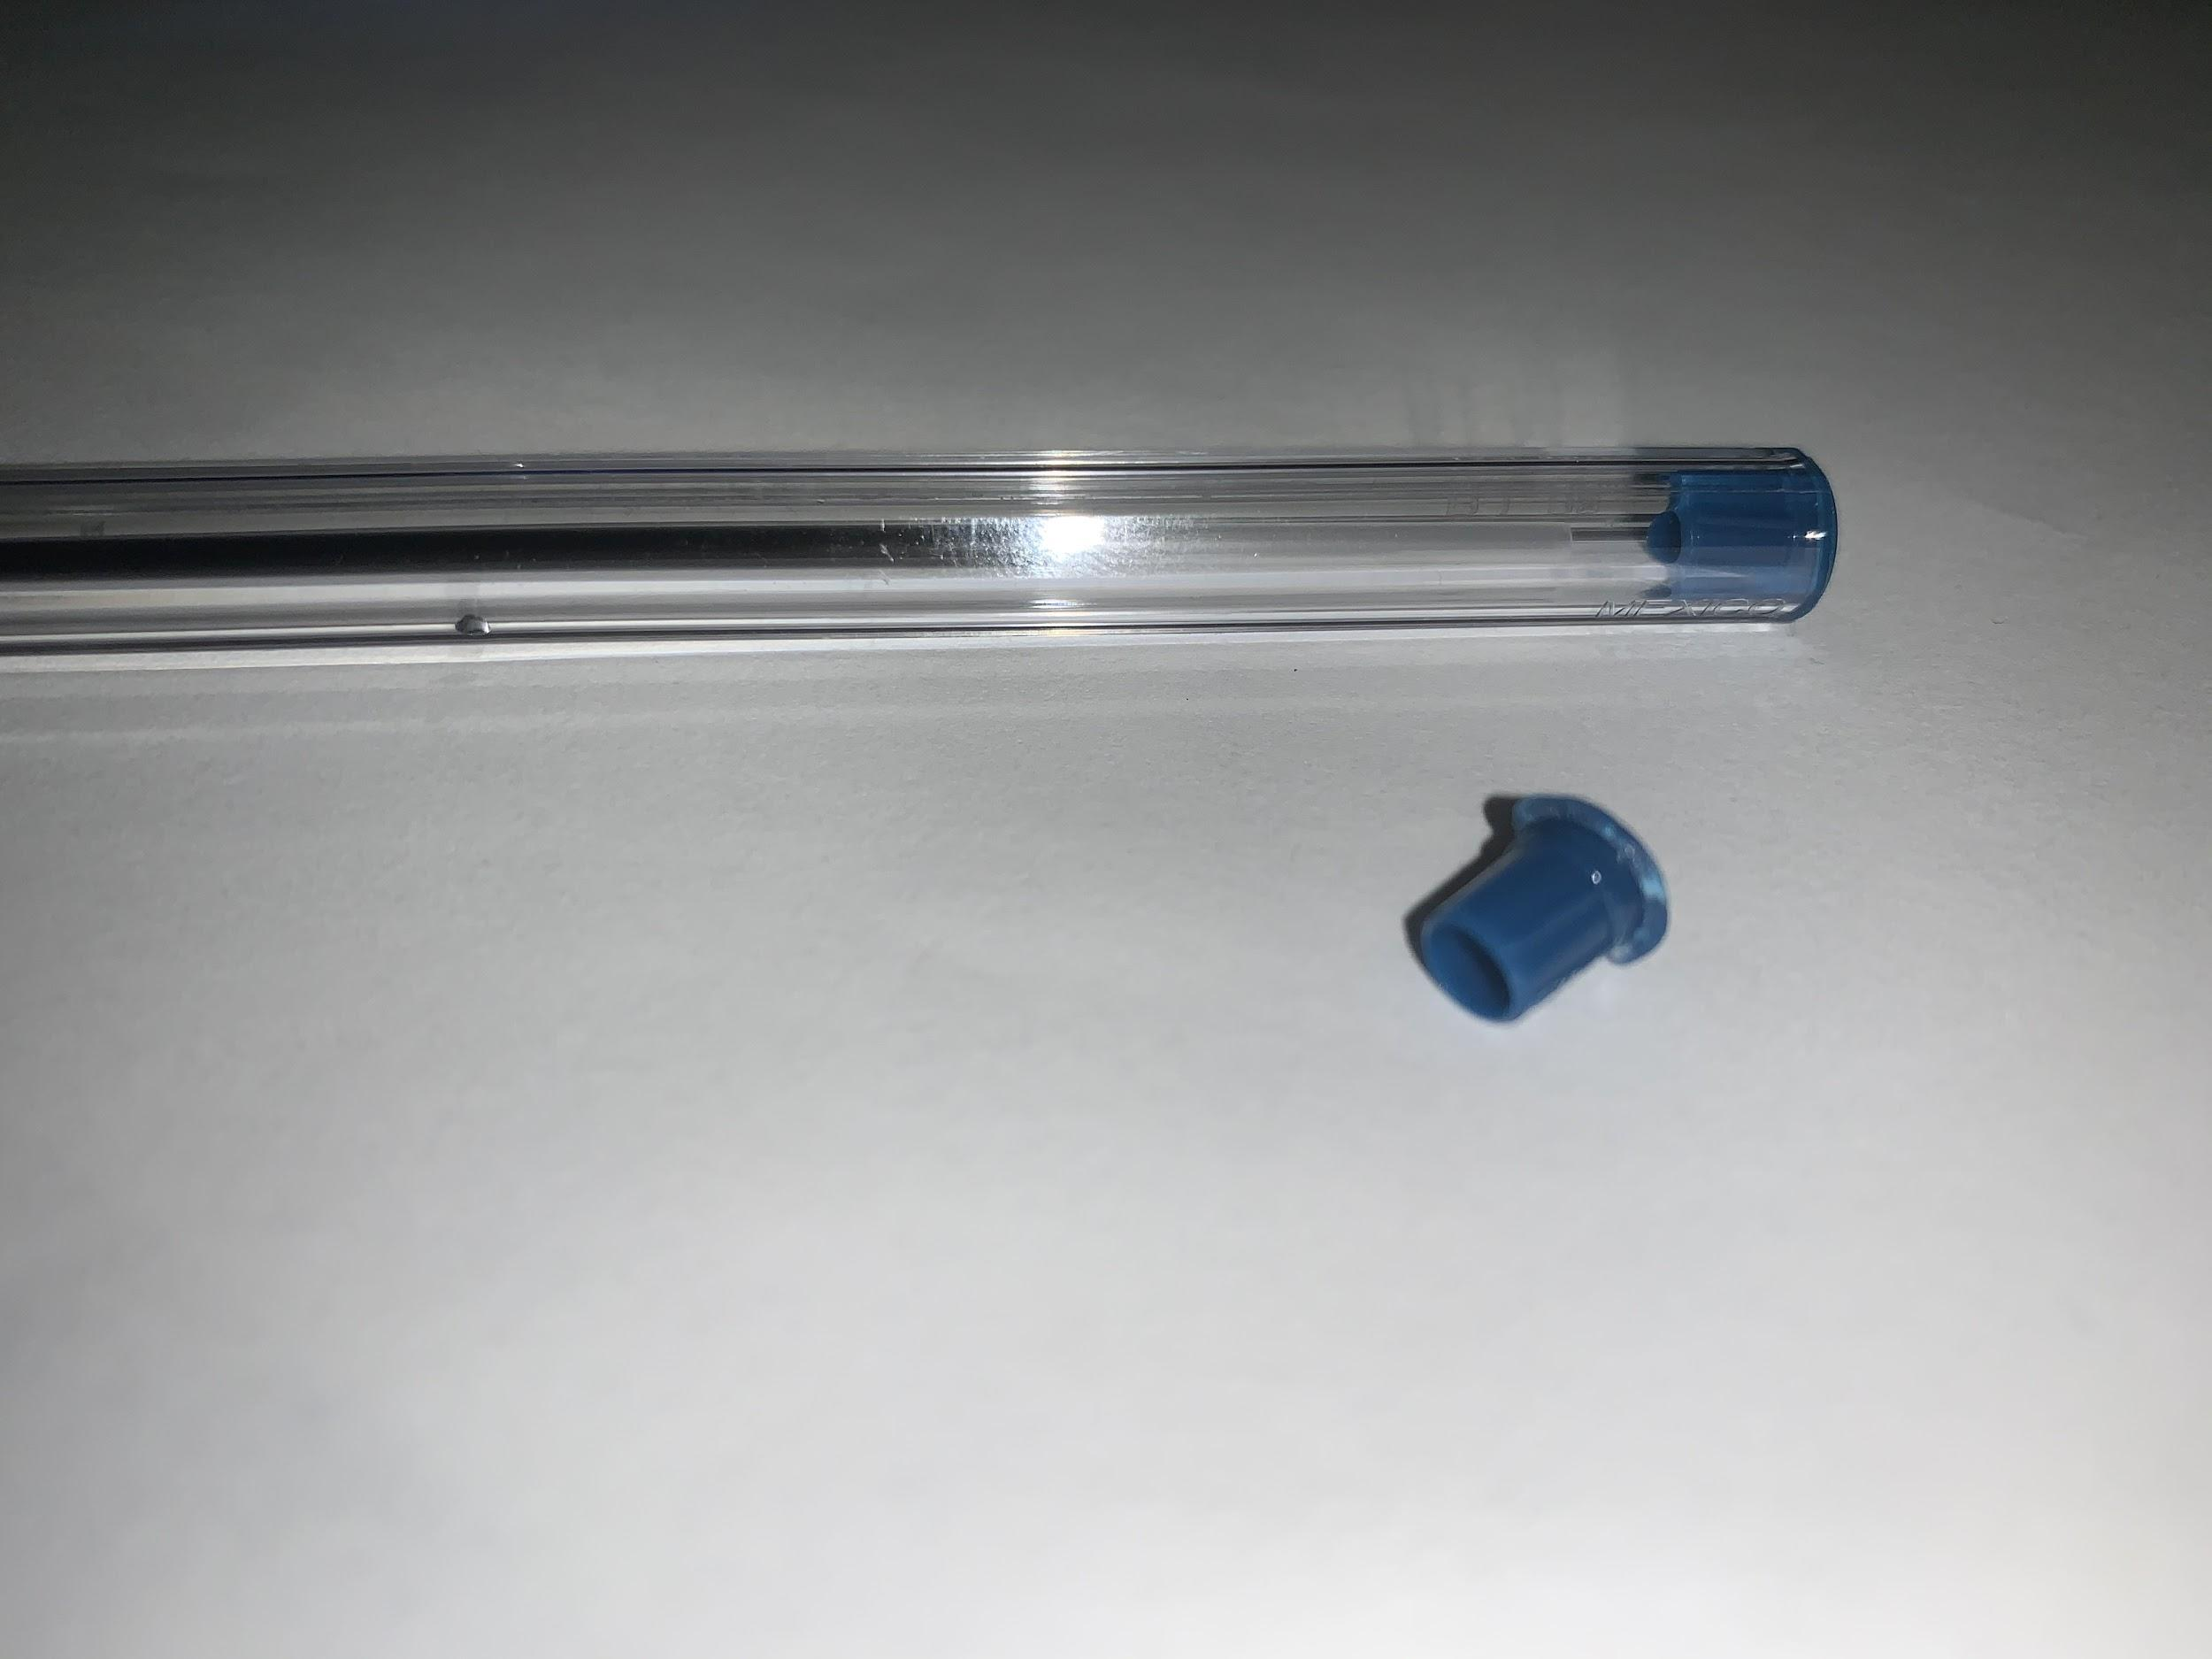
The stopper is what you find attached to the bottom of the barrel. This stopper is blue due to the inks color. It is made up of plastic just like the other pieces. The diameter of the bottom of the stopper is smaller than the one of the barrel so that it can fit inside in order to hold the ink cartridge. The top of the stopper has a matching diameter to the barrel so that it can fit proportionate to the barrel. The stopper has a length of ¼ of an inch. The purpose of the stopper is to prevent any stain and damages from an ink leak.
It prevents the ink from leaving the barrel in case the ink cartridge ever pops inside. This piece looks just like a mushroom, Figure 4: The Stopper
skinny at the bottom, and very round at the top as seen in figure 4. This part has the same width as the barrel and is attached directly to the end of the barrel and is very difficult to remove.
Interior of the BiC Pen
The interior of the BiC pen is made up of the following pieces:
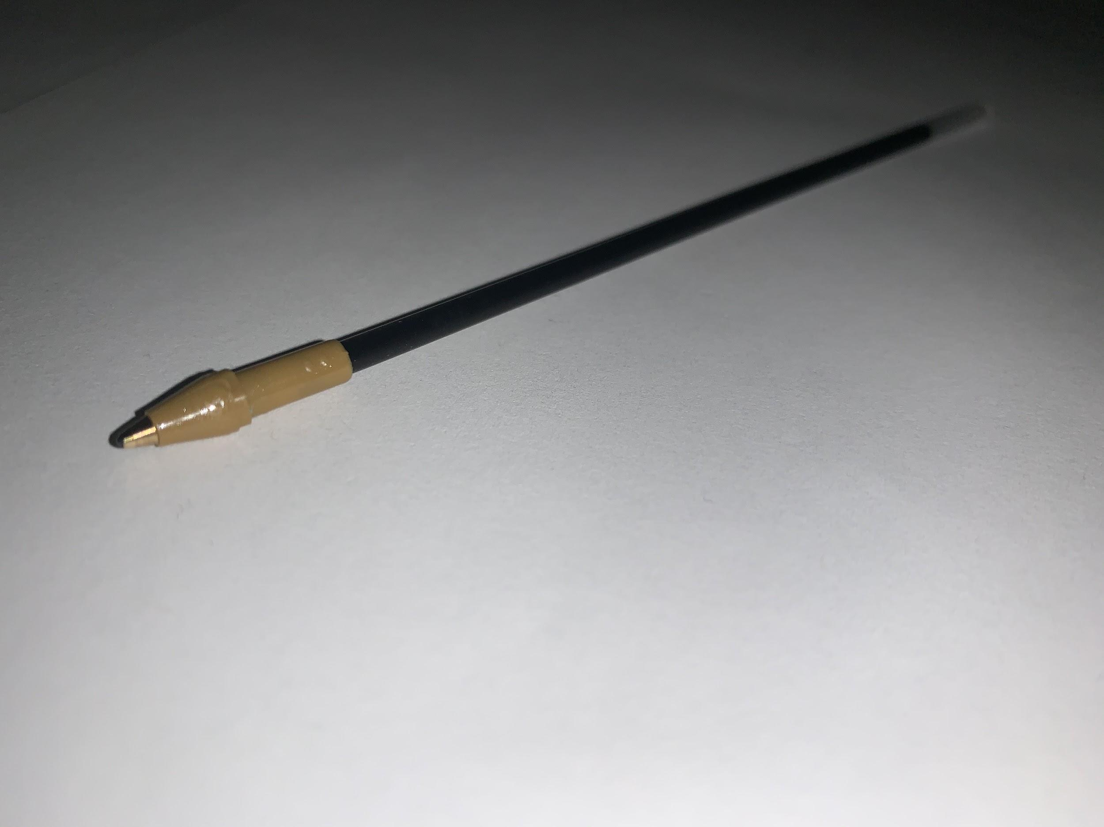
- Ink Cartridge
- Brass tip holder
- Brass tip
- Ballpoint
The Ink Cartridge:
The ink cartridge is a 4 ⅞ inch long disposable capsule that is filled with the pens ink as seen in figure 4. Since this tube is transparent you are able to see the color of the ink. It has the shape of a cylinder but with a ⅛ of an Figure 5: Ink Cartridge
inch diameter, almost looks like a skinny tube or you can say very thin straw. It is made up of polypropylene which is a form of plastic. This tube has no smell but the ink inside it does, it has a sweet smell at first but can smell like various chemicals afterwards. As you can see in figure 5, this ink cartridge holds 0.38 grams of ink and when it is all used up it can be replaced. The ink cartridge is found inside the barrel and fits directly into the brass tip holder which is explained in the next section. The purpose for the ink cartridge is to keep the ink in one place so that it can flow directly to the brass tip and not go everywhere else and eventually leave stains.
Brass Tip Holder:
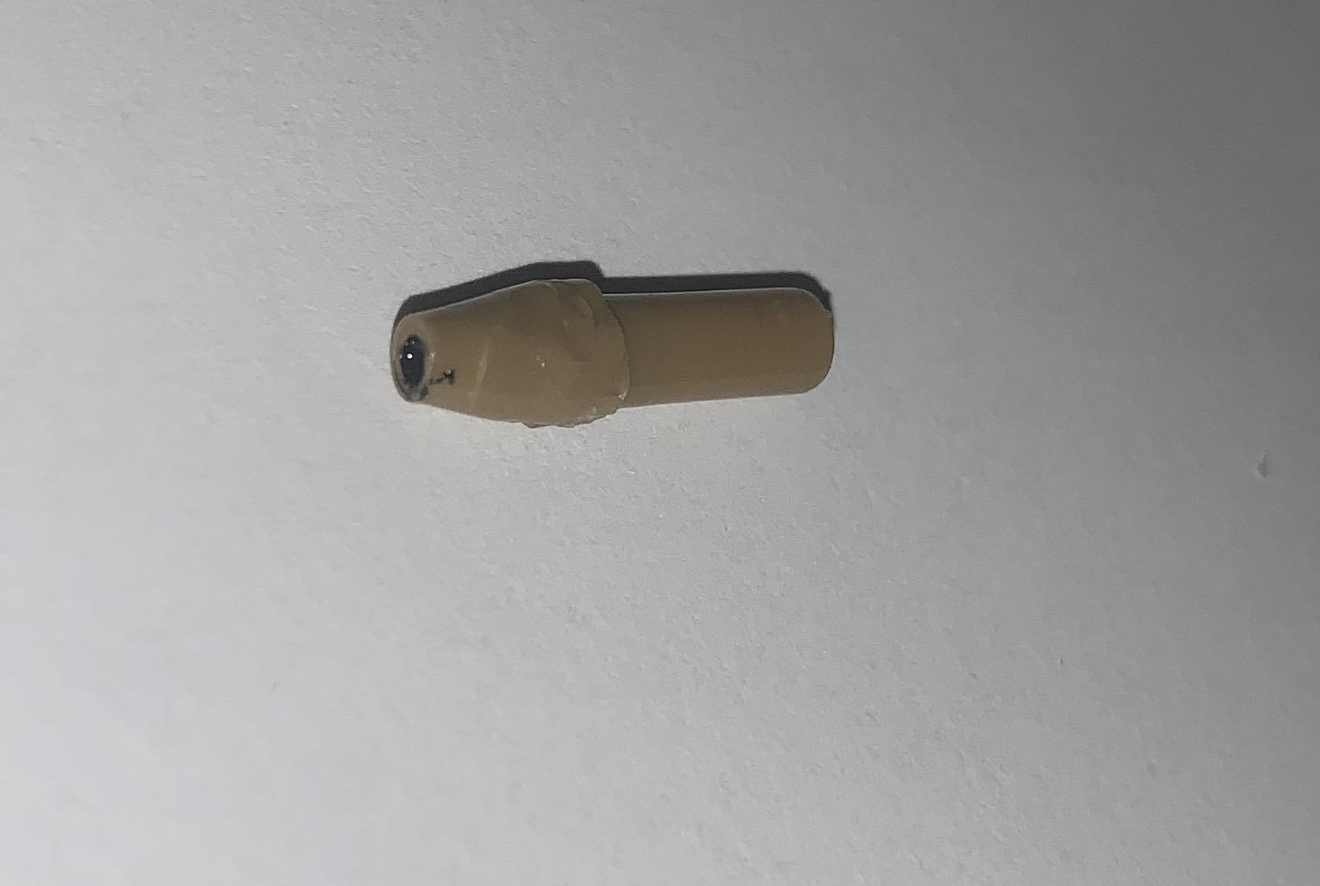
The brass tip holder is ⅝ of an inch polystyrene plastic piece, and is made up of a conical shape and a cylindrical shape. The top of the brass tip holder is conical shape and the bottom is the cylindrical shape as seen in figure 6. The bottom of the brass tip holder is the part where the ink cartridge is connected too. The top of the brass tip holder is where the brass tip is found which is what will be explained next. The purpose of the brass tip holder is to Figure 6: Brass Tip Holder
connect both the ink cartridge and the brass tip which causes the ink to reach the tip of the pen allowing for the pen to create marks.
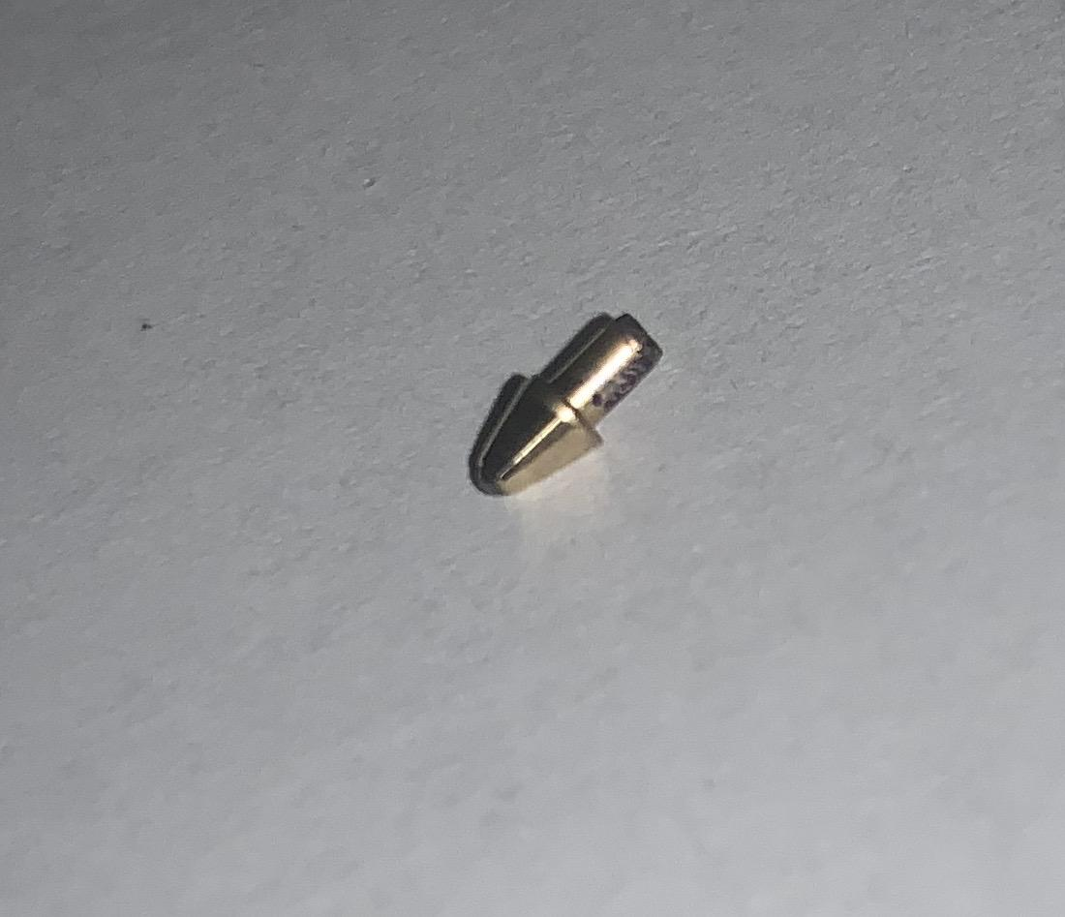
The Brass Tip:
The Brass tip is made of brass which is an alloy of copper and zinc. This piece is ¼ of an inch long and also has a conical shape and a cylindrical shape (figure 7). The top is the conical shape and the bottom part is the cylindrical shape. The brass tip is found inside the brass tip holder. The cylindrical part of the brass tip is found inside the conical shape of the brass tip holder. The brass tips main function is to get Figure 7: Brass Tip
the ink to flow to the top and to the ballpoint. The brass tip is connected to the brass tip holder and the brass tip holder is connected to the ink cartridge. Therefore, as the BiC pen is positioned to write, the ink flows from the ink cartridge through the brass tip holder then eventually gets to the brass tip, then to the ballpoint which will be explained next. It is designed to get the ink to flow smoothly to the top and out the pen.

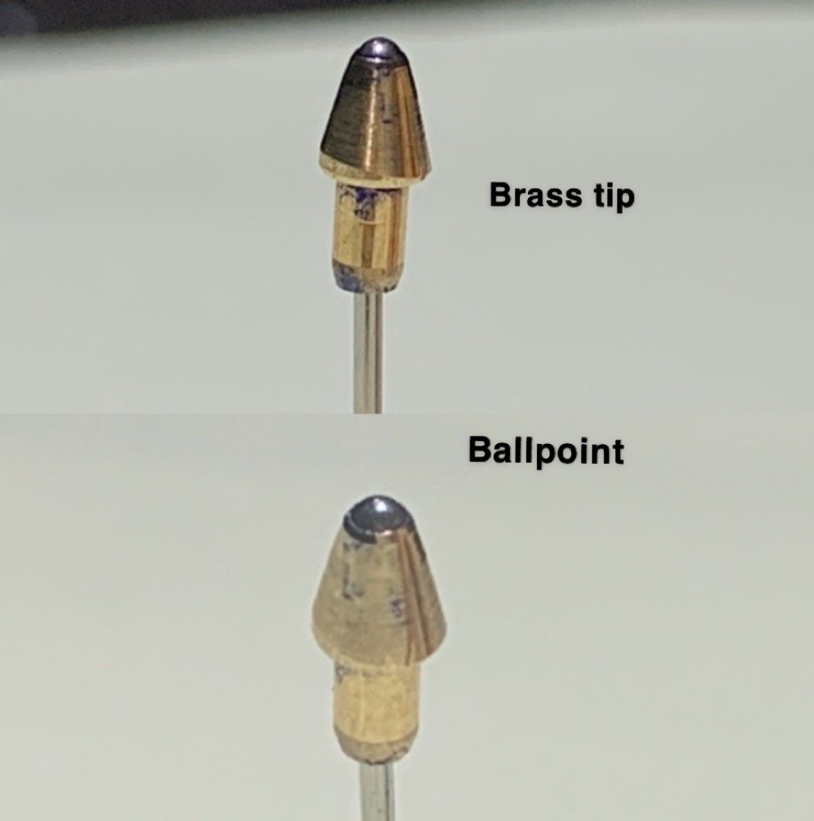
The Ballpoint:
The ballpoint is a sphere shaped small ball that is made up of tungsten carbide. This piece is super tiny with a 1 mm diameter and is found inside the brass tip. The ballpoint is the main component of the BiC pen. It fits perfectly into the Brass tip as seen on figure 8.The main function of the ballpoint is to keep the ink from drying as the pen is being used. The way it works is that as the pen is being used, the ballpoint turns and draws ink from the ink cartridge which creates a link line on the surface of a page. The ballpoint also creates Figure 8: Ballpoint
a quick dry time for the ink, so that it won't dry off as it is touching the page. It also is what keeps the ink flowing, as you start writing the ball keeps turning which keeps the ink flowing so it writes continuously without needing more ink (Contributors, 2020).

How to use the BiC pen
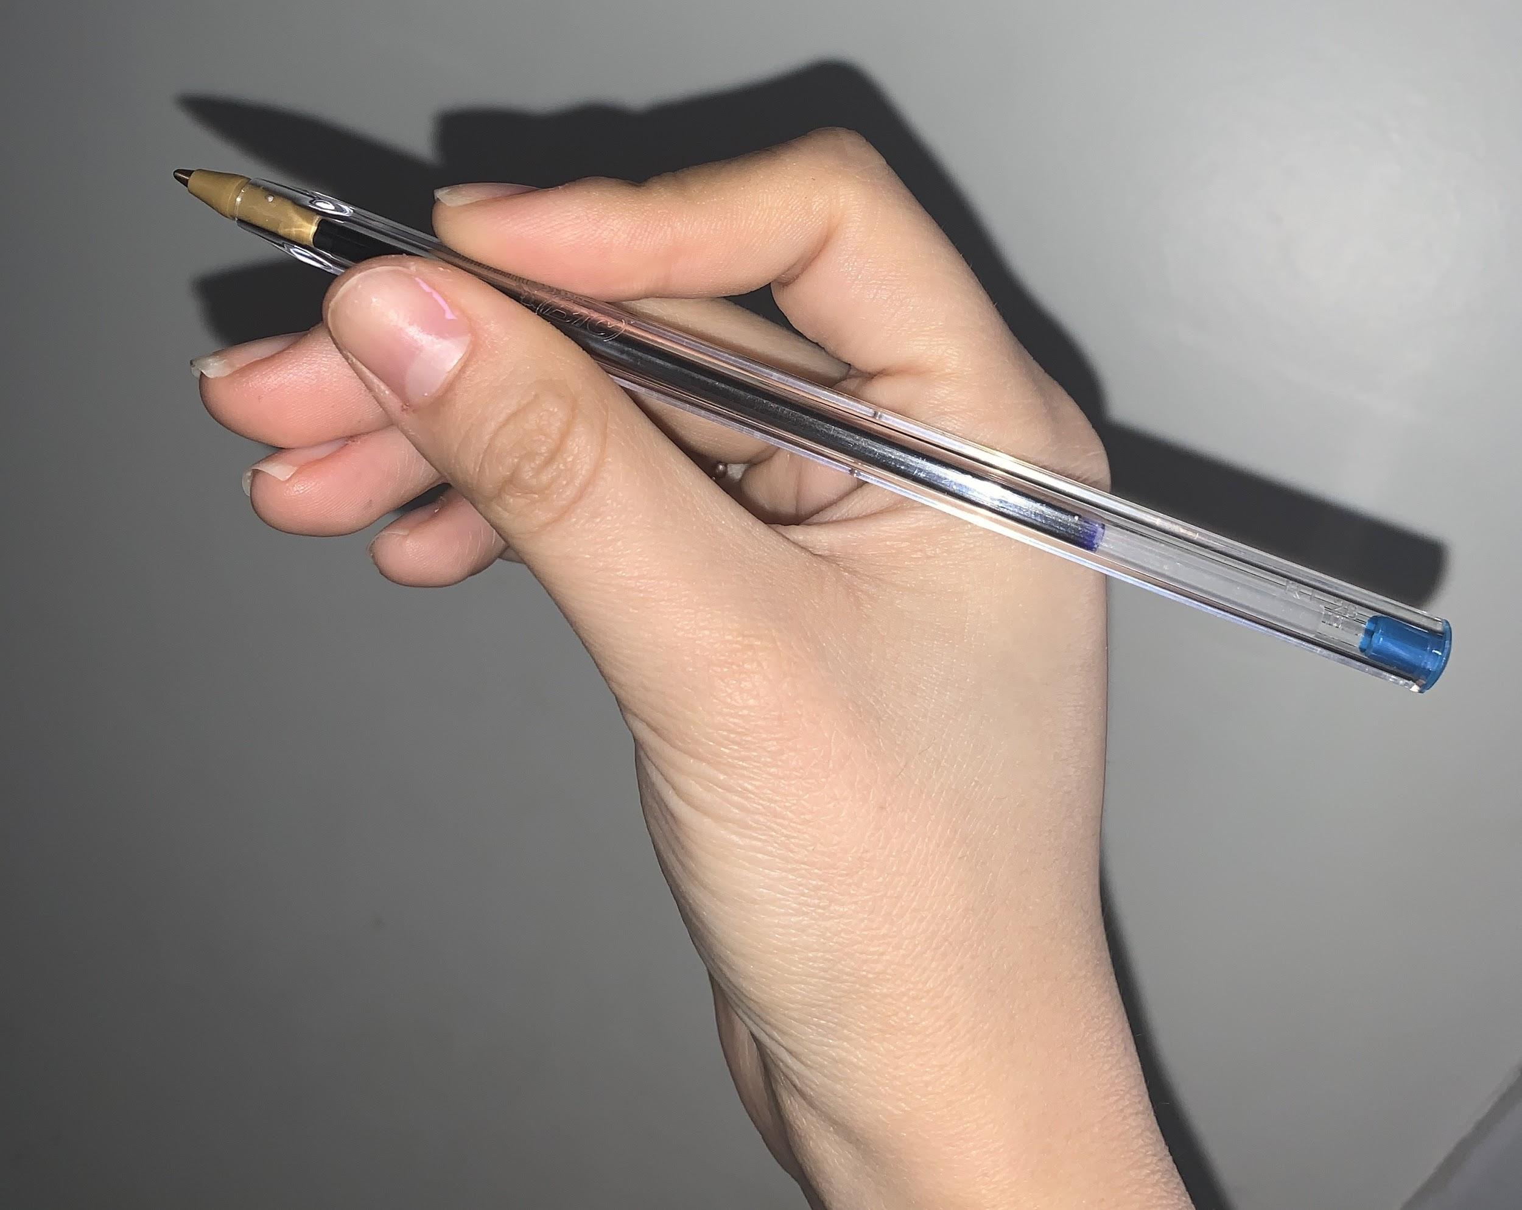
Using the BiC pen is very simple if you follow these steps:
- Once you have a surface to write with you are going to pick up your pen with your thumb and index finger (for better control hold the pen closer to the side of the tip). Use your dominant hand for better writing or whichever is most comfortable to write with. Allow for the back of the pen to rest on your purlicue, which is the skin between your thumb and index finger. Figure 9: Holding the BiC pen
- Grip the pen by squeezing the pen with your thumb and index finger. Make sure to hold the pen very firmly, as seen in figure 9.
- Place your middle finger under the pen to give it another surface to rest on. Your ring and pinky finger won't be used throughout this process so it can curl into your palm.
- Rest your hand on the surface you are writing on and adjust the pen until it can touch the surface you will be writing on.
- Since your pen is going to be at an angle, apply pressure and move your hand so it can start writing!
Summary
As you can see there are many components to the BiC pen. Inside you have the main part which is the brass tip holder, this is what holds the ink cartridge on the right end and the brass tip on the left end. Inside the brass tip you have the ballpoint which is where the ink travels too. Once all these pieces are put together, you can slide in the ink cartridge into the barrel from the right side until it meets the brass tip holder. Then on the right end of the barrel (with the point facing the left) is where the stopper is found. Then the cap goes on the brass tip.
Conclusion
There you have your BiC cristal Pen Xtra-Smooth. All these parts come together to create this nice comfortable pen that will please anyone who uses it. Unlike other pens, I highly recommend using the BiC pen because it has a ball point, and you never have any problems with it. There will never be any leakage, stains, or any hassle when using it. Yes the company BiC has many other pens such as Xtra-Fine, Ultra Round… etc but I can assure you that you are better off using this pen. It fits perfectly in your hand, has a very smooth texture and is very comfortable when you write with it. I hope you enjoyed the anatomy of the BiC cristal Pen Xtra-Smooth! I hope you enjoyed the anatomy of the BiC Cristal Pen Xtra-smooth. Hope you enjoy this pen as much as I do.

More Information
There are many outside sources that can provide you with any other information that you would like to know about the BiC pen. The website https://www.bicworld.com can provide you with facts and details about the pen itself. You can purchase this BiC cristal pen in many different places. For example, the BiC Cristal Pen can be found at local 99 cents stores, Walgreens, Walmart, Rite-aid, Staples, Amazon, Target..etc. A pack of these pens can typically cost around $6. It all depends on how many comes in a pack and the style you are looking for.

References

BicWorld. (2003, August 6). Retrieved February 20, 2020, from https://www.bicworld.com/

Contributors, H. S. W. (2020, January 27). How does a ballpoint pen work? Retrieved February
17, 2020, from
https://science.howstuffworks.com/innovation/science-questions/question683.htm

Giesbrecht, J. (2016, September 26). How the Ballpoint Pen Killed Cursive. Retrieved February
19, 2020, from https://www.theatlantic.com/technology/archive/2015/08/ballpoint-pens-object-lesson-history-handwriting/402205/

Karpret , R. (2018, June 20). The History of Pens: The Journal Shop. Retrieved February
19, 2020, from https://www.thejournalshop.com/thejournal/history-of-pens/

Rolger, J. (2009, June 20). 02 – Raw Materials. Retrieved February 18, 2020, from
https://u.osu.edu/bicpens/02-raw-materials/

Reflection

When we were given this assignment, I had no idea what I was going to write about. At first I wanted to write about a stapler, and then changed my mind to a book bag but then as I was walking home I thought about writing a technical description about a pen. I thought to myself how many don't really write about the small things that may look simple. Who would ever want to know about the inside of a pen? This was where I decided to write about the BiC Cristal Pen that was Xtra-smooth. Also because it is personally my favorite pen to use. This may sound weird but when I am in class or doing my work, if I don’t have a good pen then my writing won't be nice and the way I want it. In order for me to actually want to write I have to be using a nice, smooth pen, that doesn't hurt my fingers or feel like I have to press hard enough in order to write. This pen is the Xtra-Smooth BiC pen. The way it feels on my fingers just satisfies me and makes me want to write. I have tried to use other pens but they tend to bother me or hurt me. This will always be my go to pen which is why I decided to write about it and convince others to try it as well. I started to use these pens when I was a sophmore in highschool and I continue to use them till this day.
The genre of my assignment is a technical description. Technical description is when you explain an object to a person, in other words the objects functions, structure, working mechanism and the different parts to it by giving as many details as possible. My work follows the requirements of a technical description. To start off I provide the reader with a history on pens and how the revolution of the pen has changed over the years.I then give a background on the brand I am talking about. After this I start talking about the pen and the different parts to the pen, the interior and exterior. I break down my work in different sections, each section defines a piece of the pen, states it's dimensions, it's function and the mechanism to it. I describe each part in detail so that the reader can picture this in their mind. I also added visuals of each piece so that the reader can know exactly what I am talking about.
The media of my technical description is print as well as digital. My final copy was a print out and was handed to my professor and was also posted on blackboard. Throughout the process of editing, I had to upload my work on blackboard so that my group could peer review my work. I felt that having my work on paper instead of a power point would be more effective. Since I want my reader to know and learn about the anatomy of a pen, reading off the paper would make it easier for them. When on paper, it is easier for them to locate my ideas and absorb my information better.
My purpose in this assignment was to inform the reader on the anatomy of a pen. A pen is something that is overlooked and not taken into consideration. We use pens everyday so I wanted to inform people on how something they use every day works. I wanted to explain it's mechanisms, the purpose of each piece, and why and how they all work together. I want to educate the reader on the BiC pen since I know they don;t know the specifics and background to it. Also to educate them on the revolution on the pens and how it went from pens made out of animal feathers to pens made out of plastic and copper which is pretty cool if you ask me.
The exigence for this technical description is to convince the reader to use this pen because of how nice and comfortable it is. Many people don’t care about the pens they use and just use whatever pen they have, but I want to convince them to use the cristal ballpoint pen Xtra-Smooth because in my opinion it is the best pen out there. I want them to want to write with this pen. In my work I said how this pen is very comfortable, is very smooth, has a nice texture and doesn't bother or hurt your fingers unlike other pens. I explained the smooth surface and how beneficial this pen can be to anyone. The way it was made by the BiC company is unique and this pen has a lot to offer to whoever decides to use it. Since this is my favorite pen, I would like others to use it as well because the way it works and feels when you write is amazing, many can benefit from this pen!

My stance and attitude about the topic is that BiC is the company that manufactures the best pens, and one of the best pens they have is the Cristal Ballpoint Pen Xtra-Smooth. Like I said in my technical description, many people don’t really care about what pen they use. As long as they have something to write with then they are fine, but in this assignment I mention to the reader the many benefits that come along with purchasing this pen. The first factor is that it is very cheap, and the quality of the pen is one of the best. It is very comfortable to write with, it doesn't hurt your fingers when writing. Also since it is a ballpoint pen, it feels really smooth as you write which is one of its best features. Many people don't know about this pen or the anatomy of it which is why I decided to write my technical description on the BiC Cristal Ballpoint Pen Xtra-Smooth. Another thing that motivated me was the fact that people don’t often think about the history of a pen and how it has changed overtime.

The audience of this work is anyone who draws, writes, paints and has used a pen before. Also anyone who is in school, who works at an office, basically anyone who is in an environment where a pen comes in handy and doesn’t know the history of the pen. In my technical description I tell the history and revolution of pens to educate the reader on how the manufacture of pens has changed throughout the years. In my work I also try to convince those who use pens, to try and use the Cristal Ballpoint Pen Xtra-Smooth due to the benefits it comes with. I am very specific with the history as well as why this pen is something the reader should have. I also provide them with information on where they can buy this pen and how much it will cost them. I also added on the BiC website so they can learn more about the pen if they are interested.
My technical description meets Course Learning outcomes 2,3, 7, & 8. In this assignment I enhanced my strategies when it came to revising my work after getting my peer reviews back from my peers. I was able to compose a draft, look at what they had to say, edit my work, and compose a final piece (2). In this assignment I also made sure I used rhetorical situations, making sure my audience was presented as well as genre and media. I made sure my purpose was easy to determine as well as my exigence and stance. I knew I had to address all these aspects in my writing so I made sure I did (3). In order to make sure my audience was aware of what I was writing, I did not assume the amount of background knowledge the reader had on pens, so I provided them with a brief background on the history of pens as well as the company. In order to do this I used the internet to locate sources appropriate to my topic (7). I also strengthened my practice on using the APA format and on how to cite the information I used. I composed a reference table and referred to the source when I paraphrased (8).

