Making a peanut butter sandwich

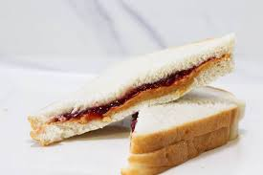
IMG 1

History
Peanut butter sandwiches fed the American soldiers during the first World War after Welch’s figured a good way to store grape jelly for an extended period of time. When those soldiers came home tired and hungry, they wanted nothing other than the same sustenance that fueled them at battle. This vegetarian dish is delicious and here is what you need to know to make your very own Peanut butter and Jelly sandwich.
Materials:
At least two pieces of slice bread *other breads could used*
Peanut Butter
Jelly
Spreading utensils (eg. butter knife, spoon)
THE RATIO:
It’s important to find a ratio that works for you. Though it is the general consensus that the ratio should be close to 2 part peanut butter to every 1 part jelly, everyone is different. Some people like more jelly, others like even more peanut butter. Don’t let others tell you how to make your own pb&j!!

Assembly:
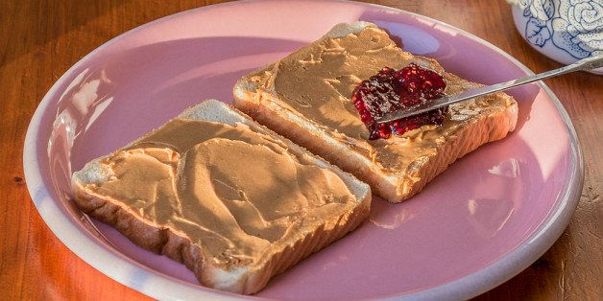
The assembly is quick and easy.
Split and spread your peanut butter evenly between the two pieces of bread. You want to cover one side of each piece. You do this to avoid your jelly from making the bread soggy. I like to use a butter knife to spread the peanut butter.
IMG 2
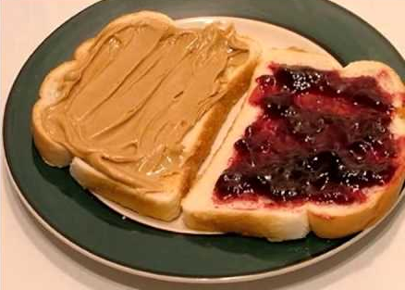
Now place your jelly on top of the peanut butter covered bread and spread. I use a spoon to scoop and spread the jelly. (IMG 2)
Note: Some people prefer to dedicate a piece of bread to a respective condiment. Jelly side/ peanut butter side. (IMG 3)
Smash them together with the spreads facing each other and there you have it. Your very own, delicious, PB&J sandwich. After assembling the sandwich, you can slice the sandwich in half or cut the crust off the bread.
IMG 3

