How to Prepare Tea
Audience
This set of instructions is intended for a person responsible enough to safely use a stove on their own. We assume that everyone reading these directions knows how to use a stove top and can safely pour the boiling water into a mug without burning themselves.

Ingredients
- Tea bag
- Water
- Sweeteners like sugar, honey, etc... (optional)

Utensils
- Kettle or pot
- Stove
- Mug or teacup.

Instructions

- The first thing you need is a tea bag. A box of tea bags can be bought at any grocery store. Choose the flavor that you prefer.

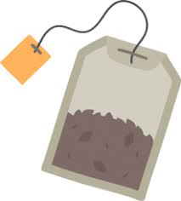
- Place a pot or kettle on the stove and add water.
- Turn on the stove and let the water boil (until you can notice it starts to release bubbles). If using a kettle, wait for the kettle to begin to whistle.
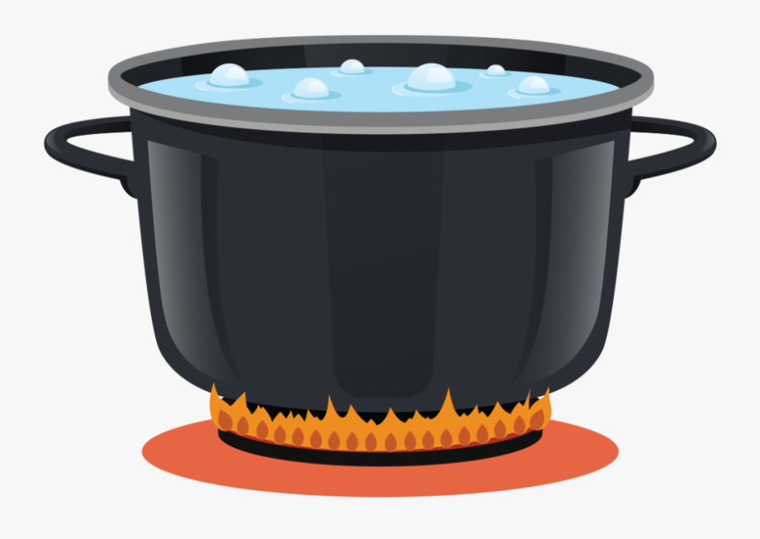 | 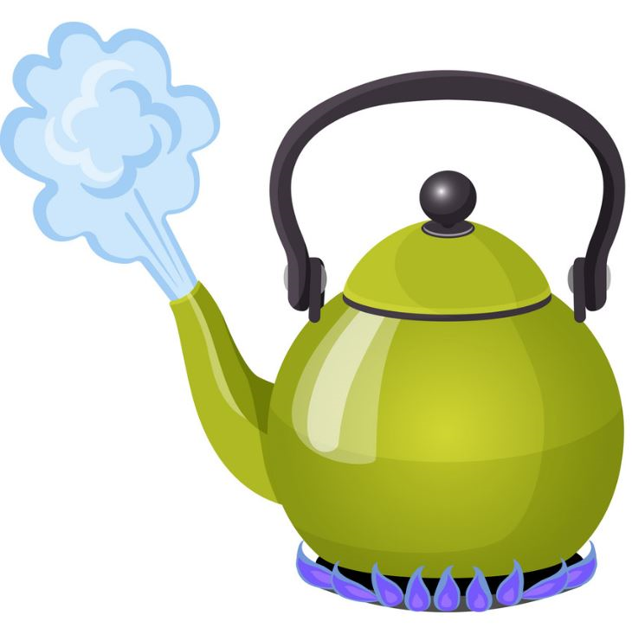

- Turn off the stove!

- Place one tea bag into a mug or teacup.
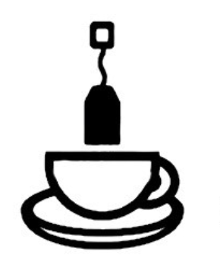

- Pour the boiling water into the mug, soaking the tea bag.

- The longer you leave the tea bag inside of the tea, the stronger the flavor. For more flavor, let the bag soak for a few minutes before removing it. This will also allow it to cool.

- If it satisfies your preference, add honey or sugar to sweeten the beverage, make sure to stir.
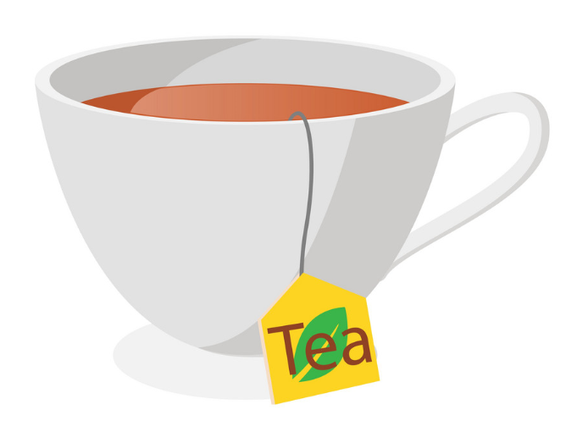
- Enjoy.

Names: Patryk, Edison, Michael, Jose, Junead

