Removal of harmful microorganisms in the Hudson River by boiling and Ultraviolet (UV) light methods
Trent Strachan
The City College of New York
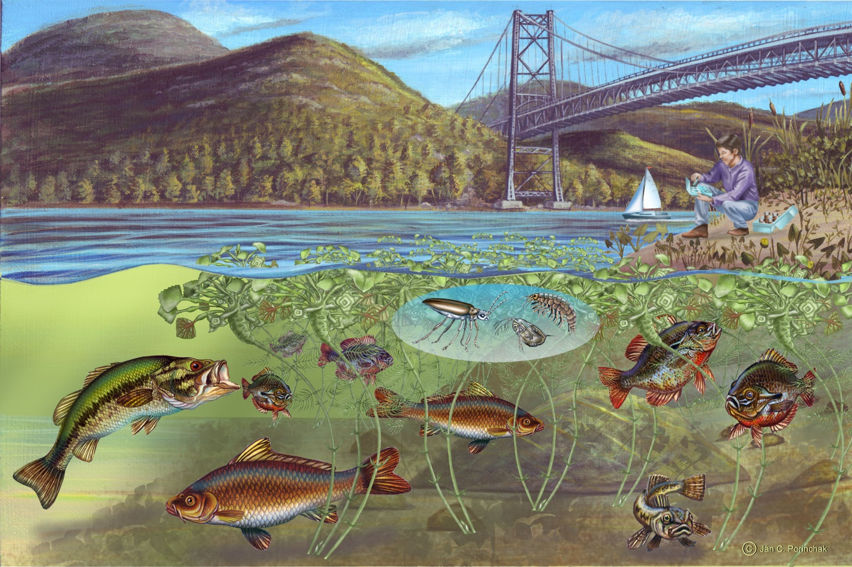

Abstract
The Hudson River is a large body of water spanning both the states of New York and New Jersey. There was a major concern with the health of the water system from a rise in population size. There was a large bacteria count of total coliforms bacteria, from sewage discharge, present in the study area. As a result, the removal of total coliforms in the Hudson River was the focus of this study. The results suggested that there were an estimate of 20 total coliforms from each of the water samples. Three-fourths of total coliforms were removed using boiling method and half of the total coliforms were removed using ultraviolet (UV) light method. The general procedure was to collect 51 water samples and to determine the amount of total coliforms to be removed. From the 51 water samples, there was 1 sample that acted as a control throughout the experiment. Each method for disinfecting water was applied and the water was retested to determine the bacteria count removed. The experiment was proven to be effective and consistent since each method was done multiple times. After the study, the boiling process was the most effective method for treating water.

Table of Contents
Introduction… ……... ……... ……... ……... ……... ……... ……... ……... ……... ……... 4
Materials and Method ……... ……... ……... ……... ……... ……... ........... ……... ……... 5-6
Results…..……... ……... ……... ……... ……... ……... ……... ……... ……... ……... 6-8
Discussion…. ……... ……... ……... ……... ……... ……... ……... ……... ……... ……... 8
Conclusion…..……... ……... ……... ……... ……... ……... ……... ……... ……... ……... 9
References….. ……... ……... ……... ……... ……... ……... ……... ……... ……... ……... 10

Introduction
Boiling and UV radiation are two processes that can remove microorganisms for example total coliforms from water. The boiling method is a pathogen (disease-causing organism) reduction method that involves heating the water to a high temperature of about 100° C (Howe & Payero, n.d.). Boiling is considered to be the most effective method to remove microorganisms. A fact sheet for healthy drinking water showed boiling for 1 minute minimum showed very high effectiveness from protozoa, bacteria and viruses (Centers for Disease Control and Prevention [CDC], 2009). UV light destroys bacteria by using a special lamp of “intensity and saturation” rating of about 40,000 micro watts second per centimeter squared (Oram, 2014). The light changes processes in the bacteria thus making the bacteria unable to properly reproduce/multiply and making the bacteria inactive and destroyed.
After conducting the research, the experimenter was able to confirm that the Hudson River is highly polluted. Also, the experimenter was able to identify boiling method as the most effective method. The samples were placed in an agar plate on a membrane filter. The samples are then incubated for 24 hours at 35 degrees Celsius and the total coliforms count is identified by have a gold-green sheen (Oram, 2014). Although there have been an attempt to clean the Hudson River by dredging, the Hudson River still has bacteria present due to sewage discharge.
This experiment serves to provide accurate data on the bacteria count and the best means to remove total coliforms in the water samples present. Perhaps, the experiment can be used to provide a larger study of the area for remediation.

Materials and Method
Materials:
- Two 1 gallon sterilized containers
- Fifty-one 50 mL water samples
- Total coliforms bacteria
- UV system (special lamp that shines at 40,000 micro watts second per centimeter squared)
- Stopper
- Test tubes
- Test tube racks
- Electric stove top
- Sterile pot with cover
- Agar plate
- Pencil
- Paper
- Microscope
- Electrical outlet
In the experiment, the experimenter and fellow experimenters went out to the Hudson River. They assessed the area and chose to collect the water samples near the coast. To collect the samples they used two 1 gallon sterilized containers. The experimenters went to the environmental engineering laboratory to setup the lab. The samples were labeled 1 through 25. The bacteria were placed on an agar plate and using the microscope the number of total coliforms bacteria (gold-green sheen) from each of 25 samples was recorded. Each sample was then placed on the stove top in a sterile pot and covered. When the samples bubbled rapidly, the stove was turned off and immediately placed into test tubes and then into a test tube rack and the samples covered with stoppers. The samples were placed in a cool cupboard and incubated for 24 hours. The samples were then placed on the agar dish and their count was recorded on paper.
The UV system was connected to the electrical outlet. The samples were labeled 26 through 50. The remaining 25 samples were each in turn placed on an agar plate and using a microscope the number of total coliforms was recorded. They were then placed into a test tube and the system shined for 2 minutes on each sample. They samples were then covered, placed in the cool cupboard and incubated for 24 hours. Thereafter, the samples were placed on the agar dish and the number of total coliforms recorded. The average of both the initial and final total of coliforms bacteria was then found.

Results
Water Sample# | Initial Total Coliforms Bacteria Count | Final Total Coliforms Bacteria Count
1 | 30 | 5
2 | 20 | 4
3 | 15 | 2
4 | 42 | 10
5 | 55 | 22
6 | 43 | 12
7 | 54 | 8
8 | 44 | 22
9 | 12 | 0
10 | 4 | 0
Figure 1. Initial and Final Total Coliforms Bacteria Count using Boiling Method
Average initial total coliforms bacteria count = 31.9 total coliforms bacteria
Average final total coliforms bacteria count = 8.5 total coliforms bacteria

Water Sample # | Initial Total Coliforms Bacteria Count | Final Total Coliforms Bacteria Count
11 | 30 | 20
12 | 22 | 12
13 | 55 | 33
14 | 10 | 9
15 | 20 | 8
16 | 15 | 40
17 | 33 | 44
18 | 1 | 40
19 | 3 | 0
20 | 4 | 0
Figure 2. Initial and Final Total Coliforms Bacteria Count using UV Light Method
Average initial total coliforms bacteria count = 19.3 total coliforms bacteria
Average final total coliforms bacteria count = 20.6 total coliforms bacteria
Note: The above results were truncated since the remaining data does not significantly affect the method that would be most effective.

Discussion
From the results, boiling is the most effective method to remove total coliforms bacteria from the Hudson River. The average initial total coliforms bacteria count was found to be 31.9 total coliforms bacteria in boiling samples while UV light samples were 19.3 total coliforms bacteria. There was a greater initial number count but a smaller number count when the boiling method was used compared to a smaller initial number of total coliforms bacteria but a greater number of total coliforms as the final total.
The fact that UV light generated more bacteria from the final total than the initial total may seem skewed but it is correct. UV light does not necessarily destroy the bacteria but makes the bacteria inactive. The inactive bacteria will act as a food source for the bacteria present in the samples. Thus, the bacteria multiply exponentially and produce more than the initial total.

Conclusion
This lab was done in order to determine the most effective method of removal of total coliforms bacteria from the Hudson River. Based on the results obtained, the boiling method was the most effective method to the removal of the microorganism as compared with UV light systems.
Bacteria do not grow slowly but multiply. Under certain conditions, there is an exponential increase in the bacteria count.

References
Centers for Disease Control and Prevention [CDC] (2009). Water treatment methods. Fact Sheet for Healthy Drinking Water. Retrieved from https://www.cdc.gov/healthywater/pdf/drinking/Backcountry_Water_Treatment.pdf

Howe, M., & Payero, J. (n.d.). Disinfection. Disinfection by boiling and chlorination. Retrieved from https://www.oas.org/dsd/publications/unit/oea59e/ch23.htm#TopOfPage

Oram, B. (2014). UV Disinfection. UV Disinfection Drinking Water. Retrieved from https://www.water-research.net/index.php/water-treatment/water-disinfection/uv-disinfection

Reflection
This assignment proved to be the most challenging yet. I have never done such an in-depth lab report such as this one. In most of my previous lab reports, the title, materials and example results were a given. The lab report required me to peruse through journals and internet sources. With so much information, I started thinking about newer methods that can be used to clean up the Hudson River and other remediation sites. Each assignment that I have done makes me feel more connected to the environment and to consider how to change consumer patterns.
The genre, in other words, the type of writing, is a lab report. Lab reports are the most common kind of writing by engineers and they are usually done for archiving work and to share with management. The report seeks to make management accept findings and conclusions so as to allow for construction or rebuilding plans. My assignment follows this genre’s requirements because it has a title which says that the experimenter is removing harmful microorganisms from the Hudson River by boiling and UV light. Also, there is an abstract that provides a premise as to why the Hudson River was chosen as the study site and the results obtained from the experiment. Furthermore, there was an introduction section detailing the use of boiling and UV light to treat waterways and a general procedure on how the setup to conduct the experiment will be done using a special lamp. In addition, materials and methods, results, discussion of findings, viable conclusion and references were given in the lab report.
The media for this assignment is multimodal since it incorporates both digital and print. The team of future environmental engineers of group four posted on blackboard the general outlook of their lab report and together, we composed four to five relevant questions to other future engineers’ groups. Each member critiqued each other’s work during class. This was done by printing four copies to give to the professor and other group members.
My stance on the subject matter is somber but hopeful. The larger bacteria count present was shocking. There was a removal of a sufficient amount of bacteria from the Hudson River but the bacteria count is still high. Bacteria multiply and as such would increase in size three fold or more. I am hopeful that my generation of engineers would make a change. We would unite and find ways to answer the problem of sewage not only in the Hudson but in as much waterways as possible.
My purpose in this assignment is to change the way in which we treat our environment and in this case, the Hudson River. From my research it is quite normal to dump raw sewage into the river and is not concerning for one’s health at the moment. This cannot be right. How can it be okay to discharge sewage into the river? There must be change, and a proactive approach must be considered.
My exigence, or, the situation that lead to rhetoric writing, is water contamination. Toxic substances enter water bodies largely due to human activities. It seems like whenever there is not enough land space to dump sewage, the ideal place is to discard it in waterways. This not only has a negative effect on animals and plants, but also on the quality of life of human populations.
My audience in this assignment is the general public. Municipal industries are the ones dumping waste into the river, lakes and ponds and they do it indiscriminately. They do it because an outdated law says that they can. Our voices must be heard. We can make this city, state, world a better place. Businesses, industries seek to please consumers. Our yes means yes, and our no means no. They must listen.
Course learning outcome 3 is achieved through this assignment. My goal is to instill a sense of urgency. Natural phenomena are occurring more frequently. I hope my audience reads the lab report and act accordingly. We can make a difference.

