Portfolio and Self-Assessment
Erica Kreisberg
ENGL 21007 K
City College of New York
May 10, 2018

Table of Contents
Introduction 3
Purpose: 4
Audience: 5
Stance: 6
Genre: 7
Medium/Design: 8
Exigence: 8
Course Learning Outcome #1 9
Course Learning Outcome #2 10
Course Learning Outcome #3 11
Course Learning Outcome #4 11
Course Learning Outcome #5 12
Course Learning Outcome #6 13
Course Learning Outcome #7 13
Course Learning Outcome #8 14
Conclusion 15

Introduction
Looking back on my assignments from this semester really gives me a perspective on my skills as writing for my future career as an engineer. In the past my writing has been almost purely literary, especially in high school when in literature or composition class I only wrote about the literary elements of the work or the rhetorical arguments of the work and the speaker. I was excited to find out that the rhetorical situation and rhetorical elements play a major role in the science communication field and within engineering writing. Using my writing as a way to deliver scientific and engineering ideas to a specific audience falls in line with a lot of what I eventually want to do with my career as a Biomedical engineer.
Some topics that I found really impacted my view, as a whole on the engineering field would be the rhetorical elements, especially the different genres of writing in engineering and the persuading or informing a particular audience. I will show how I have improved throughout the semester in these skills and what skills I may still need to improve upon.
The hybrid assignments were very good at supplementing the in class work. The specific hybrid assignment that included the resume was one that had each person pitch themselves to another group’s company for their product, device, or service included in their engineering proposal. I found an interesting dichotomy between pitching myself and helping to pitch my group in the engineering proposal. When pitching myself I focused on my skills and how I personally would help a project already in progress. When helping to pitch my group’s product, I was focusing more on the product, how investors would benefit, how people in the audience benefit, and how the problem would be solved by our solution.
Other elements of the rhetorical situation include purpose, medium, stance, and exigence. Many of these elements are interconnected but they are all different and I find each one necessary in their own right when constructing a document for engineering. When it came to the engineering proposal the media was very important. The group had to devise a proposal that had a medium that included an oral presentation with a slides presentation to accompany it. It also included the printed copy of the proposal and my group even included flyers to pass out during the presentation.
In another sense I found exigence to be very important in my technical description for the iPod Nano Third Generation. The situation that propelled me into this topic really intrigued me and made me want to share this information along with the pure nostalgia that comes with discussing a product that went on the market in 2007. These rhetorical elements will be further discussed along with evidence of my journey throughout the semester from my actual assignments.

Purpose:
Purpose is the reason we write as engineers. For me especially what shown throughout all of my assignments was the fact that this element seemed the most applicable and relatable to each topic. In each reflection paper I found that it was easy to find most of the other elements within my documents once I had seen what my purpose was.
At first I wasn’t really looking at the purpose before writing because I simply saw it as an assignment much like in the other writing classes I had in the past. Then I realized during my lab report that I really honed in on the purpose of my assignments and was able to apply it to my field. In this assignment the class was to write about an experiment or study they were doing to solve a problem or fill a void in their field. I chose a very specific topic in Biomedical engineering that focused on the human impact in the workplace with trial and error type experimentation. The study I chose was one with cochlear implants and how they impact the people who use them. My purpose of this report includes the peer review process on BlackBoard. The following is quoted from my post on BlackBoard about the lab report topic, “ The device that I will have research on is a cochlear implant. [The study will be done to test] its comfort for the people who use it, the reasons people may use it, the reasons people may not want to use it, and how this study can be used to improve the device for the user.” Since this was the first stage of my process in finding out what the write in the lab report I needed to find a very specific topic. Lab reports need a hypothesis of what will occur so there needs to be a larger purpose behind the experiment. The blue typed words in the quote signify the specific moments that I took purpose into account. The cochlear implant was the topic but the people who use cochlear implants became the focal point, and the study’s purpose was to find the reasons why people who may need cochlear implants would want to use them, not want to use them, or what ways the device could be improved. I was able to move forward with the assignment and understand why I was even writing this document in the first place.

Audience:
There are many different types of audiences when writing as an engineer. The three main types would be primary (the people whom the communication is directed to), secondary (the people who are distant from the writer and need to be aware of the contents of the document but who will not directly respond) and tertiary (the people who are further removed from the writer but take an interest in the content). I mainly focused on the primary audience when writing my assignments. This would be an area that I definitely need to improve upon because it is necessary to consider who else may be reading or hearing my work other than those at the focus of my audience.
I focused a lot on the audience aspect of the technical description. I found great enjoyment in finding the audience in every section of the document since I was writing about a particular product that they would need information about. The following is an example from that summary section of this assignment showing that particular aspect, “Congratulations Thank you for purchasing your iPod Nano 3rd Generation. Please enjoy all the features provided by your new portable music player… The iPod Nano is being made with convenience in mind, no hassle of carrying your entire music library in CDs or cassettes.” The blue typed words show the attention to the audience members because even with the first word being “congratulations.” I am directing it to those who have purchased this iPod to enjoy themselves with it knowing that they have a convenient way to listen to music. I had looked at Apple’s website to find the company’s promotion of the product and description to find that they also had a focus on the user experience. This was why I chose my audience to be consumers looking at the nostalgia of the product as well as why it is so historically significant. Manufacturers and Apple employees working to promote the product in stores or creating the product could also have been apart of the audience but the description mainly focuses on the customers.

Stance:
Stance was a rhetorical element that wasn’t a strong suit in my class. The element is the attitude a writer has towards their work. I always can find a way towards the end of writing to find my perspective on the work but it was hard to conceptualize at the start. This will probably develop further as I become more comfortable in my field because my attitude of passion towards the field itself will transfer over into many of my projects and into my writing.
A stance of passion was what my group had when proposing our wearable medical device RiPost-Pro. We collaborated well on the topic because we had a mixture of different engineering disciplines and each person had a different reason for creating the device. We had passion and great interest when discussing the necessity of a device that performs the job of personal medical safety. The following is a quote from the group’s needs statement from the engineering proposal. It provides an example of how our stance of this device being necessary can be supported by what we found were the needs of our community. “This alternative will allow for people to get the help they need much quicker, avoiding the potential case of help not arriving in time or at all.” I can see how the stance is intertwined with purpose of wanting to help people with this product, but this stance is slightly different. We show how we have urgency with this product knowing that in many cases ambulances and other emergency services don’t arrive fast enough to the scene.

Genre:
Throughout the semester the class discussed many different genres, or types, of writing within engineering. The genres made up each assignment because they each were similar to one another but had different ideas behind them. Before delving into each topic the class discussed what elements went into each different genre that made them unique. The following is an image of those notes that helped me to distinguish what actually is a technical description. 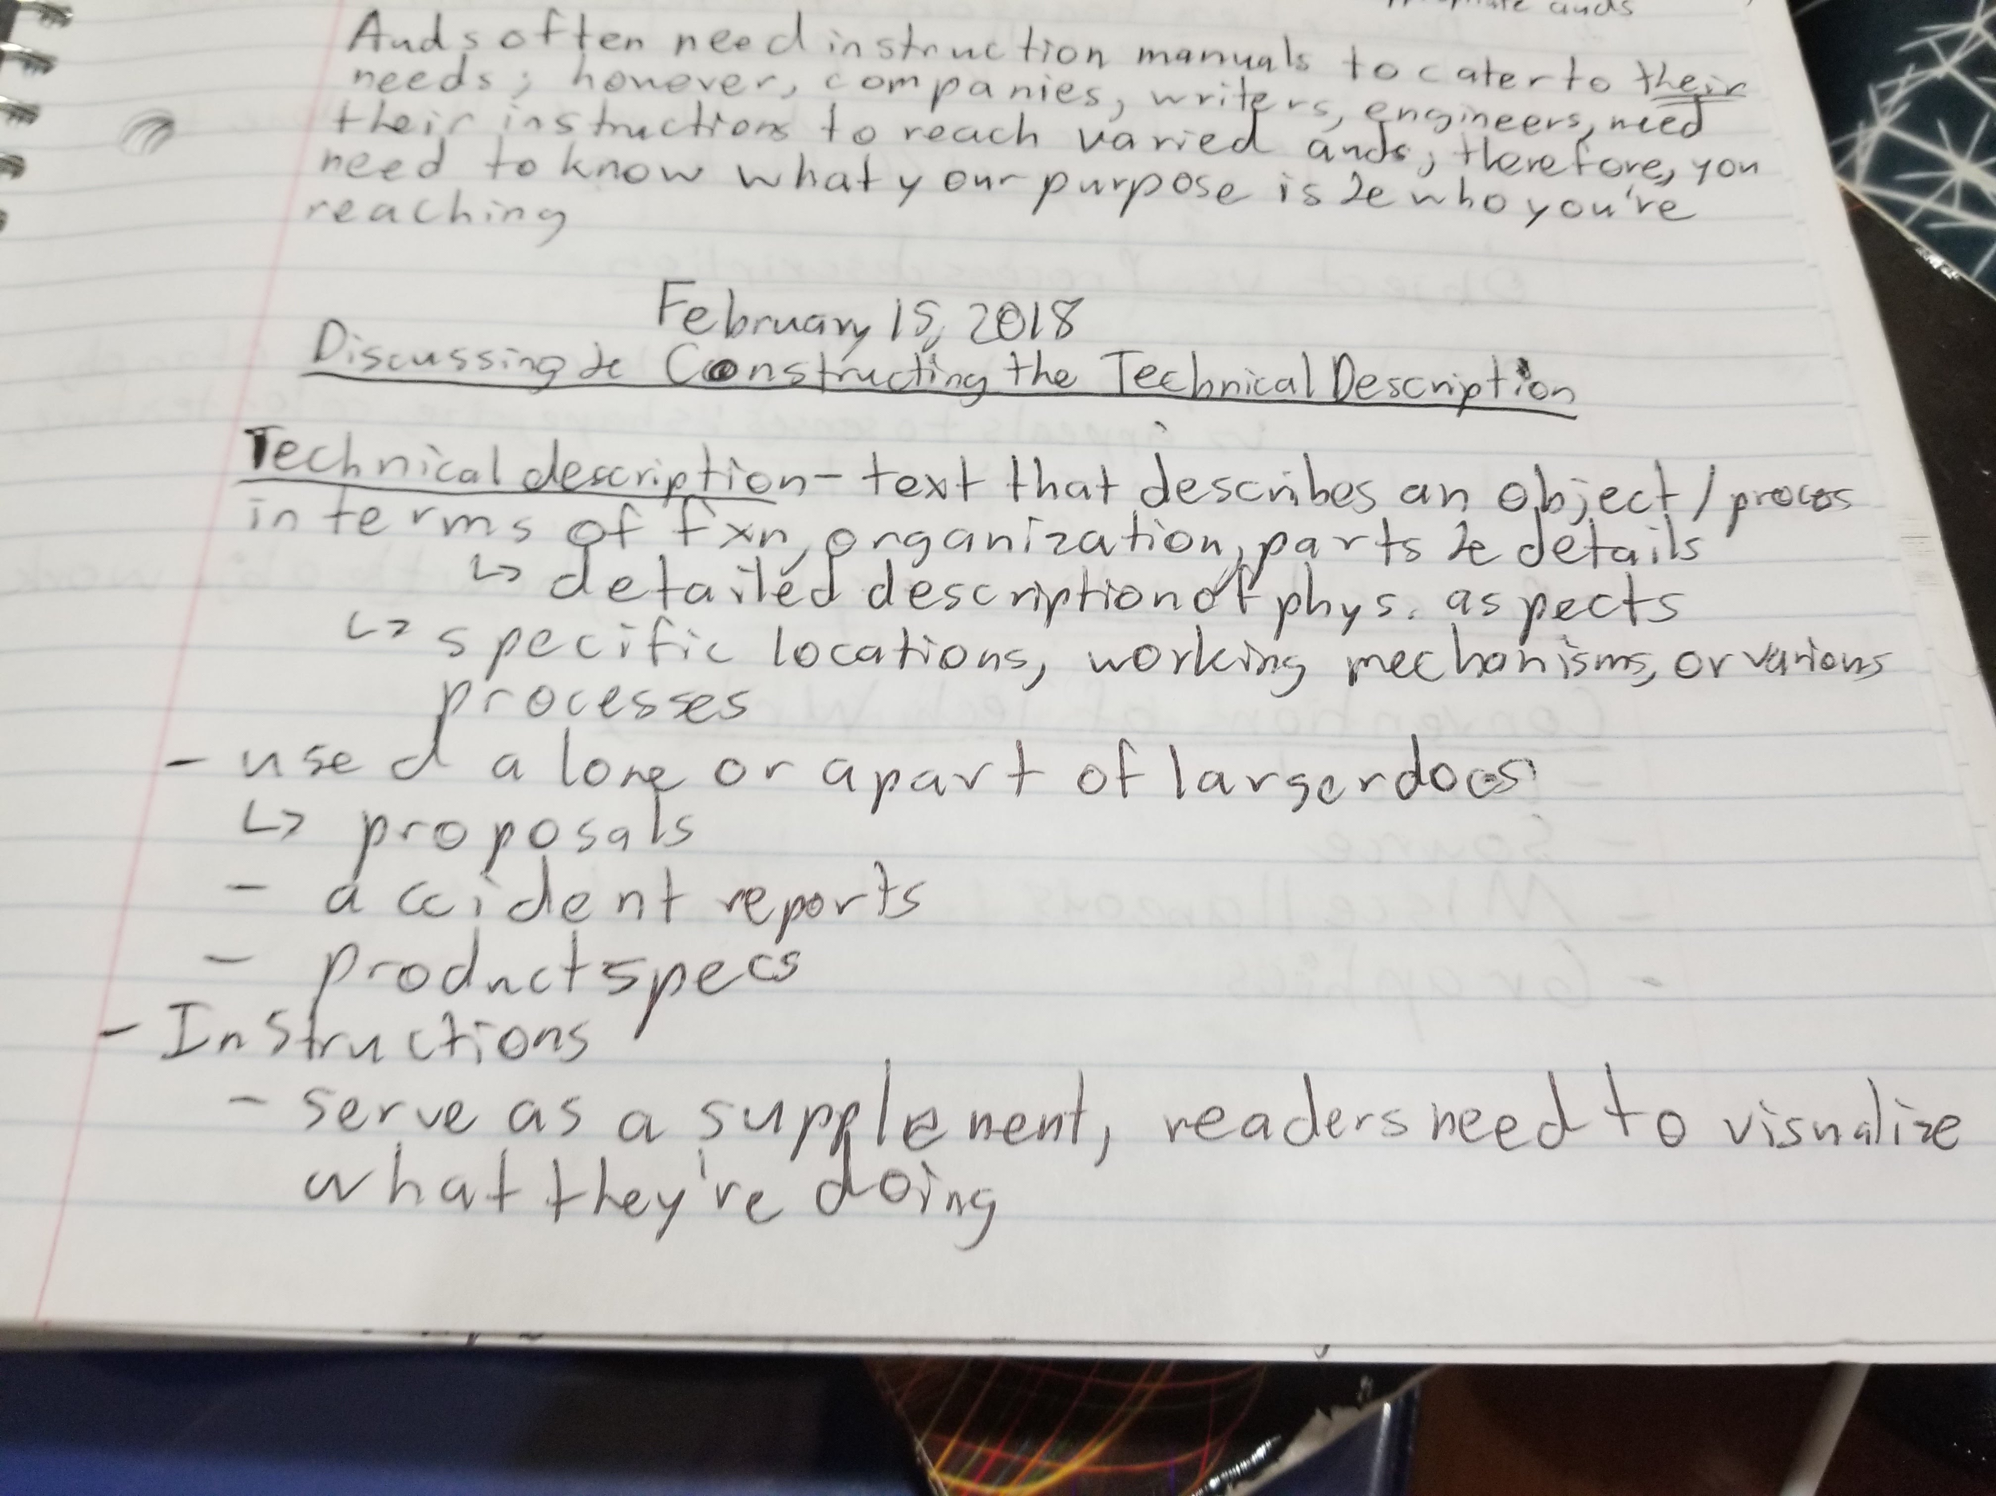
Figure 1: In class notes about the genre Technical Description
We spent a lot of time in class discussing genres and this one I remember the most because it was the first major assignment of the class that was specific to the engineering field. Technical descriptions are meant to specify and characterize a specific object or process. I was very nervous to write this assignment because I had never realized what a technical description was in my daily life. Then I remembered that it includes many products including car manuals and electronic device leaflets.

Medium/Design:
Medium or design is the way that information is conveyed to an audience, and although I understand that it is a very important portion of making a document and being able to communicate to different audiences, I found that this portion of my reflection papers was so repetitive. Every single assignment felt like it was simply just multimodal with print, online peer review, and one time including oral presentations. It is significant in the writing process when determining the way to reach an audience, but I never spent enough time in my reflection papers writing about how it impacted the whole assignment. The medium of the assignment was very important to focus on with the hybrid assignment that went with the engineering proposal.
The class was tasked to develop their resumes for one of the other group’s projects. I created a LinkedIn profile, a resume, and a cover letter directed towards Group 3 about their project that pertains to renewable energy. The portion of this assignment that made it different was the online LinkedIn profile, adding a new dimension to pitching myself.

Exigence:
At the beginning of the semester I knew nothing about exigence as a rhetorical element. It then became obvious how important considering the situation that leading up to an assignment. I mostly had a clear situation that caused me to write. I chose my topics in this class allowing me to figure out what situation made me choose this topic. My favorite exigence was from my technical description’s reflection paper. The following quote is an excerpt, “I was on my afternoon commute home during senior year of high school and I was listening to music. A young girl maybe seven or eight years old asked what type of device I was listening to music on because she thought it was a tiny cellphone.” Then I mentioned how this story immediately brought me to the historical aspect of the iPod and how it changed how people listen to music, “Many people don’t stop to think how things came about and what updates to new technology actually create new conveniences in your daily lives.”
In that last quote I bolded the blue type word “daily” because it so important that we now can listen to music every single day without a hassle thanks to the revolution of the iPod. Society is now removed from that revolution to the point where people do not remember a time where they couldn’t listen to their music on their phone with the press of the button. This became the inciting reason and situation for the technical description.

Course Learning Outcome #1
“Acknowledge your and others' range of linguistic differences as resources, and draw on those resources to develop rhetorical sensibility.” This quote is the first course-learning outcome. This was very important throughout the whole semester. Other people’s resources influenced me during online peer review. It gave me a new perspective on my work that would be very useful in the collaborative setting as a professional engineer. The following figure is from a peer review for my lab report on cochlear implants.
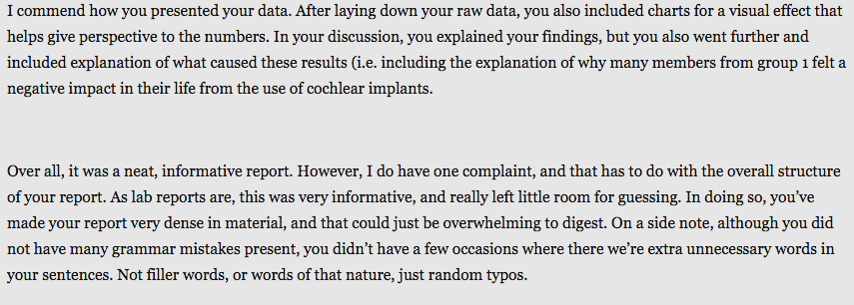
Figure 2: Example of peer review from a classmate about my lab report on cochlear implants
This is the end of the peer review where my classmate sums up what they had already discussed within the rubric. This was good for understanding how people in the audience would view my work and my classmate was able to show me how I could improve upon the clarity in my report. In my draft I didn’t know that I had been wordy in some areas that could have made it a bit confusing to read. Understanding the diction and connotation felt by the audience also helps in reworking a document to better suit multiple different types of audience members.

Course Learning Outcome #2
“Enhance strategies for reading, drafting, revising, editing, and self-assessment.” My favorite proofreading strategy was reading my work out loud to myself and to someone else to improve upon grammar and wording. Proofreading allows me to see the flow the content and see if it all makes sense. Even having someone else read it for themselves makes it easier to know if all of it would make sense to an audience.
Reading aloud is great practicing for oral presentations. Within the preparation for the presentation with my group about out engineering proposal, we allocated who would say what portion and what time the slides would be on the projector. On Google Slides we were able to edit portions together. The following is an image of some of the initial edits to the presentation.
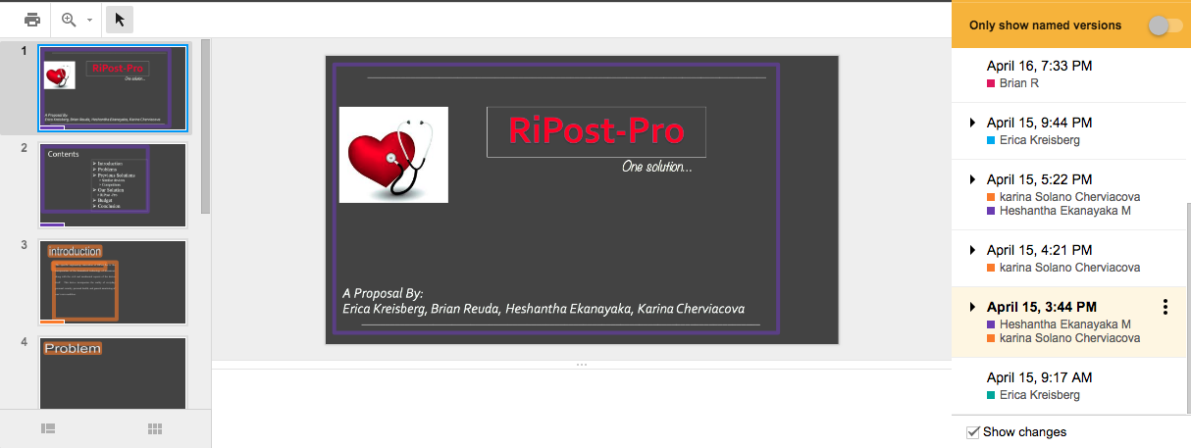
Figure 3: One of the first edits to the group’s slides presentation
In the final presentation the layout of the slides had changed. We had added more information, better graphics, and cohesiveness to the font style of each of the slides. Revising a project together adds direct feedback from others about how the presentation looks and how it may impact them if they were audience members.

Course Learning Outcome #3
“Negotiate your own writing goals and audience expectations regarding conventions of genre, medium, and rhetorical situation.” When beginning to understand an audience and analyzing their perspective, I always looked to how I might be able to use a feedback mechanism to gather this information. I really like using surveys and incorporated this type of audience participation in my lab report. It was whole idea behind the study of cochlear implants to understand the different perspectives in the consumer market. Many people who could have cochlear implants do not necessarily want to for a multitude of reasons. This type of feedback is crucial to the innovative process because as a Biomedical engineer I would want to focus on user-centered design. User-centered design requires the audience feedback and can change the way I give information to my peers. A survey could be online, in print, or oral. In my lab report I chose an in print version.

Course Learning Outcome #4
“Develop and engage in the collaborative and social aspects of writing processes.” This outcome was used a lot during the group project. A main aspect was ensuring that each person was content with our work ethic and how we were all completing our portions. In our initial meeting we discussed our ideas for a topic and how each of our different expertise could contribute to the project. We then established collaborative documents such as Google Docs, Google Slides, and Google Hangouts to develop our ideas. The following is an image of one of those online conversations.
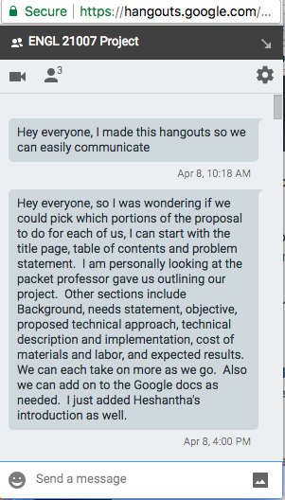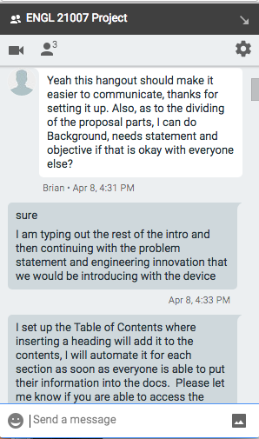
Figure 4: Google Hangouts conversation from the group project

Course Learning Outcome #5
“Engage in genre analysis and multimodal composing to explore effective writing across disciplinary contexts and beyond.” Within genre analysis I was able to fully understand what each assignment entailed. As shown in the rhetorical element genre prior to this, we discussed in class what each assignment was in conjunction with reading from the Technical Communication textbook by Mike Markel. This book went into depth on how to write each different type of genre and showed me how to apply these skills in the work force. Both the textbook and when discussing in class, I was able to see samples of each genre, including samples for this self-assessment essay. Having an idea of how to format each document made it easier to start each assignment. It can be a daunting task to format these documents without any prior knowledge. Having the resource for the APA format on the website Purdue OWL was very helpful.

Course Learning Outcome #6
“Formulate and articulate a stance through and in your writing.” As shown in the section on stance in the rhetorical elements, I was able to develop stance later on in the writing process and became proficient in it from my group project where each of us found great necessity in the product. My understanding of stance really came from my technical description where I was passionate about informing people about the significance of the iPod. The stance for that project really came from the exigence of the young girl on my afternoon commute not knowing what device I was listening to music on. These two elements became intertwined because it was easy to see how the situation sparked a particular feeling and attitude towards the topic for me.

Course Learning Outcome #7
“Practice using various library resources, online databases, and the Internet to locate sources appropriate to your writing projects.” To practice using library resources and online databases we had a class where CCNY librarian Tynan Hoffman delivered a presentation that was very insightful. He gave us tips on what keywords to use when searching on these databases and where online to access the databases available to CUNY and CCNY students through the CCNY library system. He mentioned where on campus different types of libraries are available. I was able to use the online databases in my lab report and in the group project. The following is a picture of the PowerPoint presentation that he used to introduce us to the different resources.
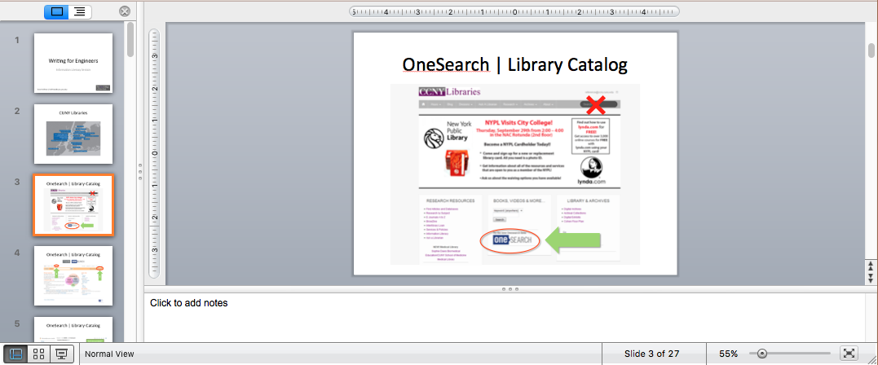
Figure 5: Library resources and online databases information session (Tynan Hoffman)

Course Learning Outcome #8
“Strengthen your source use practices (including evaluating, integrating, quoting, paraphrasing, summarizing, synthesizing, analyzing, and citing sources).” In writing each of my assignments I was able to learn more about integrating the different kinds of sources I wasn’t used to. APA format was fully introduced to me this semester. In the past when I wrote a lab report using APA format in high school I found it very confusing because I was so used to MLA formatting. The following is an image of my editing process for an assignment that shows Microsoft Word’s track changes to the document.
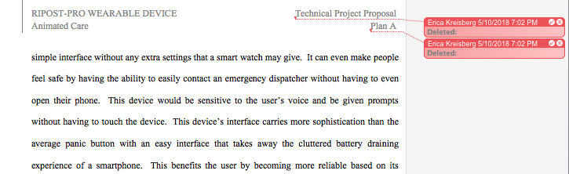
Figure 6: Formatting changes to my group project
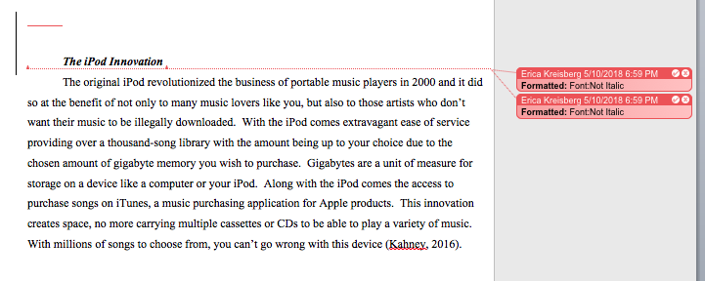
Figure 7: Formatting changes to my technical description
In these track changes I am showcasing the integration aspect of writing for an engineering field because I am making sure that each of the titles for the sections is italicized and uniform. I was also ensuring that each of the sources was mentioned or parenthetically cited. In this self-assessment essay I have referenced my own works my mentioning them before quoting or before the figures that show images of my work.

Conclusion
Along with the rhetorical elements, the course learning outcomes became very important throughout the semester. Those outcomes were significant in the development of my and my classmates’ actual writing progression. They helped to guide me through the editing, drafting, and revising, process. The built in peer review portion of the class also helped in incorporating more of the course learning outcomes into my assignments. The class also discussed resume building and online profiling that were incorporated into the engineering proposal portion with a hybrid assignment. These different writing tools are a good development for my future career and within the rest of my classes for the rest of my school career.

