Technical Description of WD-40

Patryk Strugacz
Grove School of Engineering, City College of New York
ENGL 21007: Writing for Engineers
Professor Danielle Carr
September 30, 2020
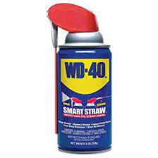

Table of Contents

Introduction/ History 3-4

Exterior Components 4-5

Interior Components 5-6

How to Use WD-40 6

Conclusion 6

References 7

Introduction to your new can of WD-40
Historical Background of the Company
WD-40 emerged from humble roots. According to the company’s website, in 1953, a small, newly established chemical company called the Rocket Chemical Company and its 3 staff members, made it their goal to create a rust prevention and degreaser solvent for aerospace use (WD-40, 2020). The product was first used by an aerospace contractor in order to protect the outside material of the Atlas Missile in order to prevent it from it rusting or corroding. In terms of the name itself, the 40 represents how it took the trio 40 attempts to get their water displacing formula to work, while the “WD” simply stands for water displacement. A few years after its invention, Norm Larsen, president of the company, experimented with putting the lubricant into aerosol cans, as he felt that it would be useful to many more people as a consumer product (WD-40, 2020). A few years later, in 1958, WD-40 lubricant was sold for the first time on store shelves (WD-40, 2020). Today, the products main branded uses are lubrication, protection against rust, penetrating to free stuck parts, and displacing moisture (WD-40, 2020). The product is also capable of many other things such as removing paint scratches from cars and preventing snow buildup on windows, just to name a few from personal experience.

Elements
According to the staff from Wired, the lubricant inside is primarily made of a mix of mineral oils such as baby oil, Vaseline and material from lava lamps (Wired, 2017). These oils are what give WD-40 its lubricating qualities. The rest of the ingredients include chemicals such as tridecane and undecane, which make the lubricant freeze resistant, water repellent, and give it its scent (Wired, 2017). The rest of the chemicals are not essential to understanding the product for the purposes of this technical description, but for more information, visit “www.wired.com/2009/04/st-whatsinside-6/”.

Historical Background of Aerosol Spray Cans
Essential to understanding your new can of WD-40 is becoming familiar with the aerosol can it was packaged in. Aerosol are small particles of liquid or solid that are in the air (Bowen, 2015). Fog is an example of a natural aerosol because during fog, small particles of water are suspended in the air. In an aerosol can, compressed gas is used to force the liquid contents up the tube, and out the nozzle. The first time the concept of aerosol was used was in 1924, as U.S soldiers needed a way to protect themselves from malaria carrying insects (Bowen, 2015). They used low-pressure liquefied gas to atomize droplets of insecticide into the air, repelling these harmful insects. This was considered an aerosol spray because it dispersed the particles into the air in tiny droplets (Bowen, 2015). A couple of decades later, after WWII, the founder of “Precision Valve Corporation,” Robert Abplanalp, created the very first mass produced aerosol valve (Bowen, 2015). Today, aerosol cans are used for a variety of different uses such as spray paint, hair spray, air fresheners, lubricant spray, etc.

Outer Components of the Can
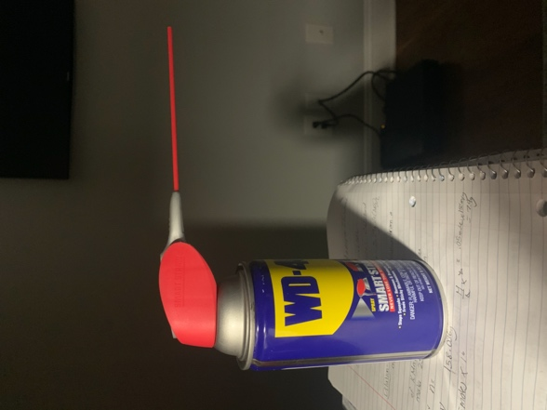
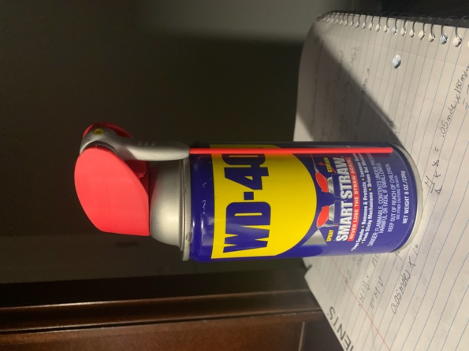
Figure 1. WD-40 can with spray activated vs. stream activated
WD- 40 comes in a blue, hard aluminum leakproof can measuring 6.5” in height. The rear of the can features directions for use, common uses for the product, and warning about dangers of flammability and the possibility of an explosion since the can is pressurized. The outside of the can also features a smooth, red plastic nozzle with a grey button to press down on. The grey button has three small bumps on it to provide some extra grip when pushing down, helping the users’ finger not slip off. This is a useful feature, since the plastic is quite smooth and slippery. The nozzle comes with two different points of exit since it is adjustable. When in the downward position, the lubricant will come out of the small yellow opening. This specific exit is used for spraying the lubricant, which can be useful when you need to coat a large surface of something. If you pull the adjustable nozzle into the upwards position, there is not enough pressure in the tube to push the lubricant upwards, so it continues down the tube, and through the long red plastic straw. The straw measures about 4’ and ejects the lubricant in a stream-like pattern. The straw is bendable up to 90° in any direction, making it optimal for hard to reach places. The straw is also the best option when the job requires lubricant on a small surface of a larger object. It ejects the lubricant precisely to where you aim it so there is no overspray onto things that you didn’t need lubricated, which could happen if you use the yellow tip nozzle.

Inner Components of the Can
The inside of the can contains three main components that work together to eject the lubricant out of the nozzle: A gaseous propellant, a tube that goes from the bottom of the can up to the nozzle, and the liquid lubricant itself.
Figure 2. Inside of an aerosol can (Your Dictionary, 2016)

The first component is a gaseous propellant. In a WD- 40 can, this is CO₂. This is the gas that becomes compressed when you press down on the actuator (button) outside of the can (Harris, 2001). This takes us to the second component, the tube. Compression of the gas forces the liquid within the can to move through the tube, into the actuator and out of the yellow opening, or the red straw. The valve is always sealed when not activated in order to prevent leaks (Harris, 2001). When the outside button is pressed, the valve opens, allowing the lubricant to exit. The final inner component is the liquid itself. If the liquid exits the yellow tip, it disperses as a wide coating of small liquid particles. If it is released from the straw, it exits in a stream of liquid.

How to Use Your WD-40
In order to use your WD-40, first, figure out what you want to use it for. Determine if the job requires that a large surface is coated in lubricant, or that a small area needs to be lubricated. The first step for both of these options is to shake the can well (WD-40, 2020). If your goal is to coat a large surface to prevent rust, flip the straw down to activate the spray nozzle. Aim the nozzle at the object and press down on the actuator, spraying an even coat. Let the lubricant soak on the area for several minutes in order to get the best rust prevention. If your goal is to coat a smaller area, for example, loosening a rust bolt, flip the red straw upwards. Aim the straw at the bolt and press down on the actuator, coating the bolt. Once again, let it soak for several minutes in order for the bolt to loosen. After several minutes, the bolt should come off with less effort. Remember to never wipe off WD-40 for best rust prevention results (WD-40, 2020).

Conclusion
Thank you for purchasing WD-40 and I hope you use it to its fullest potential. By learning about the history of the product, you know that it was originally used as anti-rust prevention for rockets, so you know that it is well engineered. The creators of the product realized it can be very useful for everyday use, and that is why you are able to buy it today. Now, the product has a wide variety of possible uses, making it extremely valuable to keep at home. No more squeaky doors, cabinets, carpet stains, window snow buildup, and frozen locks. Yes, you can do all these things with WD-40 and many more. In fact, search the internet for many more great ideas of how to use your new multipurpose product.

References
Bowen, Joe. (2015). History of the Aerosol. National Aerosol Association (NAA). www.nationalaerosol.com/history-of-the-aerosol/

Harris, Tom. (2001). How Aerosols Work. How Stuff Works. https://science.howstuffworks.com/innovation/everyday-innovations/aerosol-can.htm

Staff at Wired. (2017). What's Inside WD-40? Superlube's Secret Sauce. Wired. www.wired.com/2009/04/st-whatsinside-6/

WD-40 Company. (2020). History - WD-40 Company. WD. www.wd40company.com/our-company/our-history/

Your Dictionary. (2016). Aerosol Can. www.yourdictionary.com/aerosol-can.

Reflection

Originally, I wanted to write a technical description on WD-40 because it is used by many mechanically inclined people. I began to rethink the idea since the product itself would suit a chemical engineer more than my major, mechanical engineering, since there are many chemicals in WD-40 that give it it’s properties. However, I realized that I could also write a description on the can itself because it uses mechanical mechanisms in order release the lubricant inside.
The genre of this assignment is a technical description. A technical description can be found in a wide range of documents such as a proposal, accident report, product specification or some kind of instructions. My technical description is a standalone document, but it would be a good fit for a WD-40 ownership manual. A technical description is used to describe the background, function, and characteristics of an object. Within the description, all parts of the object are described in detail, both outlining their physical properties and their functions within the mechanism. In my technical description, I separated WD-40 into outer and inner components in order to organize the description. I included objects such as the nozzle, straw and can on the outside, and tube, lubricant, CO2, and valve on the inside. In addition, I provided graphics of both the inside and outside in order for the reader to be able to visualize the things I am describing and better understand the mechanism at hand. This assignment’s media is digital since we are not meeting in class and currently everything is online. However, if this technical description were to be put into a physical WD-40 owners manual, it would become a multimodal media.
The purpose for writing this technical description was to educate customers of WD-40 about their new product. In the description, I go into detail about its history, components, what it is made of and how to use the product. The exigence behind this technical description are my own personal experiences with the product. I have used it on many occasions such as lubricating my door hinges so that they no longer squeak, lubricating rusted bolts on a car so that they are easier to take off, and spraying car parts so they do not rust. I feel that it is important to educate people about WD-40 because if it can make people’s lives a little easier, they should use it. I hope that people purchase the product and read my description on it so that they know what it is, how to use it and what to use it for. The audience of this piece is for people interested in the function of aerosol cans or those who want to learn more about WD-40 and its function. I have provided a sufficient amount of information on the topic for your average consumer and did not make it overly complex since most people wouldn’t be familiar with the terminology. However, I provided people with a link to learn more about the chemical makeup of WD-40 if they are interested in the science behind how it works and the chemicals it is composed of. The stance of this paper is neutral. I am not advocating for people to go purchase WD-40, I am simply describing how the can functions, what the liquid is made of, and ways in which the product can be used.
During this assignment, I have met the course learning outcome of acknowledging others ranges of linguistic differences and draw on those resources to develop rhetorical sensibility. This is evident because I acknowledged that I have a very wide audience with my tech description so I made sure the language wouldn’t be too difficult to read for the majority of consumers, while making sure it wouldn’t be overly simplistic either. I also met the course learning outcome of strengthening my source use practices because I had to conduct lots of research for this assignment. When doing research, I needed to locate the most important information, either paraphrase it or quote it, analyze why the information was important and then communicate it back to the audience in an easy to understand way. In addition, I needed to cite multiple sources.

Audience Analysis

Reader’s Name: Anyone who is interested in the function of aerosol cans or wants to tackle a project which involves lubrication could be reading this document.
Reader’s Job Title: A user of the product analyzed in this technical description.
Kind of Reader: The reader is probably a secondary reader because not everyone who purchases a can of WD-40 will read this document, it is more of a suggestion for the customer
Education: This audience could have a very wide range of education levels, therefore, it is tailored towards a group with an average level of education. It is not too complex for the majority of people to understand it, but not overly simplistic to the point where it sounds like it is meant for children.
Professional Experience: My audience can have a wide range of personal experience since WD-40 is very diverse in its uses. It could be used by mechanics, rocket scientists, stay at home moms, a regular person working around the house, etc. Therefore, I mentioned the products wide range of uses to tailor to all these people.
Job Responsibilities: The responsibility of a WD-40 purchaser is to use the product correctly to get the best use out of their can.
Personal Characteristics: I do not know any of the audience personally, but many people who use WD-40 are likely hands on people who like to do some work on their own, rather than hiring someone.
Cultural Characteristics: Anyone from any culture can use this product. In my technical description, I did not refer to any cultural references in order to avoid offending anyone since the audience can be so vast and diverse.
Attitude Toward the Writer: The audience most likely has no attitude towards me since they do not know who I am. I am merely just informing them about their new product and telling them how to use it.
Attitude Toward the Subject: I, the writer, have a neutral stance on the product. I do not endorse the product, I only describe its history, uses, components, and instructions on how to use it.
Expectations About the Subject: The audience expects this subject to be about the new product they purchased.
Expectations About the Document: The audience expects this document to inform them about their new product if they are not very familiar with it yet.
Reasons for Reading the Document: The audience has just purchased a can of WD-40 and would either like to know about its history, its contents, components, and/or how to use it.
Ways of Reading the Document:
Skim it ___ Study It ___ Read a portion of it _X__ Which portion?
Depending on what the person wants to know about the topic, they will read that specific section. I doubt that many people will read the entire document because not many people care for everything there is to know about WD-40
Modify it and submit it to another reader _No__
Attempt to implement recommendations __No_
Use it to perform a task or carry out a procedure _Yes__
Use it to create another document __No_
Other ___ Explain- The reader will use this document to learn how to use their new product, hence carrying out a procedure.
Reading Skills: The reading skills are assumed to be at least high school level because most people reading this will be adults.
Reader’s Physical Environment: The reader will likely be at home, or in their workshop.

