Kingston HyperX Savage USB Flash Drive Technical Description
Xu Chu Zhang
City College of New Yok
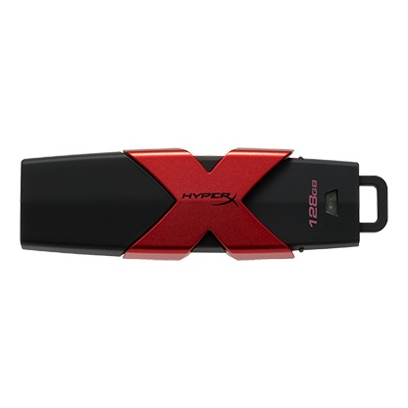

Table of Contents
Introduction to the Kingston HyperX Savage USB Flash Drive…………………………………3
About Kingston Technology and HyperX………………………………………………………..3
Functions and Components of the Kingston HyperX Savage USB Flash Drive…………...…….4
Exterior Components……………………………………………………………………………..4
Interior Components……………………………………………………………………………...5
How to use the Kingston HyperX Savage USB Flash Drive…………………………………….6
References………………………………………………………………………………………..7

Introduction to the Kingston HyperX Savage USB Flash Drive
Historical Background Information on Flash Drives
In 1981, a Japanese electrical engineer by the name of Fujio Masuoka patented EEPROM (electronically erasable programmable read only memory), also known as flash memory. This is the type of memory that all USB flash drives use. In 1994, a computer architect named Ajay Bhatt was credited for developing the stand USB (Universal Series Bus) interface. This allowed for all computers to have a standardized port and flash drives to have the same connector. The world’s first iteration of the flash drive was created and patented by Dov Moran. In 1995, Dov Moran and his company, M-Systems, introduced the DiskOnChip (predecessor of the flash drive) which can hold 2 megabytes of memory. Couple of years later, M-Systems created the DiskOnKey, which has the same physical appearance and characteristic of our modern-day flash drive (Sioni, 2011).

About Kingston Technology and HyperX
Kingston Technology was founded in 1987 by John Tu and David Sun to address the shortage of memory chips and memory modules in the computer technology industry. Kingston Technology constantly sets industry standards of consistence and reliability for their products. Kingston Technology has grown to be the world’s largest independent manufacturer for memory products (Kingston, n.d.). In 2002, Kingston Technology created a high-performance product division called HyperX. This division of the parent company focused mainly on gaming products. Over the years, HyperX has created multiple product lines of high-performance memory modules, solid-state drives, USB Flash drives, headsets, and other gaming accessories. HyperX products are the go-to choice for top gamers and tech enthusiasts. Throughout the years, HyperX continuously improves the frequencies (transfer speed) and capacities of their memory products. In 2013, HyperX launched the world’s first 1 terabyte (1000 gigabytes) USB Flash drive (HyperXGaming, n.d.)

Functions and Components of the Kingston HyperX Savage USB Flash Drive
The Kingston HyperX Savage Flash drive is a portable memory transfer and storage device for any USB compatible devices. This Flash drive uses a type of computer memory called flash memory with a USB interface. Flash memory is a memory storage medium that can be electronically erased and reprogrammed. On November 16, 2015, HyperX introduced this USB Flash drive to their Savage product line. The HyperX Savage USB Flash drive operates at a transfer speed on 350 megabytes per second read and 250 megabytes per second write. It offers a storage capacity of 64, 128, 256, and 512 gigabytes. The Flash drive has dimensions of 76.3 mm x 23.48 mm x 12.17 mm. HyperX Savage is compliant with USB 3.1 Gen. 1 and is compatible with USB 3.0 and USB 2.0 ports. The HyperX Savage USB Flash drive is compatible with multiple platforms such as desktops, laptops, and many other gaming consoles (Kingston, 2015).

Exterior Components
The outer components of the Kingston HyperX Savage USB Flash drive consist of 2 main parts: the body and the cap.
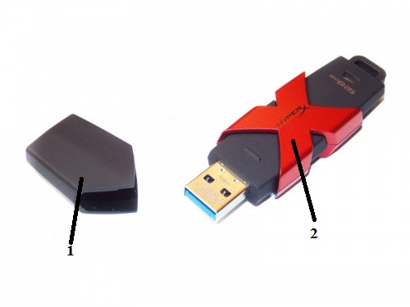
Figure 1: Exterior components for the USB Flash drive (Hellstrom, 2015)
- USB Cap: this is the cap for the USB Flash drive. It protects the USB connector from damage when it is unused.
- Body: This is the body of the USB Flash drive. It contains all the inner components of the Flash drive. Sometimes the body may have various designs.
Interior Components
There are 8 main parts that make up the interior of the USB Flash drive, parts include: USB connector, USB mass storage controller, test points, NAND flash memory chip, crystal oscillator, LED indicator light, write-protect switch, and additional space for a second memory chip.
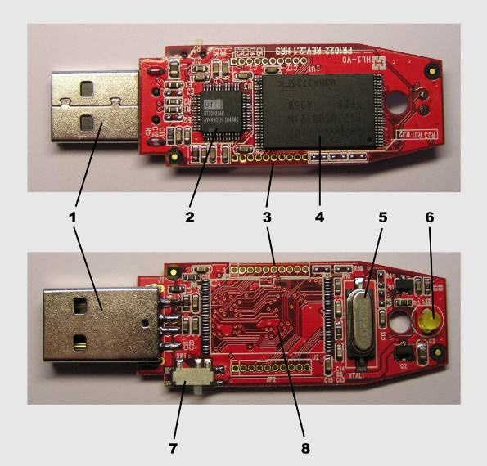
Figure 2: Interior components for the USB Flash drive (Sioni, 2017)
- USB Connector: this is the part of the USB Flash drive that forms a physical connection with a compatible device. It is where the user plugs the flash drive itself to a USB port.
- USB Mass Storage Controller: this microcontroller makes the flash drive accessible to the computer or other compatible devices. The mass storage controller facilitates the data transfer with the computer.
- Test Points: the test points are only used for engineers to test out the flash drive during manufacturing and assembling process. In other words, they are used for quality control.
- NAND Flash Memory Chip: this NAND memory chip is the backbone to every USB flash drives. It gives the power and storage space it needs to storage data.
- Crystal Oscillator: this part of the USB flash drive controls the flow of information. It uses a clock signal to control the device’s output. The signal oscillates from one end to the other, which helps coordinates the action of all the electronics inside the USB drive.
- LED Indicator Light: the indicator light lets the user know that the flash drive is working as it should.
- Write-Protect Switch: this switch is the security for the flash drive. This is a way for the flash drive to protect and preserve the integrity of the users’ data.
- Space for Additional NAND Flash Memory Chip: this is an additional slot for manufacturers to put another NAND flash memory chip to increase the storage capacity. (Sioni, 2017)

How to use the Kingston HyperX Savage USB Flash Drive
- First the user must find the nearest USB port and plug the flash drive in.
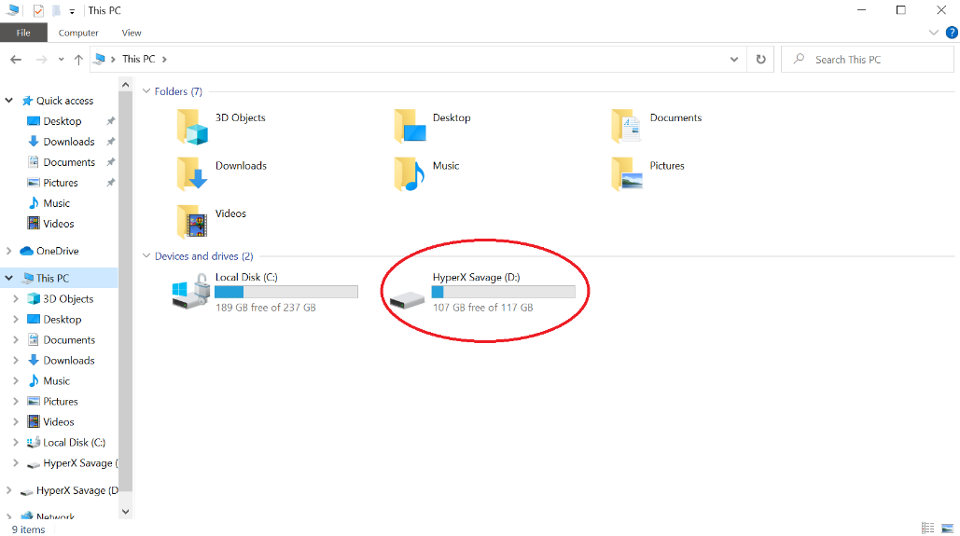
Figure 3: “This PC” Folder
- Now, on the computer, locate and open the “This PC” folder as shown in figure 3.
- Double left click on the drive to open the flash drive.
- Once the flash drive is opened, the user can drag and drop files into the flash drive to storage or transfer those files.
- In order to safely remove the flash drive from the computer, go back to “This PC” folder and right click once on the drive and locate “Eject” on the list of options. Click on it, then the user can unplug the flash drive from the computer.

Conclusion
Having an USB Flash drive comes in handy when you need to store/transfer your important files. Unlike many other flash drives, having a Kingston HyperX Savage USB Flash drive makes you so much cooler. This USB Flash drive is unique due to its brilliant design, high transfer speed, and high storage capacity. If your job requires you to work on software to design things, the Kingston HyperX Savage USB Flash drive is a must have. You can store up to possibly thousands of design files and the transfer speed is a couple of seconds. If you want to work on your projects at home, this USB flash drive is perfect to transport files from your work computer to home computer. Kingston Technology is also the world’s most reliable company when it comes to memory modules. It comes with a five-year warranty when you purchase one of many Kingston Flash drives.

References
Hellstrom, J. (2015, November 17). When you need fast portable storage, the Kingston HyperX Savage Flash Drive. Retrieved from https://pcper.com/2015/11/when-you-need-fast-portable-storage-the-kingston-hyperx-savage-flash-drive/

HyperXGaming. (n.d.). About Us – The Choice of Top-Rated Gamers: HyperX. Retrieved from https://www.hyperxgaming.com/unitedstates/us/about

HyperXGaming. (n.d.). Savage USB 3.1 Thumb Drive – 64GB-512GB: HyperX. Retrieved from https://www.hyperxgaming.com/unitedstates/us/storage/savage-3-1-usb-flash-drive?partnum=HXS3/128GB

Kingston. (n.d.). About Kingston Technology. Retrieved from https://www.kingston.com/unitedstates/en/company/about-kingston

Kingston. (2015, November 16). HyperX Adds Fast USB Drive to Savage Product Family. Retrieved from https://www.kingston.com/unitedstates/us/company/press/article/43377

Sioni, N. (2011, August 11). Who Invented the USB Flash Drive? Retrieved from https://www.premiumusb.com/blog/who-invented-the-usb-flash-drive

Sioni, N. (2017, January 12). What's Inside A USB Drive? Retrieved from https://www.premiumusb.com/blog/whats-inside-a-usb-drive

Reflection
The audience of this technical description is anyone who do their work on computers often and need something to store/transfer their work, tech enthusiasts, and gamers. Professions such as engineers, photographers, and video editors would be interested in this technical description. Having an USB flash drive that fast and high capacity to store and transfer their work would be helpful for these professions. Tech enthusiasts and gamers would also be interested in this technical description because Kingston on the world’s largest technology company that sells memory modules and HyperX is a company that sells products gears towards gamers.
The purpose of this technical description is to inform the readers about what the Kingston HyperX Savage USB flash drive has to offer and its make-up, as well as some background information on the companies that created this product. USB flash drives are on of the most common piece of technology. I wanted to show a brief history on the invention of flash drives.
My stance and attitude towards this technical description is neutral. I picked this item for the technical description because I use it regularly, therefore I know quite about the USB drive and I wanted to show the audience all the components to make up the USB drive and the functionality of it.
The genre of this writing is a technical description. A technical description is a writing that describes a certain object’s parts, functions of each part, and how to use that certain objects. My work fits the requirement of a technical description because I started out with the history of the invention of USB flash drives and the company that created the Kingston HyperX Savage USB flash drive. I presented both external and internal components of the USB flash drive and how the flash drive functions.
The media of this technical description is digital. This entire work is created on a computer and uploaded digitally for my classmates to review. All of the parts of this technical description is edited digitally and uploaded to Blackboard for final submission.
The exigence for this technical description is that I wanted to show how useful USB drives are and just how easy it is to use. I chose the Kingston HyperX Savage USB drive because this is one of the best flash drives in the market and I wanted to make the audience aware of this USB drive.
The technical description assignment meets Course Learning outcomes 2, 7, and 8. It meets outcome 2 because I enhanced the strategies through peer review. I was able to use the suggestions made by my peers to better revise my work. It meets outcome 7 because I found online sources required for most parts of this assignment, from background information to components and functionality of the USB flash drive. It meets outcome 8 because it strengthened my ability to summarize and paraphrase the sources I found online. I also cited the sources in text and in the references page.
Audience Analysis
Reader’s Name: Engineering professionals of any concentration
Reader’s Job Title: Engineer
Kind of Reader: Primary
Reader’s Level of Education: Obtained a college degree of at least a Bachelor of Engineering
Reader’s Professional Experience: Had experience working on software such as AutoCAD and Revit
Reader’s Job Responsibility: To work on AutoCAD and Revit to create designs related to their engineering concentration
Reader’s Personal Characteristics: N/A
Reader’s Cultural Background: N/A
Reader’s Attitude Towards the Writer: N/A
Reader’s Way of Reading the Document: Skimming it
Reader’s Reading Skill: Excellent
Reader’s Physical Environment: Office or home setting

