Glucometer for Diabetic Haitians
ENGL 21007
Prof. Danielle Carr
Heejin Cho

TABLE OF CONTENTS
1. Introduction
1.1. Problem Statement___________________________________________________3
1.2. Needs Statement_____________________________________________________4
1.3. Objective___________________________________________________________4
2. Technical Description_______________________________________________________4-8
2.1 Distribution Plan __________________________________________________8
2.2 Quality Assurance ___________________________________________________9
2.3 Budget____________________________________________________________
3. Audience Analysis__________________________________________________________8
4. References______________________________________________________________9

Background
Earthquakes in Haiti are triggered by a sudden and strong movement of two plate sides, the Caribbean and North American plates, sliding past one another in an east-west direction (Thompson 2010). While major earthquakes are rare in Haiti because the Caribbean plate is a minor plate, the unusually high magnitude of earthquake caused an enormous damage to Haiti. This devastating quake revealed an inability of fast and organized response of the Haitian government to the earthquake. The Haitian government aid efforts are barely visible that made the situation more difficult for its citizens who found themselves sleeping on the ground for days without medical or food support after the disaster. As the poorest nation in the western hemisphere where more than half the population lives on less than a $1 a day, there was no choice but heavily replying on international relief organizations. But many Haitians are still in need of support, not only emergency aid but long-term support, allowing them to prepare for the next disaster.

Problem Statement
One of the most important medical aids for Haitians is a portable glucometer, which would allow diabetes Haitians to monitor their glucose levels during natural disasters. While the prevalence of diabetes and pre-diabetes in Haiti is 6.8%, which is moderately high (Jean-Baptiste, 2006), the international and national medical aids for the diabetic patients are almost absent. Since diabetic patients could become severely ill if their glucose levels are not kept at the certain levels, there is a great need for an emergency glucometer kit among diabetic patients.

Need Statement
A total of 11.2 million, the diabetic population is estimated as 800,000 Haitians. An affordable and effective glucometer with a long battery life will be selected for the distribution. All hospitals in Haiti should participate in this project as hospitals are the places diabetic patients regularly visit and easy to track those patients. A group of interpreters and medical teams would be distributing the glucometer kit to those who are not able to come to the hospitals. To do our project, we need funding and permission to obtain diabetic patients’ information.
Objective
Our goal is to distribute an emergency glucometer kit to every diabetic Haitian with a description written in Creole. The diabetic patients will be more prepared for the next natural disaster because the glucometer kit will allow them to maintain their glucose levels.
Technical Description
Note the technical description below will be translated into Creole prior to the distribution.
Contour Next One is one of the most affordable and effective self-monitoring blood glucose meters. The dimensions of the meter are 97 mm (L) x 28 mm (W) x 14.9 mm (H) with a weight of 36 grams. It tests a sample of capillary whole blood referenced to plasma and serum glucose. Its sample volume is 0.6 μL with a measuring rage of 20 mg/dL-600 mg/dL of glucose in blood. The meter operating temperature ranges from 41°F to 113°F. The control testing temperature ranges from 59°F to 95°F. The meter lasts 5 years (contourone.com, 2017).
Figure 1 is provided to display what each button is used for. Any button can be used to bring up the meter screen when the screen dims after 30 seconds of inactivity. The up button and down button on the meter allow you to scroll through the options. It will scroll continuously through a list by holding up button or down button. The OK button is located between up button and down button and used to accept a selection. When the meter is off, you can turn it on by pressing and holding the OK button. You can also turn it off by pressing and holding the OK button when the meter is on.

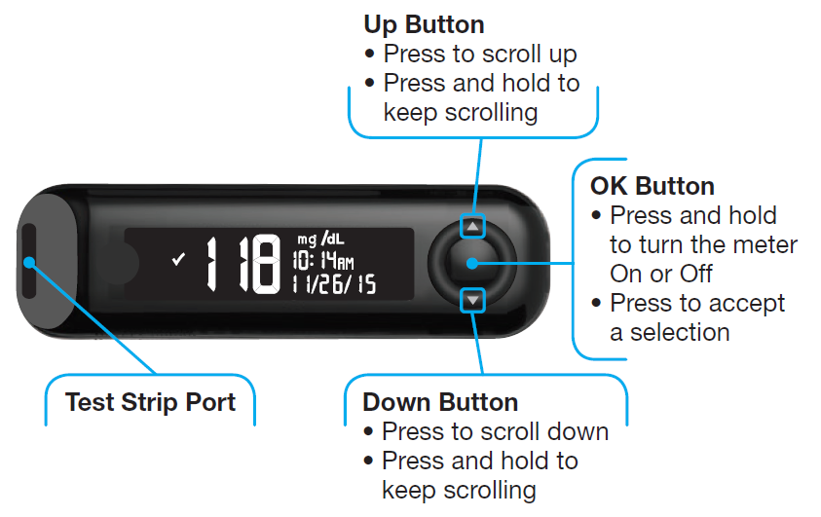
Figure 1. Outer Components of Contour Next One Meter (Contournext.com)
The test strip port is where the test strip is inserted into. If blood is not applied to the test strip within 3 minutes, the meter will turn off itself. When the test is complete, the test strip port displays a color representing your result value compared to the before meal, after meal, or overall target range. Red represents below target, green represents in target, and yellow represents above target as shown in figure 2.
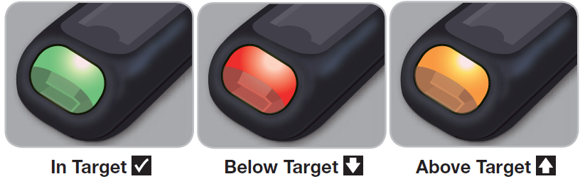
Figure 2. Target Lights of the Test Strip Port (Contournext.com)
The battery is a power source for the meter. The meter has removable batteries. The battery type is a 3-volt CR2032 coin cell, which is equivalent to DL2032 coin cell battery. It has a capacity of 225 mAh and a size of 20 mm X 3.2 mm as shown in Figure 3. The bitter coating on the cell prevents accidental ingestions (Duracell.com). The meter holds two batteries with a positive sign facing down. The battery life is approximately 1000 tests or one-year average use with 3 tests per day.
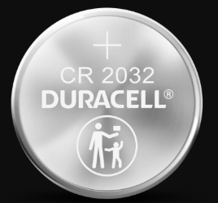
Figure 3. CR 2032 Lithium Coin Battery with Bitter Coating (Duracell.com)
For testing, you need to have Contour Next test strips and lancing device that come with Contour Next One meter. Always wash your hands with soap and dry them well before and after testing. The meter works only with Contour Next test strips because these strips have the specific arrangement of electrodes for the meter. Note that the current is produced by electrodes. Any other test strips that have different arrangements of electrodes will not work with the meter. Any lancing device can be used if used by the same person, but lancets cannot be reused. Lastly, any expired materials cannot be used. Dispose of used test strips and lancets as medical waste or as advised by your health care professional.
Before getting a blood drop from your finger, the Contour Next test strip needs to be inserted with the grey square end facing toward the meter as shown in Figure 4.
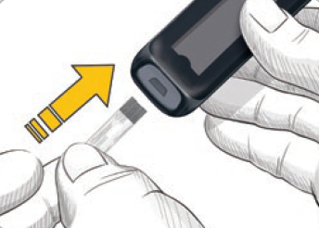
Figure 4. Grey Square on the Contour Test Strip (Contournext.com)
The meter beeps and displays the blinking blood drop at the top left corner on the screen when it is ready. After you get a drop of blood by using a lancing device or lancet, immediately touch the tip of the test strip to the drop of blood so It will be drawn into the test strip through the tip as shown in Figure 5. Once the test is complete, the meter beeps, and the test strip port displays a specific color, green for in target, red for below target, and yellow for above target. You should consult with your health care provider for you blood glucose target. If the meter beeps twice and displays the blinking blood drop, more blood needs to be applied within 60 seconds.
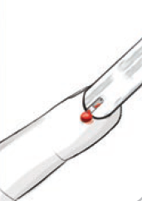
Figure 5. Blood Drawn into the Contour Test Strip (Contournext.com)

Distribution Plan
To minimize the budget, we will recruit volunteers or work in partnership with non-profit organizations for the distribution. We will ask Contour Next for a lower price or donation. We will also ask each hospital in Haiti to partner with us for the distribution and provide us with a list of diabetic patients who qualify for the emergency kit. The kit will be first distributed to those who often visit the hospitals for their diabetes. The doctors in the hospital will be responsible to provide their patients with the kits. For those who can’t come to any of these hospitals, a group of volunteers and medical teams will visit one by one to provide the kits. This will take a tremendous effort and good communication and teamwork between our staffs and local staffs.
 | Plan
01/01/21-01/31/21 | Volunteers will be recruited, and our team will be partnered with non-profit organization.  Descriptions will be translated by interpreting volunteers and printed.
02/01/21-02/28/21 | Recruited staffs will visit hospitals in Haiti and begin the distribution
03/01/21-03/31/21 | Staffs leave and hospitals keep distributing kits
04/01/21-04/08/21 | Follow up visit for the hospitals and additional kits
Quality Assurance
Our partnered hospitals will be responsible to recruit more diabetic patients from the area so they can receive the kit. While hospitals should have a enough supply of the kit, our staffs will visit regularly to make sure every diabetic patient in the hospital received the kit.
Budget
The total budget was estimated based on the number of glucometer kit necessary and a round trip flight ticket from Haiti to the United States, the accommodation fee and food, etc.
 | Price per unit ($) | Unit Necessary (Unit) | Total
Glucometer kit | 20 or lower | 800,000 | 16,000,000
Transport | 1000 | 50 | 50,000
Accommodation for staffs and volunteers | 1000 | 50 | 50,000
Food and other necessaries | 500 | 50 | 25,000
Total |  |  | $16,125,000

Audience Profile Sheet

Reader's Name:
Dr. Marie Greta Roy Clement
Reader's Job Title:
Haitian Minister of Public Health and Population
Kind of Reader: | Primary__X__ Secondary______
Reader’s Level of Education:
Highly educated, Medical Degree
Reader’s Job Responsibilities:
Health policy/plan formulation and legislation, development and implementation of strategies for public health
Reader’s Cultural Background:
Haitian culture, which is a mix of African, Taino and European
Reader’s Attitude Toward the Writer (you):
Paying attention to the solution to the diabetic population vulnerable to natural disasters
Reader’s Way of Reading the Document: | Skim it _____ Study it __X__  Read a portion of it ___ Which portion?  Modify it and submit it to another reader____
Reader’s Reading Skill:
Excellent
Reader's Physical Environment:
In her office or home office
Adapted from Markel (7th Ed.), p. 88

Reference
Jean-Baptiste, E. D., Larco, P., Charles-Larco, N., Vilgrain, C., Simon, D., & Charles, R. (2006). Glucose intolerance and other cardiovascular risk factors in Haiti. Prevalence of Diabetes and Hypertension in Haiti (PREDIAH). Diabetes & metabolism, 32(5 Pt 1), 443–451. https://doi.org/10.1016/s1262-3636(07)70302-6
CONTOUR®NEXT ONE. (n.d.). https://www.contournext.com/products/contour-next-one/
CR2032 Battery: #1 Trusted Battery Brand. (n.d.). https://www.duracell.com/en-us/product/cr-2032-lithium-coin-button-battery.
Thompson, A. (2010, January 13). Haiti Earthquake Science: What Caused the Disaster. Retrieved from https://www.livescience.com/9798-haiti-earthquake-science-caused-disaster.html

