Group 7: Mohamed A., Johnson, Sebastian, Lia
Professor Danielle Carr Morning Session (TuTh)
22 February 2021

Proper Instructions on How to Compose an Email to a Professor

- Open up your preferred internet browser and go to the emailing site you usually use.
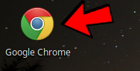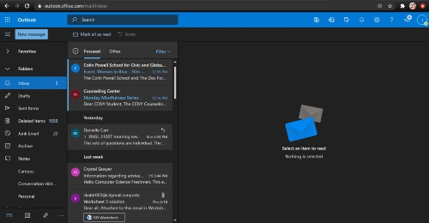

- Once you are in the emailing site you use, press compose email/new message.
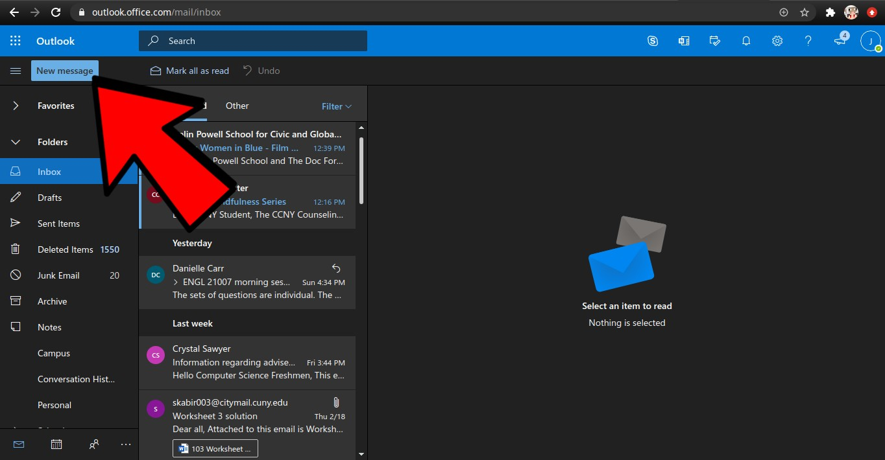
- Once you open up a new draft, you will see, “To” which is the person you’re sending the email to, “CC” which is to send the same email to other people, “Subject” which is the single line of text that the recipient will see when they receive this email, usually discussing the topic and the big empty space which is where you are going to write your intended messages.
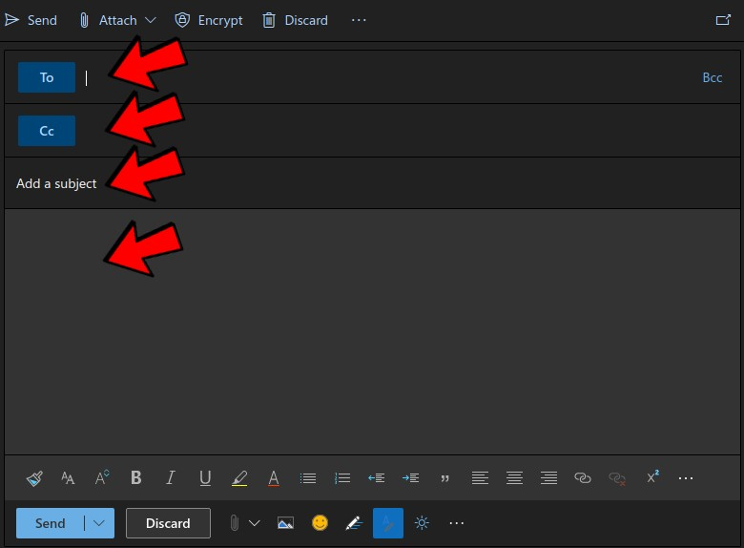

- In the “To” box, write the person’s email address.
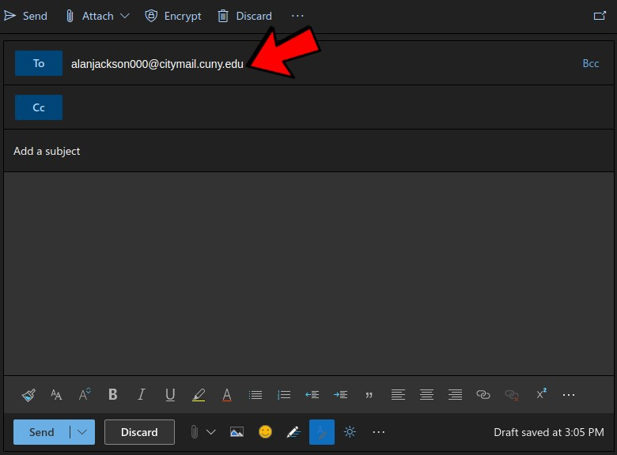
- In the “Subject” box, write the topic of your intended message. Try to keep this limited to under 9 words.
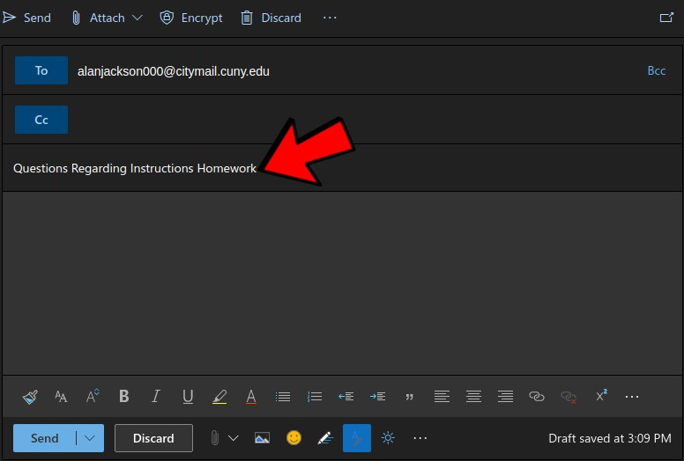

- Go down to the message box. Greet your recipient by saying hello and follow with the way they prefer to be addressed. An example of this would be to write, “Hello Professor Jackson”. After you write the greeting, you put a comma after the greeting and go to the next line to start your intended message.
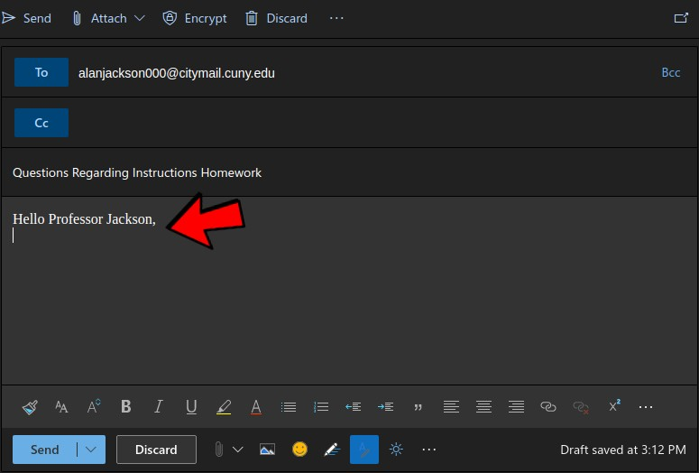
- When starting your intended message, you first want to ask the professor how their day was and how they are feeling. Many students forget to realize that professors have just as much if not more stress to deal with throughout their day. After you ask the professor how they have been, you introduce yourself. The professor has many classes with many students to keep track of, so introducing yourself will allow them to know who you are which will make this a smooth email to follow up on. You start off by giving a name, and what class you have with the professor and when. An example would be to write, “My name is Justin Brown, and I have class with you on Tuesdays and Thursdays from 8:00 AM to 9:15 AM”.
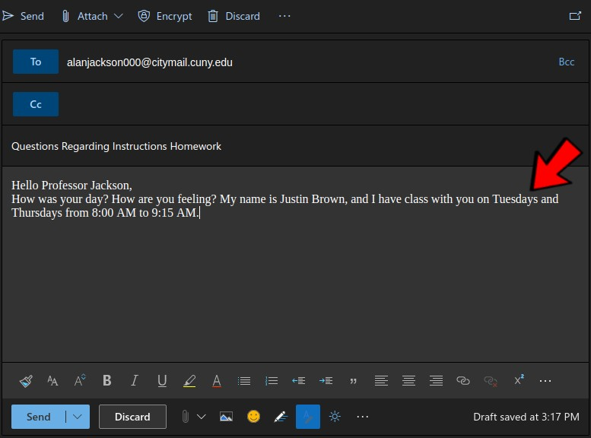

- After you have finished greeting the professor and introducing yourself, you would then nicely write about what you need from the professor which is the intended message/purpose of this email. Keep this message very professional, concise and make sure you avoid emoticons and slang. Please remember, you aren’t messaging a friend, you’re emailing your professor.
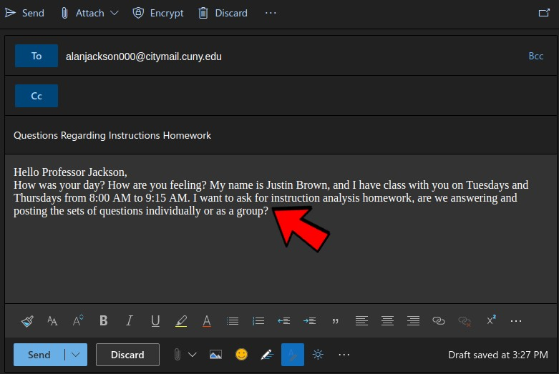

- After you finish writing about your request to your professor, you close off by showing your gratitude and sending them off in a kind manner. An example would be to write, “Thank you so much professor for taking time out of your day to read this email, I hope you have a wonderful time”. Then you close off by signing out and writing your name, which can be written like, “Sincerely, Justin Brown”.
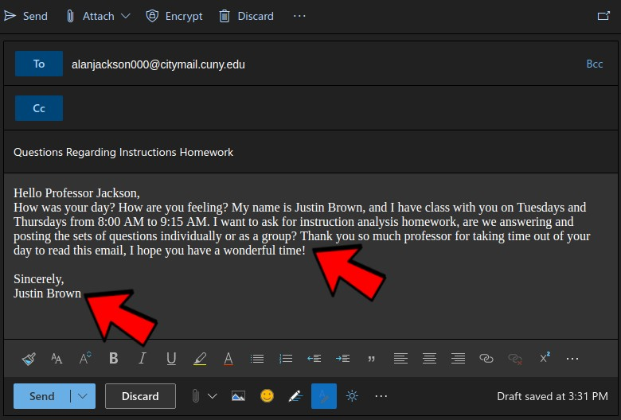

- Read your email over and make sure you don’t have any typos, everything you wrote makes sense, and you are being kind and professional when asking what you need from said professor. After this is all done, you send the email and wait. You have to realize a professor is a very busy person, so be patient and refrain from sending multiple emails for the same reason or sending emails in rapid intervals.

