ACE VENTURA
PET DETECTIVE CORP.
WILDLIFE ANIMAL RESCUE VIA TEMPORARY HABITATS AND RELOCATION
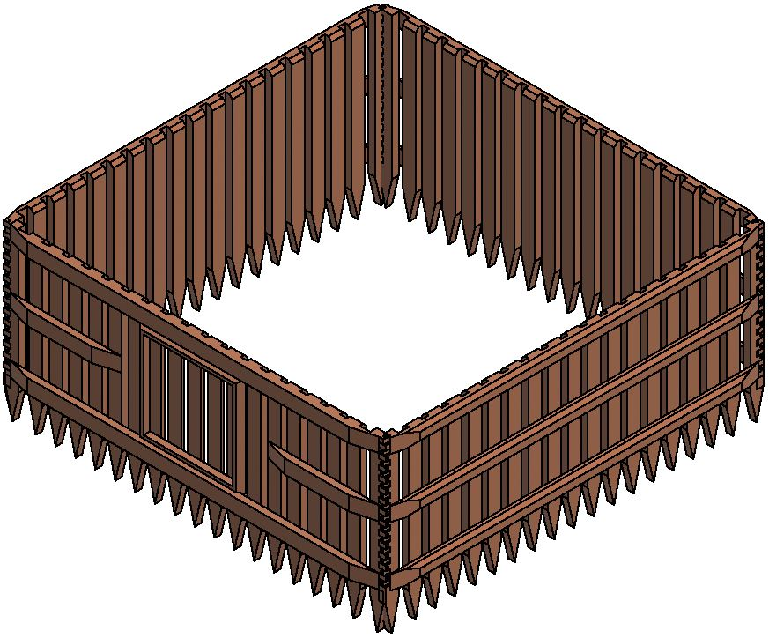
THE CITY COLLEGE OF NEW YORK
ENGL 21007 L - GROUP 2 FALL 2020
JOSE ZAMORA
MICHAEL BARTSEVICH
PATRYK STRUGACZ
EDISON MENENDEZ

Table of Content
1. Introduction 3
1.1 Problem Statement 3
1.2 Background 4
1.3 Need Statement 4
1.4 Objective 5
2. Proposed Technical Approach 5
2.1 Requirements 6
2.2 Architecture Design 7
2.3 Technical Description 8
2.4 Implementation Design 9
2.4.1 Drawing 9
2.4.2 Parts 11
2.4.3 Instructions 11
2.5 Quality Assurance Plan 11
3. Expected Project Results 12
3.1 Measure of Success 12
3.2 Costs 12
3.3 Budget distribution per year 13
4. Schedule 14
5. About us 15
5.1 Our Company 15
5.2 Our Team 15
6. References 17

1. Introduction

Healthy natural ecosystems require a balance between flora and fauna. Unfortunately our human progress has negatively impacted these ecosystems in a direct and indirect way. Such is the case of plastic pollution which has been a problem for many decades and is currently affecting all living creatures on the planet. There is no denying that our presence has forced species to evolve or to succumb. The problem is that a natural evolution requires thousands of years and wildlife animals are disappearing by the minute along with their habitats. Just in one hour 240 acres of wildlife habitat will have disappeared (Animals Matter, 2020). If this trend continues we will soon have a planet where the only living animals will be those inside zoos and farms.
We are beyond the point of neglecting this problem and expecting a natural recovery from habitats. Our carbon emissions have been so aggressive and out of control that the first mammal species has already gone extinct by climate change (Howard, 2019). This animal was a small rodent that lived in Australia and due to the rise in ocean levels was unable to adapt and survive. Like this rodent, many more animals will soon disappear if we refuse to help them survive.

One of the places in the world with the most animal abundance is Australia. The country is famous for having a huge variety of fauna and flora. However, in recent years this place has also been the main headline in the news for their unruly bushfires that have destroyed more than 46 million hectares (Center for Disaster Philanthropy, 2019). Our team's main goal is protecting wildlife animals by helping those that are affected by bushfires in Australia. Our plan is to capture koalas that are threatened by bushfires and relocate them in temporary cages that are located far away from the fire, here they will be fed and taken care of by professional staff, once these koalas are in healthy conditions they will be freed into a new area that will be safe and suitable for them to live in.

1.1 Problem Statement

With the increase of carbon footprint on our atmosphere; bushfire frequency has increased across the globe. “The Australian 2019/2020 bushfire season was one of the worst in recent times … with countless numbers of wildlife exposed” (Granwal, 2020). We have the duty to protect our biodiversity wildlife and implement safe regulations where humans and nature can coexist. We strongly believe the best way to tackle this problem is to provide temporary habitats to animals with an easy and safe way for them to be transported. This work is important because animals are part of the environment that humans inhabit, and they hold nature in balance. According to the BBC, nearly 3 billion animals were either killed or displaced in the 2020 Australian wildfires. This is statistically one of the worst wildfires in modern history. From September to February, 11.46 million hectares of land were scorched. For comparison, this is relative to the size of England. In February, the Australian government declared that 113 species of animals are in need of “urgent help” after the bushfires. This displays the reason for our decision to make an inexpensive and non-invasive structure that can serve as a temporary habitat. These 113 species of animals need new homes, food, and for some, medical attention. These temporary habitats would serve as their homes while they are transported to a new location away from the fires.

1.2 Background

Many volunteers and Australia's police, military and navy have been working together to prevent further extension of these bushfires (DoSomething, 2020). Some organizations like the Irwin Family have helped over 90,000 wildlife animals by providing medical attention and a temporary refuge in their zoo( Elassar, 2020). Celebrities like Chris Hemsworth, Elton John, etc. have also helped by donating money to combat this problem (DoSomething, 2020). Despite all these actions there are still a lot of animals that are suffering and dying. Ace Ventura Pet Detective is a newly funded organization that aims to protect Australian Wildlife animals. The best way to save and protect animals is by relocating them before the bushfires extend or begin. Thanks to our technological improvements we can monitor the surface temperatures and predict which areas may be more susceptible to a fire, if a bushfire has already begun, we can anticipate the direction it may extend to with the previous data gathered and wind direction around the area. After gathering this information, we can deploy our portable shelters which will be attached to trucks, we will then provide any medical attention necessary and relocate the animals to a proper habitat.

1.3 Need Statement

We are seeking funding in order to design, develop and mass produce these portable shelters, as well as hire skilled workers to operate them and rescue these animals. These shelters will comply with the guidelines for captive management in South Australia, the region in which we will be mostly operating. We will first transport these Koalas in our truck bed shipping containers, and then transfer them into our temporary enclosures which will be located in a safe location. Our enclosures will be transportable so that in case the bushfires spread closer, we can transport the animals away further along with the enclosures. Each enclosure will be about 20m² which follows the requirements to house 2 Koalas at a time. Currently, organizations rescue and care for animals as well but they do not have portable shelters. They have to bring all of these animals to their medical stations. Our idea shines because we are able to care for and relocate these animals anywhere since our shelters can be transported anywhere. This can reduce travel time to shelters and make sure animals get the care they need faster.

1.4 Objective

Bushfires in Australia are not rare in human history, ever since the 19th century there have been records of bushfires occurring in Australia. The oldest major bushfires is known as the Black Thursday Bushfire Victoria and occurred in February 1851 killing over 1 million animals and burning 5 million hectares (theguardian, 2013). Australia’s flora has adapted to these conditions and regrows every year once the fire season is over, in a way there was a balance between fire seasons and regrowth seasons for Australia. But 2020 has been the first year where this balance has been lost, 7 months after the fire season ended there is no regrowth in the places where the bushfires extended, wildlife animals have been unable to return to their habitats because these no longer exist and those that return are unable to find food or water and die of starvation or dehydration (Glover, 2020). These animals are in need of finding a new place to live and we pretend to help them find it.
Many species may not be endangered but if we do not act now they will soon be in this position. If we compare the amount of wildlife animals that have been rescued with the amount that have died it is clear that their population is descending drastically. Our goal is to prevent the extinction of animals affected by the Australian bushfires because many species are currently endangered, including the Koala, which we will be focusing on the most. By taking care of koalas and reintroducing them to proper habitats we will ensure their species survival and that they will be able to repopulate. If we are able to help koalas and prove this system to be worthy then it could be implemented for more animals.

2. Proposed Technical Approach

As a mechanical engineering team we have strong knowledge on the use of AutoCAD and the design of simple structures. Our first task is to recollect data of the areas mostly affected by bushfires, we will also research koalas’ habitats and areas safe from bushfires where they may be properly reintroduced to nature. We shall then design the first prototype of a portable shelter on AutoCAD that complies with all the necessary requirements to inhabit koalas. This is by far one of the steps that will take the most time as we need to make sure they are portable, sturdy and long lasting. After completion, we will present the design to a professional wildlife keeper to ensure it satisfies all needs a koala may have. Once our design has been adjusted and finished we can proceed to gathering fundings for this project as well as looking for a team of professional wildlife veterinarians and specialists who know how to properly care for koalas, we will also open volunteer recruitment to have more personnel. To test our portable shelters we will begin by helping a small number of koalas inside a small area. We will capture them and place them in our portable shelters until they have received all the appropriate attention and can be released in a safe area where they can be monitored. If our test plan succeeds we can then work on bigger areas and help more koalas.

2.1 Requirements

As engineers we are not qualified to work with wildlife animals and do not understand their needs and care, therefore we consider the following to be essential.

General Requirements

-Office space (area to monitor wildlife and bushfires)
-Material to build portable shelters (wood and screws)
-Trucks to transport the portable shelters
- Food and water for Koalas

Personnel Requirements

-Construction workers/engineers
-Truck drivers
-Animal maintenance staff
-Animal rescue staff
-Zookeepers
-Wildlife Veterinarians
-Wildlife Biologists
-General overseers/managers
-General volunteers

2.2 Architecture Design
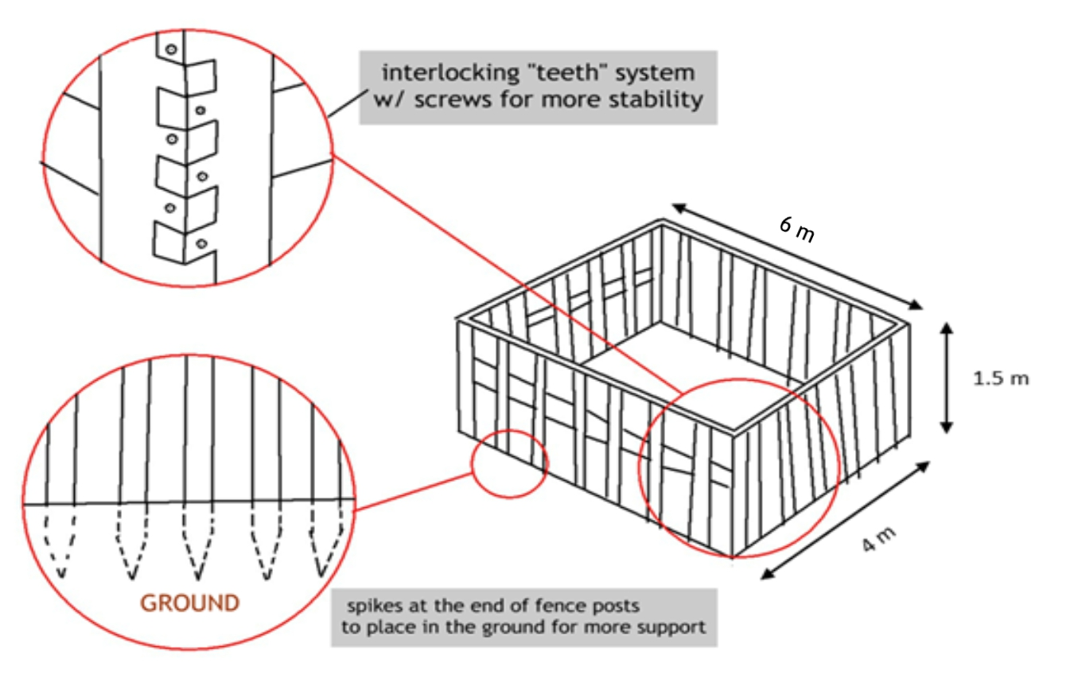
Figure 1. Portable shelter design

The koala enclosures will be 4 meters wide, 6 meters long, and 1.5 meters tall. It will consist of a sequence of fence sections that could be put into the ground, and connected to each other in an interlocking mesh, and with screws for stability. The fence posts will also have spikes on the bottom end, so that securing them properly is easier. This design is also fully enclosed so it will prevent the possibility of predators attacking the koalas.

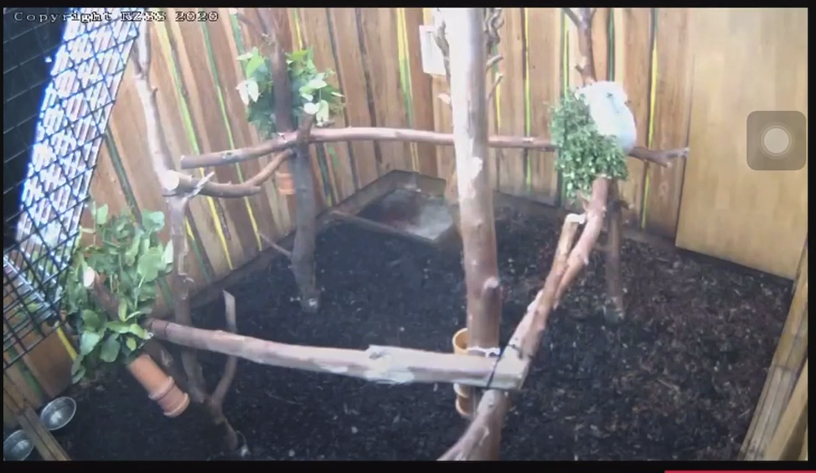
Figure 2. Koala inside portable shelter

The ground inside the enclosure will have soil and small wooden forks will be placed in the ground for the koalas to climb on. On one of the walls, there will be a wooden door, with a window, that is secured with a lock. This will allow caretakers to enter the enclosure to perform their duties (feeding, cleaning, monitoring, etc.). The good thing about these fences, is that they are easy to make and can be disassembled and stacked inside of trucks, making them very portable.
As an option, cameras can also be installed inside to supervise and monitor the well being of the koala.

2.3 Technical Description

The enclosure is primarily made of cedar wood because of its longevity, abundant and relatively inexpensive prices. Each enclosure would consist of 4 pieces. Two of the pieces will be a set of wooden fences 1.8 meters tall and 6 meters in length. The other two pieces will be nearly identical being 1.8 meters tall but the length would be 4 meters for each. However, one of the 4 meter pieces will have a wooden door built into it, in the middle of the section. The fence sets would consist of multiple pickets, 5.5 inches wide, with 2.5 inch gaps between each post. The thickness of all the posts and pickets would be 2 inches. There would also be a 4 meter long and 5.5 inch wide wooden post that would be screwed to the back of the pickets horizontally. It would lay horizontally (parallel to the ground). The last picket on each side would consist of alternating “teeth-gaps” (around 30 of them) that would be 2 inches in length, width and depth. The teeth would be fixated using 3-inch long screws.

2.4 Implementation Design

2.4.1 Drawing
Fence A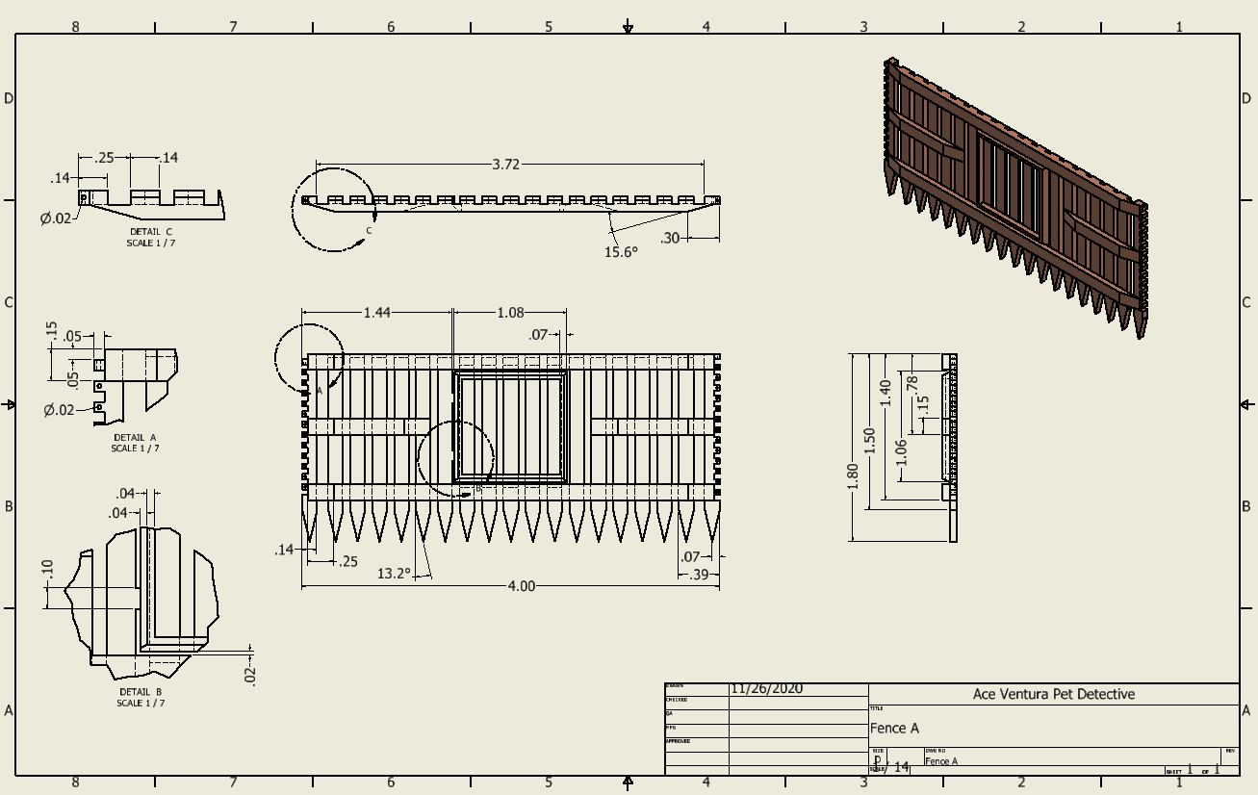
Fence B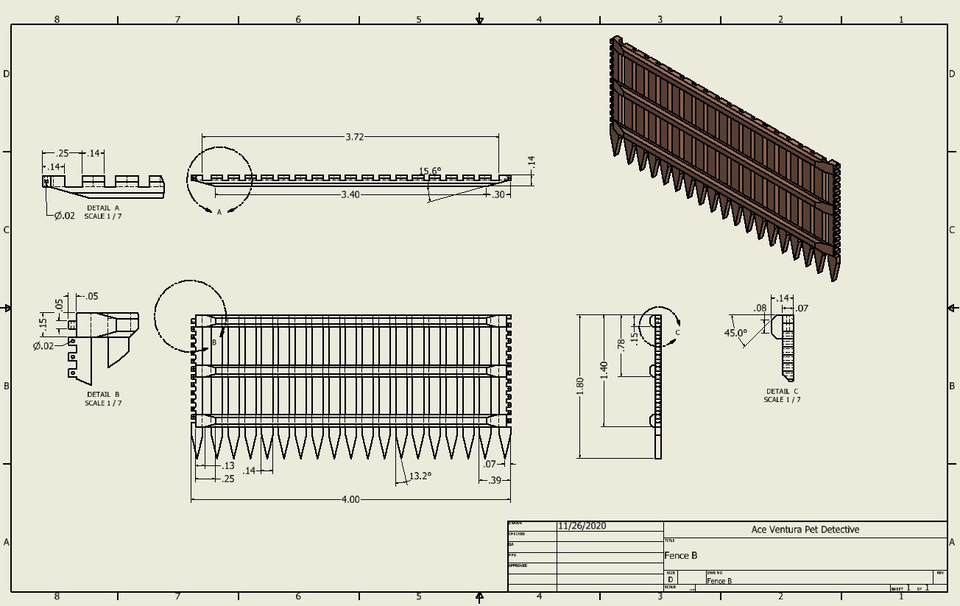

Fence C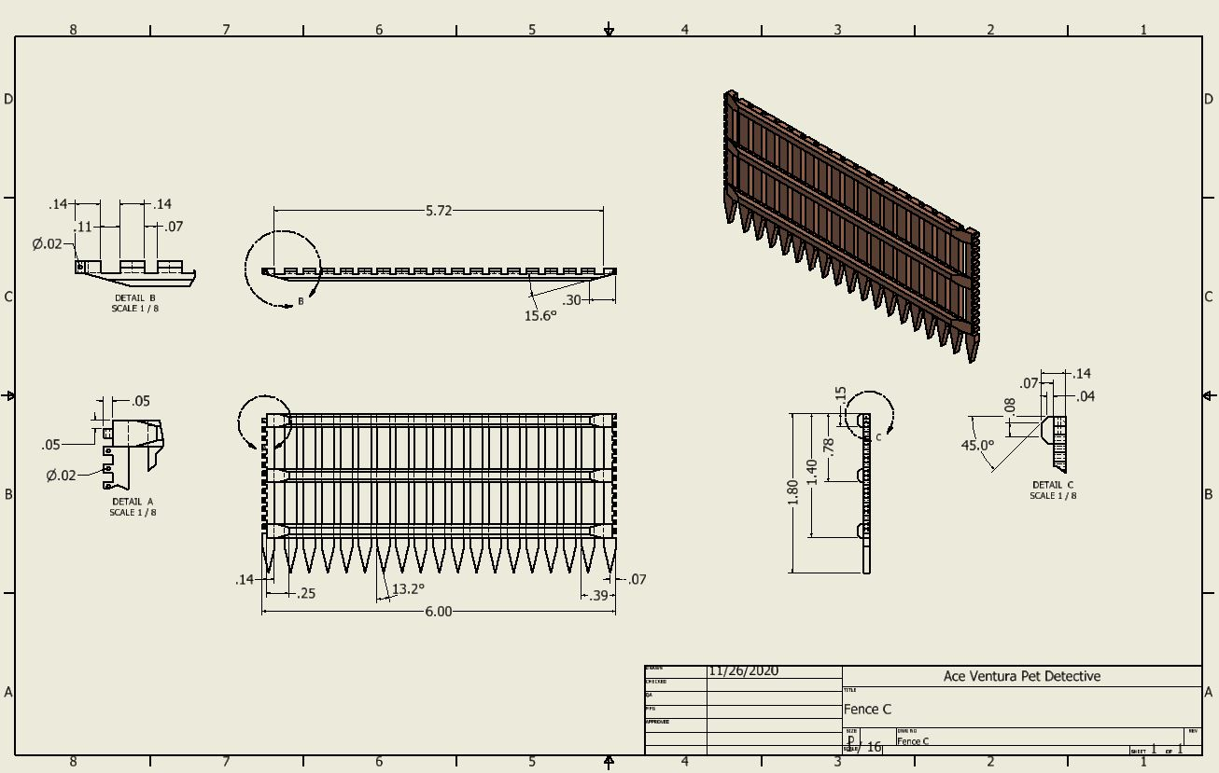

2.4.2 Parts
- Fence A
Model A is the frontal fence of the enclosure. The Fence has the following dimensions: 4 m in length, 1.8 m in height and 0.14 m width. It has three horizontal supports to provide workers with an easy grip for them to transport the fence. Fence A has a mass of 15 kg approximately. For this particular model, a door is installed in the middle of its front side at approximately chest height, this allows care workers to have access to the enclosure. Only one fence of model A is needed to assemble one enclosure.
- Fence B
Model B is the back fence of the enclosure. It has similar dimensions as model A: 4m in length, 1.8 m in height and 0.14 m width. Fence B has a mass of 14 kg approximately. No particular attachments are present for this model except the three supporters for easier transport. Only one fence of model B is needed to assemble one enclosure.
- Fence C
Model C is the side of the enclosure. The fence differs from the previous model in its length, fence dimensions: 6 m in length, 1.8 m in height and 0.14 m in width. The fence has a mass of 18 kg . Apart from the three supporters already stated on the previous models no other attachments are present for this model. Two fences of model C are needed to assemble one enclosure

2.4.3 Instructions
- Dig the perimeter of the enclosure’s area (4 m x 6 m) at 10 cm deep.
- Place fence A facing outward on its corresponding side of 4 meters.
- Place fence C, the two of them, facing outward as well, their corresponding sides are 6 meters in length.
- Lastly, place fence B on the remaining side facing outwards too. This side is 4 meters in length.
- Adjust fences so that the interlocking teeth match.
- Secure the enclosure.

2.5 Quality Assurance Plan

Some potential risks for our enclosures is that the materials may get worn out over time. Wood may rot when exposed to a lot of moisture. Thankfully this will most likely not be an issue for a long time because the region we will operate in is dry, and any rotten wood can be replaced.
Another risk is that wood catches fire easily. In order to prevent this from happening, we will make sure our shelters are never near the flames and we will spray them with fire retardant to prevent them from ever catching fire.

3. Expected Project Results

- We expect to receive help and donations from other organizations to understand and provide better help for koalas.
- We expect help from volunteers that will reduce project costs and provide a sufficient and high quality attention to all koalas.
- We expect to reduce the life lost of koalas and prevent their extinction.
- We expect to raise more awareness of our project and goals and motivate more people to help wildlife animals.

3.1 Measure of Success

The most accurate measure of success for our project would be the assessment of the number of koalas that are negatively affected as a result of the bushfires. It is important to consider that wild animals are bound to die as a result of natural predators or other natural factors. Therefore it is important to only analyze the number of koalas that have been injured, killed, or displaced out of their habitats as a result of the annual bushfires. There have been statistics of the number of animals impacted by these fires in the previous years, so it wouldn’t be difficult to compare the numbers.

3.2 Costs

Some of the costs would be:
- Construction of the enclosure fence sets (material and assembly), including the small-tree sets for the koalas to climb on
- Transportation bunkers (certain # of them)
- Maintenance of the animals (food, water, hygiene, etc)
- Trucks or vehicles for transport (either rent or buy)
- Utilities including gasoline for the vehicles and insurance
- Salaries (construction workers, engineers, truck drivers, animal rescuers, animal caretakers and experts, general managers/leaders)
- opportunity for volunteering (No additional cost)

3.3 Budget distribution per year

Project Category | Labor | Materials | Total
Human Resources | $445,000.00 | $124,000.00 | $569,000.00
Traveling Spendings | $6,000.00 | $23,000.00 | $29,000.00
Training Fees | $4,000.00 | $1,700.00 | $5,700.00
Material Resources | $13,000.00 | $68,000.00 | $81,000.00
Professional Services | $68,000.00 | $14,000.00 | $82,000.00
Capital Expenditures | $13,000.00 | $47,000.00 | $60,000.00
Contingency Reserves | $82,670.00 |  | $82,670.00
Total |  |  | $909,370.00
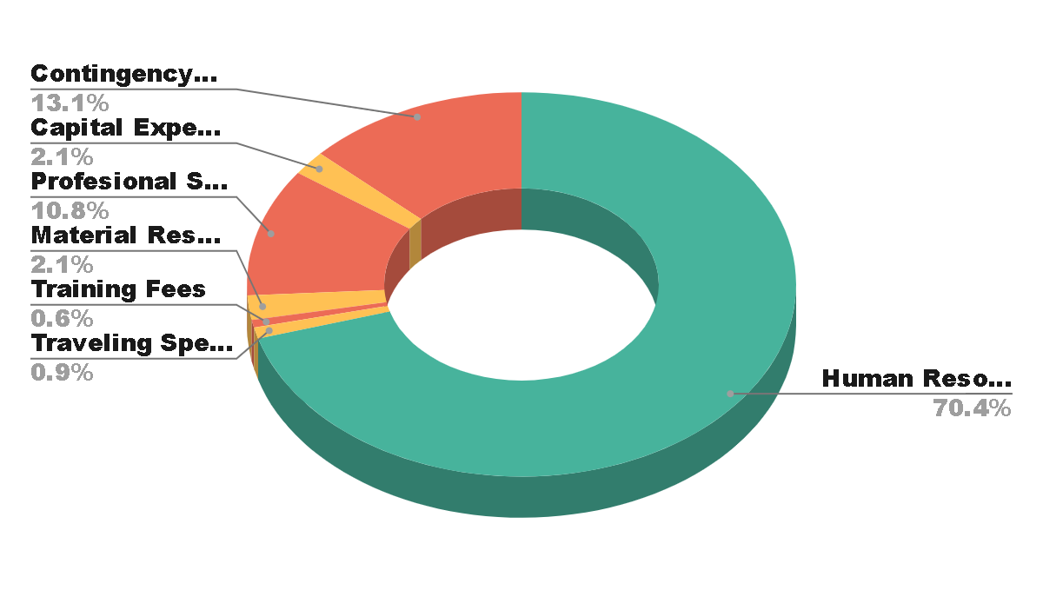

Human Resources | Salary Rates of Full-Time and Temporary Workers.
Traveling Spendings | Anyone who travels from one location to another to do project work (Including Budget for meals and lodging).
Training Fees | Conferences, workshops, outside contractors.
Material Resources | All the items we might need to perform the work, including software, equipment, or other unique materials like food and water for Koalas.
Research Expenses | Studies or data to support the project and deliver the best result.
Professional Services | Legal advice, consultants, market research firms, etc.
Capital Expenditures | Equipment or technical upgrades to complete the project.
Contingency Reserves | Contingency funds to allow flexibility and reduce risks of budget overruns.

4. Schedule

Date | Task
01/01/2021 | Meet with Andrew Metcalfe, Executive of Australia's Department of Agriculture Water, and The Environment. This meeting will be conducted via zoom due to the current pandemic.
01/15/2021 | Travel to Australia to meet with representatives of Andrew Metcalfe and further discuss our proposal.
02/01/2021 | Visit veterinarian wildlife hospitals to meet with caretakers and specialists to have a better understanding of the situation that animals are facing regarding bushfires.
02/10/2021 | Travel to areas that have been affected by bushfires to study the habitats and gather more information.
02/15/2021 | Gather all materials and necessary tools to build the portable shelters.
03/01/2021 | Deploy first portable shelter and troubleshoot.
03/15/2021 | Visit an area with high risk of bushfire and capture a small amount of koalas to redeploy in portable shelters where they will be given medical attention and proper care.
04/01/2020 - 05/14/2020 | We expect to reintroduce koalas to safe areas between these dates, however, the date may vary for each koala.
05/15/2020 | After proving to be successful we will work on more areas and accept any and all koalas who may be suffering a loss of their home.

5. About us

5.1 Our Company
Ace Ventura Pet Detective Corp. is a newborn organization from the U.S., New York. We are an organization that will always prioritize wildlife animal care above any financial or political interest. Our goal and mission will always be conducted with respect and care for all living animals. We are also an environmentally friendly company that avoids unnecessary waste and pollution. We consider our highest value to be respect, inside and outside our organization we encourage respect for all workers and volunteers.

5.2 Our Team
Jose Zamora
Has an A.S. degree from BMCC in Engineering Science. Currently pursuing a Bachelors in Mechanical Engineering at CCNY. Fluency in spanish as a second language. Jose is a person who likes to work on the field and a quick learner. His biggest attributes are honesty, respect and hard work. He is also an open minded person who likes to receive feedback and different opinions to improve his work or learn how to improve. He will work close with the caretakers because he is a person who enjoys working with animals and other people.

Patryk Strugacz
Patryk is just beginning his college education. He is pursuing a Bachelors in Mechanical Engineering at CCNY. He is fluent in Polish as a second language, allowing our team to potentially collaborate with some foreign investors or engineers. Patryk is not very experienced in the field, but he is a quick and eager learner who is ready to take on any challenge. He also has experience doing manual labor, as he has worked on construction sites. Therefore, he could help and supervise the rescue team in setting up the enclosures and storing them back once we are ready to move to a new location.

Michael Bartsevich
Michael is currently pursuing a B.S in Mechanical Engineering at CCNY. He knows how to use AutoCAD which can help with tweaking and improving construction design. He has experience with manual labor, so he can help build the first enclosures, to set things in motion. He can professionally edit videos in Premiere Pro which can help spread awareness and communicate ideas in an effective and interesting manner.He is also fluent in Russian and English, which can help to collaborate with foreign engineers and contractors.

Edison Menendez
Edison has an A.A.S degree from NYCCT in Mechanical Engineering Technology. He is pursuing a Bachelors in Mechanical Engineering at CCNY. He is fluent in Spanish as a first language. Edison enjoys designing and modeling using CAD and CAM softwares for multiple purposes. He also has experience in the manufacturing industry where he improved his skills as a designer. Therefore, he can oversee the entirety of production, which includes designing, troubleshooting and quality control testing at every stage of manufacturing.

6. References

Animals Matter. (2020). Facts - Wildlife. http://www.animalmatters.org/facts/wildlife/
Center for Disaster Philanthropy. (2019). 2019-2020 Australian Bushfires. https://disasterphilanthropy.org/disaster/2019-australian-wildfires/
DoSomethingEditors. (2020). 2020 Australian Bushfire Crisis. https://www.dosomething.org/us/articles/2020-australian-bushfire-crisis?&utm_source=twitter&utm_medium=social&utm_campaign=australian-bushfire-crisis
Elassar, A. (2020). The Irwin family is working to save the animals injured in the Australian Wildfire. CNN. https://www.cnn.com/2020/01/06/australia/irwin-family-australia-fire-full-circle-trnd/index.html
Glover, R. (2020). Seven months after the bushfires, Australia is still devastated. The Washington Post https://www.washingtonpost.com/opinions/2020/07/30/seven-months-after-bush-fires-australia-is-still-devastated/
Government of South Australia Department for Environment and Water. (2020). Guidelines for the captive management for Koalas in South Australia. https://www.environment.sa.gov.au/files/sharedassets/public/plants_and_animals/pa-gen-koalaguidelines.pdf?BestBetMatch=koalas|720cd45f-5fec-4627-9f29-24303b5b894c|1771538a-419d-4c71-bd57-9e0e00fd8c25|
Granwal , L. (2020). Bushfires in Australia – Statistics and Facts. https://www.statista.com/topics/6125/bushfires-in-australia/
Howard, B. C. (2019). First mammal species recognized as extinct due to climate change. National Geographic. https://www.nationalgeographic.com/news/2016/06/first-mammal-extinct-climate-change-bramble-cay-melomys/#close
Theguardian. (2013). History of Australian bushfires:interactive.
https://www.theguardian.com/news/datablog/interactive/2013/dec/01/history-bushfires-australia-interactive

Audience Analysis
Andrew Metcalfe

Reader’s Name: Andrew Metcalfe
Reader’s Job Title: Secretary (CEO) and Director of Biosecurity
Australian Department of Agriculture, Water and The Environment
Education:
- INSEAD : Certificate in Corporate Governance
- The University of Queensland: Bachelor of Arts, Bachelor of Laws
- Toowoomba Grammar School
Professional Experience:
- Secretary (CEO) and Director of Biosecurity, Australian Department of Agriculture,
Water and the Environment
- Board Chair, National Science Forum (National Science Summer School)
- Deputy Chair, National Science Summer School Inc
- Consultant, Andrew Metcalfe
- Secretary (CEO) Australian Department of Immmigration and Citizenship
Job Responsibilities:
- Responsible for the overseeing farming, ranching and forestry industries as well as
regulating aspects of food quality and safety
- Protect, manage and conserve Australia’s groundwater and surface water supply sources.
- Conserve, improve and protect Australia’s natural resources and environment.
- Manage the overall operations and resources of the department.
- Act as the main point of communication between the board of directors and the government of Australia
Personal Characteristics:
Mr. Metcalfe has won many achievements of leadership and administration throughout
his career. Moreover, he has an affinity towards science as he has received praise and
awards from the scientific community.
Cultural Characteristics:
Mr. Metcalfe’s cultural characteristics are primarily of Western origin, but
they are influenced by a multicultural ethos due to his profession in the government,
where he has to make decisions that might affect people with different backgrounds.
Attitude Towards the Writer:
Indifferent, as we are a made up company that is not even based on his home country.
Attitude Towards the Subject:
Concern, due to the increase of bushfires.
Expectations about the Document:
To be clean, neat, concise and straight to the point.
Reasons for Reading the Document:
To provide a thought out idea about the temporary enclosure of koalas during and
emergency.
Ways of Reading the Document:
Skim it _X_ Study It __ Read a portion of it __ Which portion?
Modify it and submit it to another reader _X_
Attempt to implement recommendations ___
Use it to perform a task or carry out a procedure _X_
Use it to create another document ___
Other ___ Explain
Reading Skills
Advance.
Reader’s Physical Environment
An office.

David Littleproud

Reader’s Name: David Littleproud
Reader’s Job Title: Minister for Agriculture, Drought and Emergency Management Education:
- Toowoomba Grammar School
- Chinchilla State High School
Professional Experience:
- Minister for Water Resources, Drought, Rural Finance, Natural Disaster and Emergency Management.
- Member of the Australian Parliament for Maranoa.
- Deputy Leader of the National Party.
Job Responsibilities:
- Represent the government at meetings and functions on special occasions.
- Delegate and conduct negotiations on behalf of the government.
Personal Characteristics:
Mr. Littleproud recognizes the importance that rural areas apport towards the economy.
He forged a career in agribusiness while living and working in towns and rural areas.
Cultural Characteristics:
Mr. Littleprouds cultural characteristics are primarily of Western origin, but
they are influenced by a multicultural ethos due to his profession in the government,
where he has to represent the government and the people who lives under his
jurisdiction.
Attitude Towards the Writer:
Indifferent, as we are a made up company that is not even based on his home country.
Attitude Towards the Subject:
Concern, due to the increase of bushfires.
Expectations about the Document:
To be clean, neat, concise and straight to the point.
Reasons for Reading the Document:
To provide a thought out idea about the temporary enclosure of koalas during and
emergency.
Ways of Reading the Document:
Skim it _X_ Study It __ Read a portion of it __ Which portion?
Modify it and submit it to another reader _X_
Attempt to implement recommendations ___
Use it to perform a task or carry out a procedure _X_
Use it to create another document ___
Other ___ Explain
Reading Skills
Advance.
Reader’s Physical Environment
An office.

David Basham

Reader’s Name: David Basham
Reader’s Job Title: Minister for Primary Industries and Regional Development
Education: Diploma of Agriculture; Australian Rural Leadership Program, St Peters College
Professional Experience: Daily Farmer of 30 years, President of SADA, President of ADF
Job Responsibilities: Parliament member; legislative procedure of Southern Australia
Personal Characteristics: He has a wife and three daughters. Member of the Liberal Party.
Cultural Characteristics: White male Australian; grew up farming
Attitude Toward the Writer: Unknown; mostly open
Attitude Toward the Subject: Positive; passionate about agriculture and forests
Expectations About the Subject: No expectations; might see it as “another environmental program”
Expectations About the Document: N/A
Reasons for Reading the Document: A possible legislative idea that can benefit the environment
Ways of Reading the Document:
Skim it ___ Study It ___ Read a portion of it ___ Which portion?
Modify it and submit it to another reader _X__
Attempt to implement recommendations ___
Use it to perform a task or carry out a procedure ___
Use it to create another document ___
Other ___ Explain
Reading Skills: Excellent
Reader’s Physical Environment: Most likely a nice family home.

Reflection

Edison Menendez
For this final project we decided to help give refuge to animals in Australia that have been affected by bushfires. We decided that the best approach for it will be to design a sustainable enclosure for them to reside on until the disaster has passed. This idea for the proposal complimented us perfectly as my group was based and revolved around mechanical engineering students. We quickly began to come up with posibles ideas about the design for the enclosure. At first, our intended design was to be large because our main intention was to save as many animals as we could, but we decided this idea, although compassionate, will not work due to our limitations in transportation and area of operation. Moreover, we decided to target only koalas as they are the most affected by it. Our next design was to come up with an enclosure that will satisfy those two criterias, the idea we came up with was to use containers (cargo ship containers) but designed to accommodate them. This also failed because they are heavy and occupy a lot more space than we wanted too. At last, we decided to go with fences because of their lightweightness compared to a container while still providing koalas with a comfortable place for them to reside on. Every member of my team apported for the development of this proposal. My role primarily focused on the design of the enclosure as well as part of the finances of the project.
The genre of this assignment is an engineering proposal. An engineering proposal is a persuasive document that describes a project that you will conduct in detail. Our proposal meets all of the requirements because we first state the problem providing accurate research about bushfires, we then introduce our design to the audience by giving a detailed technical description of our design as well as a budget where all our finances will end up.
The audience is the receiver of the proposal, in other words, who is the person that is going to receive this proposal. For this proposal our audience consists of government positions in Australia like the CEO of the Department of Environment Andrew Metcalfe. We choose him as our primary audience because he is responsible for the department that bushfire affects the most.
The exigence is the issue or situation that leads to this proposal. Our exigence is the damage bushfire causes to koalas because they are animals that suffered the most during this disaster that are becoming more common and deadlier.
The media is the form that we deliver this proposal to the audience. For this particular assignment we choose digital to be our media because of the relative easy as well as the distance between the audience and us ( Australia and USA).
The stance is our position of argument on the message. Our stance is of a company (Ace Ventura Pet Detective) explaining the impact bushfires have on koalas in Australia as well as to describe how our company can develop a possible solution to help them.
The purpose allows the reader to understand a concept, adopt a particular belief, or carry out a task. Our purpose is to persuade our audience to accept our proposal as a valid solution for koalas rescue missions during bushfires.

Jose Zamora

This proposal relied on a lot of background research; I consider my team to be very good at researching, each one of us contributed towards the background research including myself. It is hard to point out which specific information belongs to each one of us because I believe that we all contributed equally. We did not have a group leader because it seemed unnecessary as each one of us worked hard and equally. Working in a group is always hard because the majority of the time there will always be a member that does not work as hard as the rest or that does not communicate, unfortunately this was also the case for our group as we lost 1 member right at the middle of the semester. As bad as this looked, I think it made the team work harder and closer. We constantly maintained communication through Discord and never had the need to call someone out for not doing his part or slacking. We all set dates to finish our parts and despite working at different schedules each one of us finished at the schedule accordingly. Coming up with a subject for the proposal was a matter of brainstorming, it was done during one of the meetings in class so everyone had a voice in the subject and we were all pleased and happy to work on this. During our first draft we all contributed certain parts, if a section was unfinished one of the team members would finish it without having to feel obligated to do so. I believe that our group is hard working and we all really want to get an A for this class. Many students feel satisfied with passing their classes but fortunately this was not the case for our group. Personally I always aim for a good grade and I was happy to see that my team shares the same goals. During the proposal my specific task was to work on the introduction and give it a proper structure. I used a lot of the information we had previously gathered from the draft and investigated more to have a real understanding of the problem and the direction our proposal was intended to have. I also worked on the section of Schedule and by doing minor adjustments and restructuring to the proposal overall.
The purpose of our proposal is to save wildlife animals and prevent their extinction. We humans have been responsible for the extinction of many species and we have not changed our course of actions or prevented this problem. We want to save animals from having a painful death and to preserve their species.
The audience for our proposal is the main representatives of the environment of Australia. Despite facing the problem of bushfires they have been unable to stop this problem or to prevent the death of billions of animals. Considering that Australia is a country that has attracted a lot of tourism thanks to their gorgeous environments and fauna diversity, I believe that they should work harder to prevent these catastrophes. If this problem keeps growing, it will affect the capital income overtime and stop being such an attractive tourist site.
The stance that our proposal has is that wildlife deaths should be more important to all societies in general. More money should be focussed on helping and saving animals from bushfires, this is a very painful death and it will only increase through time. We are strongly committed to help and save species from extinction.
The genre for this assignment was a proposal, we created a proposal for the representatives of Australia where we explained in detail how our project is planned to work and how expensive it would be, this proposal also gives specifications of our structures to be built.
The medium for this proposal is to be done through email. Given the current pandemic we are facing it is impossible to deliver documents by hand, mail would be very hard to deliver because many government and organization offices have been closed and people are working remotely.
The exigence we have is to the government of Australia, in my opinion saving wildlife animals and preventing their extinction should be a matter to be taken more seriously, especially in a place such as Australia. Unfortunately, people and governments ignore the damage caused to the environment.

Michael Bartsevich
This assignment felt like a culmination of the work that we did during this semester. It combined many types of documents such as memo, job posting, technical description and proposal into a task that me and my group had to tackle. Even though we had group work before, this was on a much larger scale. It proved to be more difficult at first because major group projects like these are done in person, and I was used to collaborating in the same space. I was fortunate to have group members that were hardworking and committed to getting this proposal done.
The main audience of this proposal, as described in our audience analysis sheets, are the Secretary and Director of Biosecurity of the Australian Department of Agriculture, the Minister of Agriculture, and the Minister of Primary Industries and Regional Development. All of these people hold high positions and have great power and influence in deciding and causing major change in Australia. It is important to be persuasive and professional when addressing these people since they probably receive many similar potential endeavors. They are very busy people, and their time is limited, so being an effective writer and presenter is of the utmost importance.
The purpose of the proposal is to receive approval and funding for our program. We want to set up an operation to protect koalas from Australian bushfires, and we need to convince people of the importance of such a project being executed. It is also important to be able to answer follow up questions and be familiar with your own content enough, so that you appear confident, knowledgeable, and trustworthy.
The thing that caused us to write up this proposal, or the exigence, is seeing the atrocious damage that human-initiated fires have caused animals that aren’t able to save themselves. As we were composing this proposal, it was important to keep this in mind. Oftentimes, people create programs to help other people from natural disasters, but it is very rare for someone to consider the defenseless beings that compose a huge part of the earth’s ecosystem.
The media is entirely digital since every part of the assignment was submitted via the internet. The blackboard post was made at the beginning of the assignment and helped us to round-out our topic and gave us an understanding of what we needed to do. The final proposal will be submitted online via email and blackboard, since we can’t hand it to Professor Carr in person.
The genre of this document is that of a conventional proposal. It contained all the proper components, like a need statement, objective, introduction, and a described solution. In addition to all of this, the final project included a finished memo and technical proposal. The former met all of its requirements, while the latter was a more basic and simple form of a technical description.
The stance in this document is that we need to preserve our environment, and that means saving our animals. It is worth spending $600,000 dollars, with a full team of people working to provide safety and security for koalas that have been greatly impacted by the ignorance and selfishness of human beings.

Patryk Strugacz
My role in this project was to work with the group on the proposals outline and work on the PowerPoint presentation. However, I’d say that most of the work was done as a group. We rarely assigned specific sections to specific people, we all just set up a time and date for everyone to work together on the document and this worked very efficiently. Everyone worked on what they were most comfortable with working on so everyone was able to work to their strengths, which I personally think was the most efficient way of doing it. For example, there were some specific tasks that required specific skills, so when it came down to drawing our portable koala enclosure, Edison worked on this since he is skilled in AUTOCAD. I took part in doing some of the research since I was very interested in the topic of wildfires because I am passionate about the environment and animals. Through working as a group, I learned that teamwork and collaboration can be very effective, especially for engineers. A team of engineers may have members with different strengths such as writing, design, planning, presentation, etc. By collaborating, a team can overcome many issues that you would otherwise not be able to easily overcome on your own due to a limited skillset.
The genre of this assignment is an engineering proposal. Proposals are used to persuade the reader to fund a specific project or idea. This project follows the format of a proposal because it contained all the necessary components of a proposal such as the needs statement, design, memo, technical description, schedule and budget.

The audience of this proposal is Andrew Metcalfe, Secretary (CEO) and Director of Biosecurity, David Basham, Minister for Primary Industries and Regional Development, and David Littleproud, Minister for Agriculture, Drought and Emergency Management. These are all people who have the ability to determine major change in biosecurity, agriculture, and regional development, all things that involve the wildfires and saving the koalas. Therefore, it makes sense to write to them and ask for funding for such a project.

The purpose of this proposal is to successfully acquire funding that matches the budget we proposed to fund our project. We need at least $909,370.00 in order to carry out our mission to save koalas from their current status as an endangered species. In order to do so, we needed our project to be well executed, with thorough research, a well thought out plan, and a great design so that it is clear that we have done our homework. These people need to be sure that we will not waste their time or money, and can trust us to successfully carry out this project.

The exigence behind this proposal is the heartbreak my group members and I have felt looking at the devastating effect of the bushfires, and seeing the horrifying statistics about animal deaths and species loss. Our planet is already suffering greatly at the hands of global warming, so it is important that we help play a part in preventing the loss of species, which is important for a healthy ecosystem and rich biodiversity.

The media of this engineering proposal is digital. Every aspect of this proposal has been done through and internet, and since we are not currently in Australia, the easiest way to send this document to our audience would be through email. Sending a paper copy would take very long and would be inefficient. In addition, during the pandemic it is a better idea to send digital copies rather than paper copies.

The stance of this document is that it is worth spending just under $1 million in order to help save koalas from possible extinction and keep the biodiversity of our planet's ecosystem rich. These are defenseless creatures that are being impacted by the selfishness and neglect of humans, so we have a duty as members of the ecosystem to fix the damage that we created. Humans spend money on projects that make them wealthier or benefit themselves, but it is rare for people to fund projects that benefit the helpless animals who are struggling because of us.

This assignment meets the first learning outcome of acknowledging other people's range of linguistic differences as resources. This is clearly evident in the process of our work because each of our members worked on parts of the project that best filled their skill sets. We also met the outcome of developing and engaging in collaborative and soa

