The Atlantis Cloud Storage Project
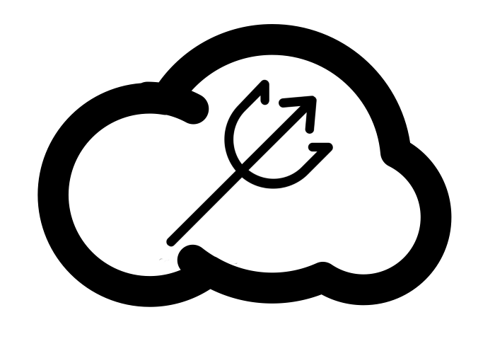

Atlantis Prevention Inc.
(Borelle Fabrice, Omar Johnson, Citlaly Norales, Seth Pine, Kendrick Roy)
ENGL 21007: Writing for Engineering
Danielle Carr
December 1, 2020

Table of Contents
Introduction 3-5
Problem 3
Background 3-4
Needs Statement 4
Objective 4-5
Architecture Design 6-7
Data Center 6
Software 7
Implementation Design 8-11
Phase 1 - Infrastructure 8
Phase 2 - Software Development 8
Phase 3 - Education 10
Quality Assurance Plan 10
Phase 1 Objectives: 10-11
Phase 2 Objectives: 11
Phase 3 Objectives: 11
Expected Project Results 11
Measure of Success 12
Budget 12-15
Schedule 15
Appendix 16-17
Team Credentials 17-23
References 24

Introduction

Problem
In 2017, the U.S. Virgin Islands were struck by hurricanes Irma and Maria. These two hurricanes hit the islands within two weeks: Hurricane Irma hit the Virgin Islands on September 6 and Hurricane Maria on September 20. These disasters left St. Croix in ruin. A long-term result of this environmental tragedy is that many people lose their documents such as photos, birth certificates, house deeds, insurance claims, and many other things due to water damage and wind displacement. This makes it harder for people to receive insurance on their damaged property, provide proof of ownership, and even find loved ones

Background
The Virgin Islands currently have a warning system called Alert VI. Residents of the Virgin Islands can sign up for this alert system and connect it to up to 5 phone numbers as well as their email and fax. This warning system also has an application. However, this system isn’t automatically offered to all citizens of the Virgin Islands because people have to sign up for it, and there is a chance that not everyone will get it This puts people at risk, especially the elderly and families that live in areas that are prone to the most damage after a hurricane.
There are currently two weather stations on St. Croix that are used to track natural disasters such as hurricanes. There is also the Virgin Islands Territorial Emergency Management Authority (VITEMA) which is in charge of emergencies. On their website, they give tips and guidelines on how to prepare for a natural disaster or emergency.
They advise that people store their personal documents on their email accounts or on a flash drive, which is not guaranteed to be completely safe for the residents of St. Croix.
The Atlantis Cloud Storage Project will allow for the majority of the residents of St. Croix to have a notification system that will alert them if there is a hurricane or other disaster coming. In addition, the project will also provide a cloud service where the residents can upload and save their documents safely and securely.

Needs Statement
To have such a successful outcome with The Atlantis Cloud Storage Project, we require a financial partner to help cover the expenses of this vast plan. After covering the finances listed in our cost section, we hope to become not only an organization but a partner of the government. At Atlantis Prevention Inc., we will require some extra minds in order to get our data center up and running within our projected schedule. With the help of some of your brightest employees, we will be able to see our plan executed with as much of an open mind as we can have, viewing the design, software, and even placement of our equipment from all angles.

Objective
With financial support and team contribution, we will be able to transform our plot of land into something extraordinary. The data center that we will construct will allow the people of St. Croix to upload their physical files digitally to our cloud services. This way, when evacuating due to a hurricane or other natural disaster, no one has to worry about carrying out their house deeds, birth certificates, family pictures, or other important documents or files. They only have to worry about their friends, family, and neighbors. By sending out notifications reminding the people of St. Croix to back up their files, if they did not already, Atlantis Prevention Inc. hopes to strengthen the bonds and provide a feeling of togetherness when faced with a disaster. After all, we are stronger when we are united.

Architecture Design
This project requires the construction of a data center to house servers to store the islanders’ data, as well as the creation of new software that will interact with the Alert VI system.

Data Center 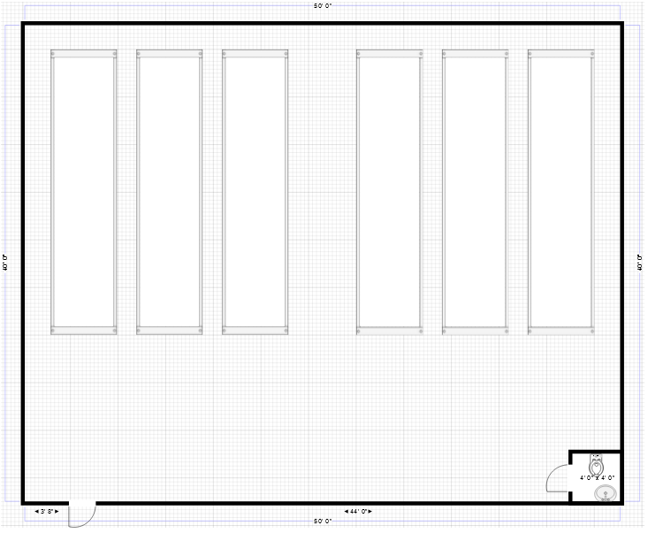
Figure 1. Blueprints for the data center including the server rack orientation
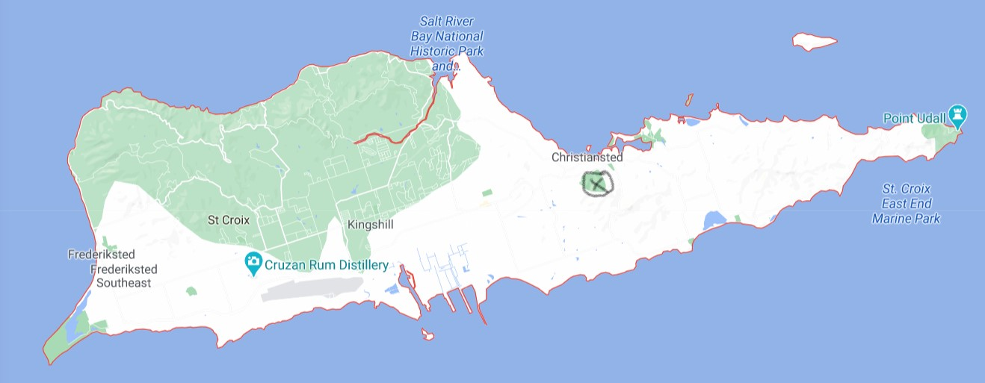
Figure 2. Proposed location for the data center

Software
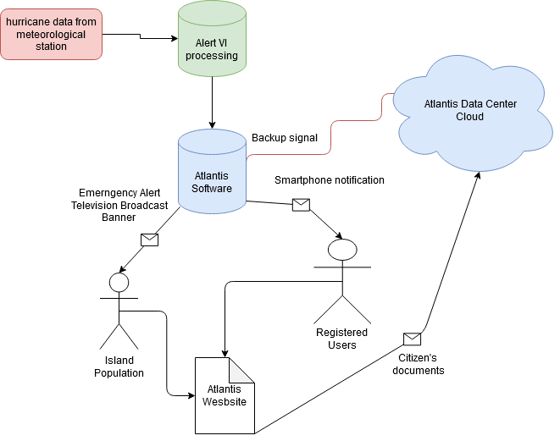
Figure 3. Flowchart illustrating how Atlantis software will accept data from Alert VI and send backup notifications to registered users, and a prompt to local broadcasting, as well as back up all stored data at the data center

Implementation Design

Phase 1 - Infrastructure
During phase 1, a data center will be built on the island of St. Croix on land above the floodplain provided by the government. The structure will be assembled by a subcontractor according to hurricane-resistant standards and will be outfitted with a biodiesel generator and methane bioreactor to provide power in the event of an outage. (see Tables one and two for estimate). The building will be 200 ft² with a single bathroom, and house 6 server racks with a total storage capacity of 46.8 Pb. After initial construction, the local government of the U.S. Virgin Islands will be responsible for the data center

Phase 2 - Software Development
Phase 2 will be devoted to writing software that will make use of the existing Alert VI system to prompt registered users and government departments to back up their data as early as possible. It will also automatically ensure the servers within the data center are fully updated. During this phase, a web platform will also be created that will allow citizens to sign up for cloud backup for their documents, and access documents they have already saved. This website will be hosted on a .gov domain making it more reliable and trustworthy, and the project will only be responsible for its initial creation and not hosting or maintenance.

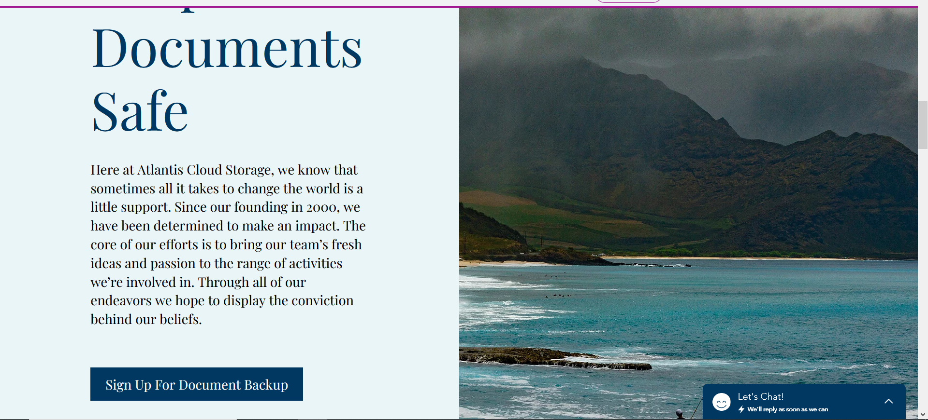
Figure 1. Mockup screenshot # 1, view of the website home page
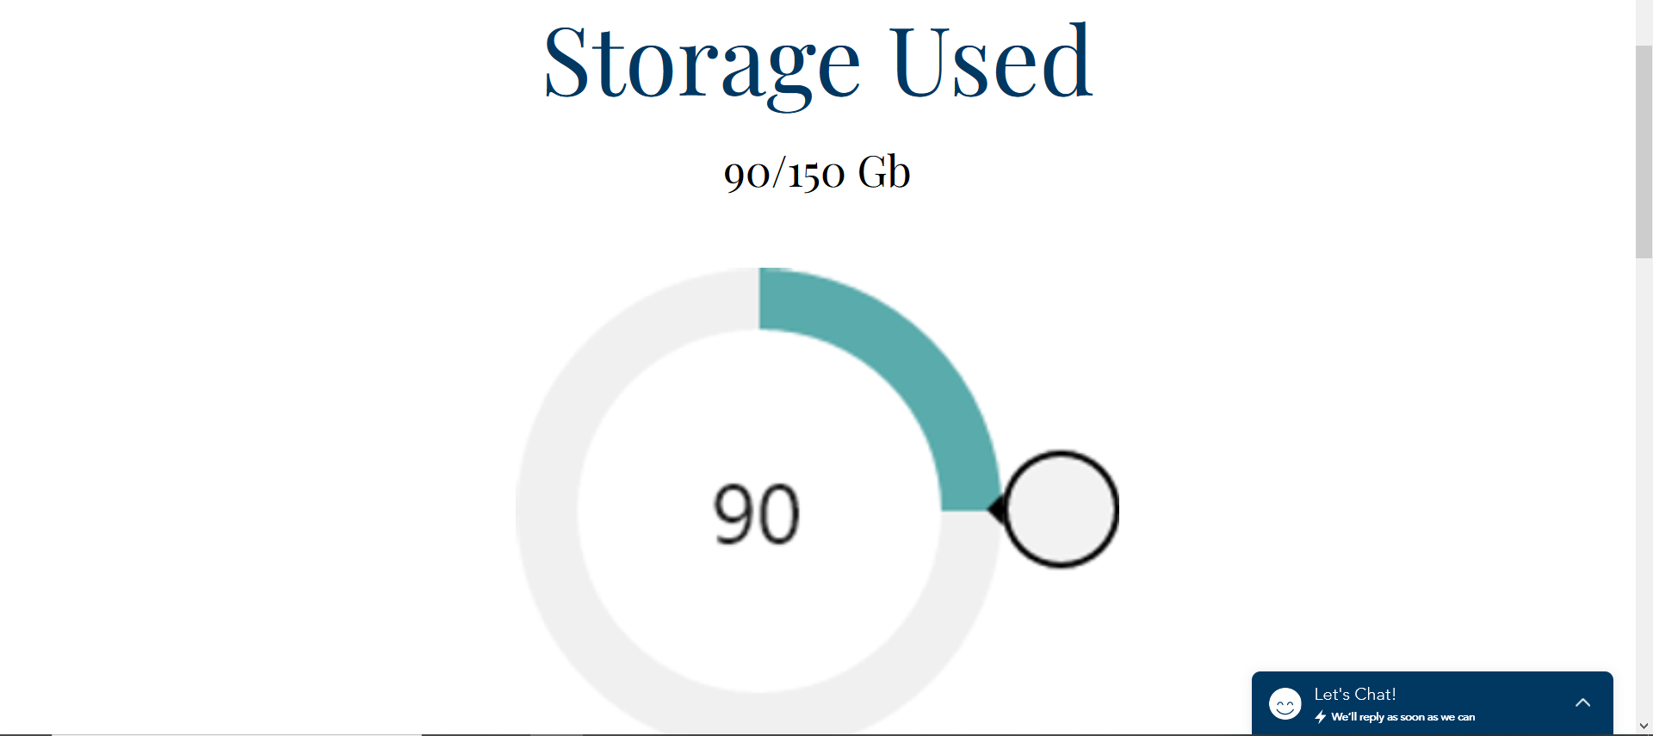
Figure 2. Mockup screenshot #2, view of a registered user’s document storage page
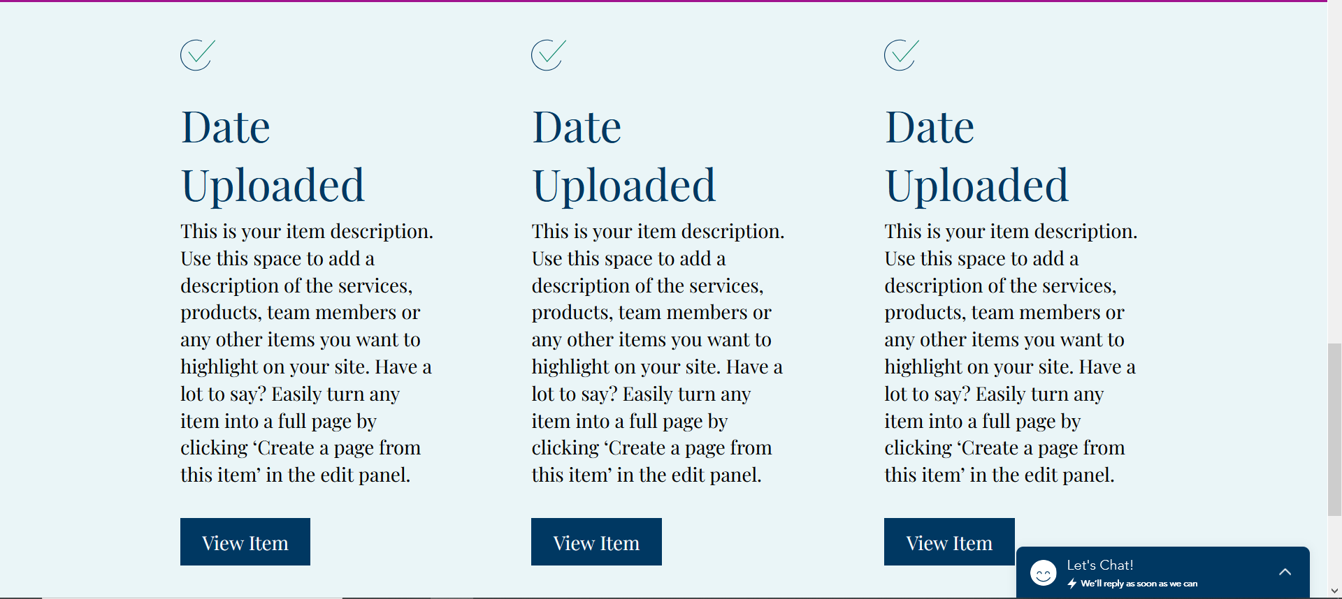
Figure 3. Mockup screenshot #3, view of a registered user’s documents stored on the cloud

Phase 3 - Education
Phase 3 will be devoted to liaising with the local government to coordinate with their IT departments and database managers to inform them of the capabilities and specifications of the new data center and familiarize them with the new software. We will also work with the government to formulate the most effective advertising campaign to ensure that our primary audience for this project, the residents, get the most benefit from our servers.

Quality Assurance Plan
At each phase of the project, an expert in the field will be on-site to evaluate project deliverables for safety and quality. Each phase will require comprehensive progress reports at regular intervals.

Phase 1 Objectives:
- The data center will be constructed according to code, plumbed, and wired.
- The bio-reactor will be assembled and tested for fuel production by environmental engineers.
- The server stacks will be assembled, wired, and tested.

Phase 2 Objectives:
- The software will acquire data from the Alert VI system.
- The software will send a warning to users when the earliest sign of a hurricane is detected.
- The website will allow users to register, login, and upload and view documents and photos.

Phase 3 Objectives:
- Government IT professionals will be briefed on the specifications and capabilities of the data center.
- Government outreach to citizens will be coordinated and a timeline of specific outreach methods agreed upon.

Expected Project Results
The project will only be considered finished when all of the objectives for all three phases and all safety checks are met satisfactorily.
At the end of this project, there will be a new data center constructed on St. Croix to these specifications, a new .gov website for the citizens to interact with, a new piece of software that will send backup prompt notifications, and the government will have full control and in-depth knowledge of this new system.

Measure of Success
A successful outcome for this project would require the data center to be completed on time and within budget, the government to have full working knowledge of the facilities and software, and at least 75% of the population to be registered for the document backup service by the next hurricane season.

Budget
Table 1. Simplified budget broken down by major project components, labor and materials
The indirect costs for this project are estimated at 9% of this budget or $90,522.792.
Project Component | Labor | Materials | Total
Bioreactor | $10,000.00 | $400,000.00 | $410,000.00
Servers | $1,170.00 | $515,849.82 | $517,019.82
Data Center | $17,890.00 | $37,399.00 | $55,289.00
Website | $3,000.00 | N/A | $3,000.00
Software Development | $11,000.00 | N/A | $11,000.00
Information Seminar | $9,000.00 | $500.00 | $9,500.00
 |  | Project Total: | $1,005,808.82
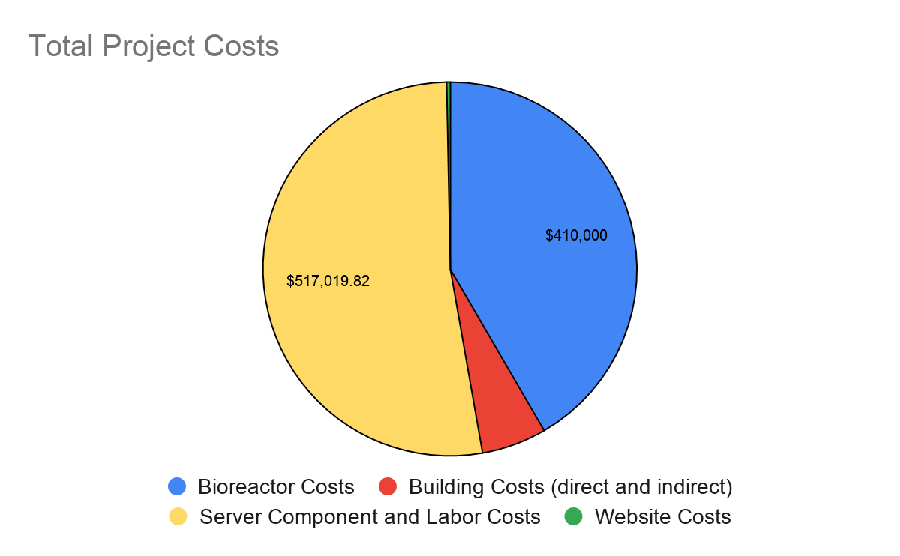
Figure 4. Project costs broken down by major expenses
Table 2. Contractor’s estimate for the data center building
Contractor Estimate
Direct
Description | Material | Labor | Total
Site Work | $983.00 | $336.00 | $1,319.00
Sewer, Water Gas | $2,175.00 | $570.00 | $2,745.00
Septic System | $0.00 | $0.00 | $0.00
Propane Tanks | $0.00 | $0.00 | $0.00
Building Concrete | $2,858.00 | $1,655.00 | $4,513.00
Outside Concrete | $1,226.00 | $2,089.00 | $3,315.00
Rough Carpentry | $4,001.00 | $2,136.00 | $6,137.00
Finish Carpentry | $495.00 | $418.00 | $913.00
Exterior Doors | $1,983.00 | $559.00 | $2,542.00
Insulation | $1,054.00 | $284.00 | $1,338.00
Exterior Siding | $5,163.00 | $4,106.00 | $9,269.00
Roofing | $665.00 | $206.00 | $871.00
Hardware | $445.00 | $111.00 | $556.00
Painting | $239.00 | $414.00 | $653.00
Plumbing | $1,623.00 | $1,620.00 | $3,243.00
Tubs, Showers | $0.00 | $0.00 | $0.00
HVAC System | $2,631.00 | $1,791.00 | $4,422.00
Fireplace | $0.00 | $0.00 | $0.00
Electrical | $728.00 | $836.00 | $1,564.00
Light Fixtures | $132.00 | $27.00 | $159.00
Fire Protection | $405.00 | $238.00 | $643.00
Direct Total | $26,806.00 | $17,396.00 | $44,202.00
Indirect
General Requirements | $658.00 | $494.00 | $1,152.00
Building Permit | $3,782.00 | $0.00 | $3,782.00
Utility Connection Fees | $4,076.00 | $0.00 | $4,076.00
Construction Plans & Specs | $2,077.00 | $0.00 | $2,077.00
Indirect Total | $10,593.00 | $494.00 | $11,087.00
Project Total: |  |  | $55,289.00

Schedule
Phase | Tasks | 3/1 | 3/8 | 3/15 | 3/22 | 3/29 | 4/5 | 4/12 | 4/19 | 4/26 | 5/3 | 5/10 | 5/17 | 5/24
I | level and pour foundation
 | mold and pour walls
 | cut in for wiring and plumbing
 | insulation and doorjambs
 | wiring and plumbing insulation
 | Reactor Installation
 | finishing
 | server assembly and connection
 | testing
II | website development
 | API development
 | database integration
III | information seminar

Appendix
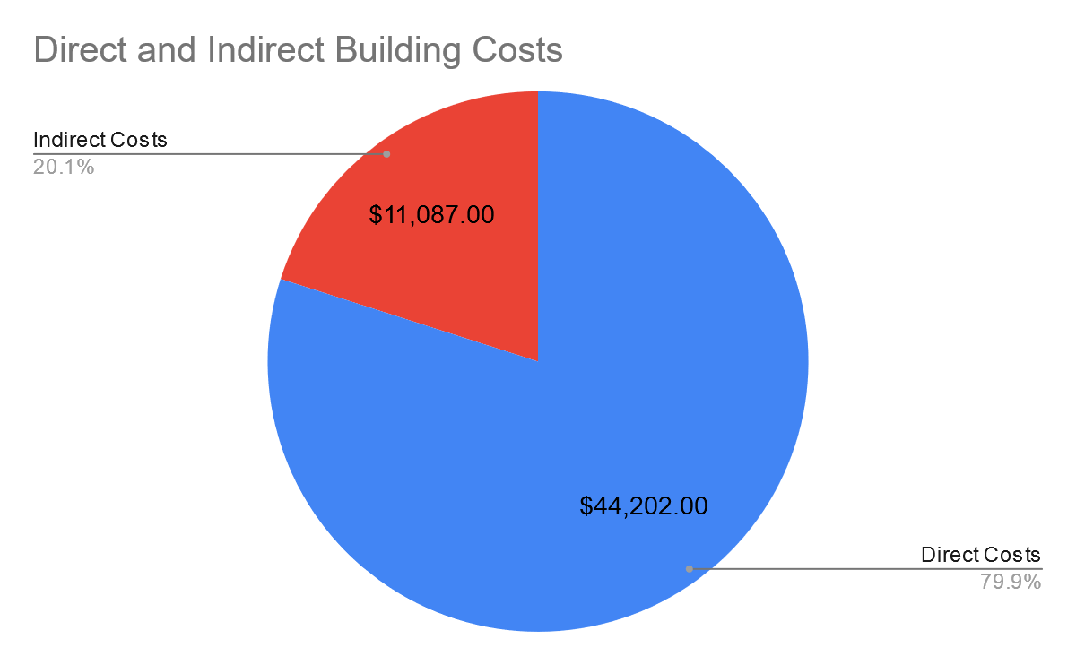
Appendix 1. Building costs broken down by direct and indirect expenses

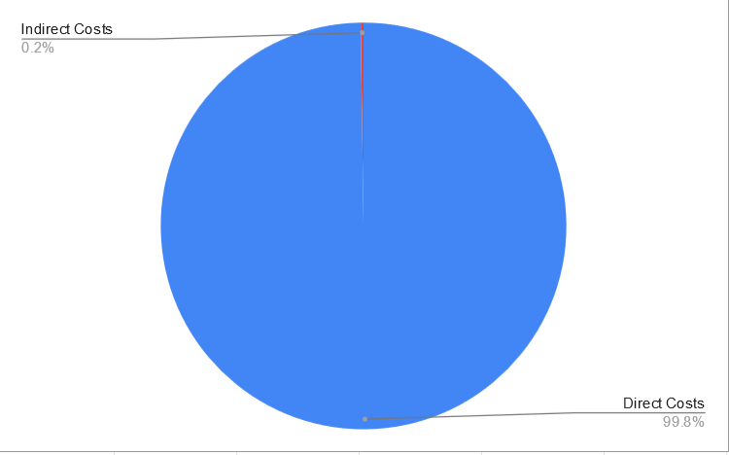
Appendix 2. Server costs broken down by direct and indirect expenses

Team Credentials
Our team is composed of five prospective computer scientists and engineers who have an intense desire to see the world around us improved through technology. We have a personal stake in the well being of the citizens of the U.S. Virgin Islands as one of our engineers, Omar Johnson, has family in the area.
Between the five of us, we have a broad range of experience and expertise including database management, software and website design,web programming, IT and network design and various programming languages as well as a broad range of clerical and personnel skills that are necessary for executing an undertaking of this scale. The resumes of our team members are listed on the following pages.
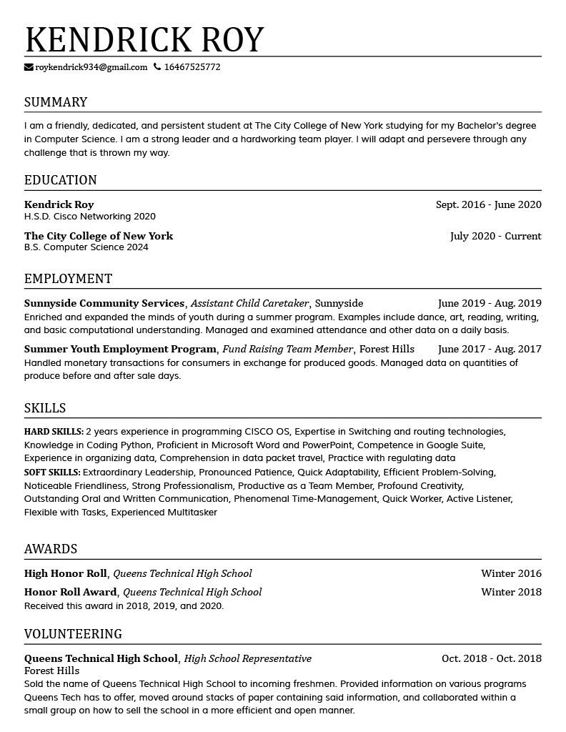
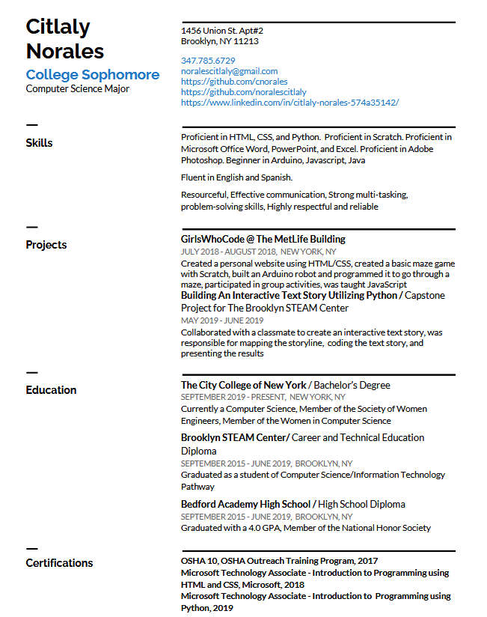
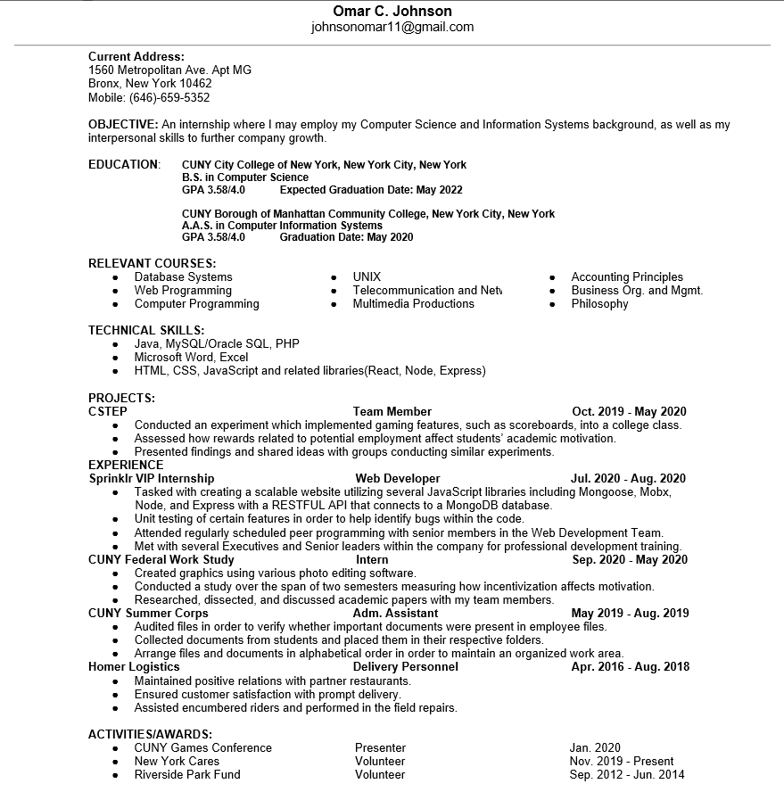
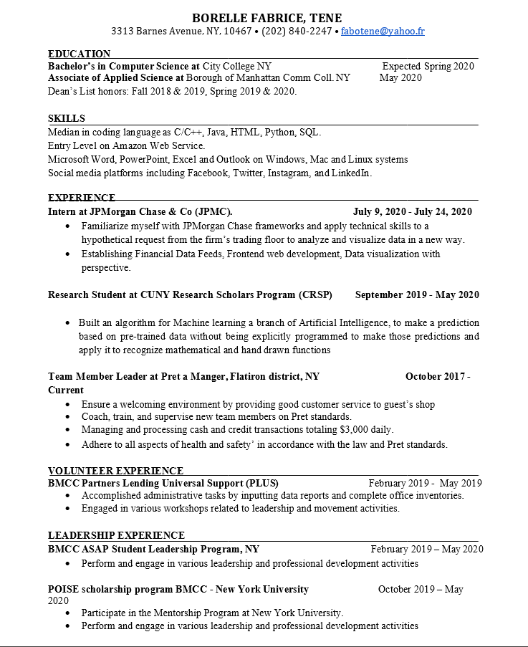
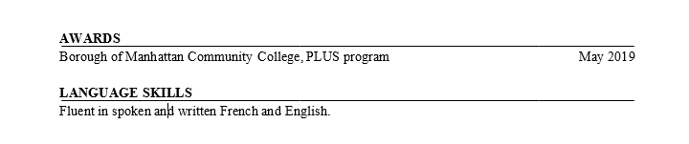
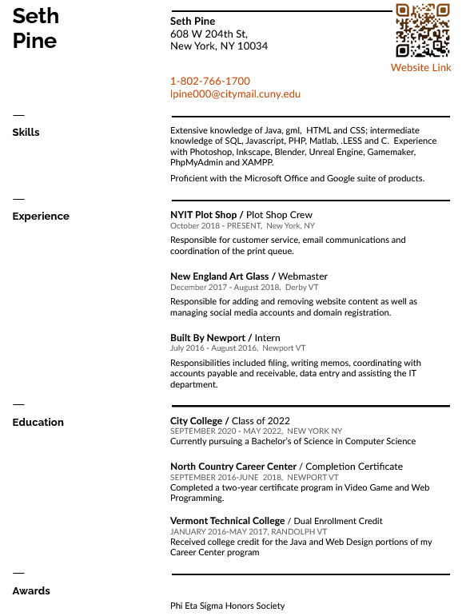

References
Unknown, (2020). Anaerobic Digesters.
Exploring Energy Efficiency and Alternatives. Retrieved from;
https://www.e3a4u.info/energy-technologies/anaerobic-digesters/economics/#:~:text=General%20Cost%20Information&text=approximately%20%24400%2C000%20to%20%245%2C000%2C000%20depending,unit%20costs%20approximately%20%241.2%20million.

Government of The United States Virgin Islands, (2018). VITEMA.
VITEMA. Retrieved from;
http://www.vitema.vi.gov/

Source Staff, (2020, March 4). VITEMA Provides List of Emergency Alert System Device Manufacturers.
The St. John Source. Retrieved from;
https://stjohnsource.com/2020/03/04/vitema-provides-list-of-emergency-alert-system-device-manufacturers/

XPERTECHS, (2012, April 25). How Much Does A Server Cost?
XPERTECHs. Retrieved from;
https://www.xpertechs.com/2012/04/server-article/#:~:text=Businesses%20price%20out%20a%20server,%2C%20assuming%20straight%2Dline%20depreciation.

David C. Ekroth, (unknown). Building To Resist Hurricanes.
Retrieved from;
https://www.hsdl.org/?view&did=30117

Government of The United States Virgin Islands, (2014, March 10). Public Review Draft.
Retrieved from;
http://www.chrishanley.com/wp-content/uploads/2014/05/Zoning-Consolidated_Public_Review_Draft031014.pdf

Department of Planning & Natural Resources, (2001, September 1).
Retrieved from;
http://courses.washington.edu/onsite/Virgin%20Islands%20onsite%20sewage%20disposal.pdf

Reflection Papers
Kendrick Roy

When I first heard about this assignment, I thought that it would be hell to go through. It sounded very similar to the technical description, in the sense where we would have to make a multi-paged analysis on something of our choosing. After beginning the project, however, I found that it was relieving to have so many other group members helping out and doing their parts. Considering how we are all computer science majors, it was pretty easy to find a topic to write about all together. Once we got our topic down, we ran into a few standstills concerning our group name, what exactly our group will be doing, and who the stakeholders will be. After getting past these few roadblocks, however, we sped right through it and finished a lot of work before we even started working on our final draft.
Since we are a group of computer scientists, we reached a mutual agreement to develop a cloud system so that the people of St. Croix will be able to back up their physical documents electronically so they can have peace of mind when evacuating a natural disaster. Not only this, but the data center will also be sending out notifications to the people of St. Croix whenever one of the many weather stations on the U.S. Virgin Islands detects a hurricane or any other natural disaster. After doing our research for the data center, summarizing, and editing, we came up with a wonderful proposal that would definitely wow any stakeholders that read it.
While we were writing our proposal, we figured that the information would sell itself, so we didn’t put much thought into wording or anything like that. The only time we put thought into our wording was during the needs statement and objective. For the rest, we knew that our research and interpretation of that research would stand out on its own, with the help of some scattered images that we have taken from our website and other sources. For example, our website, wonderfully crafted by Seth, is one that will definitely catch the eyes of any one of our stakeholders and the people of St. Croix.
The genre of our project was an engineering proposal. The proposal of this engineering proposal was the construction of the data center in St. Croix. The point of this data center is to store physical information electronically so that the people of St. Croix will have peace of mind and only need to focus on what’s really important; friends, family, and neighbors. By sending out alerts whenever a disaster is going to hit and prompting people to back up their files whenever they get a notification, this system will ensure that no one will have a single misplaced file or photo that will be destroyed or lost forever.
The media of this assignment will be print and presentation. By including the general necessary in our PowerPoint, we get the main point across to our stakeholders so they get a general understanding of how our organization will be helping the people of St. Croix and expanding the influence of modern technology to new horizons. While providing a general overview of how the project will work, we include our written medium which is the proposal. Through the proposal, we go into specifics to answer some general questions that the stakeholders might have had watching our presentation.
My stance toward this proposal is that I am tired of hearing people worrying about material objects when fleeing a natural disaster. Now that cloud services are a thing, people don’t need to worry as much as they used to. I wish for this technology to be extended out to people who live in areas that are more heavily affected by such natural disasters, so they can worry more about survival than how their own belongings are.
My purpose is to convince humanitarian organizations to group up with my group and I and help bring my dream to life. By gathering the support of a humanitarian group, I will be bringing experience with me into this journey of making the world a more tightly-knit place. By putting our minds at ease when it comes to physical objects, I feel that we can all worry more about one another.
My exigence comes from the many people that go missing and that are left behind during evacuations because someone cares more about their bag than their own people. I am tired of hearing that people get knocked down when doing last-minute evacuations and hear that they get trampled because people want to make sure their house deeds, birth certificates, photos, etc. are on the plane before they start to worry about each other.
The audience would have to be humanitarian groups. With their help, this project will be able to get on its feet and start helping people by allowing them to have a safe space for their documents to be stored. Although this project mostly impacts the people of St. Croix, we need the organizations to provide us with enough funding so we can help the people. Therefore, our audience are the humanitarian groups.
This assignment meets Course Learning Outcomes 1, 2, 3, 4, 5, 7 and 8. It meets number 1 “acknowledge yours and others' range of linguistic differences as resources, and draw on those resources to develop rhetorical sensibility,” as I had to work with my group mates and figure out ways for our different types of writing to sync up and sound as clear and cohesive as possible. In addition to this, I had to do a lot of research and make sense of multiple different sources and their writing in order to implement it into my own writing. It meets number 2 “enhance strategies for reading, drafting, revising, editing, and self-assessment” because the assignments require a lot of reading, revision, and editing to gather the exact information that we need. It meets number 3 “negotiate your own writing goals and audience expectations regarding conventions of genre, medium, and rhetorical situation,” as we have to check what the needs of the citizens are of St. Croix, as well as the needs of the humanitarian group so that they will invest in us.
The assignment also meets number 4, “develop and engage in the collaborative and social aspects of writing processes.” As a group we have to work together to be able to reach our goal and convince the audience with our ideas while making sense of each other’s ideas. It meets number 5, “engage in genre analysis and multimodal composing to explore effective writing across disciplinary contexts and beyond,” as we had to do our project as a presentation which is very different than just writing a paper. For a presentation, we have to convince our audience with general information, and then provide specifics in writing.
Along with all of these objectives, our paper meets number 7, “practice using various library resources, online databases, and the Internet to locate sources appropriate to your writing projects,” as we used a lot of online sources for each part of the proposal, and had to research the multiple types of renewable energy in order to make our data center as energy efficient as possible. Lastly, this assignment meets number 8, “strengthen your source use practices (including evaluating, integrating, quoting, paraphrasing, summarizing, synthesizing, analyzing, and citing sources)” as we did so much research on the internet and had to paraphrase and summarize a lot of it just so we can include it in our own writing.

Seth Pine
My role in this project was basically to figure out how all of the details of the implementation design were going to work, and to come up with the appropriate graphics. I created the mockup website, chose the location for the data center, created the spreadsheets and graphs for the budget and the timeline. As far as the document itself I worked on everything below the introduction.
The rhetorical situation for this project is unique because unlike other projects where we have seen problems and proposed solutions, we had to actually plan how the solution would be implemented.
The exigence for this proposal is the destruction of personal property in the U.S. Virgin Islands during extreme weather events like tropical storms and hurricanes. The audience for this proposal is the local government including the governor, director of the emergency management branch, and the director of the bureau of Information Technology. We are addressing our proposal to these three men because they are the ones who will evaluate if a technology would benefit the citizens they represent.
Our purpose for this document is to persuade the government to allow us to build this data center and create software to interface between the cloud and the people of the island. Our stance on this subject is positive: we believe that this will work and that our audience should allow us to do it. The genre of this document is an engineering proposal.
The genre can be identified by the document structure: it includes an introduction with a purpose and a needs statement, a proposed solution and our explanation of how we plan to implement that solution as well as a budget and schedule for the work that will be done. The medium for this document is a digital file, as none of us lives in the U.S.V.I. to deliver a printed document, as well as the global pandemic preventing us from traveling and making paper documents less desirable in general.
This was a big project and required us to participate in many of the course learning outcomes. Firstly, this was a collaborative project. It required us to communicate between our groups and be accountable for work we had agreed to do. Additionally, the amount of writing in this project allowed us to interact with group members who might not have English as their first language and address the multicultural aspect of our class.
Those of use who did research for this project were required to find sources that would help us in our purpose of being persuasive, and cite those sources according to the APA guidelines. This document is a multimodal composition because it not only involves text that fits the genre of an engineering proposal, it includes graphics and a powerpoint that make it a visual composition as well.
As I’ve already said, this was a large project. It required a lot of communication in our group and a concerted effort to be available for meetings and planning sessions. It’s a real insight into how teams of engineers work long distance. I can’t say I’m a fan honestly. We made it work, but I would have preferred a situation where we could meet in person. I think the added complication of meeting online in addition to the difficulties with matching up schedules made it unclear to people what the project was actually about and this made the report more difficult to write.
That being said, it was nice to all share a digital document that we could add to and leave comments on. I really enjoyed that flexibility. All in all, I think we did a good job of managing ourselves and dividing the work. In the future, if I were to re-do the project with the same group I think scheduled zoom meetings and coming up with our own completion schedule for the project would be a good idea. It would also be beneficial to have a designated leader who would be responsible for checking on an individual’s progress.
This was a difficult project, but I think we’ve all done our best and I am satisfied with our effort.

Citlaly Norales
When this project was first assigned, I thought about focusing on something relating to hurricanes, especially with the powerful hurricanes that have been going on recently. When I met with my group, the idea of a hurricane warning system came to me. My group liked my idea and we decided to create a hurricane warning system that also has a cloud that allows residents to upload their personal documents. This cloud would give residents the ability to focus on their loved ones rather than making sure they had their material items secure. I thought that it was a good idea for my group and I to work on our project on Google Docs so that we could all work on the same document at the same time. I also created a document where my group and I could write down all of our thoughts, ideas, research, and even questions relating to our assignment. This document was a way for us to have discussions on paper and I found it very effective. I worked on the introduction of the proposal and created the original document. I also did the presentation working alongside my groupmate Omar. I also added commentary and helped review my peers’ contributions.
Overall, I enjoyed working with my group. They all did their part and each chose to be responsible for certain tasks when my other group members were busy. We all worked together in working on this project. I think one reason why we were so successful was that we each selected a task or a part of the project that we were going to do and committed to getting it done. In the end, I am proud of how our project came together.
The purpose of this assignment was to create a proposal while collaborating with my peers. We had to work on creating our own scenarios for our project and focusing on the purpose of our proposals and who our audience is. The medium used for this assignment was digital. Since this is an online course we used several online tools such as Google Docs, Google Slides, Discord, etc. to collaborate, and work on our assignment together. The genre of this assignment is an engineering proposal. In this proposal we had to submit a written proposal, a job posting, a presentation based on our proposal, and memos to specific people that would be considered our audience. For this assignment we had to come up with who our audience is. Our audience is our classmates as well as a few leaders of the U.S. Virgin Islands. Our specified audience is the governor of the Virgin Islands, Albert Bryan Jr., the Director of the Virgin Islands Territorial Emergency Management Agency, Daryl DeFrance Jaschen, and Rupert Ross who is the Director of the Bureau of Information Technology in the U.S. Virgin Islands. The exigence of this assignment was to take all of the different genres and writing techniques that we were introduced to this semester and bring them all together. It’s also to put us in a real-life scenario on what we would have to write in the workplace. The stance of my group is that we want to help people in the Virgin Islands rebuild after the destruction caused by hurricanes. We think that the use of a cloud storage system helps relieve the stress of victims and makes them focus more on what’s important.
This assignment helped me meet the course learning outcome that says “enhance strategies for reading, drafting, revising, editing, and self-assessment.” In this assignment, I had to create a draft with my peers, revise my paper as well as review the drafts of my peer groups, and then use the comments my group and I received to edit and revise my paper. I also had to “practice using various library resources, online databases, and the Internet to locate sources appropriate to your writing projects” for this assignment. I had to do research for this assignment and include this research in my paper. I researched past hurricanes that affected the Virgin Islands. I also researched which part of the Virgin Islands was most affected by past hurricanes, which is why I convinced my group to focus on St. Croix. I also had to cite my sources using the APA citing guidelines. Lastly, I had to “engage in genre analysis and multimodal composing to explore effective writing across disciplinary contexts and beyond”. Before my group and I wrote our proposal, we had to do a genre analysis of engineering proposals and be sure to pay attention to whether or not all of the necessary components of an engineering proposal were there. I also had to “negotiate your own writing goals and audience expectations regarding conventions of genre, medium, and rhetorical situation”. My group had to create a proposal with a goal to propose an idea and plan to our audience.
Due to our circumstances, I think that working on this assignment wasn’t that hard even though we were remote. I do believe that if we were in a classroom or on campus, I probably would’ve been able to get more done with my group in a timely fashion. I also think that I prefer collaborating with someone, face to face as opposed to over a Zoom call. We also would have practiced together and better if we did this assignment in-person. But overall, we managed to make this work. Especially with my group and I are computer science majors, it makes us a bit more tech-savvy. We worked our way through remote learning.

Omar Johnson

Reflection Paper

Purpose:
The purpose of this document is to propose to the government of the US Virgin Islands, the creation of a data center on the island of St. Croix where residents will be able to store important documents and files. This data center will be paired with the already existing meteorological stations on the island and alert those who have signed up for the service of any impending hurricanes and prompt them to back up and save important documents and files such as deeds, insurance papers, passports, family photos, etc. This service would be very important to this region because of how destructive these natural disasters are. Though people may lose their property, we can at least guarantee that the things which are digital, or can that be digitized, will not be lost in the wake of one of these natural disasters.

Audience:
The audience for this document is Albert Bryan Jr., Governor of the US Virgin Islands, Daryl DeFrance Jaschen, Director of the Virgin Islands Territorial Emergency Management Agency (VITEMA), Rupert Ross, Director of the Bureau of Information Technology in the U.S. Virgin Islands. These three people are important officials within the government of the U.S. Virgin Islands, and are primarily responsible for the ensuring well being of the people within the U.S.V.I. The Director of VITEMA, Daryl DeFrance Jaschen is responsible for the oversight of the region's emergency alert system, and we would need his approval if we are to integrate that existing infrastructure into our service. Rupert Ross, Director of the U.S.V.I.’s Bureau of Information Technology is important because we would need his help in getting people to sign up, and assisting those who aren't privy to the nuances of cloud technology

Genre:
The genre of this paper is a Technical Proposal. Our group’s aim is to propose a cloud storage service that is both practical to create, and helpful to the people in the region.

Stance:
Our group's stance is that the people of the U.S. Virgin Islands deserve access to cloud storage. We want to convince government officials that there is a great need for the data center and service that will be provided by our company. We will need land and access to the region's emergency alert system, so the stance we took was direct, and informative, using many graphics created by group members, and research done by them as well.

Medium:
This Technical Proposal will be shared as a word document and presented using a PowerPoint slideshow. We think that if we are to send this proposal to these government officials, it would be imperative that we create an in-depth document that will work to inform them of any nuanced information that isn’t self explanatory when we aren’t present. We also would like to show them the charts and budgeting information that was calculated by the team. The power point is important for a physical presentation or even a virtual one where we would walk them through key points of information without dragging our explanation out unnecessarily.

Exigence:
The demand for this document and what we are proposing is created by the devastating power of hurricanes. In an era of information technology where the world is connected through the Internet of Things, cloud storage and the ability to save ones files and documents from physical harm is of great importance. We know that if this service were created, it would help save many people the price of having to replace important documents, as well as lessen the emotional strain that may come with losing cherished documents like photographs.

Borelle Fabrice Tene
Reflection paper on Project

Beyond the advancement of the project thanks to individual experiences, teamwork is ideal for developing the skills of less experienced employees. It is the opportunity to mix the employees so that everyone can benefit from the exchanges that have taken place. In a group of collaborators working on the project, mutual aid is essential to achieve a fixed goal. In the case of this project, it is a question of proposing the construction of a data center on the island of Virgin, in St Croix to be more precise. The purpose of this centralized data is to safeguard the electronic information of the majority of the inhabitants of this island. The major goal of this project is to allow these inhabitants not to worry about their data, just to worry about close friends, family, and neighbors. We make the safety of those documents our priority.
The principle of operation is that where in the first time, we send a warning message or a notification to the population of St Croix to make them understand that the disaster is close and near to strike from one moment to another. This will allow them to initiate the evacuation process quite easily and be less stressed without having to think about important electronic documentation. This idea came to us during research on the project and as a computer science engineer and we therefore unanimously decided to adopt and make a proposal to the government of Virgin island.
During the writing of the proposal, each one had a very precise role and tasks to do. When a job was done by one member of the group, the other members were going through the work with a fine comb in order to be able to agree, to correct the shortcomings, and to discuss questions to clarify the ideas. I had to contribute to the writing of several documents among which the proposal, I wrote the job posting for the mechanical engineer who was supposed to work with us on this project, I made the selection of the suitable candidate, reviewed the introduction of the proposal and other project documents.
My way of designing and seeing the project wasn’t complicated because having previously taken training on how the cloud and data center work, it was sort of easy for me to assimilate the project. It was also a challenge for me in writing the project documents since English is not my first language, I sometimes found myself stuck in the way so I had to present things. Collaboration and the exchange of ideas with my colleagues was easy. They were very receptive and above all very hardworking.
I savored working with my group. Everybody did their part of the work and in a responsible manner and were helping in the task when the one who was supposed to do it was busy. This may be the reason why we finished on time and it was in my opinion a great success. I'm happy with the rendering of this project which seemed blurry at the start of the project. This is the reason why most of the projects are successful because everyone put their hands in the dough to move forward and finish the project on time.

AUDIENCE PROFILE SHEET (1)
Reader’s Name: Albert Bryan Jr.
Reader’s Job Title: Governor of the US Virgin Islands
Education: B.A. in economics Wittenberg University, MBA in Business administration University of the Virgin Islands
Professional Experience: HESS oil, V.I. housing authority, Innovative communications, co-founded Generation Now!, board of the Young Democrats, Commissioner of Labor
Job Responsibilities: lawmaking, overseeing the executive branch, revising policies programs and budgets, overseeing the welfare of the residents of the Virgin Islands
Personal Characteristics: two daughters, lobbyist for better conditions in the Virgin Islands.
Cultural Characteristics: None
Attitude Toward the Writer: Neutral
Attitude Toward the Subject: Unknown
Expectations About the Subject: None
Expectations About the Document: None
Reasons for Reading the Document: Desire to improve conditions for those living in the U.S. Virgin islands
Ways of Reading the Document:
Skim it _x_ Study It x Read a portion of it x Which portion? Most likely the sections dealing with the budget and the introduction, possibly the implementation
Modify it and submit it to another reader ___
Attempt to implement recommendations x
Use it to perform a task or carry out a procedure x
Use it to create another document ___
Other ___ Explain
Reading Skills: college level
Reader’s Physical Environment: office or home office

AUDIENCE PROFILE SHEET (2)
Reader’s Name: Daryl DeFrance Jaschen
Reader’s Job Title: Director of the Virgin Islands Territorial Emergency Management Agency (VITEMA)
Education: Bachelor of Science (BS) in General Engineering & Mathematics from West Point, Master of Business Administration (MBA) in Management Information Systems from Oklahoma City University, and a Master of Science (MS) in Strategic Studies from the US Army War College
Professional Experience: Strategic Plans & Doctrine, Exercise, Operations, Information Management, Virgin Islands Amateur Radio Emergency Service (ARES) section emergency coordinator,
Job Responsibilities: planning emergency response for weather events in the U.S. Virgin islands, coordinating outreach and readiness training for islanders
Personal Characteristics: military background, history of volunteer service
Cultural Characteristics: None
Attitude Toward the Writer: Neutral
Attitude Toward the Subject: probably interested
Expectations About the Subject: None
Expectations About the Document: None
Reasons for Reading the Document: desire to add additional methods of protecting the interest of the islanders to the VITEMA toolkit, our plan requires the use of Alert VI which is overseen by VITEMA
Ways of Reading the Document:
Skim it _x_ Study It x Read a portion of it x Which portion? Most likely the sections dealing with the budget and implementation which deals with how Alert VI will be used.
Modify it and submit it to another reader ___
Attempt to implement recommendations x
Use it to perform a task or carry out a procedure x
Use it to create another document ___
Other ___ Explain
Reading Skills: college level
Reader’s Physical Environment: office or home office

AUDIENCE PROFILE SHEET (3)
Reader’s Name: Rupert Ross
Reader’s Job Title: Director of the Bureau of Information Technology in the U.S. Virgin Islands
Education: Bachelor of Arts from the University of the Virgin Islands with a concentration in Management Information Systems and is a Certified Public Manager®
Professional Experience: U.S.V.I department of labor, U.S.V.I. Chief Information Technology Officer
Job Responsibilities: responsible for assessing, recommending and implementing technology for the benefit of the citizens of the Virgin Islands
Personal Characteristics: unknown
Cultural Characteristics: None
Attitude Toward the Writer: Neutral
Attitude Toward the Subject: Unknown
Expectations About the Subject: None
Expectations About the Document: None
Reasons for Reading the Document: to evaluate the proposal and its usefulness for the U.S. Virgin islands in his role as director
Ways of Reading the Document:
Skim it _x_ Study It x Read a portion of it x Which portion? Most likely the sections dealing with the budget and the implementation of the software and website
Modify it and submit it to another reader ___
Attempt to implement recommendations x
Use it to perform a task or carry out a procedure x
Use it to create another document ___
Other ___ Explain
Reading Skills: college level
Reader’s Physical Environment: office or home office

