Technical Description of a Swiss Army Knife

Benjamin Kalmanowitz
Grove School of Engineering, City College
Engineering Writing 21007
Professor Danielle Carr
March 9, 2021
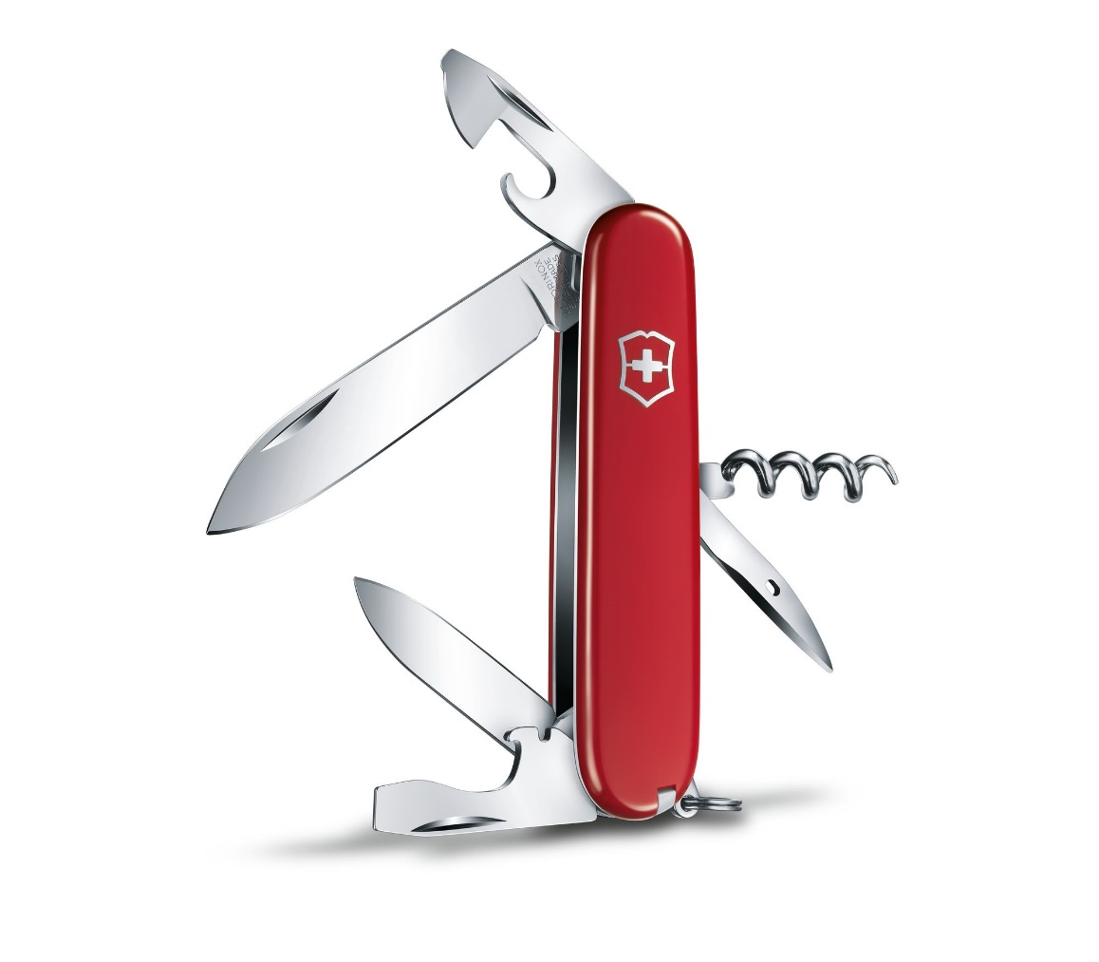
(Swiss Army, 2018b)
Contents
Introduction 3
Exterior components 3
Interior Components 4
How to use a Swiss Army Knife 6
Conclusion 6
References 8

Introduction
One of the earliest known pocketknives, the folding pen knife, has been in existence since at least the fifteenth century. It was modeled after an Iberian folding blade knife, which can be dated back to the pre-Roman era (Loehr, 1958). During the eighteenth century, the penknife became extremely popular for sharpening the dull end of a quill pen. Among farmers and gardeners, the longer bladed, all-purpose jackknives were more commonly used during the early 1700s due to England’s Industrial Revolution (Loehr, 1958). This allowed for the manufacturing of sharp, durable, portable knives, whose price decreased drastically and led to their abundance and popularity.
From about 1886, all soldiers in the Swiss Army were issued a wooden handled pocketknife. A few years later the army began using a new kind of rifle that could be opened with a screwdriver. So, a screwdriver was added to the standard-issue knife, along with an awl, reamer, and can opener (Jackson & Hook, 2018). Those first tool-loaded Swiss Army knives were manufactured in Germany but in 1891 Swiss silverware manufacturer, Karl Elsener, founded the Swiss Silverware Guild to supply his country’s army (Victorinox, 2011). The most popular among the different kinds of pocketknives that he designed, was the Officer’s Knife. It was a lightweight knife with two blades, a screwdriver, a can opener, an awl, and a corkscrew. After the death of Elsener’s mother in 1909, he renamed his line of knives with her name, Victoria. This was the name until the 1920s when Elsener modified it slightly by adding an “inox” to it (meaning the metal does not oxidize). Henceforth, changing the name to Victorinox, which is the name that this Swiss brand still uses today (Victorinox, 2011). Today’s red-covered Swiss Army knife with the Swiss cross logo comes in many different models and colors, some of which date back to when the company was first founded.
Exterior components
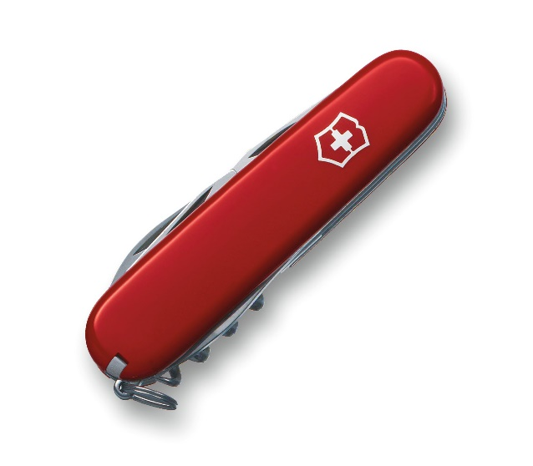
The Swiss Army knife comes in many different sizes and shapes, some with plastic exteriors and some with metal exteriors. Over the past decade, the most popular model has been the Spartan (Jackson & Hook, 2018). The Spartan has the iconic red plastic shell exterior which surrounds the knife as shown in Figure 1; the tools enclosed within it. Emblazoned on the red plastic shell, you will notice the Swiss cross which has been emblazoned on the knife since their early production for the Swiss Army (Bethanne Kelly Patrick & Thompson, 2009). On the exterior, you will also find a stainless-steel keyring to attach the knife, so your keys can always be accessible. Extruding out from both sides of the plastic shell are many different stainless-steel tools on the Spartan. Each tool extrudes a few millimeters difference from one another, so you do not need to pull out one tool to reach another. On each tool, there is a slight imprint so one could use either their nail or their finger to access the desired tool. The spartan consists of a small blade, a large blade, a can opener, a flat-headed screwdriver, a bottle opener, a corkscrew, a reamer/sewing awl, a toothpick, and tweezers (Swiss Army, 2018a). A photo of the Spartan with all the tools exposed can be found on the cover page. The Spartan also has a toothpick and tweezers that are not located within the metal housing but instead within the plastic shell. This allows both the toothpick and tweezer to be removed and used independent of the rest of the knife for easy access.
Figure 1: Spartan Swiss Army Knife (Swiss Army, 2018b)

Interior Components
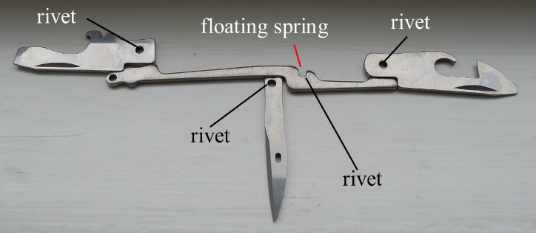
The Swiss Army knife uses a unique, patented floating spring mechanism to secure all of its tools when they’re being used and when they are in the casing (BBC News, 2009). As labeled in Figure 2 you can see the floating spring, it is secured in place by four rivets. The two rivets in the middle of the spring act as a fulcrum for the spring to balance off when a force is applied to the tool. When a strong force is applied downward with one of the tools, for example when using a knife to cut something, the rivet and tool on the opposite side of the knife act as a counterbalance (SAKHome, 2016). This allows the user the ability to apply large forces on any individual tool without the worry of breaking any internal components.
Figure 2: Floating spring mechanism and rivet holes (SAKHome, 2016)
If you have ever opened a Swiss Army knife you will have felt the knife locking into place. This is achieved by the detailed angular milling during the manufacturing process (SAKHome, 2016). As seen in Figure 3 at the end of the knife by the label “Angle” the end of the knife is rounded. This allows the stainless-steel metal tool to roll off the spring and around the rivet. The spring will then decompress due to the force the user is applying to the tool which is in turn transferred from the tool onto the back end of the same spring. As the tool opens into its full position, the indent marked by “X” and “Xa” in Figure 4 falls into the angle in the spring thereby locking the tool into its full opening position. Each layer of the Swiss Army knife is also separated by a thin aluminum plate which prevents each tool from interfering with another.
Figure 4: Floating spring mechanism with knifes in open positions (SAKHome, 2016)
Figure 3: Pivot angle (SAKHome, 2016)
The Spartan Swiss Army knife weighs 2.1 ounces, is 3.6 inches long, and is 0.6 inches in height (Swiss Army, 2018a).

How to use a Swiss Army Knife
By design, using a Swiss Army knife is very simple. The user should hold the knife in their dominant hand to become familiar with it. Once the user feels comfortable will the knife, they should open all the tools individually to better understand each tool and its respective purpose. The user should open each tool by locating the little metal indention on each tool and prying the tool out, away from the body of the knife with either their fingernail or the flat part of one’s finger. After opening each tool, the user should hold the Swiss Army knife by its body to become more comfortable with using them. The user should be careful not to harm themselves as the two knives when open are very sharp. After becoming familiar with each individual tool, the user should pick the desired tool for the task at hand while holding the knife by its body in their dominant hand. Their grip on the knife body will differ depending on which tool they choose, for example, if they choose to use the corkscrew or the can opener.

Conclusion
The many different design choices made regarding the internal components of the Swiss Army knife allow it to last for many years without needing any maintenance or breaking while sitting idle. The design was purposely kept simple, with its stainless-steel body, aluminum construction, and few moving parts in the knife to ensure it would be sturdy and reliable. The use of a floating spring as opposed to a coil spring creates a knife that is resistant to breaking or falling apart. Its many different tools, compacted into a small portable device, ensure its continued popularity. This knife can be used for an endless number of different tasks such as removing the cork from a bottle of wine or cutting a small piece of wood. The Swiss Army Knife is a consistently dependable tool which is why it is relied on by the Swiss Army and by the rest of the world as well.

References
BBC News. (2009, July 30). From humble tool to global icon. News.bbc.co.uk. http://news.bbc.co.uk/2/hi/europe/8172917.stm
Bethanne Kelly Patrick, & Thompson, J. M. (2009). An uncommon history of common things. National Geographic.
Jackson, D., & Hook, P. (2018). Victorinox Swiss Army Knives : a collector’s companion. Chartwell Books.
Loehr, M. (1951). Ordos Daggers and Knives: New Material, Classification and Chronology. Second Part: Knives. Artibus Asiae, 14(1/2), 77. https://doi.org/10.2307/3248690
SAKHome. (2016). How a Swiss Army Knife works. In sakhome.com. https://www.sakhome.com/305357085
Swiss Army. (2018a). Check this out:Spartan. Victorinox Swiss Army. https://www.swissarmy.com/us/en/Products/Swiss-Army-Knives/Medium-Pocket-Knives/Spartan/p/1.3603
Swiss Army. (2018b). Spartan Victorinox. In www.Swissarmy.com. https://assets.victorinox.com/mediahub/33608/2000Wx1750H/SAK_1_3603__S2.jpg

Reflection
This assignment has helped me learn about different aspects of writing as they relate to our course learning outcomes. While writing this assignment, I found myself constantly thinking about who my specific audience was as I wanted it to be applicable to the reader. While I was writing I wanted to ensure that nothing was too technical, and everything could be understood on an elementary level as this was a technical description for any type of reader. I took these considerations into account as I was researching information for this article; I read articles on many different reputable websites, patents, journals, and even a few books to find information about the Swiss Army knife. I came across a few patents related to the Swiss Army knife but realized that they were too technical for most readers to comprehend. Therefore, I looked elsewhere to gain a better understanding of how the Swiss Army knife works. I wanted to be able to summarize the pertinent information and inform my audience as to how the Swiss Army knife works. While researching the Swiss Army knife, I came across a long, but interesting history of the knife that I wanted to summarize for my reader.
The audience for my technical description is anybody interested in knives, the history of the Swiss Army knife and how it works. It would also be of interest to people interested in the mechanical operations of multitools. As this is a very wide audience with no specific education level, I wrote in basic and generalized terms, so this information was understandable to everyone.
The purpose of this technical description is to educate the reader about the Swiss Army knife and its history. It will help the reader better understand all the different features a Swiss Army knife has, as well as explaining how to use one. Although they may have had or own a Swiss Army knife, most people do not know the inner workings of the knife, or how the knife locks into place.
My stance while writing this technical description was neutral. It would not be appropriate to write an informative technical piece whose purpose is to educate the reader about the Swiss Army knife with a bias.
The genre is a technical description. Technical descriptions are used to educate a reader about a specific item. They are used to describe the history of an item, how an item works and operates, and its different uses. I had all these characteristics in mind while writing the technical description of the Swiss Army knife.
The media/design of this technical description is multimodal although it is in a digital form, it can be printed. This document will most likely remain digital as it is shared with the class for peer review.
The exigence for this technical description was my own Swiss Army knife. Recently, I was on a hiking trip and was using my Swiss Army knife a lot. This made me wonder about the history of the knife and how exactly it worked. When this assignment was assigned, I thought a Swiss Army knife would be the perfect simple yet complex item to write about. I am sure there are many other people who too would want to learn about the inner mechanics of this knife.

Audience Profile Sheet
Reader: The reader is any person interested in learning about Swiss Army knives. They may be looking to purchase one or are interested in the mechanics of the knife.
Reader’s job title: The reader can have any job title.
Kind of reader: Primary
Education: The reader may have a background in different kinds of knives, or they may have some hunting/army knowledge. But this knowledge is not necessary for the reading of this paper.
Professional experience: unknown
Job responsibilities: unknown
Personal characteristics: They have a general interest in knives or tools.
Personal preferences: They may prefer having multiple tools in one rather than carrying multiple.
Cultural characteristics: unknown
Attitude towards the writer: unknown
Expectations about the subject: The reader expects to learn how about and how to use a Swiss Army knife. They may also expect to learn the inner mechanics of the knife.
Expectations about the document: They expect the document to be well researched and informative.
Reasons for reading the document: The reader may be looking to learn more about the device and how it may benefit them.
Way of reading the document: The reader will most likely skim the document; find a part they find interesting and read it in detail.
Reading skill: unknown
Reader’s Environment: unknown

