Logitech MX Master 3 Wireless Mouse Technical Description
Department of English, City College of New York
ENGL 21007: Writing for Engineering
Prof. Danielle Carr
March 6, 2021

Table of Contents

Historical Background of Logitech (3)

Historical Background of Logitech (3)

Product Specifications (4)

Dimensions (5)
Physical Features (5)
Conclusion (5)
References (6)

Historical Background of Logitech

The computer mouse was invented in 1964, by Douglas Engelbart. The first mouse had two perpendicular wheels in a wooden box, with one button on top. It was only able to move left and north as well as forwards and backward. That was to represent the XY plane making the cursor on a computer screen move in the same direction as the mouse. By 1968, the company Telefunken, developed a mouse that used a ball to navigate instead of wheels. That allowed the mouse to move in a 360-degree direction. However, the ball would collect dust and dirt over time, making the ability to fix it a hassle as the whole mouse needed to be dismantled. That wasn’t the end of development as mouses then used Light Emitting Diodes (LEDs). The ball would be replaced by a light detector to track the motion by the 1980s. (Navarrete, 2020)

Historical Background of Logitech
The Logitech company is a provider of personal devices such as webcams, game controllers, mobile game accessories, multimedia speakers, headsets, advanced universal remote controls, digital writing solutions, keyboards, trackballs, and mice. The birth of the company started in 1976 at Stanford University, in Palto Alto, California. The business partner, Daniel Borel and Pierluigi Zappacosta wanted to develop an early word-processing system while at their time at Stanford University. They spent four years securing funding and eventually built a prototype for the company Bobst. After the built prototype, the engineer Giacomo Marini joined the business partners and all three of them founded the Logitech company. As the technology for computer mouses improved, the Logitech company started to delve into the computer mouse industry. As the company got involved in the technology of mouses, the LEDs started to further develop to the point that every other mouse production soon followed Logitech. (Darrel, 2007)

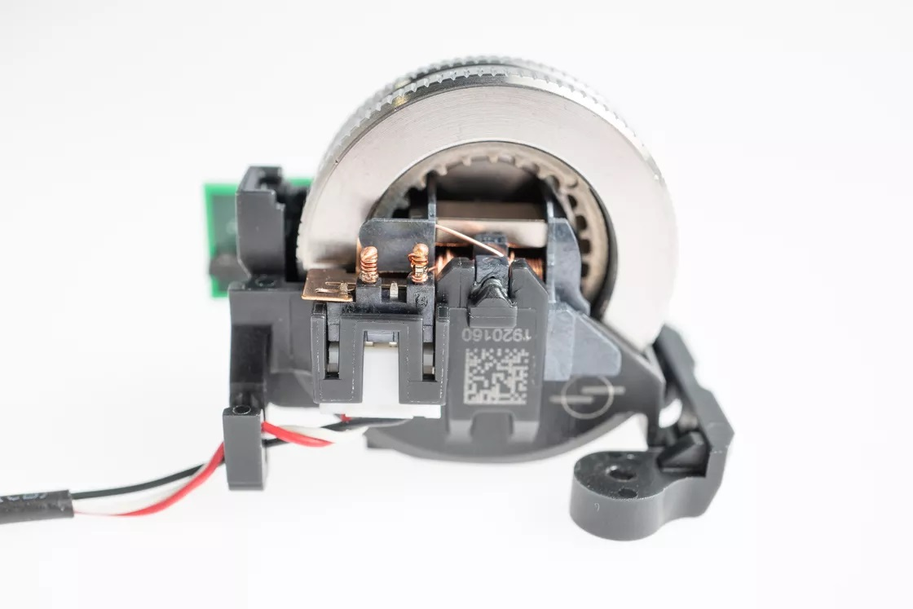Product Specification

The Logitech MX Master 3 includes a stainless steel scroll wheel, with a hole in the middle. Inside the hole there are electromagnets which can either have the same polarity, allowing the user to feel force when scrolling through each line, or it can have different polarities so the users can feel no force while scrolling. The users can change the polarity by hitting a button underneath the device (Harding, 2019).
Figure 1

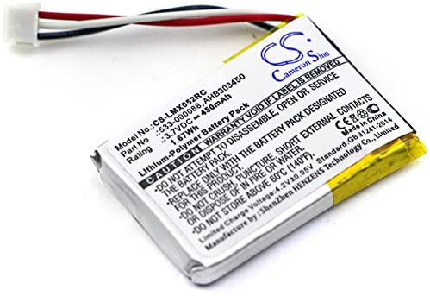The Logitech MX Master 3 includes a rechargeable lithium-ion battery, more specifically a 450mAh battery. To charge the battery, the mouse includes a USB-C port which allows the USB-C cable to connect into it so the battery can charge (Harding, 2019).
Figure 2

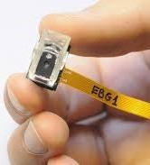

The Logitech MX Master 3 includes a Darkfield sensor. The lens found with the sensor illuminates light on any surface, keeping track of the movements to makes the cursor on a computer follow. The computer can track the product at a 4,000 dots per inches with the sensor (Darrell, 2009).
Figure 3

Dimension
Length: 4.9 inches
Width: 3.3 inches
Height: 2.0 inches
Weight: 5.0 ounces

(Honorof, 2019)
Physical Features
The mouse has considerable height compared to most mice found in the industry with some curvatures. The height and all the curves are designed for the human hands to be comfortable to hold for a long period of time. There is a thumb rest on the mouse which is designed to make the product feel like a nice glove instead of an oval object that is meant to be held. Both the thumb rest and palm rest are lightly textured as well as a matte finish so no fingerprints are left on the product. (Honorof, 2019)
Conclusion

There is an appreciation for considering the Logitech MX Master 3 Wireless Mouse for personal uses. With the knowledge of the history of the wireless mouse, the influence of the Logitech company on mouse production can be viewed. Knowing the influence of Logitech should be a great tell in how the company produces the most quality content for computer mouses. Knowing the product specification will allow for greater knowledge of what goes in the product. That would entail that if some issues were to arise with the product then there is information on specific items on the product. Lastly, the dimensions and physical features are to give a sense of how the product feels without having to feel it.

References
Darrel, B. (2007, March). Logitech History. Retrieved March, 2021, from https://www.logitech.com/lang/pdf/logitech_history_200703.pdf
Darrell, B. (2009). Logitech® Darkfield Laser Tracking: The World Is Your Mouse Pad An Innovation Brief. Retrieved March, 2021, from https://www.logitech.com/images/pdf/briefs/Logitech_Darkfield_Innovation_Brief_2009.pdf
Epstein, Mike. (2019). Logitech MX Master 3 Review. Retrieved March, 2021, from https://www.pcmag.com/reviews/logitech-mx-master-3
Harding, Scharon (2019). Logitech MX Master 3 Wireless Mouse Review: Reinventing the Wheel Successfully. Retrieved March, 2021, from https://www.tomshardware.com/reviews/logitech-mx-master-3-wireless-mouse,6311.html
Honorof, Marshall. (2019). Logitech MX Master 3 Review. Retrieved March, 2021, from https://www.laptopmag.com/reviews/accessories/logitech-mx-master-3#:~:text=The%20MX%20Master%203%20is%20a%20large%2C%20ergonomic%2C%20right%2D,a%20rechargeable%20lithium%2Dion%20battery.
Navarrete, Glynis. (2020, October). The History of Computer Mouse. Retrieved March, 2021, from https://linuxhint.com/computer_mouse_history/
Porter, J. (2019, October). Logitech MX Master 3 Teardown Offers an Intriguing look at its New Scroll Wheel. Retrieved March, 2021, from https://www.theverge.com/circuitbreaker/2019/10/9/20906042/logitech-mx-master-3-teardown-bolt-magspeed-scroll-wheel-engineering
Estry. (2021). 450mAh Battery Replacement for Logitech MX Anywhere 2 MX Master MX Master 3 910-004362 MX Master 2s M-RO052 MX Master 2 910-004374 AHB303450 533-000120 L/N: 1412 533-000121 3.7V. Retrieved March, 2021, from https://www.amazon.com/Replacement-910-004362-910-004374-533-000120-533-000121/dp/B07V7VLBR5

Audience Profile Sheet
Kind of Reader: Primary
Reader’s Job Title: Computer Science Engineer
Education: High School Diploma, Bachelor’s degree.
Professional Experience: Individuals who’s career depends on being on a computer for a long period of time.
Job Responsibilities: Computer being required for work.
Attitude Toward the Writer: N/A
Attitude Toward the Subject: Wants to be comfortable while using a computer.
Expectations about the Subject: N/A
Expectations about the Document: N/A
Reasons for Reading the Document: To want a mouse that is comfortable to use for the long term which includes multiple features.
Reading Skill: Understanding of the English Language.
Reader’s Physical Environment: N/A

Reflection
I wrote a technical description about the Logitech MX Master 3 wireless mouse because I believe it is important to know about a product that can keep you comfortable for the long term. My major is Computer Science and my career goal is to be a software engineer. One of the aspects of being a software engineer is that interested me is that usually coding is involved. Coding is a process that requires a lot of problem-solving, which is something I quite enjoy. Not to mention, coding requires a large portion of a job on a computer, which is something I usually like to do. Even though I enjoy coding, some issues come with it. Long hours of coding can be quite exhausting, even though there is only a lot of sitting. That is why I chose to write a technical description of a Logitech product that focuses on comfort.
The genre of this assignment is a technical description. Technical descriptions are found in a large number of places, like product instructions, and product proposals. The technical description I wrote is a document that stands alone and could be a document that comes with the product. It can also be a document used to sell the audience on the product or wants to be informed of the product. The technical description gives a detailed background of the product and the company of the product. I then go on to describe the specifics in my product, and what goes into making one. There is a description of the scroll wheel, battery, and laser sensor. In the descriptions, images are showing exactly what it is that goes in the mouse. The media for the assignment is digital since it’s online. For it to be multimodal media, it would need to be printed.
The purpose of this technical description is to inform and educate people interested in buying the Logitech MX Master 3 wireless mouse. My technical description includes historical information about the history of mouses itself and the manufacturing. This comes before the product specification. The exigence of this technical description is that someone interested in getting a mouse that is good to use in the long term will want to read the document and want to buy it. Another exigence of the document is that someone who already brought the product and wants to learn more about it. I hope that reading my technical description will help individuals to make an informed decision about computer mouses.
The audience for the document are individuals that spend a lot of time on a computer and are interested in purchasing a mouse or learn about a mouse. To appeal to a broader audience in terms of language and education, I used simple words and not that many complicated terms. If there is a complicated term, it is thoroughly explained. The paper’s stance is neutral, as I do only talk about the product but don’t discourage from buying or researching other computer mikes from other companies.
In the process of writing this assignment, I have met the course learning objective of enhancing strategies for reading, revising, editing, and self-assessment. I read my paper over and over again and made proper changes to enhance the technical description.

