Bullard Standard Series Hard Hats (Bullard 2021)

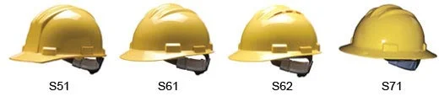

Technical Description of the Bullard Hard Hat
Ranjit Pershad
Department of English, City College of New York
ENGL 20700: Writing for Engineering
Prof. Danielle Carr
March 9, 2021

Table of Contents
Page
Introduction 3
History of the Hard Hat 3
History of Bullard 4
The Bullard S62 4
Features & Specifications 5
Conclusion 6
Reference Page 7

Introduction
The first hard hat which was modeled after the world war “doughboy” was designed by Bullard a company that revolutionized head protection for workers. Hard hats which are now widely used in workplace environments such as an industrial or construction sites to protect the head from injury due to falling material, impact with other objects, debris, electric shock, and other types of danger that cannot be foreseen.

History of the Hard Hat
A little over a hundred years ago, the hard hat did not exist. While fifty years ago, head protection was not widely required for workers. But, thanks to advances in safety, the hard hat has evolved over the decades. (Bullard,2021) In 1915, E.W. Bullard began work on a helmet that could protect miners from falling objects. He based it on the doughboy, a helmet he had worn as a soldier in World War I. Dubbed the “Hard Boiled® Hat” because of the steam used in the manufacturing process and later patented in 1919. (Bullard,2021) It was manufactured out of steamed canvas, glue, a leather brim, and black paint and had a built-in suspension device which became the worlds’ first, commercially available, industrial head-protection device. 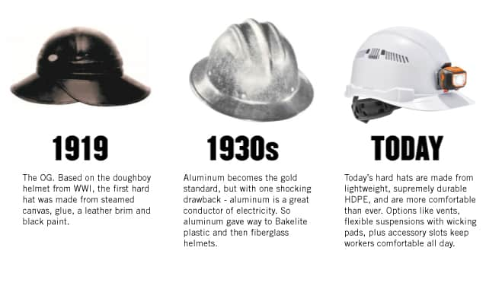
Evolution of Head Protection (Ergodyne,2019)

History of Bullard
Bullard Logo (Bullard,2021)

Bullard is a leading manufacturer of high-quality personal protective equipment and systems that are marketed worldwide. Founded in San Francisco 1898 by Edward Dickinson Bullard. The Company originally supplied carbide lamps and other mining equipment to gold and copper miners in California, Nevada, and Arizona. (Bullard,2021) The company later evolved when his son, E.W. Bullard, returned from World War one and combined his understanding of customer needs and his experience with his doughboy army helmet to design a protective headgear for miners. Dubbed the “Hard Boiled®” hat, introduced in 1919, represented the first of many innovative designs that have led Bullard to its prominent position in head protection for industrial and emergency response applications. (Bullard,2021) Now more than a century after it was founded Bullard product lines include thermal imagers, hard hats, firefighter, and rescue helmets, supplied air respirators, powered air-purifying respirators, and air quality equipment

The Bullard S62
The S62 (Image 1) is the Bullard Standard Series vented hard hat. It sports a low-profile, vented shell design and upgraded features and benefits. With its 4-point suspension system, users can choose from a pin lock or upgraded Flex-Gear® ratchet suspension with absorbent, cotton brow pad. The S62 is ideal for the construction and everyday work environments. (Bullard,2015).
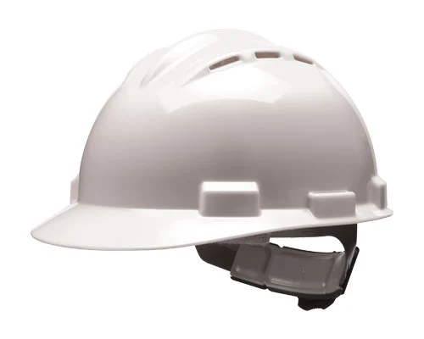
Bullard standard Series S62
Image 1 (Bullard,2021)
Features & Specifications
The S62 has the choice of either the self-sizing 4-point Pinlock suspension (RS4PC) which offer incremental sizing makes a secure fit (See Image 4) or the Flex-Gear ratchet suspension (RS4RC) which s can be adjusted (See Image 4). (Bullard 2015)
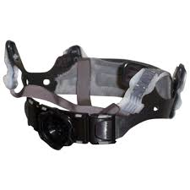
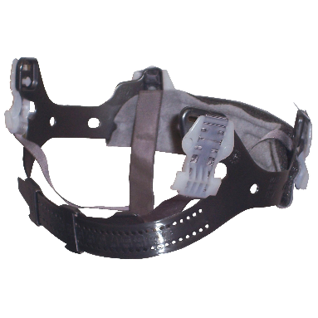
Image 2
4-point Pinlock suspension (RS4PC)
Image 3
Flex-Gear ratchet suspension (RS4RC).

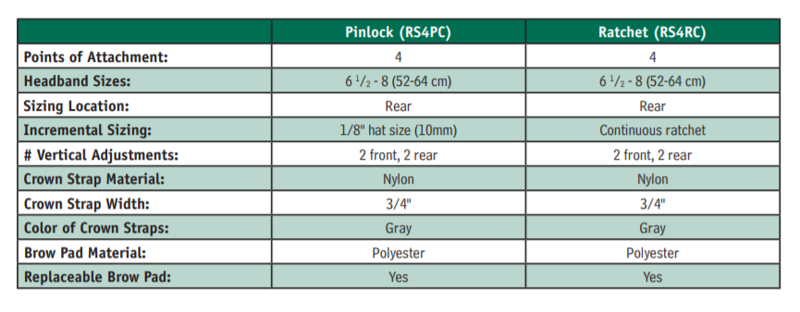
Image 3 (Bullard,2015)
Pinlock (RS4PC) and Ratchet (RS4RC)
Comparison

Image 2 ((Bullard,2021)
Image 3 (Bullard,2021)
Conclusion
This technical description aimed to inform reader about a brief history of the hard hat and about Bullard the company which is credited with its popularizations. This paper also gave an overview of the Bullard standard series S62 and the specifications of its design.

Reference Page
Bullard. (2021). History of Bullard Hard Hat. https://www.bullard.com/history-of-the-hard-hat.
Bullard. (2021). Bullard's History. https://www.bullard.com/about-bullard.
Bullard. (2015). Standard S62 Bid Specs. Bullard. https://www.bullard.com/uploads/bullard_downloads/HP_S62_BIDSPECS_AM_EN_LOW_8356.pdf
Image 1 - https://www.bullard.com/uploads/products/standard_series_hard_hats/Standard-series_S62.jpg
Image 2 - https://www.bullard.com/uploads/products/hp_accessories/RS4PC.jpg
Image 3 - https://www.bullard.com/uploads/products/hp_accessories/RS4RC.jpg
Image 4 – Screen clipping from https://www.bullard.com/uploads/bullard_downloads/HP_S62_BIDSPECS_AM_EN_LOW_8356.pdf

Audience Profile Sheet
Kind of Reader: Primary ____ Secondary ____
Reader’s Name: Construction worker and industrial site workers.
Reader’s Job Title: N/A
Education: Basic English.
Professional Experience: Entry level to experienced Construction site worker and industrial site workers
Job Responsibilities: Varies
Personal Characteristics: N/A
Personal Preferences: N/A
Cultural Characteristics: N/A
Attitude Toward the Writer: N/A
Attitude Toward the Subject: Personal and compliance safety
Expectations about the Subject: N/A
Expectations about the Document: N/A
Reasons for Reading the Document: N/A
Way of Reading the Document: Skim it ____ Study it ____ Read a portion of it ____ Which
portion?
Modify it and submit it to another reader N/A
Attempt to implement recommendations ____
Use it to perform a task or carry out a procedure ____
Use it to create another document ____
Other ____ Explain:
Reading Skill: Basic English.
Reader’s Physical Environment: Construction site/ industrial site

