Technical Description of Staedtler’s Mars ® Micro 775 Mechanical Pencil

Meri Stojanova
Grove School of Engineering, City College of New York
ENGL 21007: Writing for engineers
Professor Danielle Carr
March 9, 2020

Table of Content

Introduction………………………………………………………………………………….  Components…………………………………………………………………………………  Conclusion ………………………………………………………………………………….  References ………………………………………………………………………………….  Audience analysis…………………………………………………………………………...  Reflection paper …………………………………………………………………………... | 03  05  09  11  12  13

Introduction
A mechanical pencil looks just like a ballpoint pen, but instead of ink uses a lead of graphite to write. This type of pencil opens just like a normal pen, but instead of refilling it with a new ink cartridge, a length of specially manufactured pencil lead is fed into the writing barrel. Once the pencil is closed, lead can be pushed through the barrel in small increments, as it is used by clicking the tip of the pen, depressing a ratchet button, or twisting the cone of the barrel, depending on the model (Kayane, 2021).
Historical Background of the Mechanical Pen
The mechanical pencil was invented five centuries ago. The device has different names in different countries. In the US, we know it as "mechanical pencil." However, in the UK is called "propelling pencil" and is known as "pen pencil" in India (History of mechanical pencils, 2021). Regardless of the name, in 1565 by Conrad Gesner, a Swiss naturalist and bibliographer, invented the first mechanical pencil. This mechanical pencil was primeval. It was more of a lead holder pencil, and the sharpening process was manually adjusted (History of mechanical pencils, 2021).
The first mechanical pencil that had a mechanism to propel the lead, and the lead could be replaced, was patented in 1822 by Sampson Mordan and John Isaac Hawkins in Britain. Mordan's company was manufacturing this pencil until the Second World War, when the factory was destroyed (History of mechanical pencils, 2021).
Between 1822 and 1874, people worldwide worked to improve the mechanical pencil, then around 160 patents were filed to do just that. In 1877, the first spring mechanical pencil emerged, and after that, in 1895, the twist feed mechanical pencil was invented (History of mechanical pencils, 2021).
In 1915, Tokuji Hayakawa invented an improved mechanical pencil called "Ever-Ready Sharp Pencil." This mechanical pencil uses a screw-based mechanism. Parallel to this innovation in the United States, Charles R. Keeran is developing a similar but ratchet-based pencil (the history of mechanical pencils, 2021).
Today all mechanical pencils work on three principles: reached-based pencils, screw-based pencils, and clutch pencils (History of mechanical pencils, 2021).
Historical Background of The Manufacturing Company
Staedtler is a German pencil company founded by Johann Sebastian Staedtler in 1835. Staedtler Group's boom happened in 1853 when Staedtler showed his merchandise at the Exhibition of All Nations' Industry in New York. Shortly after that, these high-quality German products made a name for themselves in France, Britain, Italy, Russia, America, and the Middle East (Staedtler "Staedtler's History," 2021).
The fascination for pencils has run in the Staedtler family for years. Johann S. Staedtler's ancestor, Friedrich Staedtler, worked as a “pencil-making craftsman.” For the first time in Nuremberg's official records, Friedrich Staedtler was mentioned as a "lead pencil maker" in the year 1662 (Staedtler "Staedtler's History," 2021).
The Staedtler Group shares Johann Staedtler's vision for precise, high-quality pencils to this day. They are one of the oldest top-quality innovation brands on the market. According to the company, "STAEDTLER turns ideas into products – and writing instruments into people's favorite pens. This combination of tradition and innovative excellence is what makes STAEDTLER so unique. It is a core component of our corporate culture – and will continue to make history in the future" (Staedtler "Staedtler's History," 2021).
Components
General Description
Staedtler's, Mars ® Micro 775, Mechanical Pencil is for writing and drawing (Staedtler "Staedtler's Products," 2021). It is a type of pencil with a mechanism that extends a solid lead core called graphite. The pigment core is not bonded to the shell and is replaceable (History of mechanical pencil, 2021).
Figure 1: Staedtler Mars micro 0.3 mm
(Staedtler “Staedtler’s Products,” 2021)

Staedtler's Mechanical pencil uses Simple "12-a-go" refilling Mars micro carbon 250 leads, grade B, which stands for soft black leads (Staedtler "Staedtler's Products," 2021). This type of lead has a small quantity of clay, making the lead soft and dark in the shade. It has a very dark line density and is difficult to erase. It is ideal for bold, thick lanes (Diksha, 2015). If necessary, HB grade lead can also be used. The leads are available in 4 single line widths in mm, as shown in Figure 2 (Staedtler "Staedtler's Products, " 2021).
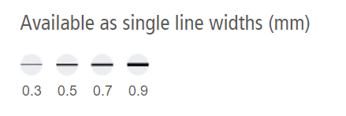
Figure 2: Single Line widths
(Staedtler “Staedtler’s Products,” 2021)

The Staedtler's Mars ® micro 775 mechanical pencil uses the Iso Standard 128 system to color-code pencils and specific line widths (Staedtler "Staedtler's Products, " 2021). We can see the color-coded system in Figure 3.
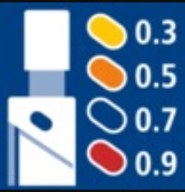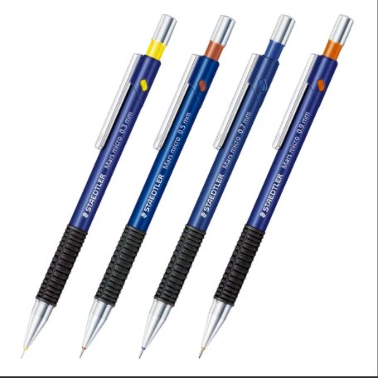
Figure 3: Iso Color Coding
(Staedtler “Staedtler’s Products,” 2021)

The Staedtler’s Mars ® micro 777 Mechanical Pencils weights 0.4 ounces, and its dimensions are ("Staedtler's Products, " 2021):
- 5.91 inches in length
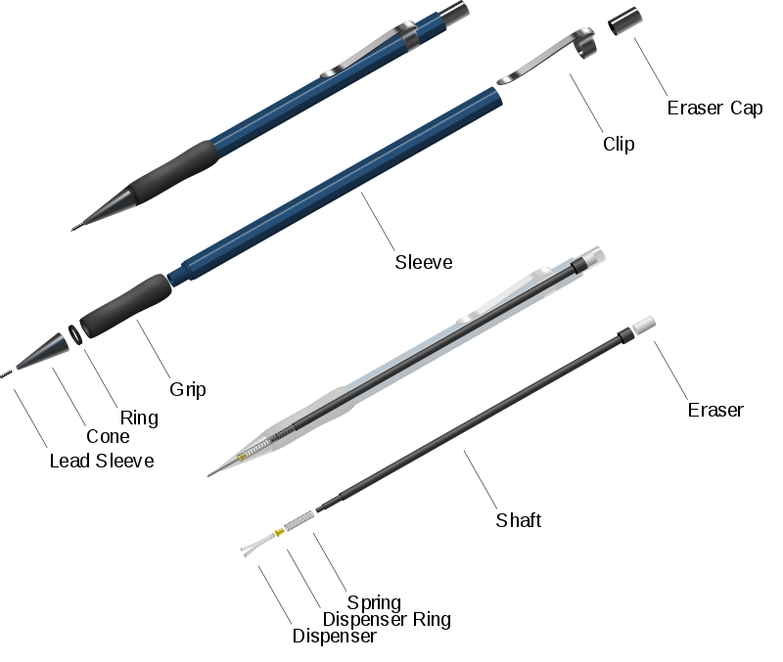
- 0.39 inches width
- 0.59 inches height
The mechanical pencil has external and internal components (Danya, 2021). The Staedtler’s Mars ® Micro 775 mechanical pencil components are listed in Table 1 and graphicly showed in Figure 4.
Figure 4: Components of the Mechanical pencil
(Danya, 2021)
Figure 4: Mechanical Pencil Components

External Components | Internal Components
- Lead Sleeve  - Cone  - Grip  - Body (Sleeve)  - Pocket Clip  - Push Button with push button cap | - Lead  - Lead Retainer  - Dispenser (Chuck)  - Dispenser Ring (Chuck Ring)  - Spring  - Lead Reservoir Tube (Shaft)  - Eraser Holder  - Eraser
Table 1: Components of the mechanical pencil
(Danya, 2021)

External components
The lead sleeve is a cylindrical holder for the lead in the mechanical pencil, strengthening the lead roads and preventing them from breaking (Fields, 2020). Staedtler's pencil has a rigid, cylindrical lead sleeve, ideal for use with rulers and templates. The lead sleeve on this pencil is also retractable, making it pocket safe (Staedtler "Staedtler's Products, "2021). For better visualization, please refer to Figure 5.
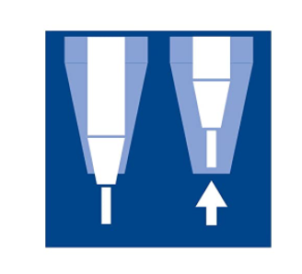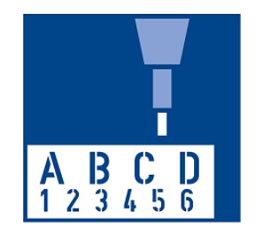
Figure 5: Rigid, retractable cylindrical sleeve
(Staedtler "Staedtler's Products, "2021)

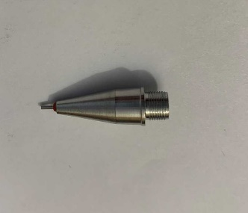
The cone's main function is to protect the mechanical lead retainer on the inside (Fields, 2020). The Staedtler's Mars ® micro 775 Mechanical Pencil is made from metal, with a silver finish (Staedtler "Staedtler's Products, "2021). Has a coned barrel, 1 inch in length (See Figure 6).
Figure 6: The Cone

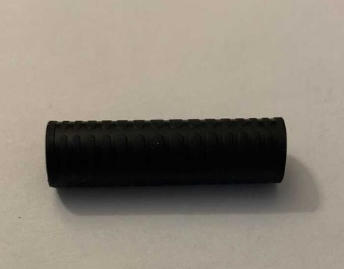
The grip has two main functions: to protect the pencil's inner components and allow the user to hold the device comfortably (Fields, 2020). The Staedtler's Mars ® micro 775 Mechanical Pencil has a non-slippery black rubber grip zone, which allows long use without fatigue and discomfort on the fingers (Staedtler "Staedtler's Products, "2021).
The rubber gripping barrel measures are:
Figure 7: The grip
- 1.25 inches in length
- 0.27 inches diameter
The body on The Staedtler's Mars ® micro 775 Mechanical Pencil is always blue (Staedtler "Staedtler's Products, "2021). It has a cylindrical shape, and it is designed to hold and protect the lead reservoir tube (Fields, 2020). The body is 5 inches in length.
The clip is designed to clip the pencil to objects such as books, notebooks, and pockets. It is made from steel.
The push-button is located on the tip of the pencil. With pressing the push button-down, a lead is ejected at the mechanical pencil's bottom through the lead sleeve. The push-button cap also covers the eraser (Fields, 2020).

Internal Components
The chuck and the chuck ring. These two parts always work together to transfer the lead from the lead reservoir tube through the lead sleeve. Once the push button is pressed, it engages the spring, which causes the chuck and chuck ring to grab and pull the lead out. The spring is attached to the reservoir tube and the chuck, and it provides tension to advanced and retracts the lead (Fields, 2020).
The lead reservoir tube contains the led. It is an orange cylindrical plastic tube whose main function is to hold the stored lead (Fields, 2020).
The removable eraser is a cylindrical rubber plug that fits into the eraser's hold and removes lead particles on paper (Fields, 2020). The removable eraser is made of white rubber.
How to use the mechanical pencil
The mechanical pencil is very easy to use. Three simple steps can describe the process:
Step 1: Insert the lead. Open the push button cap and remove the eraser from the lead reservoir tube. You can add one or more leads. Do not overload, because you will jam the pencil. When finished, put the eraser and the cap back on.
Step 2: Pressing the push button will eject lead from the lead sleeve. To start a new lead, keep clicking the button until you see the tip of the lead from the lead sleeve. To keep the lead from breaking, do not eject too much lead.
Step 3: Write just like you are writing with a regular pencil. If the lead breaks, simply eject more. If the pencil is out of the lead, repeat the previous steps.
Conclusion
Mechanical pencil is the favorite tool for writing and technical drawing among engineers, architects, builders, and designers. If you belong in any of these fields, you know how inconvenient it is to stop your calculations or stop drawing to sharpen your wooden pencil. Even more irritating is when your line width is inconsistent, which in some cases can be crucial for your technical drawing. Mechanical pencils are often more comfortable to use, and in some cases, they are eco-friendly. These pencils are refillable, and you can buy one pencil and reuse it for years (Lucy, 2020).
Staedtler's Mars ® micro 775 mechanical pencil is a reliable mechanical pencil choice that will not hurt your budget. This pencil is for writing and drawing. They come in different line widths, color-coded by ISO standard 128. It has a non-slippery double grip zone, metal clip push button, and clip, and it is pocket safe thanks to the retractable lead sleeve. It is effortless to refill with "12-a-go" Mars micro carbon mechanical pencil 250 B leads (Staedtler, 2020). These characteristics make this pencil high quality but also affordable. You can have it for only $10.
References
Kayne, R. (2021, February 4). What is a Mechanical Pencil? wise-geek. https://www.wise-geek.com/what-is-a-mechanical-pencil.htm.
History of the Mechanical Pencil - Inventor of Mechanism. History of Mechanical Pencils – Invention and Inventor. (2021). http://www.historyofpencils.com/writing-instruments-history/history-of-mechanical-pencils/#:~:text=First,%20rather%20a%20primitive,%20mechanical%20pencil%20(or%20more,which%20sank%20in%201791,%20was%20found%20in%201977.
STAEDTLER. (2021). Staedtler’s History. https://www.staedtler.com/intl/en/company/about-staedtler/history/.
STAEDTLER. (2021). Staedtler’s products. https://www.staedtler.us/en/products/pencils-accessories/mechanical-pencils/mars-micro-775-mechanical-pencil/.
Diksha. (2015, August 12). Difference between HB and B Pencil Lead. Difference between HB and B Pencil Lead | HB vs B Pencil Lead. http://www.differencebetween.info/difference-between-hb-and-b-pencil-lead.
Danya. (2021). Simple machines: Mechanical pencil (Lead pencil). prezi.com. https://prezi.com/w_8tl_dgzqnq/simple-_{machines}-mechanical-pencil-lead-pencil/.
Fields. (2020). Mechanical Pencils - What's inside and how they work. YouTube. https://www.youtube.com/watch?v=QkS3P-W4VNE.
Lucy. (2020). A guide to mechanical pencils. The Pen Company Blog. https://www.thepencompany.com/blog/pens/a-guide-to-mechanical-pencils/.

Audience Profile Sheet
Kind of Reader: Primary ____ Secondary ____
Reader’s Name: engineers, architects, builders, and designers and students in the same fields interested in purchasing the mechanical pencil.
Reader’s Job Title: unknown.
Education: high school and higher.
Professional Experience: people who write and draw technical documents.
Job Responsibilities: writing and technical drawing.
Personal Characteristics: unknown
Personal Preferences: unknown
Cultural Characteristics: unknown
Attitude Toward the Writer: n/a
Attitude Toward the Subject: interested in writing clean, presentable documents with a reusable writing tool
Expectations about the Subject: n/a
Expectations about the Document: n/a
Reasons for Reading the Document: n/a
Way of Reading the Document: Skim it ____ Study it ____ Read a portion of it ____ Which portion?
Modify it and submit it to another reader ____
Attempt to implement recommendations ____
Use it to perform a task or carry out a procedure ____
Use it to create another document ____
Other ____ Explain:
Reading Skill: Basic English.
Reader’s Physical Environment: n/a

Reflection Paper
For this assignment, I decided to write a technical description of Staedtler's Mars ® micro 775 Mechanical Pencil. I have decided on this item because I consider the Mechanical pencil to be one of the most used tools in the engineering world. It is a fundamental writing tool that every engineer carries most of the time. It is convent to have a tool that writes precisely with the same width all the time, without the need to be sharpened. It is also reusable and eco-friendly.
The genre of my assignment is a technical description. A technical description is a document that describes an object or a process in detail. To be more precise, it describes its function, organizations, and parts. I believe that my document follows the requirements for the technical description. It starts with a table of content, which allows the reader to navigate the document easily. I wrote an introduction paragraph with the history of my object and the brand. Then, I described my object in detail by breaking it down component by component. My descriptions of the components are backed up with properly labeled graphics. I also wrote a how to use instruction and a conclusion.
The media of my technical description is digital. Because of the Covid-19 virus, digital media is the only way to present my technical description document.
This assignment's purpose was to inform the reader of the Staedtler's Mars ® micro 775 mechanical pencil's unique components and the advantages this pencil has and give simple instruction on how to use it. Also, educate the reader about the history of the mechanical pen and the manufacturer.
This technical description's exigence is to tell the reader to use this pencil because of its advantages compared to a regular pencil. Nevertheless, to convince the rather that this mechanical pencil is a high-quality pencil for a budget-friendly price. Personally, I like using mechanical pencils for the same reason I stated in my document. The Mechanical pencil is a great writing and drawing tool. Very neat with the same line width and does not need sharpening. Also, this pencil is eco-friendly and reusable.
My stance and attitude about the topic are neutral. I tried to deliver a simple description of my item of choice.
The audience of these technical descriptions could be anyone who writes and draws technical drawings and is looking to buy an affordable, high-quality mechanical pencil. However, because this is a vast audience, I was specifically trying to target engineers, architects, builders, and designers.
My technical description meets Course Learning outcomes 2,3,7 & 8. To complete my assignment, I had to use online databases to find reliable sources with the correct information, which corresponds to course learning outcome number 7: "practice using various library resources, online databases, and the Internet to locate sources appropriate to your writing projects." Once the sources are located, these sources need to be evaluated, paraphrased, summarized, and properly cited. This brings us to course learning outcome number 8. For this document, I used the APA format to cite my sources. This learning outcome is significant and needs to be concern properly to avoid plagiarism. This assignment was in stages. A draft was completed first. A beneficial revising tool that we used in this class is the peer review. Having my classmates' comment on my paper helps me correct my mistakes and create an improved final version. By following these steps to create my final version, the course learning objective number 2 was accomplished. Also, to write a good technical description, I had to follow my audience's expectations, follow the gender components, and use the right media to deliver course learning outcome number 3.

