Technical Description: EVEREADY LED Economy Flashlight
Brandon R. Thomas
City College of New York
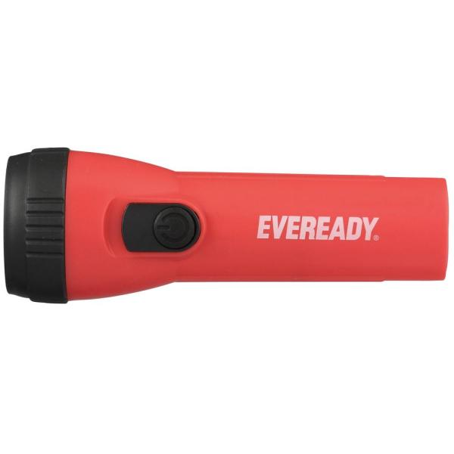
LED Economy Flashlight (Red), 2021, digital photograph, The Home Depot, Inc., accessed 8 March 2021, <https://www.homedepot.com/p/Eveready-LED-Economy-Flashlight-2-Pack-EVEL152S/204472148>.

Table of Contents
Historical Background of the Flashlight……………………………………………………….…3
Historical Background of EVEREADY…………………………………………………….…4-5
Historical Background of EVEREADY LED Flashlights………………………………………5
Product Specifications…………………………………………………………………………….6
Conclusion………………………………………………………………………………………...7
References………………………………………………………………………………………8
Reflection Paper…………………………………………………………………………………9
Audience Profile Sheet………………………………………………………………………10-11

Historical Background of the Flashlight
Today, we think of a battery as a means of portable electricity, but the battery is without a doubt one of the most significant developments in human history. According to Electropaedia, Volta's pile was first regarded as a scientific novelty, but this emerging electrochemical phenomenon soon ushered in new branches of physics and chemistry, as well as a slew of new developments, innovations, and applications (Electropaedia History of Science, Technology and Inventions, 2020). The battery paved the way for today's electronics, computers, and communications markets, as well as power engineering and much of the chemical industry.
According to Flashlight Museum, many of the electrical experimenters, inventors, and engineers who made these advancements possible had to construct their own batteries before they could begin their studies in the nineteenth century. They didn't have access to readily available, low-cost, mass-produced batteries. For a long time, the telegraph and later the telephone companies were the only users of batteries in small quantities, and it wasn't until the twentieth century that modern applications generated the market that turned the battery into a commodity brand (Flashlight Museum page one, 2021).
In recent times, batteries have undergone radical transformations. According to Electropaedia, they're no longer all electrochemical cells (Electropaedia History of Science, Technology and Inventions, 2020). Electronics and applications, power management and control mechanisms, sensing and safety circuits, networking interfaces, and thermal management are all used in today's battery systems.

Historical Background of EVEREADY
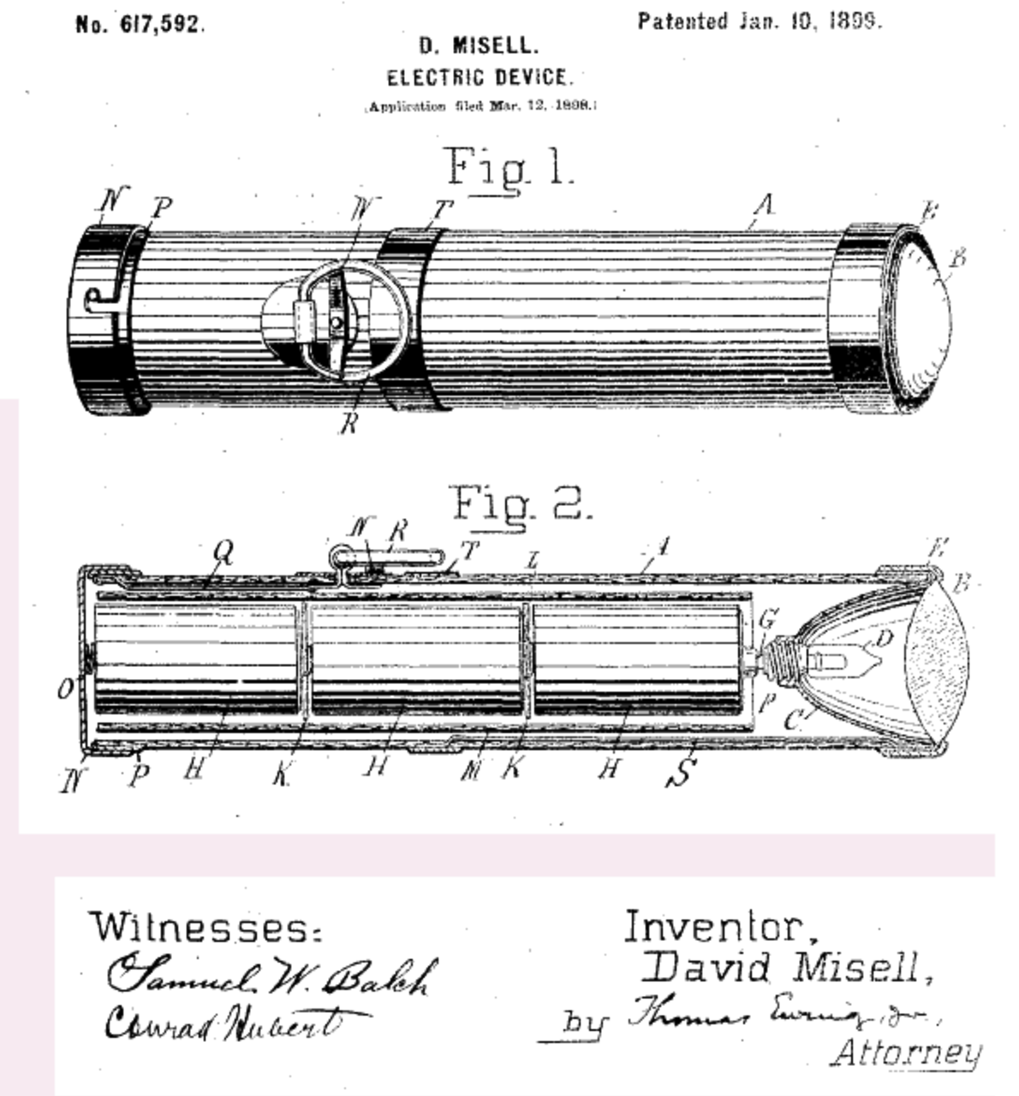
According to Electropaedia, on January 10, 1899, David Misell, an engineer, granted American Electrical Novelty and Manufacturing Company U.S. Patent No. 617,592 (filed March 12, 1898) (See Figure 1). The light bulb and a rough brass reflector were at the end of Misell's "electric gadget," which was operated by "D" batteries laid front-to-back in a paper tube. The tubular hand-held "electric gadget" was invented by Misell and assigned to Conrad Hubert's American Electrical Novelty and Manufacturing Company (Electropaedia History of Science, Technology and Inventions, 2020).
According to Electropaedia, Hubert renamed the company The American Ever Ready Company in 1905 and began distributing flashlights and batteries under the Ever Ready trademark. The British Ever Ready Electrical Company was established in 1906 to export batteries, and it became self-sufficient in 1914. The American Ever Ready Company was acquired by National Carbon Company in 1914. Hubert was re-elected as president. Eveready was the trademark's abbreviation. The Union Carbide and Carbon Company was formed in 1917 when the National Carbon Company and Union Carbide combined to become the Union Carbide and Carbon Company. Eveready used the trademark "DAYLO" on their flashlights and batteries from 1917 to 1921 (Electropaedia History of Science, Technology and Inventions, 2020).
According to Flashlight Museum, Asheboro, North Carolina, Bennington, Vermont, Maryville, Missouri, and Marietta, Ohio are the company's current US manufacturing plants for batteries and battery components, with a technology center for testing in Westlake, Ohio. China produces the bulk of batteries. Outside of the United States, there are several manufacturing plants (Flashlight Museum page one, 2021).

Historical Background of EVEREADY LED Flashlights
According to About Eveready, the American Eveready Company, which invented the flashlight, teamed up with the National Carbon Company, which invented the first D-sized dry cell battery, in the early 1900s to form EVEREADY. Eveready unveiled a new battery, the AA size, in 1907, and launched many types of lightweight vest lights that used it. The invention of the AAA battery in 1911, the first 9-volt battery in 1956, and the first alkaline battery in 1957 continued the tradition of innovation. Families have been using EVEREADY batteries to fuel toys, clocks, and other daily gadgets since then. The American Eveready Company prides itself on being synonymous with trust and dependability (About Eveready, 2021).

Product Specifications
The EVEREADY LED Economy Flashlight has the same shape as traditional 2D cell flashlights, but it only uses 1D cells. It's a good everyday light because it sits comfortably in the palm of your hand. It has a lumen rating of 9 and can run for 50 hours. (See Figure 2). It can survive a one-meter drop and comes with a battery.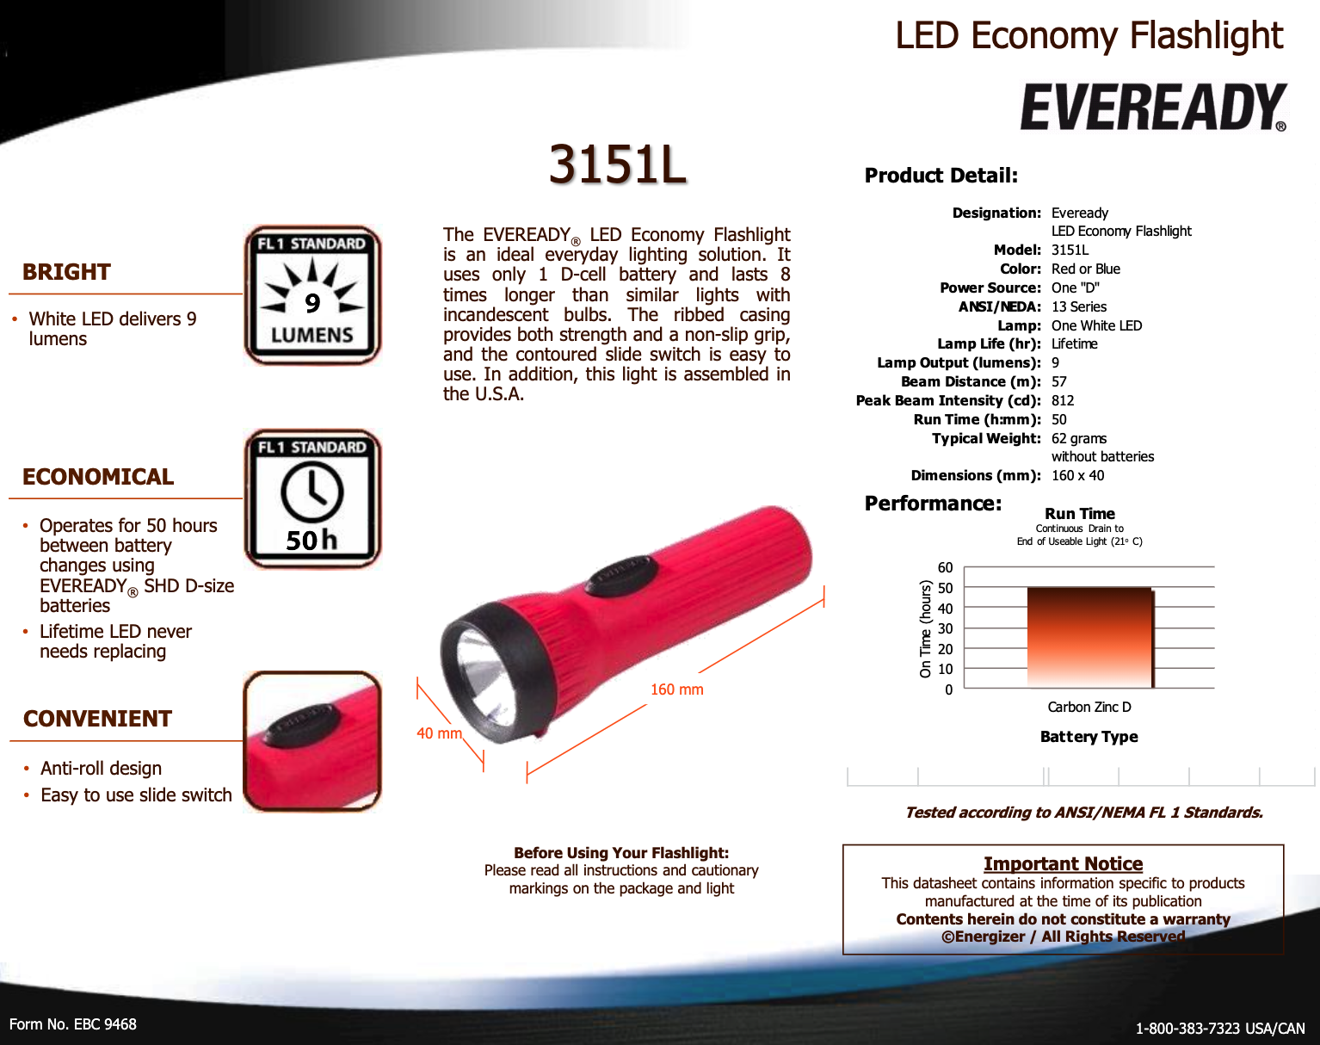Figure 2. EVEREADY® LED Economy Flashlight​​​​ Data Sheet (2021). Retrieved 10 March 2021, from https://data.energizer.com/pdfs/3151l.pdf

Conclusion

The EVEREADY brand has been transforming people's lives for over a century. From dependable on-the-go electricity to vivid, compact lighting, its trusted service and inexpensive prices are perfect for anyone’s daily needs. This amazing device can be bought from any retail provider, such as Amazon or eBay. You'll certainly will have a need for a flashlight in your pocket, whether it's finding the right key, searching for something under the car, couch, or bed, hiking at night, or using it as an emergency light source during a power outage. EVEREADY LED Economy Flashlight is the perfect choice for anyone in such trying situations.

References
About Eveready. (2021). Eveready. https://www.eveready.com/about-us/about-eveready
Dry cell. (n.d.). Www.freepatentsonline.com. https://www.freepatentsonline.com/2960558.pdf
Electropaedia History of Science, Technology and Inventions. Key Scientists and Engineers and the Context and Explanations of their Contributions. (2020). Mpoweruk.com. https://www.mpoweruk.com/history.htm
Energizer Brands. (2019). Energizerholdings.com. https://www.energizerholdings.com/brands
EVEREADY® LED Economy Flashlight​​​​ Data Sheet (2021). Retrieved 10 March 2021, from https://data.energizer.com/pdfs/3151l.pdf
Flashlight Museum page one. (2021). Wordcraft.net. http://www.wordcraft.net/flashlight.html
History of Energizer Holdings, Inc. – FundingUniverse. (2021). Fundinguniverse.com. http://www.fundinguniverse.com/company-histories/energizer-holdings-inc-history/
LED Economy Flashlight (2-Pack). (2021). The Home Depot. https://www.homedepot.com/p/Eveready-LED-Economy-Flashlight-2-Pack-EVEL152S/204472148
‌

Reflection Paper

Writing a textual and visual representation of an object was the subject of technical description. The object had to be straightforward but have a limited number of pieces. In the field of engineering communication, this kind of definition is extremely significant. The most crucial aspect is to present an object to the viewer with a straightforward description. EVEREADY LED Economy Flashlight was my option. I read the instructions for the writing materials required for this course when I received this assignment. After that, I went to the writing center for some brainstorming. I was able to get some excellent assistance in gathering my thoughts for this task.

I was a little worried when I realized I needed to write at more than four pages. It got better over time. This assignment necessitated extensive research. In this case, Google came to the rescue. I have no idea that the invention of a flashlight had such an extensive backstory. I researched its history and discovered who was the first to invent a flashlight. Reading so many articles was a daunting and enlightening experience. Before this task, I thought an EVEREADY LED Economy Flashlight was just another flashlight, but it seems that is no longer the case. I even looked up the names of the sections and subparts, as well as what certain parts do.

I gathered photographs from various sources on the internet. I tried my hardest to write in such a manner that a viewer might gain a complete understanding of an EVEREADY LED Economy Flashlight. One thing that was unclear to me was how to properly do an in-text citation, which I had no idea how to do. I did some analysis after receiving drafts. I'm not sure how I did so well, but I'll do my hardest to improve next time.
Audience Profile Sheet
Kind of Reader: Primary ✓ Secondary ____
Reader’s Name: n/a
Reader’s Job Title: Intermediate Mechanical Engineering Specialist
Education: Basic Understanding of English.
Professional Experience: Intermediate Knowledge of Mechanical Engineering
Job Responsibilities: None
Personal Characteristics: n/a
Personal Preferences: n/a
Cultural Characteristics: n/a
Attitude Toward the Writer: n/a
Attitude Toward the Subject: Intrigued in learning about LED flashlights
Expectations about the Subject: n/a
Expectations about the Document: n/a
Reasons for Reading the Document: n/a
Way of Reading the Document: Skim it ✓ Study it ____ Read a portion of it ____ Which
portion?
Modify it and submit it to another reader ____
Attempt to implement recommendations____
Use it to perform a task or carry out a procedure ____
Use it to create another document ✓
Other ____ Explain:
Reading Skill: Basic English.
Reader’s Physical Environment: n/a

