Technical Description of the Bullard Standard S61 Hard Hat

Sabrina M. Anderson
Department of English, City College of New York
ENGL 21007: Writing for Engineering
Prof. Danielle Carr
March 3, 2021

Table of Contents

Historical Background of Bullard………………………………………………………………3

Historical Background of Bullard Hard Hats...……………………………………………...3-4

Product Specifications…………………………………………………………………………4-5

Dimensions………………………………………………………………………………………..5

Conclusion………………………………………………………………………………………..5

References………………………………………………………………………………………...6

Technical Description of the Bullard Standard S61 Hard Hat

Historical Background of Bullard

First dubbed the “Hard Boiled” hat, the hard hat was first introduced by E.W. Bullard in 1919 (Bullard “Bullard’s History,” 2021). E.W. Bullard, recently returned from World War I, used his knowledge of his doughboy army helmet and his understanding of his clienteles’ needs to fabricate his creation. At the time, his clientele consisted of copper miners in need of protective headgear (Bullard “Bullard’s History,” 2021).

The hard hat was further developed during the construction of San Francisco’s Golden Gate Bridge when the bridge engineer, Joseph B. Strauss, requested that Bullard fabricate protective hats for his workers (Bullard “Bullard’s History,” 2021). Following that innovation, Bullard went on to create supplied-air respiratory protection solutions, fire helmets, and thermal imagers. The company has since become known as the “best in class” for durability, comfort, safety, quality, and innovation (Bullard “Bullard’s History,” 2021).

Historical Background of Bullard Hard Hats
The original “Hard Boiled” hat was made out of steamed canvas, glue, a leather brim, and black paint in 1919 by E.W. Bullard (Bullard “History of Bullard Hard Hat,” 2021). It was called the “Hard Boiled” hat at first because of the steam used in the manufacturing process. The construction site of the Golden Gate Bridge was the first designated ‘Hard Hat Area’ after the chief engineer requested protective headgear from E.W. Bullard due to injuries caused by falling rivets (Bullard “History of Bullard Hard Hat,” 2021).
In 1938, Bullard fabricated the first lightweight aluminum hard hat and though it protected wearers from physical injury it was a dangerously conductive material. In the 1940’s heat resistant fiberglass became the new standard, but was quickly replaced by thermoplastics. In 1982, “Bullard introduced a new helmet that incorporated a non-slip ratchet suspension with a knob in the back for simple sizing.” (Bullard “History of Bullard Hard Hat,” 2021).
Today, we have the standard yellow hard hat which is known as the “3000 R” (Bullard, 2021). It is produced from polyethylene plastic and is lightweight, durable, easy to mold, and non-conductive to electricity (Bullard “History of Bullard Hard Hat,” 2021). Since that model, Bullard has made countless improvements upon their hard hats, including a vented model that has become the standard of comfort and safety (Bullard “History of Bullard Hard Hat,” 2021).
Figure 1: White Bullard Standard S61 (Cooper Safety, 2021)

Product Specifications
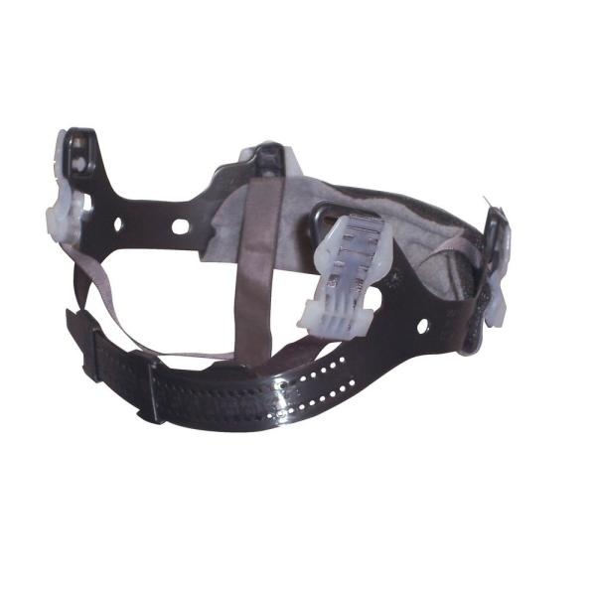
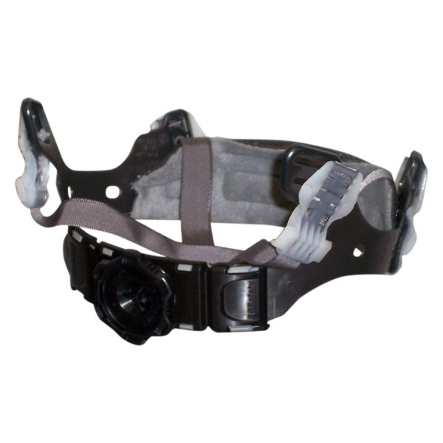
The Bullard Model S61 features Bullard’s three-Rib trademark on the top of its cap style high density polyethylene shell which comes in twenty standard colors (see Figure 1). The outer shell also includes accessory slots and a chin strap attachment. This model’s 4-point suspension system offers users an option between a pinlock (see Figure 2) or upgraded Flex-Gear ratchet suspension (see Figure 3) with an absorbent cotton brow pad (Bullard “Standard S61 Bid Specs,” 2015). The difference between the two options is that a pinlock suspension means you must remove your hat to adjust the sizing by pairing the appropriate pin with the right hole, while Bullard’s Flex-Gear suspension is adjusted by large easy turn ratchet knobs and provides a more comfortable, secure fit. Both adjustment options are capable of vertical height adjustment (two front, two rear) for a better fit. The pillowed cotton brow pad is replaceable and available in other materials such as absorbent cotton, a cooling material, or a vinyl material, and accessories such as earmuffs and face protection can be attached to the accessory slots (Bullard “Standard S61 Bid Specs,” 2015).
Figure 2: Bullard’s 4-Point Pinlock Suspension (Bullard, 2021)

Figure 3: Bullard’s 4-Point Flex-Gear Ratchet Suspension (Bullard, 2021)

Dimensions
Width- 8.62” (218.95 mm)
Length- 10.85” (275.59 mm)
Height- 6.08” (154.43 mm)
Weight- 12 oz (Bullard “Standard S61 Bid Specs,” 2015)

Conclusion
Thank you for considering Bullard’s Standard S61 hard hat for your personal safety. With your new knowledge of Bullard’s history, you understand that as the first to create hard hats they have intimate knowledge and more experience with safety hats than any other company. Bullard has been concerned for their client’s safety since 1919 and continues to prioritize safety even as their company grows and evolves. The Bullard Standard S61 is perfect for construction and work environments with comfort, safety, and adaptability built in.

References
Bullard. (2015). Standard S61 Bid Specs. Bullard. https://www.bullard.com/uploads/bullard_downloads/HP_S61_BIDSPECS_AM_EN_LOW_8355.pdf.
Bullard. (2021). Accessories. https://www.bullard.com/product/hard-hat-accessories-and-replacement-parts.
Bullard. (2021). Bullard's History. https://www.bullard.com/about-bullard.
Bullard. (2021). History of Bullard Hard Hat. https://www.bullard.com/history-of-the-hard-hat.
Cooper Safety. (2021). Bullard S61 Standard Series Hard Hats w/ Ratchet Suspension. Cooper Safety Supply. https://www.coopersafety.com/hard-hats/safety-hard-hats/bullard-s61-standard-series-hard-hats-w-ratchet-suspension.html.

Audience Profile Sheet
Kind of Reader: Primary ____ Secondary ____
Reader’s Name: A construction worker, intern, project manager, and/or engineer who needs a safe and approved hard hat to work in a designated hard hat area.
Reader’s Job Title: unknown.
Education: High School, Trade School, and/or bachelor’s degree.
Professional Experience: People who work in or visit potentially dangerous areas such as construction workers, or engineers.
Job Responsibilities: Staying safe and adhering to OSHA requirements on a work site.
Personal Characteristics: unknown
Personal Preferences: unknown
Cultural Characteristics: unknown
Attitude Toward the Writer: n/a
Attitude Toward the Subject: Interested in their personal safety
Expectations about the Subject: n/a
Expectations about the Document: n/a
Reasons for Reading the Document: To properly choose a hard hat that will keep them safe on job sites (specifically hard hat designated areas).
Way of Reading the Document: Skim it ____ Study it ____ Read a portion of it ____ Which portion?
Modify it and submit it to another reader ____
Attempt to implement recommendations ____
Use it to perform a task or carry out a procedure ____
Use it to create another document ____
Other ____ Explain:
Reading Skill: High School English.
Reader’s Physical Environment: n/a

Reflection
I wrote a technical description about hard hats because I believe that it is important to know intimately about products that are meant to keep you safe and protected. While I am currently undecided, I intend to be a civil engineering major with a focus in structural and construction engineering. My career goal is to become a construction manager. One of the aspects of being a construction manager that attracted me to the job is that construction managers are often on site when working on a project. However, this pro comes with its cons. On a construction site you are required to adhere to OSHA, being aware of what is acceptable by those guidelines and what is not acceptable is important. That is why I specifically chose to write a technical description about a hard hat that is in compliance with OSHA guidelines and made by a brand renowned for safety.
The genre of this assignment is a technical description. Technical descriptions are found in a variety of places, such as proposals and product instructions, as well as often being found accompanying a product while online shopping. My technical description is a standalone document and could be an accompanying document anywhere a Bullard Standard S61 can be purchased. A technical description gives readers detailed information about the background of a product and brand, the components of the product, and an explanation about the proper usage of the product. In my technical description I gave background on the brand and the history of the product within the brand with callouts to standard developments of the item outside of the brand. I then moved on to describe the specifications of the product and explained the difference between the two given options for adjustment of the product: the pinlock suspension and Flex-Gear ratchet suspension. I accompanied my explanation with graphics of the product and the individual adjustment options offered. The media for this assignment is digital since it is an online assignment and digital document, however if it were to be printed and administered it would become multimodal media.
The purpose of this technical description is to inform and educate people interested in buying the Bullard Standard S61 about the product. My technical description includes background information about the manufacturing company and the history of the product within the company, before delving into the specifications and features of the product. The exigence of this technical description is that as an aspiring construction manager I hope to one day work on job sites, and to properly and safely do that I must adhere to safety regulations such as wearing a hard hat. Purchasing an item that is meant to protect you from harm is an important task and you must do proper research before committing to buying in order to prioritize your safety. I hope that reading my technical description will help people like me make an informed decision about their personal safety.
The audience for this document is people interested in purchasing a hard hat for work in potentially dangerous areas. In the interest of appealing to a broader audience in terms of language and education, I used simple terms and explained any vocabulary that would be unfamiliar. The stance of this paper is neutral, while I believe that Bullard’s Standard S61 is a reputable product, I do not object to products of other brands or even different models of the same brand that may be a better fit for the audience’s unknown personal preferences and uses.
In the process of writing this assignment I have met the course learning objective of enhancing strategies for reading, drafting, revising, editing, and self-assessment. I volunteered my paper to be used in the class fishbowl in the interested of gaining constructive criticism that would help me improve my work. I revised my paper multiple times taking my peers’ criticisms into consideration before submitting the final version.

