City College of New York
Engl 21007- L
Writing for Engineers- Hybrid/Online Section
Fall 2021

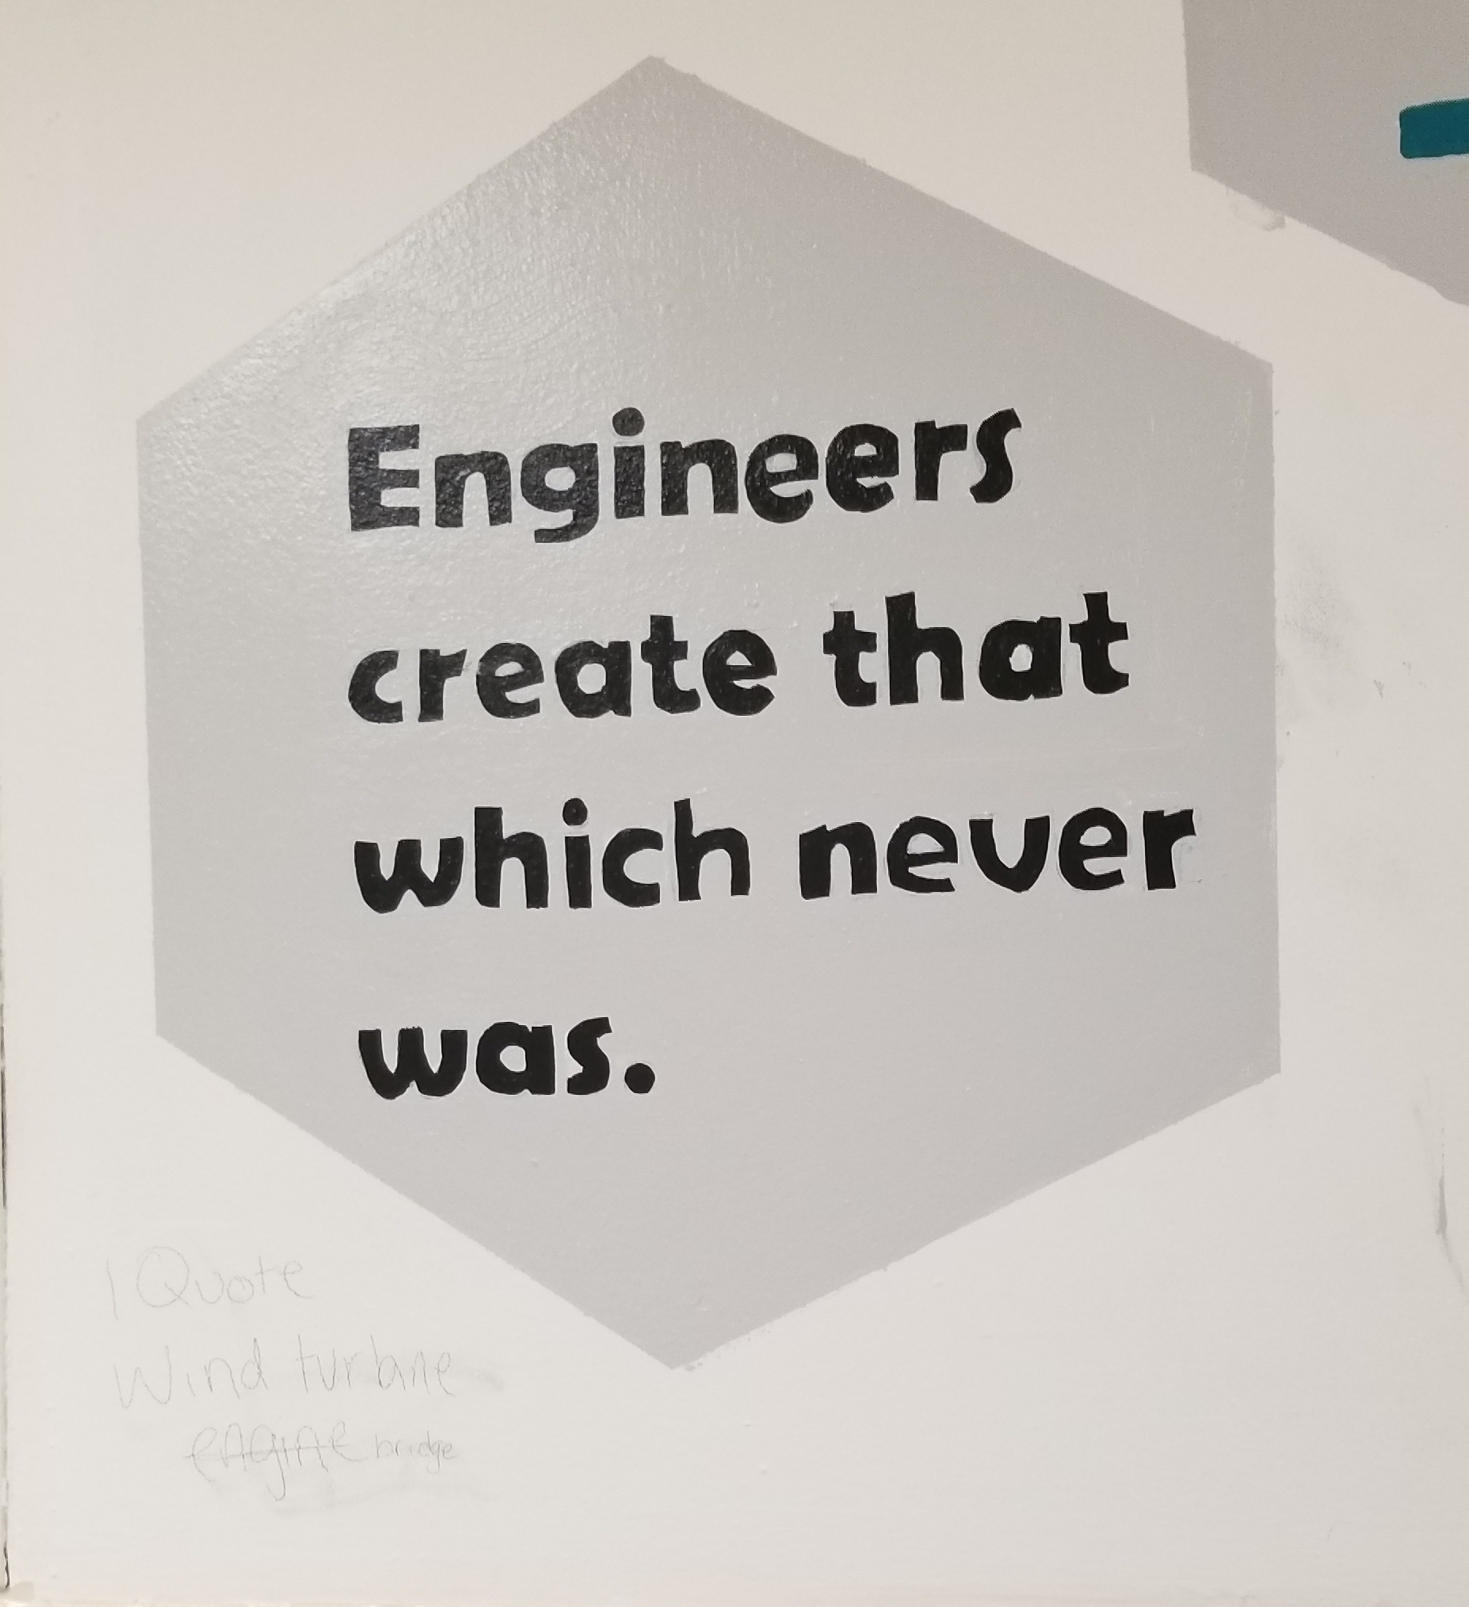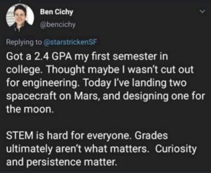

Course: Engl 210, Section L
Classroom: Zoom Virtual Classroom https://ccny.zoom.us/j/86890508347
Schedule: Tuesdays and Thursdays, 9:30am-10:45am
Writing Instructor: Danielle Carr
Office Location: The “Virtual Classroom”
Office Hours: Thursdays 1230-130 in the “virtual classroom” and by appointment
Email: dcarr@ccny.cuny.edu
Phone: 914-462-7330

Course Description:
This course will help you to hone the critical reading and thinking, research, and writing you will need to succeed in all of your writing courses and specifically your engineering courses. This course is also preparing students to write as engineers in professional environments. We will examine, analyze, and create various types of technical communication such as: memos, letters, instructions, definitions, descriptions, designs, proposals, and presentations. You will learn to synthesize information, find answers, and present ideas to some of the different audiences you will encounter. Learning to write well will enable you to present yourself in the best possible light in all situations. You will learn how to communicate your knowledge, plans, and ideas in a professional manner. Our time in this course will focus on reading and listening, essential steps in the writing process, effective writing, synthesizing material from various sources, and the ability to locate and evaluate relevant library and online research. We will also examine how writing is impacted by the elements of the rhetorical situation. By the end of the course, students should be confident in utilizing this knowledge in the construction and completion of a writing portfolio and self assessment.

How This Course Works:
Due to the Covid 19 pandemic, this fall 2021 semester will be conducted in a unique way. For students, this means that our class meetings will usually take place synchronously, or at the scheduled time in the “virtual classroom” on Zoom where attendance will be taken. There will also be days that the class will meet asynchronously, where there will be no “formal meeting,” but there will be an assignment due and that will count as both attendance and classwork grad for the day. You will be notified in advance. The traditional, literal, face to face (f2f) classroom meetings are being temporarily replaced by zoom meetings in the virtual classroom. Hopefully, this won’t change too much of your class experience. This class is also heavy on group work. Groups will be determined by the instructor and will remain throughout the semester (barring any unusual occurrences). Between group work and distance learning, students might find that this experience mimics the way that engineers work in “real life.” Students will still be responsible for attending all scheduled f2f classes on zoom and handing in all work ON TIME and properly done, via email or on Blackboard. You will also be responsible for posting projects and presentations in specific folders and also posting responses to these projects. I will let you know when these postings are due, keep in mind they are mandatory as they are part of your homework and participation grades. Asynchronous assignments will also have time sensitive deadlines. These responses can transfer to discussions held in class, so they must be thought provoking and thorough. However, it is extremely important for students to attend all in synchronous class meetings as well, as these meetings are when students will learn the required genre work for the class and discuss the assignments for the course.

Course Learning Outcomes:
Over the course of the semester, you will
- acknowledge your and others' range of linguistic differences as resources, and draw on those resources to develop rhetorical sensibility
- enhance strategies for reading, drafting, revising, editing, and self-assessment
- negotiate your own writing goals and audience expectations regarding conventions of genre, medium, and rhetorical situation
- develop and engage in the collaborative and social aspects of writing processes
- engage in genre analysis and multimodal composing to explore effective writing across disciplinary contexts and beyond
- formulate and articulate a stance through and in your writing
- practice using various library resources, online databases, and the Internet to locate sources appropriate to your writing projects
- strengthen your source use practices (including evaluating, integrating, quoting, paraphrasing, summarizing, synthesizing, analyzing, and citing sources)

What You’re EXACTLY Doing in This Course:
In this course you will learn to read, write, and speak thoughtfully and critically within your discipline. You will produce various written works in discipline specific genres and give presentations surrounding scientific topics of your choosing. Hopefully this rhetoric and writing practice strengthens your writing skills throughout your academic and scientific career.
Also, to simulate the engineer’s “experience,” you will spend much of the semester in instructor selected groups, in which you will consider the topic, direction, and composition of your projects together. However, MOST of the time, you will compose and submit individual assignments.

Required Textbook(s): Technical Communication by Mike Martel, 13th edition, Bedford/Saint Martin’s
- Supplemental Readings will be made available on Blackboard, CUNY Commons course site, or as handouts and distributed in class.
- Complementary textbooks (which, from time to time we might reference), include https://digitalcommons.kennesaw.edu/opentc/
https://open.umn.edu/opentextbooks/textbooks/412

CUNY Commons Course Website- https://engl210ccny.commons.gc.cuny.edu/
Houses various documents/files necessary for coursework
Semester Calendar

Thursday, August 26- First Day of Classes!
Tuesday, August 31
Thursday, September 2
Tuesday, September 7- No Class!
Thursday, September 9
Tuesday, September 14
Thursday, September 16- No Class!
Tuesday, September 21
Thursday, September 23
Tuesday, September 28
Thursday, September 30
Tuesday, October 5
Thursday, October 7
Tuesday, October 12
Thursday, October 14
Tuesday, October 19
Thursday, October 21
Tuesday, October 26
Thursday, October 28
Tuesday, November 2
Thursday, November 4
Tuesday, November 9
Thursday, November 11
Tuesday, November 16
Thursday, November 18
Tuesday, November 23
Thursday, November 25- No Class- Thanksgiving Break!
Tuesday, November 30
Thursday, December 2
Tuesday, December 7
Thursday, December 9- Last Day of Classes!

Class Policies

Lateness and Absences
- According to the CUNY CCNY Undergraduate Bulletin: http://www.ccny.cuny.edu/registrar/upload/2013-2015-Undergraduate-Bulletin.pdf (page 215)
Students are expected to attend every class session of each course in which they are enrolled and to be on time. An instructor has the right to drop a student from a course for excessive absence. Students are advised to determine the instructor’s policy at the first class session. They should note that an instructor may treat lateness as equivalent to absence. No distinction is made between excused and unexcused absences. Each instructor retains the right to establish his or her own policy, but students should be guided by the following general College policy: In courses designated as clinical, performance, laboratory or field work courses, the limit on absences is established by the individual instructor. For all other courses, the number of hours absent may not exceed twice the number of contact hours the course meets per week. When a student is dropped for excessive absence, the Registrar will enter the grade of "WU".
In other words: each student can miss up to THREE classes. FOUR absences results in a failure of the course. Students are expected to be in class ON TIME and remain for the duration of class. IF there is an unavoidable issue which prevents the student for remaining in the class for the entire period (as in necessity for lateness or early departure) please let the instructor know prior to arrival via email. If attendance/lateness is going to be a problem, consider switching from this section, it’s an early section and if I can arrive to school on time, ready to work, then so can everyone else.
Attendance will be taken at the beginning of every class session and posted on BB. On asynchronous class days, the submission of required assignments will determine the attendance and will still be posted on BB.

Food and Drink 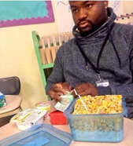 ----------------- Don’t let this be you!!!
Eating/Drinking is allowed in class but do not let it be a distraction to you or your classmates. Also, clean up after yourselves! Classrooms are communal spaces and NOT your personal bedrooms, hotel rooms, or kitchens. They need to be kept clean by ALL who use them.

Electronic Devices 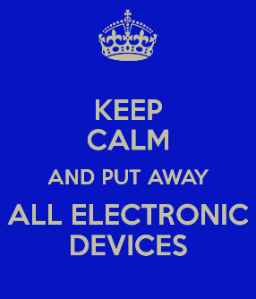
If it beeps, vibrates, rings, plays music, or has a screen, mute it before you enter class. Cell phone use is prohibited during class. Silence your cell phone, put it away before you enter the room and keep it away for the duration of class. If there is an emergency, quietly step out of the room to handle it. Tablets and computers can be used as note-taking devices or E-book readers if that is how students wish to transcribe information or read text. However, those devices can only be used SOLELY for that purpose, no web surfing, social media, or any other recreational use during class time. When those devices are not needed, they should be “sleeping,” face down, and out of reach.
“Don’t Yuck My Yum” 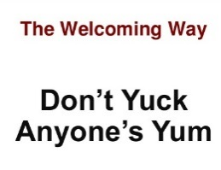
Each and every one of us, including myself, comes from a diverse background, environment, and has a unique life experience and skill set which contributes to our worldview and opinion. As members of a classroom community, school community, and society, etc., it is our duty to remember this and respect all viewpoints, even if we don’t agree with them. Remember, there are constructive ways to criticize.

Assignments and Due Dates 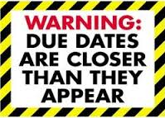
Assignments are due on the due date both in print and on blackboard unless previously arranged with the instructor. The campus is full of computer and print labs, save your work, get a cloud or a thumb drive and plan for all possible technological failures. In the case that any student will be absent on a due date, plan to submit work early! I prefer not to read on screen, so emailed work is frowned upon unless given prior permission If you are submitting print work AFTER class and I’m not there for you to put it in my hands, you MUST put it in my mailbox across from the English department and MAKE SURE someone signs and dates your submission. Work without a time and date stamp will be considered late. Work submitted after the due date will be deducted by half a letter grade every day that it’s late. First draft due dates are listed on the weekly assignment schedule, final draft due dates are due 1-2 class meetings after you receive your essays back with either my or peer comments. The exact dates will be announced in class. Various assignments will be required to be posted on Blackboard. You will receive advanced notice for this and there will be a section on Blackboard for the submission. In these cases, submission both on paper and online is required and one without the other can and will affect your grade.

Academic Integrity
Plagiarism is the unacknowledged use of another person's words or ideas. You can use other people’s ideas as much as you want and/or need to. Just make sure to properly give credit where credit is due. Words copied verbatim from another source must be quoted and the source must be cited. When you paraphrase words/ideas from another source, you must acknowledge the original author unless the ideas are common knowledge (information found in three or more different places). If you collaborate with another author to produce written work, you must acknowledge that person's contribution. “Borrowed” material must be properly cited in APA format, as is the preferred citation for the sciences. Anything incorrectly cited is considered plagiarism and is graded as an F. If there is any further question about the parameters of academic dishonesty reference page 230 of the CUNY Policy on Academic Integrity appears on page 230 of the City College of New York Undergraduate Bulletin 2013-2015.
- http://www.ccny.cuny.edu/registrar/upload/2013-2015-Undergraduate-Bulletin.pdf
All writing submitted for this course is expected to be your own. If a student’s submission contains any forms of plagiarism, he/she is at minimum subject to a failing grade for the project and/or course, and worst case scenario, academic suspension or expulsion. Part of the function for this course is to teach students how maintain academic integrity and to cite sources properly according to the standards of the American Psychological Association (APA) in order to avoid cases of inadvertent plagiarism, As part of this course, we will discuss strategies for adhering to standard conventions for responsible source use and for maintaining academic integrity and how to avoid inadvertently plagiarizing someone else’s work.
You can learn more about plagiarism at the following link: www.wwnorton.com/college/english/write/writesite/research/plagiarism_tutorial.aspx
Here are five practices defined as plagiarism in the CUNY Policy on Academic Integrity:
- Copying another person’s actual words without the use of quotation marks and footnotes attributing the words to their source.
- Presenting another person’s ideas or theories in your own words without acknowledging the source.
- Using information that is not common knowledge without acknowledging the source.
- Failing to acknowledge collaborators on homework and laboratory assignments. Submitting downloaded term papers or parts of term papers, paraphrasing, or copying information from the internet without citing the source, and “cutting and pasting” from various sources without proper attribution.

If you need ANY help at all outside of the classroom pertaining to anything at all, from writing issues and tutoring, to feeling overwhelmed, or anything in between, utilize these resources…

The Writing Center
http://www.ccny.cuny.edu/writing/
The CCNY Writing Center offers a supportive learning environment where students can have one-on-one tutoring sessions with writing consultants. It is a great resource for you to obtain extra help as you write and revise your papers. They DO NOT proofread your papers, but offer assistance on improving certain aspects of them. They also offer ESL tutoring. To set up an appointment or semester-long sessions, contact them in person at the Writing Center, which is located in the NAC, 3rd floor plaza or call (212) 650-8104. They will be partially open starting 9/8, and fully operational starting 9/15. I strongly advise you contact them as soon as possible, even if you don’t have anything specific you need assistance with yet.

Gateway Advising Center, NAC 1/220
http://www.ccny.cuny.edu/gateway/
Students without a declared major can receive academic advising, especially if you have questions about your course of study, core requirements, etc.

AccessAbility Center Tutoring Services, NAC 1/218
http://www.ccny.cuny.edu/accessability/
Provides one-on-one tutoring and workshops to all registered students with learning or physical disabilities.

SEEK Peer Academic Learning Center, NAC 4/224
Phone: 212-650-5786; Email: seekpals@ccny.cuny.edu
Offers counseling and peer tutoring for students in need of academic and financial support who have registered for the SEEK Program.

Campus Counseling Center, Marshak J-15
Phone: 212-650-8222, Email: counseling@ccny.cuny.edu
http://www.ccny.cuny.edu/counseling/
The Counseling Center offers short term individual and group counseling to help students deal with their personal and adjustment issues that may interfere with their ability to progress academically to their fullest potential.

Instructor, see front page for contact information and location
If there’s something you feel I can’t help you with during class time, please do NOT hesitate to reach out and contact me. I frequently answer email and I love hard working students.

Grading Breakdown
Students will be assigned a grade for the writing section based on their completion of their assignments, participation, and attendance according to the following breakdown:
Attendance and Participation, (online and f2f),
Coursework and in class writing 15% 94%-100% A 70%-72% C-
-Diagnostic Essay (letter to professor) 90%-93% A- 66%-69% D+
Lab Report 15% 86%-89% B+ 60%-65% D
Technical Description 15% 85%-83% B 0%-59% F
Group Project 20% 80%-82% B-
--Proposal 10% 76%-79% C+
--Presentation 10% 73%-75% C
Self Assessment/Portfolio 20%
Memo- 15%
Required Assignments
In addition to smaller assignments that will be assigned throughout the course of the semester, the bulk of the coursework will focus on 3 major assignments given with the goals of reinforcing lessons, meeting learning outcomes, and increasing writing, analytical, and rhetorical skills. These will be done in a series of drafts with scaffolding assignments in order to both lead up to the assignments and provide students opportunities for revision.

- Diagnostic Writing Assignment- 500 word minimum- two fold assignment, read in entirety!!
  - Write a professional letter to me about your life, your experiences, your achievements, your talents. What is your major in college and how does your major connects to your professional goal(s)? Include where you are from and how you want me to see you. Write about your challenges as well as your successes. How do you imagine your future place in the world of engineering? What are some of the engineering challenges you would like to be involved with? How do you plan to impact change in your world with your degree? Must include a substantive section on an “artifact,” an item that is most important to your area/concentration. Please integrate this into the letter. For example, computer engineers could discuss a mouse, keyboard, etc. Must describe the item in detail and discuss the significance of the item. You will (eventually) bring in this item (or a photo) and present it to the class. This item CANNOT be your cellphone or computer unless you are/have built the I Phone 15 or Samsung S25 or your own PC. But you can’t just select your MacBook Pro and write about it.

    - This is a formal letter, addressed to me (use the school address below), and signed at the end by you. Type in 12 point New Times Roman font, normal margins. (See the Kennesaw website, chapter 2.1, for letter templates, on the course website AND Markel Ch 14 pgs 363-375). This link is also a valid resource https://grammar.yourdictionary.com/writing/how-to-write-a-letter.html

      - My address

Danielle Carr
City College of New York- English Department
- Convent Ave
New York, NY 10031

- Memo- 1-2 pages, (500 words), 1 page reflection paper
- You will write a memo to the president of the City College of New York, addressing a problem on campus. This problem can be related to renovating or improving areas of the campus (cafeterias, dorms, classrooms, parking etc.). Be creative. The idea is to define a problem and offer a specific solution to address this problem. Remember, the president does not know about this specific problem so you will have to provide the context. Important details can be bulleted for easy reading. No cost estimates are required for this memo. Basically, it will be a memo that requires a follow-up meeting for further discussion.
    - Format: 12 pt. New Times Roman, 1 inch margins. Paragraphs are single spaced and left justified. Skip a line between paragraphs. Sections should have heading titles that are in bold face.

- Technical Description- minimum of 4 pages of text, 2 page reflection
  - You will write a description of a simple technological item, more than likely, the item you selected and included in your letter to the instructor assignment.
  - Or, choose one that you are particularly interested in and explain its purpose, as it relates to your concentration. Think carefully about your choice. Descriptions of objects, mechanisms, and processes appear in virtually every kind of technical communication. In addition, instructions are also frequently used.
  - Research and APA citations will be required for this assignment.

- Lab Report- minimum 4 pages of text, 2 page reflection paper
  - Students will compose a lab report based on a lab experiment specific to their chosen area/concentration of engineering. The lab report must have all of the elements of the lab report listed from the discussion/powerpoint from class (the appendix/acknowledgements are not mandatory, but the other elements are). The lab report also requires a bit of research, a minimum of three sources must be cited both in text and listed on the reference page according to APA standards.

- Engineering Proposal + Presentation - Proposal Minimum 5 pages. Self-Reflection 1-2 pages. Presentation, minimum 10 minutes. Each person will write his or her own reflection paper which must include their role in the project (exactly WHAT they did), how they liked (or disliked) working in teams, analysis of the rhetorical elements and how the project met specific course learning outcomes. You will also grade each other’s groupwork performance with instructor issued templates.

  - The assignment is a group/oral report of a proposal for a creative engineering innovation. The following areas of the United States (USVI, Puerto Rico, parts of Florida, and Houston), not to mention islands such as Dominica, islands of the BVI, St Maarten, Barbuda, Cuba, etc were drastically affected by hurricanes Maria and Irma. Most recently the Bahamas was affected by hurricane destruction and Puerto Rico is suffering from massive, random earthquakes. These areas are undergoing massive rebuilding projects, changing infrastructure, and considering ways to update aspects of the islands so that such immense damage does not occur in the wake of other hurricanes. Power grids, computer systems, roads, bridges, buildings, to name a few things, have been destroyed. Hospitals, airports, etc are being severely impacted. Despite the amount of human suffering that has occurred in the wake of these natural disasters, these natural disasters actually make for an engineer’s dream: how can you positively impact these areas in their times of great need? Rebuilding and upgrading to better than once was will take years, especially if natural disasters recur/occur.

    - *You are not limited to this part of the world. If you find a recent natural disaster in another part of the world where your team’s expertise could be of service, clear it with the instructor first.

  - Your task is to consider this in light of your engineering concentration (civil, electrical, computer, mechanical, chemical, etc) and develop a thing/idea that is designed to assist the rebuilding process in some way. Your design might have something to do with infrastructure: bridges, roads, sidewalks, etc. Your idea might have to do with solar panels and electrical grids, water collection (as islands are notoriously yet ironically always short on water), anything, there is no limit to idea but money must be considered (you need a budget, hurricane repair is ALREADY expensive). These are just some ideas you are not required to use them.

  - You will need to do some research to see what problems have surfaced where (as far as issue/island/location) on your own, which you will incorporate into your project (that’s the history/background part).

  - The project requires a brief technical description of your thing/idea, a brief literature review, the proposal, powerpoint, resumés, job postings, and an audience analysis- who are you presenting this to? Who are you impacting/helping with your idea/thing? How will this impact your content?
    - Project objectives:
      - Innovation
      - Process
      - Group work
      - Oral presentation
      - Overall thoroughness and logic of proposal structure

- Reflection paper- typically 1-2 pages, but depends on the assignment.
  - All major writing assignments will require a written self reflection component, which we will discuss in class. Students must make use of the terms introduced in the rhetorical situation and describe how each assignment has helped them to achieve the course learning project. *These must be attached to the final draft of all assignments.

- Final portfolio and self reflection
  - A rhetorical analysis of the student’s work that should include references to elements of the rhetorical situation: genre, audience, purpose, exigence, stance, and media/design, in digital format, on the CUNY Commons.
    - ***There is a possibility that researchers at CCNY will be collecting all assignments from all sections of Engl210 including portfolios and self-assessments. If selected for the study, you will be asked to submit your final work following specific formatting conventions.

On draft work:
“Almost all good writing begins with terrible first efforts. You need to start somewhere. Start by getting something -- anything -- down on paper. A friend of mine says that the first draft is the down draft -- you just get it down. The second draft is the up draft -- you fix it up. You try to say what you have to say more accurately. And the third draft is the dental draft, where you check every tooth, to see if it's loose or cramped or decayed, or even, God help us, healthy.”
– Anne Lammott, Bird by Bird: Some Instructions on Writing and Life

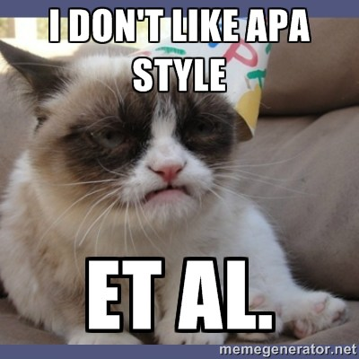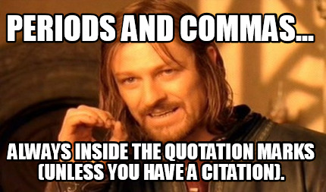
*** All written assignments must be typed using Microsoft Word in 12 point, Times New Roman font, double spaced, with one inch margins, as per APA guidelines. For this course we will be referring to the Purdue OWL website to learn and practice using the new 2020 APA guidelines: digital.wwnorton.com/apa2020 OR
- https://owl.purdue.edu/owl/research_and_citation/apa_style/apa_formatting_and_style_guide/apa_changes_7th_edition.html
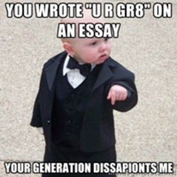 *** Also, while the course objectives do not state that I am trying to create professional grammarians, ALL writing for this course MUST be written in Standard English and not in text slang or colloquial spelling.

Weekly Assignment Schedule

Date | In Class | Assignment
Week 1
Thursday 8/26 | Review syllabus, ice breaker, assign and explain diagnostic essay assignment, discuss “Theme for English B.” | Read Markel Ch 1, pgs 3-10, Ch 5 and Ch 14, pgs 377-385, 388-395. Complete introduction letter, due 8/31
Week 2
Tuesday 8/31 | Discuss elements of Rhetorical situations, genre, stance, exigence, purpose, media/design, and audience. In class writing assignment on rhetorical situation and audience analysis. Essay/letter due. | Check on the groups posted on BB. Read Markel Ch 3, 8, 9, 10, 14 pgs 386-388, read student sample directions on “how to send an email” on course site.
Thursday 9/2 | How do engineers communicate? Discussion on assignment #1- memo, reflection papers, audience analysis. | Genre Analysis homework on memo (individual), group work- each group must post their decision/discussion on their memo topic in the appropriately marked BB discussion area AND comment on each group’s post. Due Sunday 9/5. Memo due 9/9, one draft.
Week 3
Tuesday 9/7 | NO CLASS! | Markel ch 20. Memo due 9/9
Thursday 9/9 | Memo due. In class assignment and discussion on descriptions and instructions. Discuss assignment #2- technical description. | Read Markel Ch 6. First: Group assignment: Groups must develop a set of instructions. Post on BB and prepare to present to the class on 9/14. View past student samples on the course website. Second: Individual assignment: Post your selection on an item for your technical description assignment. Provide a substantive on three different student posts. Due by Sunday 9/13.
Week 4
Tuesday 9/14 | Group presentations on directions.  Continue discussion, APA citations and quotations. | Read and complete: read the assigned student samples on tech descriptions and complete genre analysis. Post on BB. Draft work on Tech descriptions due by posted 9/20 on BB for in person (virtual) peer review. Read the drafts in your group be prepared for in class peer review sessions on 9/21.
Thursday 9/16 | NO CLASS! | Draft work due 9/20 for peer review session on 9/21.
Week 5
Tuesday 9/21 | In class (virtual) peer review.  *Possible in person in the ALC. Wait for instructions | Final drafts due 9/23
Thursday 9/23 | tech descriptions due.  No formal class meeting. Complete asynch #1, post to BB. | Read Markel Ch 19
Week 6
Tuesday 9/28 | Discussion on lab reports | Genre analysis homework due 9/29
Thursday 9/30 | library meeting online! | Lab report posts and comments are due on BB by 10/4
Week 7
Tuesday 10/5 | No formal meeting, complete asynch #2 (individual) + the extension (group work) | Complete the extension assignment, and post on BB, prepare to present
Thursday 10/7 | lab report presentations | First drafts due on 10/11 on BB
Week 8
Tuesday 10/12 | Lab report peer review workshop | Final drafts due on Thurs 10/14.  Read Markel 10, 15, 16, material on Job Postings, begin to consider possible topics for project
Thursday 10/14 | Final drafts due.  Discussion- job posting, resumé, genre of technical proposal | Genre analysis homework- Read student samples and continue research
Week 9
Tuesday 10/19 | Continue discussion. | Post your resumé on BB.
Thursday 10/21 | **Possible asynchronous class meeting, continue discussion | Post brief abstract on projects on BB, comment on other groups, due Sunday 10/24
Week 10
Tuesday 10/26 | **informal class meeting- discuss student/group abstracts etc. ***group meetings are mandatory! If missed, must be scheduled and made up. | Read Markel Ch 4 & 21, review ch 8
Thursday 10/28 | Discussion on powerpoints | Continue working on projects
Week 11
Tuesday 11/2 | Complete asynch #4- group work, no formal class meeting | Read Markel ch 11 & 12
Thursday 11/4 | Complete asynch #3- individual | Draft work on project due by 11/8
Week 12
Tuesday 11/9 | Peer review on project proposals
Thursday 11/11 | In class presentations!
Week 13
Tuesday 11/16 | In class presentations!
Thursday 11/18 | In class presentations!
Week 14
Tuesday 11/23 | *possible asynch lecture-  Begin discussion on final projects, self assessment portfolio- set up CUNY commons website skeletons | Post completed skeletons on BB by 11/29
Thursday 11/25 | No class!- Thanksgiving break
Week 15
Tuesday 11/30 | Discussion of projects | Genre analysis
Thursday 12/2 | Discussion of projects and genre analysis | Online peer review
Week 16
Tuesday 12/7
Thursday 12/9 | Last day of classes!  In class peer review of websites. | Final project due/Enjoy break **Last possible day for project submission is 12/21!!

