How to properly use a Soldering Iron to join wires
Group 3: Baljinder, Gentian, Kodie, Khizar

What is a Soldering Iron?
A soldering iron is an electric hand tool used for joining two pieces of metal together. It produces a liquid-like(which is the melted soldering iron rod) when heated at an average temperature of about 330 degrees Celsius. The melted iron then holds the two pieces of metal together when dried allowing them to have better connectivity. This tool is commonly used for other purposes such as plumbing or art, but is best known for its connection to wires.
Importance:
A soldering iron is a tool used by almost all engineering concentrations. It is one of the most useful tools due to its versatility. It can be used anywhere from plumbing, to art, to even large scale manufacturing. The most common application for a soldering iron is to use it to connect wires together, This is what is explained in this instruction document. Soldering Irons are not only very useful, but also very dangerous.
Warnings:
Soldering Irons are a very useful, and dangerous tool. They work by heating up metal to melt it, meaning they can and will leave you with burn marks if you do not take the appropriate precautions. Make sure to wear gloves and goggles if available.
Soldering Irons can also emit fumes depending on the material it is being used upon, make sure to be in an open space. Do not touch the Soldering iron once it is hot, the end of the metal that is being used, and the wire when soldering(excluding the person holding it in place).
Materials:
1 Soldering Iron
The metal you will solder(typically provided with a soldering iron)
Shrink Tubing
A heat source(hair dryer or a heat gun)
Two wires(if they are not stripped then you will need to strip them with a stripper or scissors)
Steps:
- Find the materials(wires) you wish to join. Make sure they are not active.
- Put the Solder to heat up now so that it is ready by step 7.
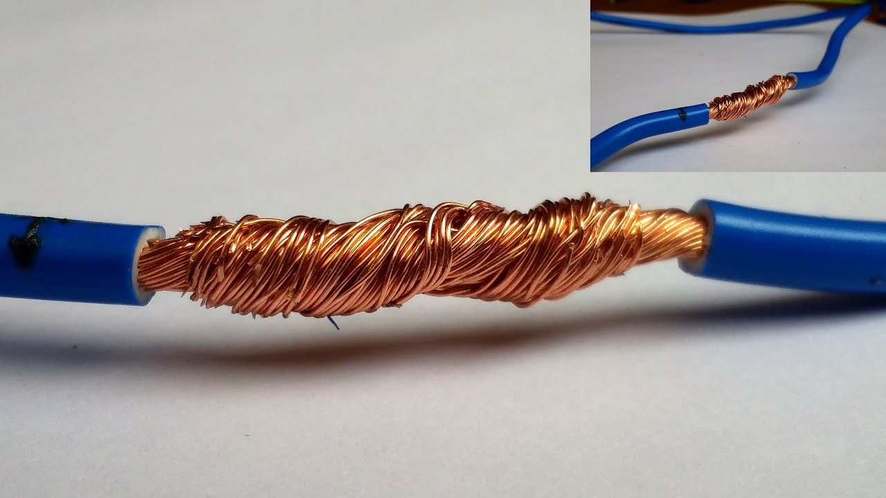
- Make sure to have the wires stripped at an appropriate length of their outer coating.
- Use your hands to twist the two wires together to connect them. Make sure that the connection is long and is tight as seen in this image(via XtraRange on Youtube).
- This is a step to ensure safety, have someone hold the two wires by the rubber coatings or have something weigh down the wires so they do not move.
- Place something below the area you are going to solder, such as a paper towel or a cloth.
- Hold the metal provided with the solder or metal of your choosing(make sure it works with your solder) above the wires and slowly touch the solder to the metal making it melt onto the wires. Refer to the image(via AriesTheRedNose on Youtube).
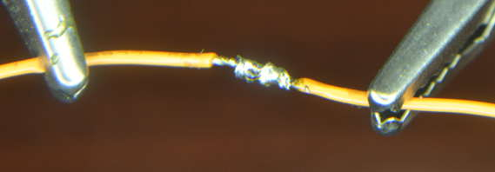
- As this is your first attempt, take it slow and steady. Not all of the metal is needed for the wire. Just have full coverage over the exposed part of the wire. This ensures that electricity will flow properly through the wire. Refer to the image(via Instructables.com) to see how this should look.
- Now that you have successfully soldered the wire, let the metal cool and solidify. The time this takes varies, but give it 30 minutes to be on the safe side. After the metal has cooled, place shrink tubing on the wire and heat up the shrink tubing using heat(hair dryer or heat gun work best).
- After the shrink tubing has shrunk onto the soldered area, you have successfully soldered a connection between two wires!

Conclusion:
It can be concluded that soldering irons are very important tools used by engineers. All they fundamentally do is heat up and melt things. This is displayed in this document as we displayed the steps on how to solder two wires together using metal. Soldering irons are very dangerous tools, but they hold immense potential as to what can be achieved with them. Using the steps shown above, you can solder two wires together giving them improved flow in terms of electricity. This allows the once two wires to seemingly become one.

