How to Change a Flat Tire
Equipment:
- Jack
- Lug nut wrench/Tire iron
- Spare tire
- Owner’s manual
- Wooden blocks/bricks

Set-Up:
- Park on level ground then engage the parking brake
- If the car has manual transmission leave it in first gear or reverse. For automatic transmission, leave it in park.
- Remove the hubcaps, reference your vehicle’s manual if you are not sure how to do so
- Remove any plastic lug nut covers and set them on the side to replace later.
- Loosen the lug nuts using either your tire iron or lug nut wrench by going in a star pattern, loosening one a half turn and then moving to the one opposite it. Do this until they are all unscrewed half a turn. Righty Tighty, Lefty Loosey.
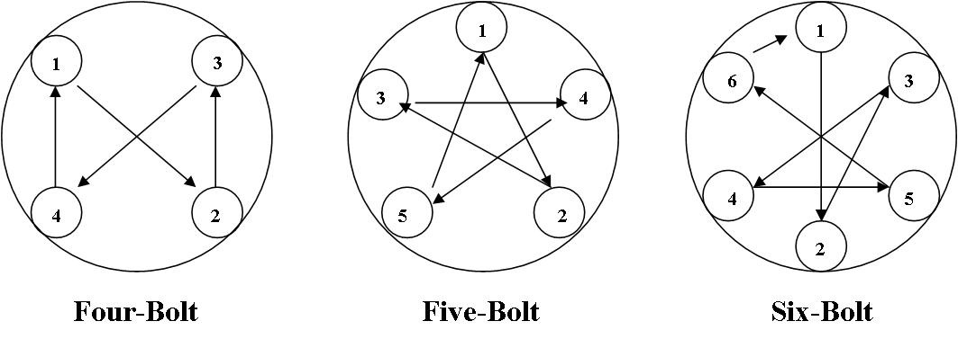

Jacking the Car:
- Before setting up your jack, place either a brick or wood block to prevent slipping
  - If jacking from the side of your vehicle, place the block/brick in front of the tire diagonal from the flat
  - If you are jacking the car from either the front or the back, wedge the blocks in front and back of both tires that are opposite from the jack
- Reference your owner’s manual for the safest place to jack your car, before placing the jack under the car’s frame.
**NEVER get under a car that is only supported by a jack, the jack could slip**
- Insert the handle into the jack and turn clockwise to raise the car high enough to replace the flat. Your new tire will have more air, so leave yourself room.

Replacing the Tire:
- Completely remove lug nuts and pull off the flat tire, placing it under the car for extra protection
- Replace with the spare tire, making sure the air valve on the tire is facing out
- Replace lug nuts in the same star order you loosened them in
- Lower the jack until the tire touches the ground, watch your feet!
- Completely tighten lug nuts in star order before removing the jack from under your car.
- Remove jack and tire from under the car and then replace hubcaps and plastic covers

Clean Up:
- Place all equipment back in your car for next time
- You have now changed your flat tire, hooray!

