How To Make Lemonade

Group 6: Omosefe, Samin, Haolan and Rafi

Have you ever experienced a hot summer day with your family and wanted a cold, refreshing lemonade? Instead of spending valuable money buying lemonades, you can make your own. Although, making your own lemonade may sound like a lot of work, it doesn’t have to be. With just a few simple materials and a couple of steps, you will be a master in making lemonade for yourself, family and friends.

This recipe makes about 1 ½ quarts of lemonade which can serve about 4-6 people

Materials/Ingredients Needed:
1 Cup of Sugar (Preferably granulated sugar)

5 Cups of Water

1 Cup of Ice

6- 8 Lemons
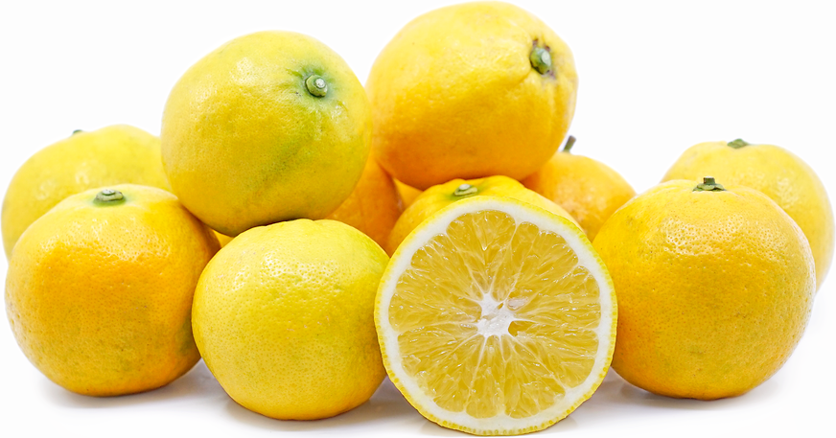
Measuring Cup
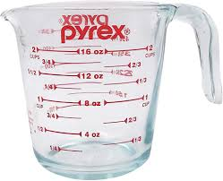
Knife & Cutting Board
Saucepan
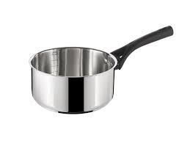
Pitcher
Steps:
- Gather all of your materials- Make sure you have enough space to carry out the rest of these tasks
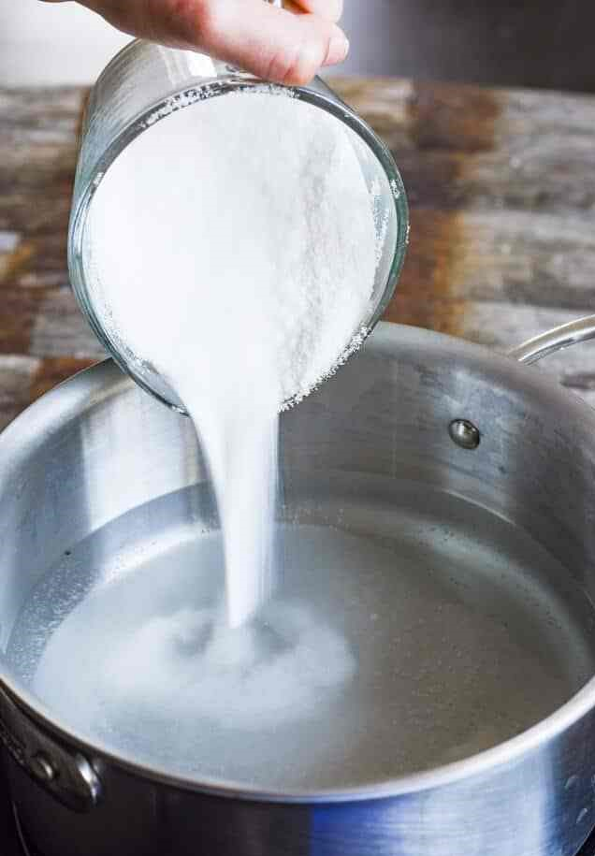
- Make the syrup- In your saucepan, add 1 cup of granulated sugar as well as 1 cup of water and bring this to a slow boil on medium heat. Once the sugar is dissolved, take the saucepan off the heat and place it somewhere else to cool.
- Squeeze the lemons- Gather all of your lemons but leave one behind. Cut all of them in half except for one and squeeze the ones you cut in half into your pitcher. Make sure you squeeze with the cut side facing you so the seeds don’t fall into the pitcher.
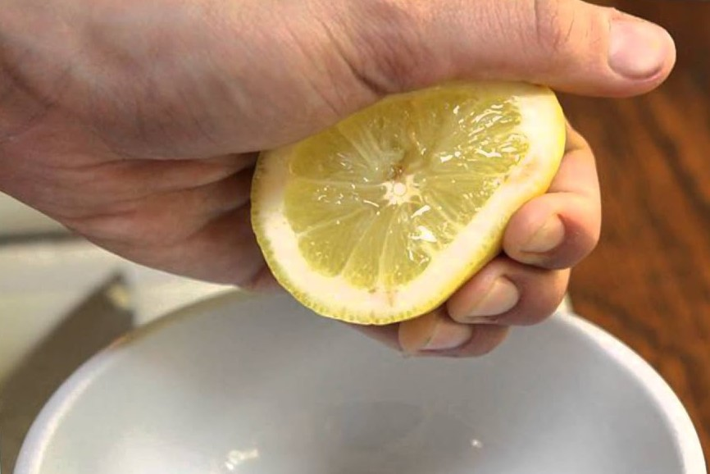
- Add your syrup- Get your cooled sugar syrup and add it to the lemon juice in your pitcher.
- Pour your water- Use the remaining cups of water you have to add it to your lemon juice mixture. Only add enough to water down the sourness of the lemons. The taste is completely up to you to determine.
- Add your ice- Get your one cup of ice and add it to your drink so that you have a nice cold pitcher of lemonade.
  - Keep in mind, the ice can water down your lemonade as well, so be careful with how much you add.
- Complete with garnishes- Finally, cut the last lemon into 5 slices. Place 4 of them into the pitcher and for the last slice cut a slit in the middle so that you can place it on the side of your pitcher.
