How to Post a Photo on Instagram
(Disclaimer: These instructions are for users who already have an account on a smartphone(IOS or Android). The instructions provided below follow Instagram’s Version 175.0.)

Table of Contents

1 The Start of the Posting Process

2 - 3 Selecting the Photo(s)

4 - 5 Placing a Filter

6 - 7 Editing

8 - 10 Location, Tagging, and Caption

11 Final Product

The Start of the Posting Process

Open the application on your device

Once the application is open, click on the + icon located on the top right of the screen

Selecting the Photo(s)

Choose a photo from your phone’s library
- If you wish to choose more than one photo, simply tap “select multiple” on your device
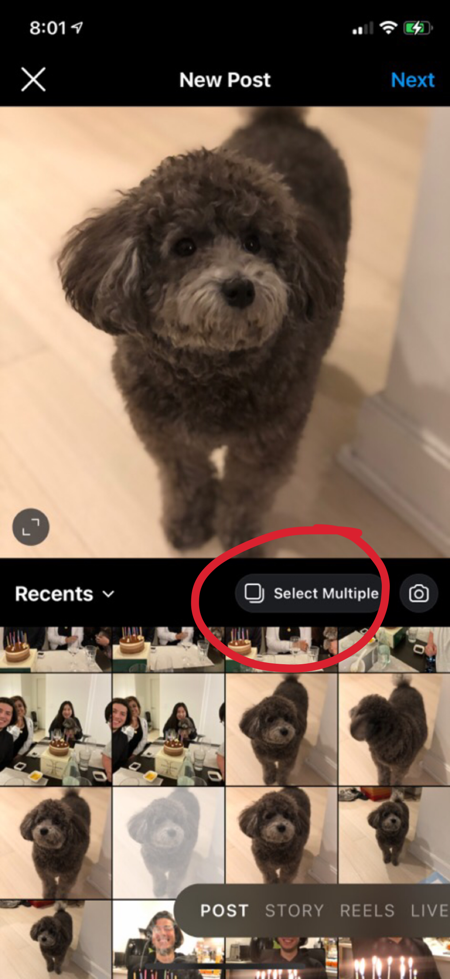
- If you wish to take a new photo, tap on the camera icon
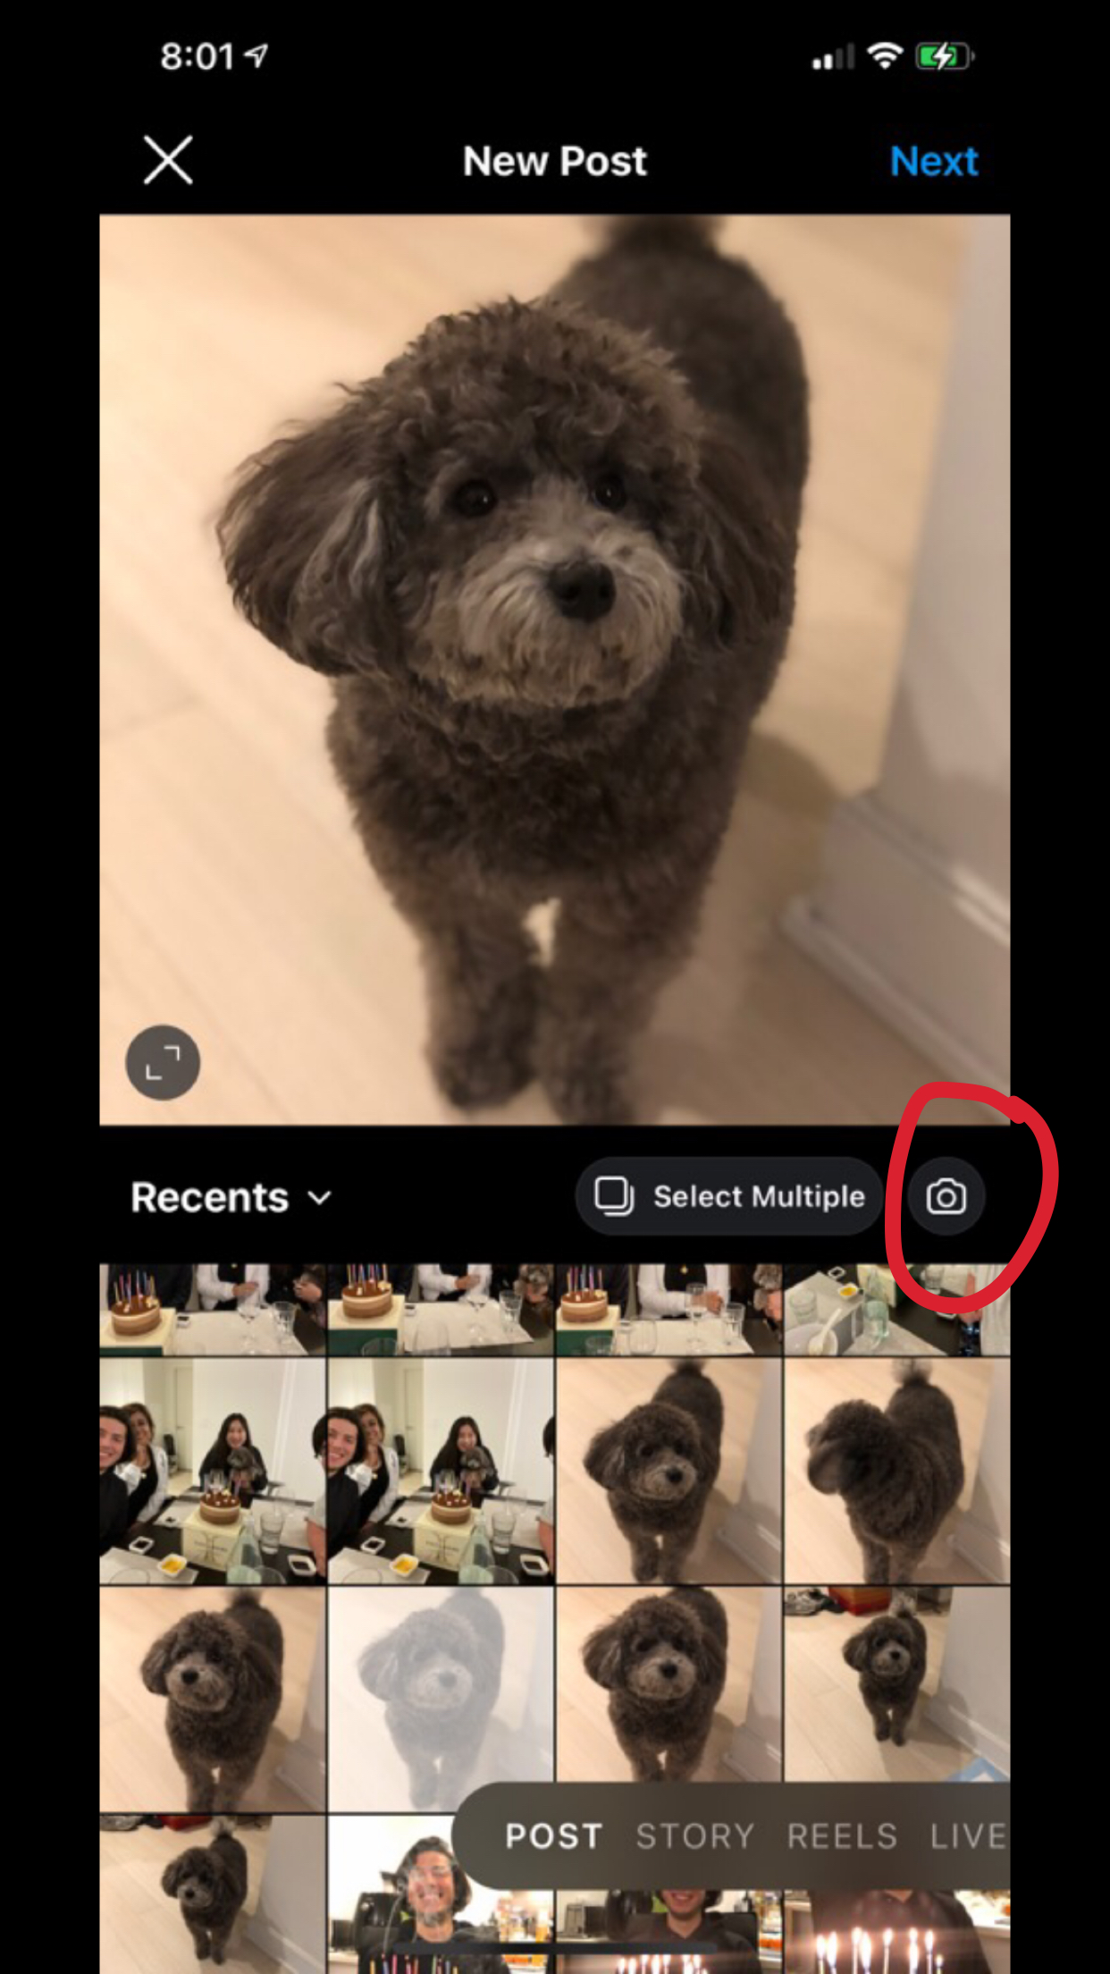

Once you’ve selected the photo you want to post, click “next” on the top right corner where you’ll be given a number of options for editing purposes.
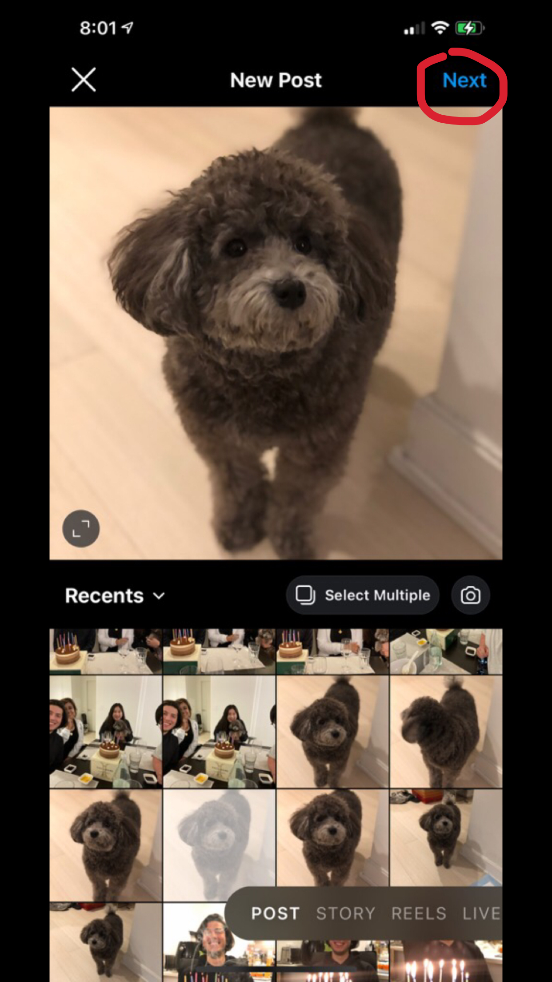

Placing a Filter

Once you choose a photo to upload, you can make changes to the photo as you please.

You can also place a filter on your photo for the desired effect you want to produce.

- If you wish to apply a filter on your photo, you can select the filter you like by tapping on the “Filter” option.
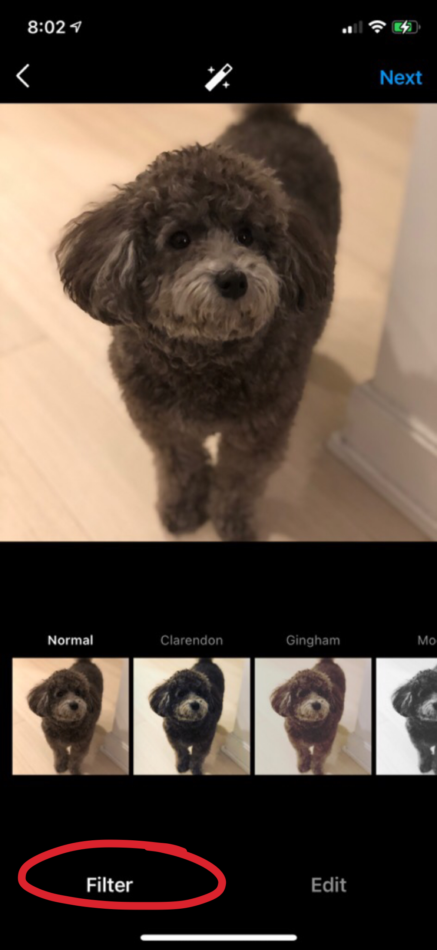
- Filters are as follows: Clarendon, Gingham, Juno, Lark, Mayfair, Sierra, Valencia, and Walden.
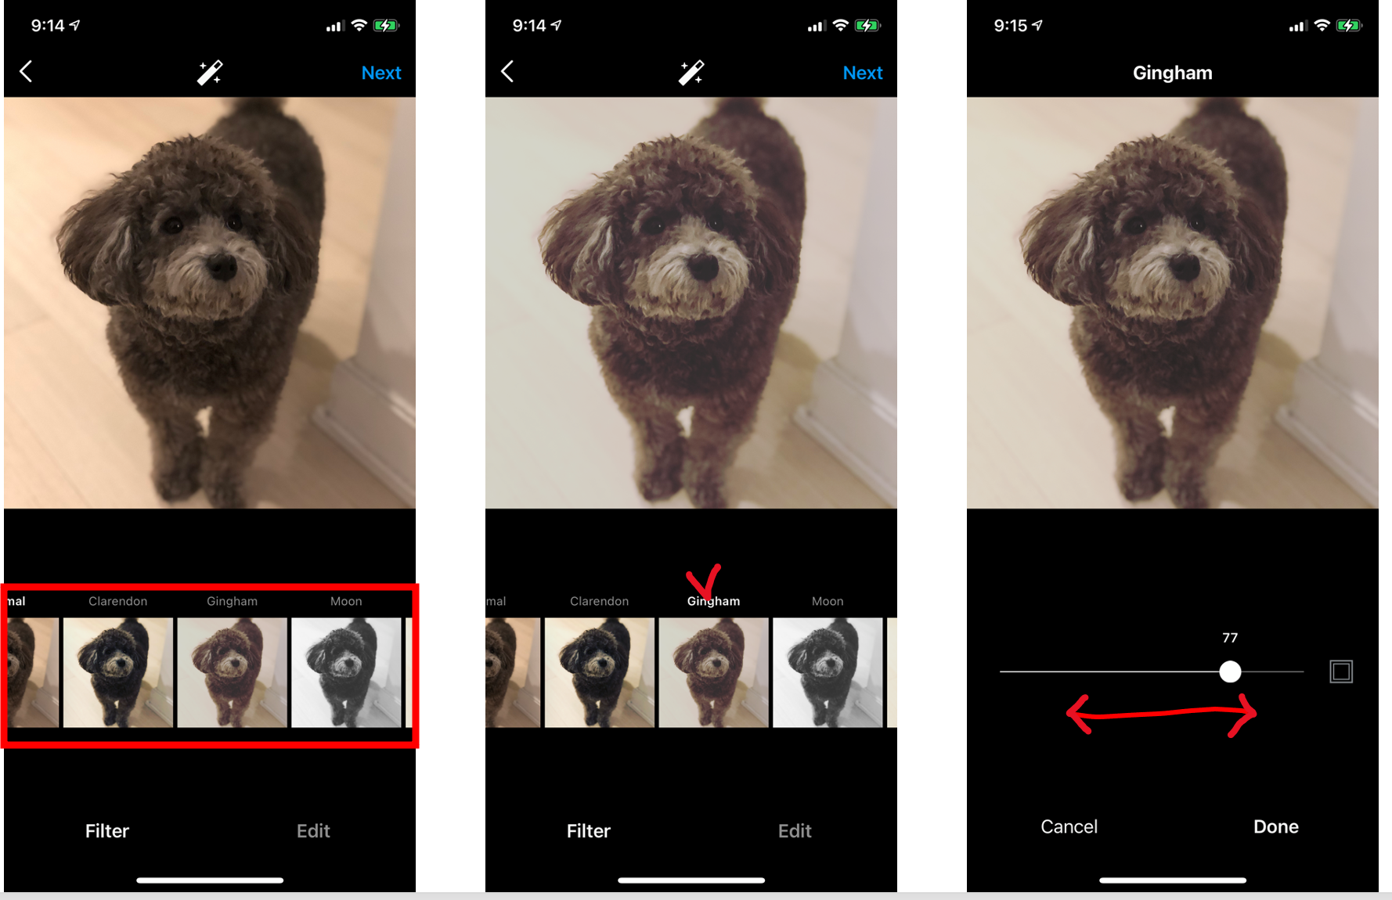

- After selecting a filter, you can adjust the degree of the filter by moving the option bar on the detail page.

Editing

You also have the option of editing the photo. There are a variety of photo editing tools to choose from.
- If you wish to edit more in depth, tap on “Edit”.
- The photo editing tools are as followed: Adjust, Brightness, Contrast, Structure, Highlights, Shadows, Vignette, and Tilt Shift.

- To operate the tools, click on the tool you need, then proceed to manipulate the tool controls to satisfaction.

When photo editing is complete tap on, “Next,” to proceed with the photo posting process.
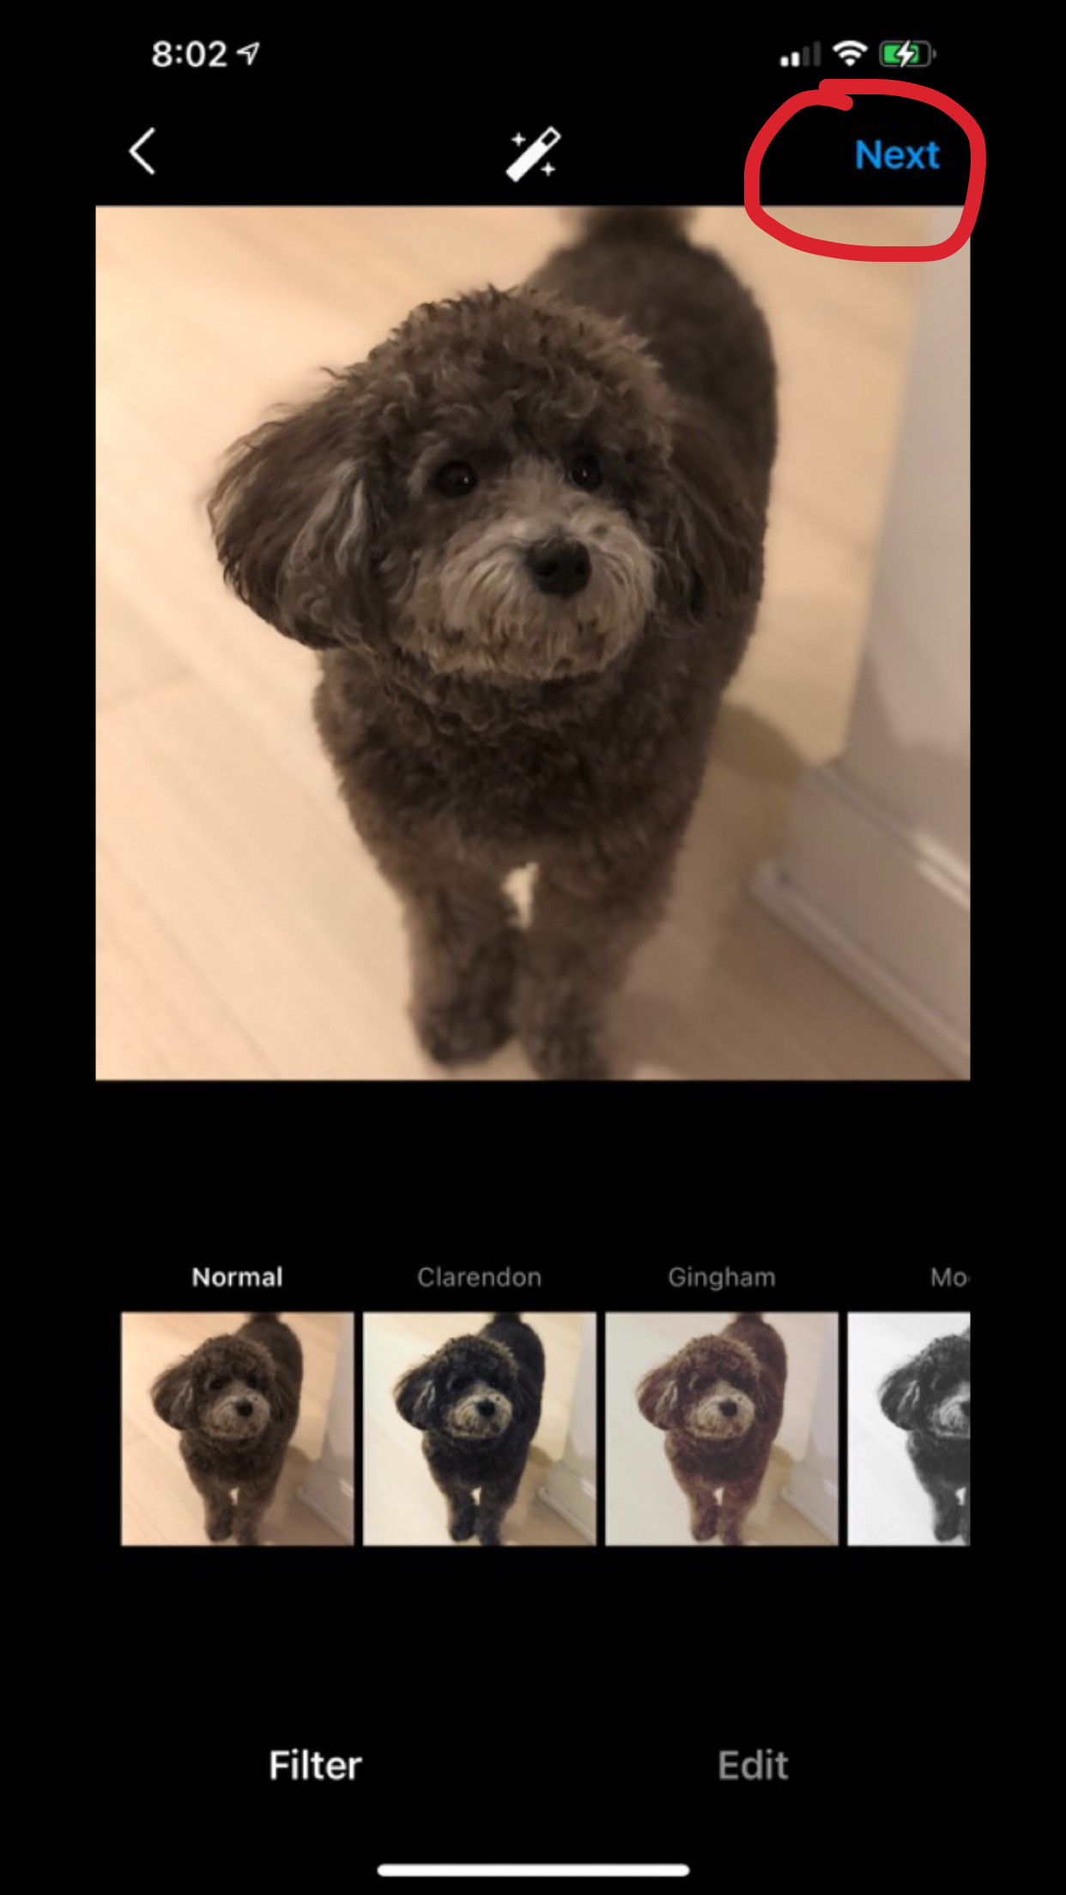

Location, Tagging, and Caption

You will have the option of providing a caption for your photo, tagging any other individuals within the photo, or marking the location in which your photo took place.

- To insert a caption, tap on, “Write a caption.”
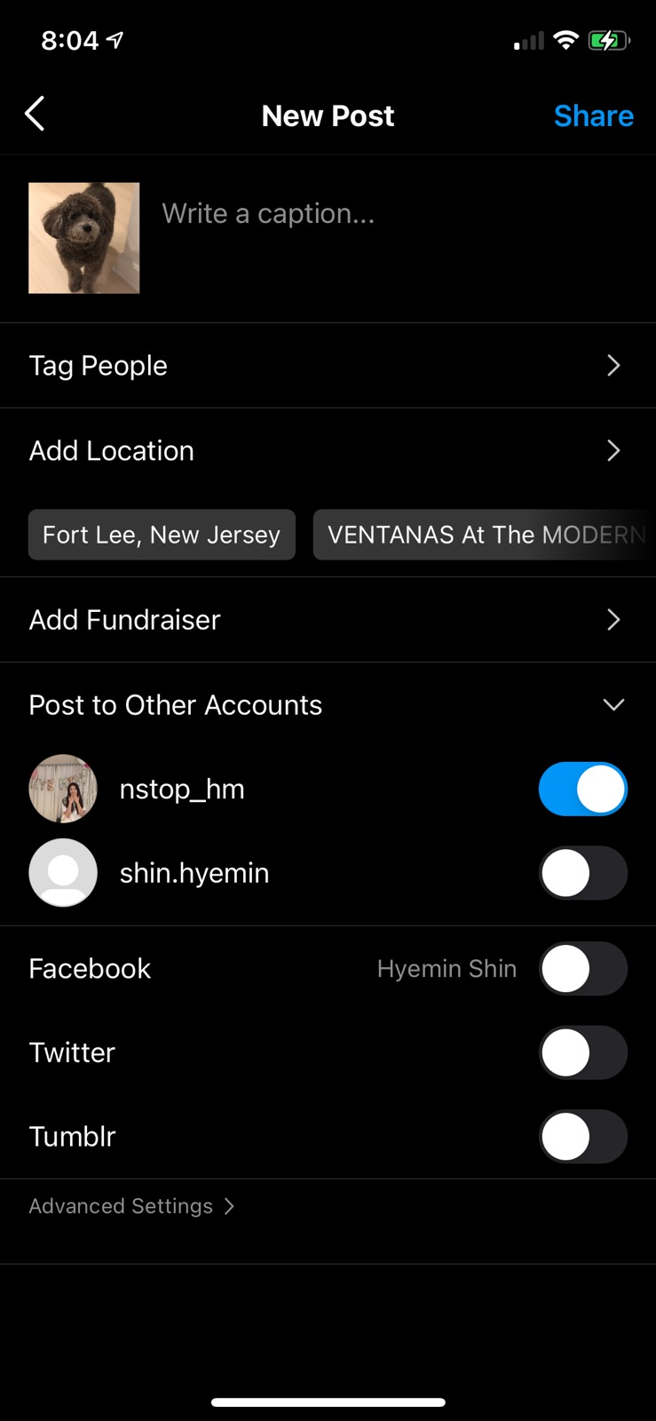
- To finalize the caption tap on, “OK.”
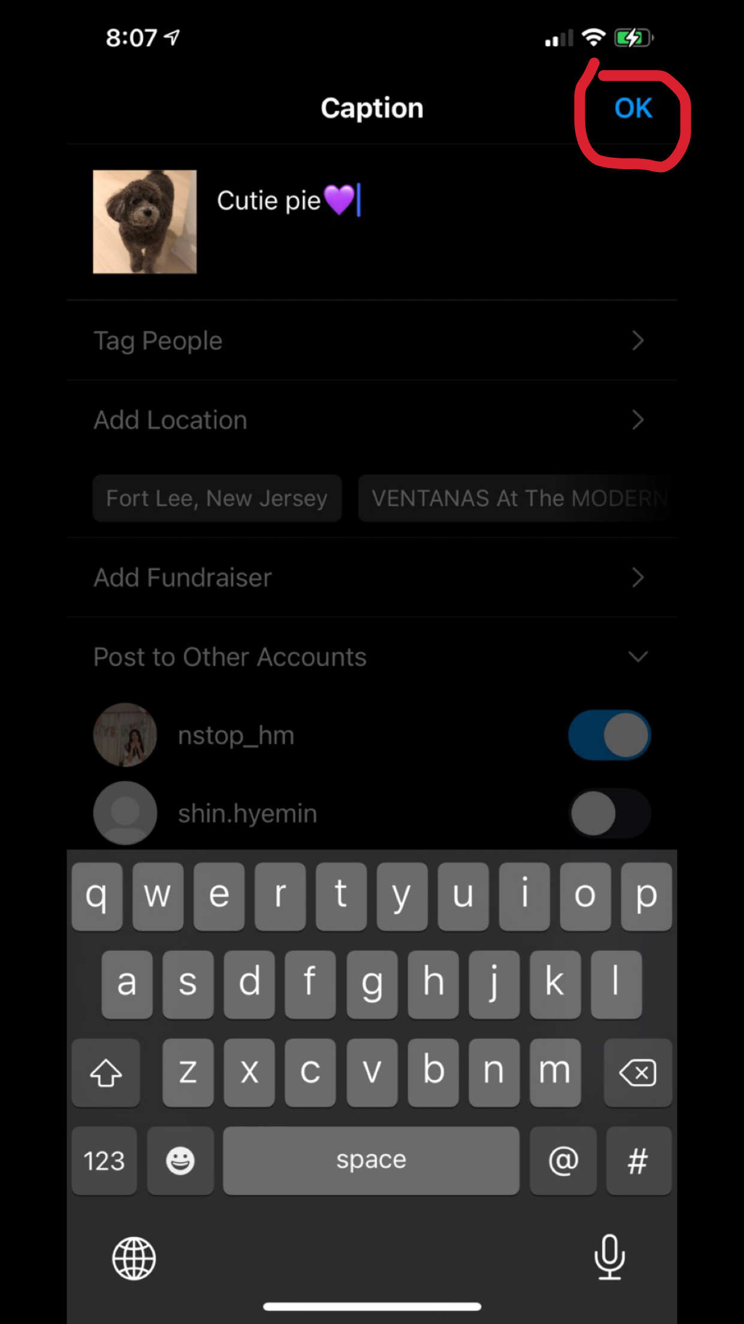
- To tag others on the photo, tap on, “Tag People.”
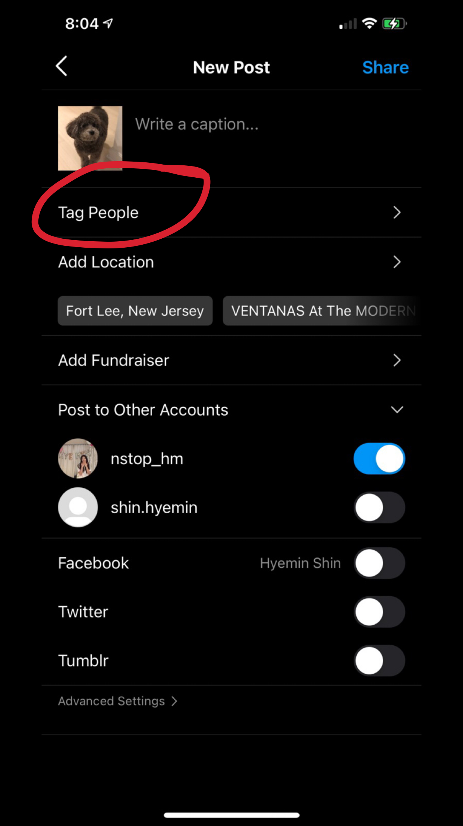
- Select the person or people you want to tag
- Tap anywhere on the photo to tag them to the photo
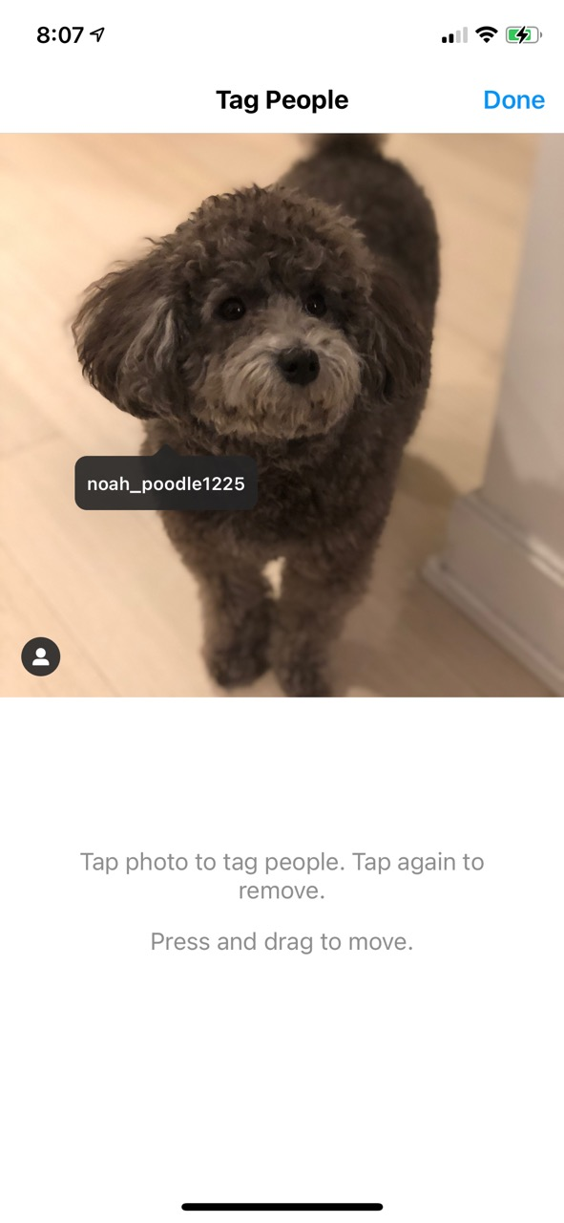
- After you’ve selected an individual, it should look like this
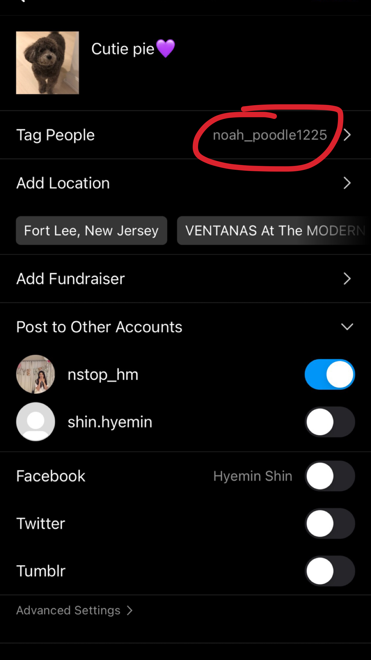
- To mark the photo with a location, tap on, “Add Location.”
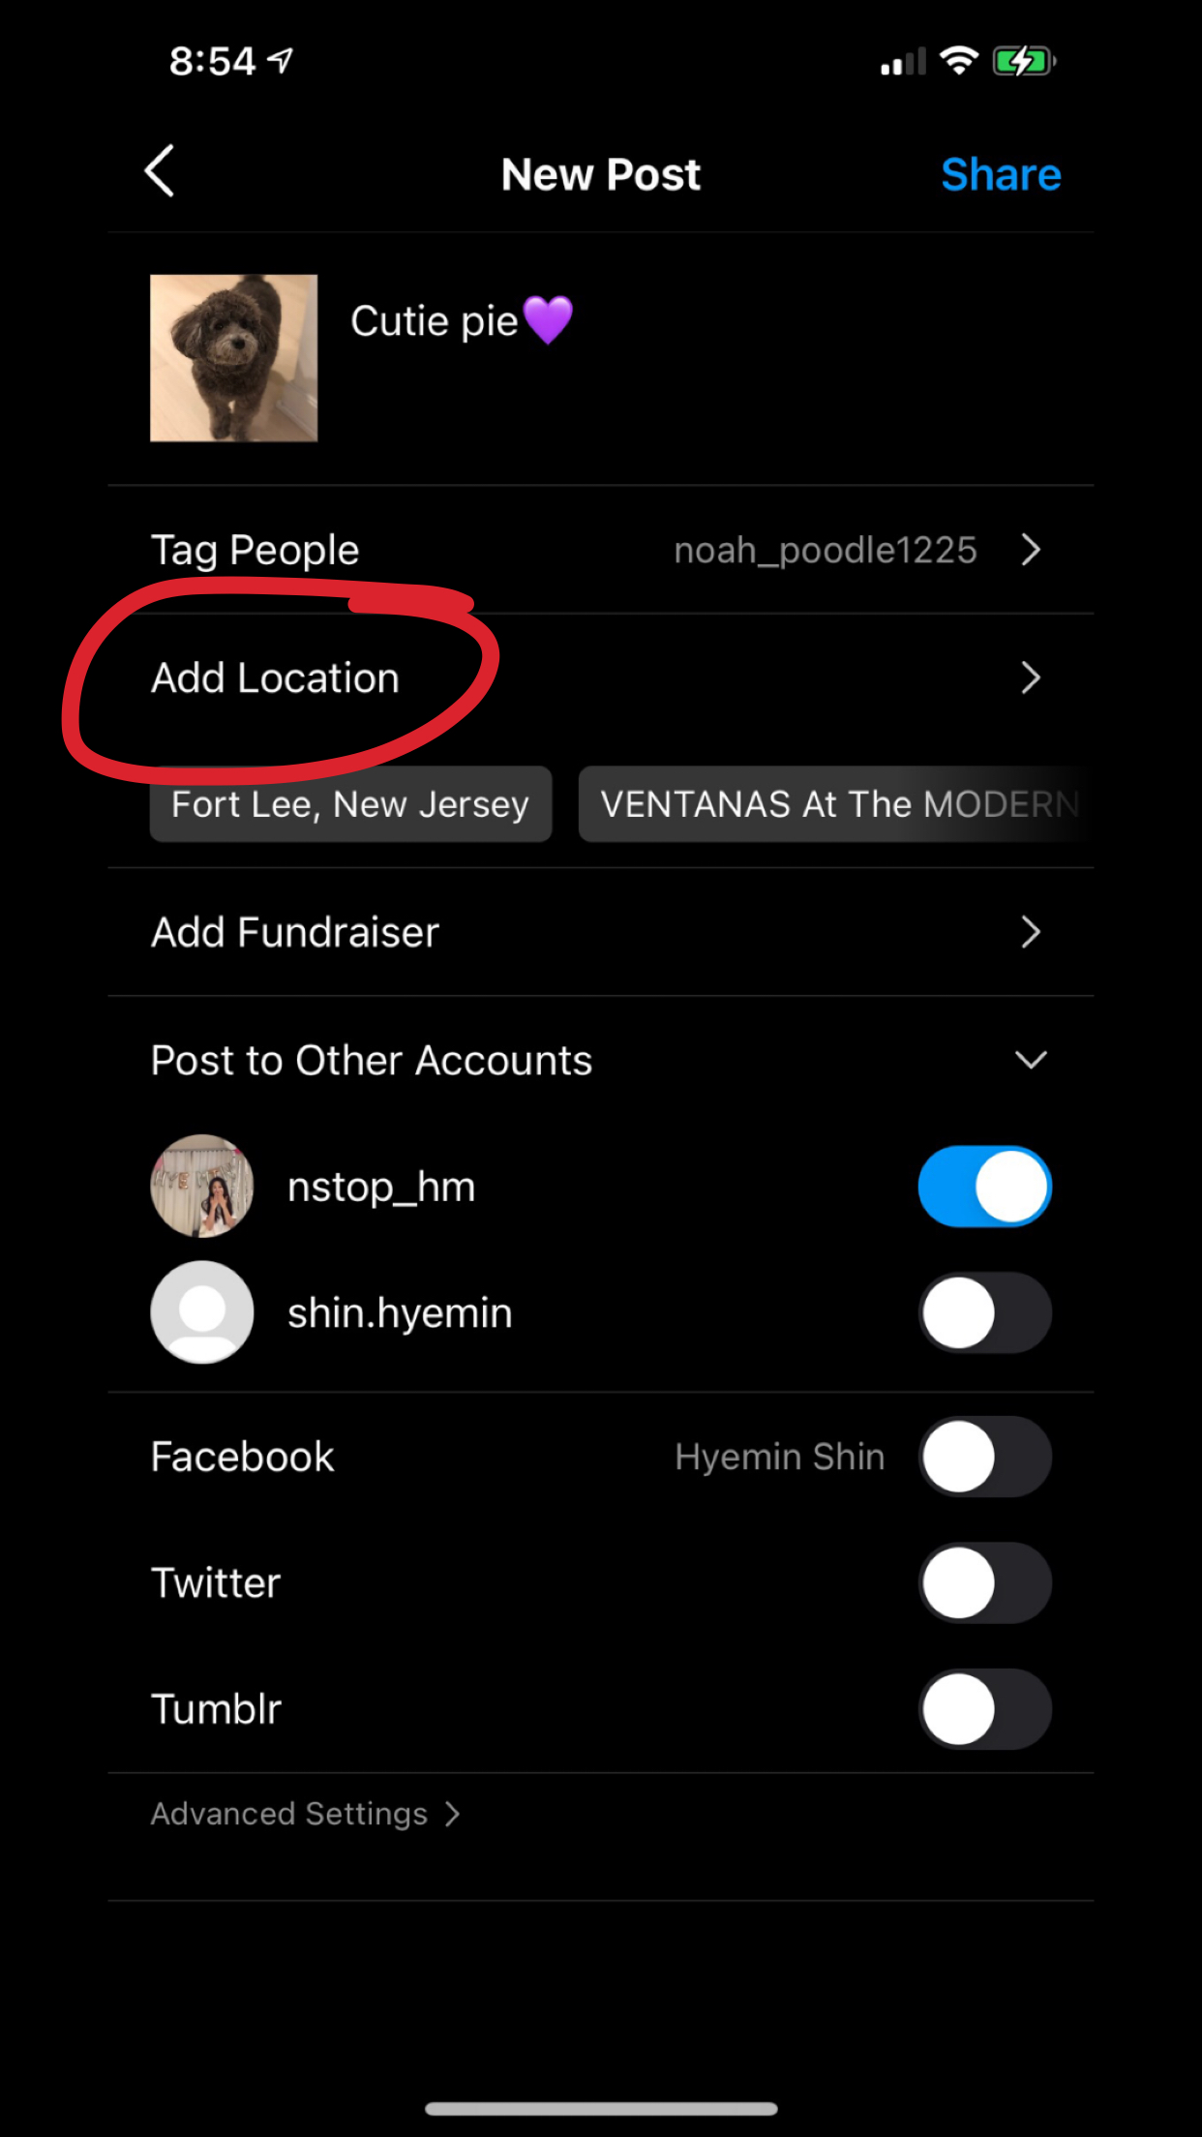
-Select from existing locations or search for a new location using the search bar.
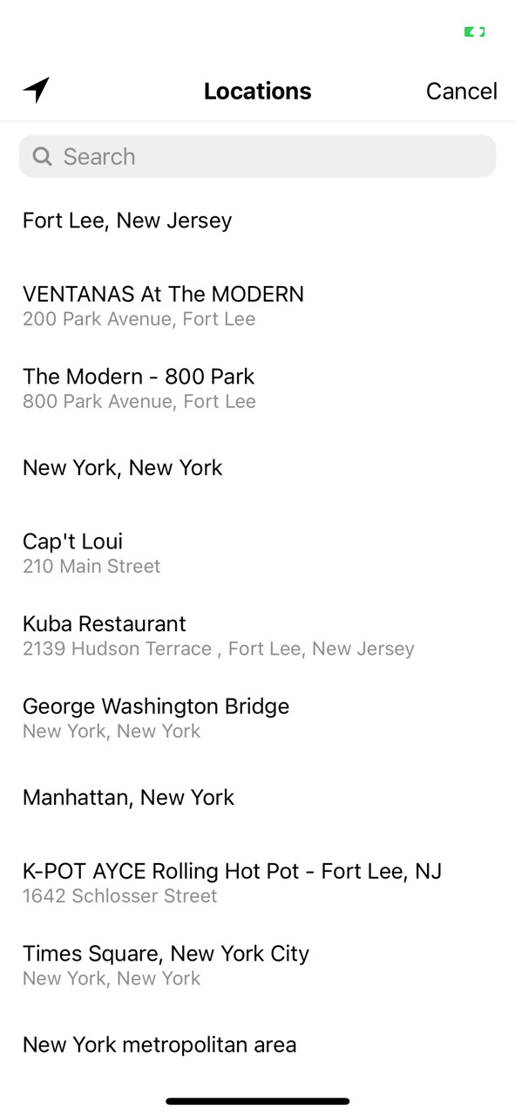

Final Product

Now that the caption, tagging, and location are done, you are ready to share/post this photo to your feed.

- To post this photo to your feed tap on, “Share.”
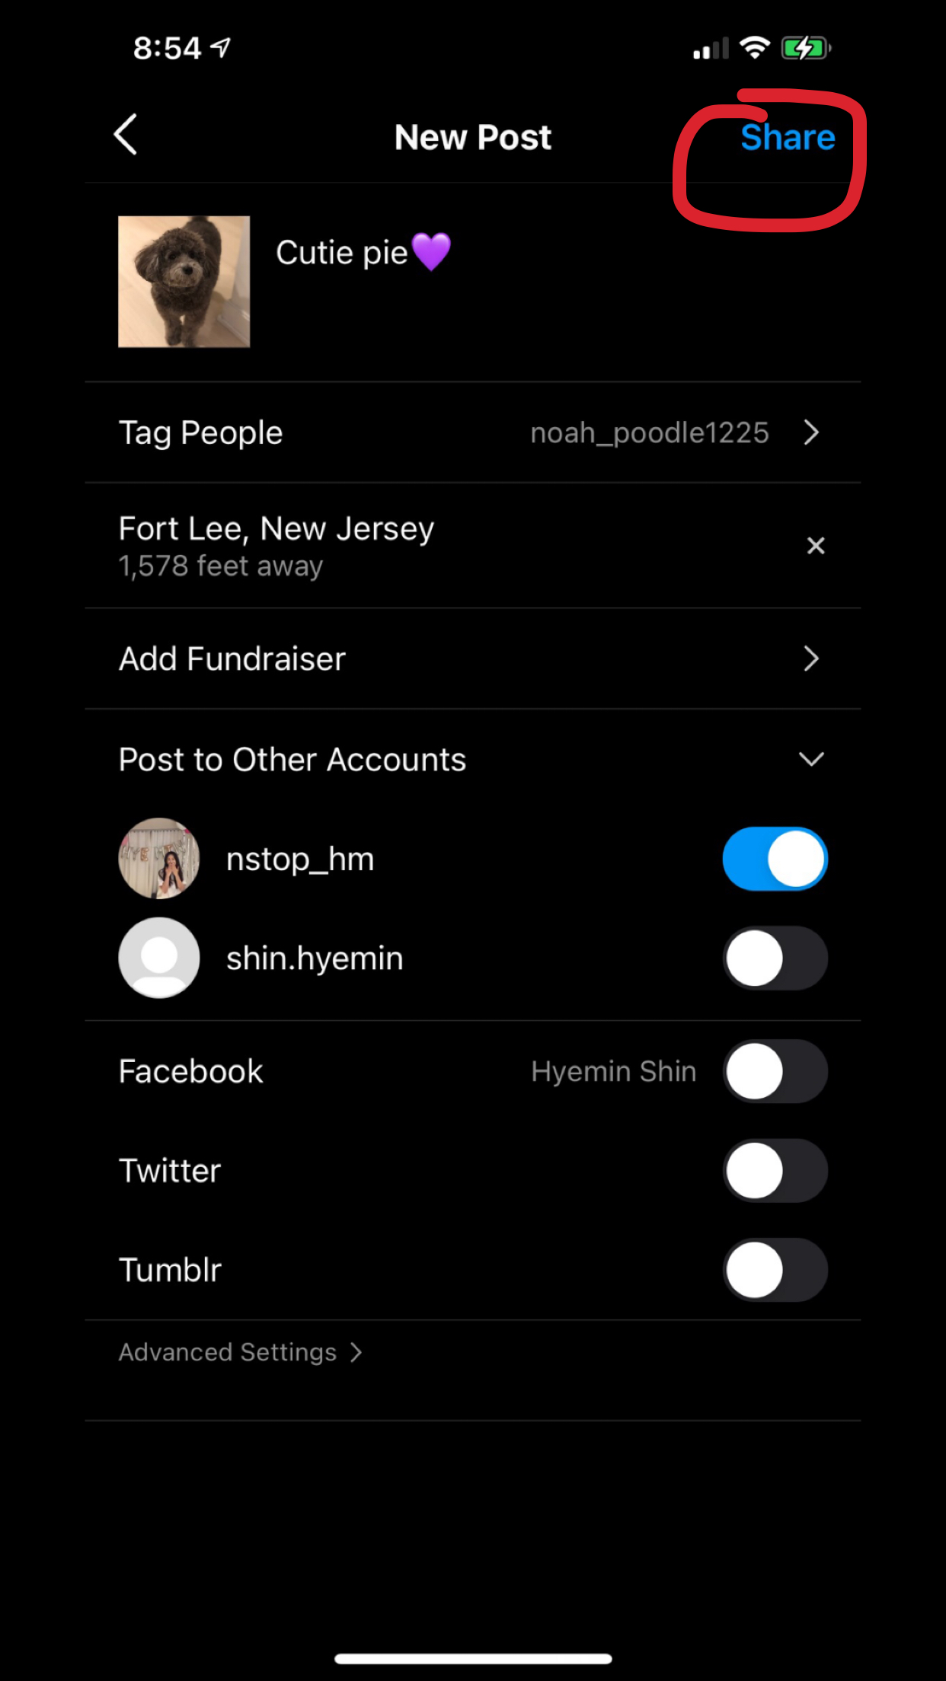
Finally, you can go to your feed where you will see your new post.
If you do not see your new post, refresh your feed by swiping down your screen.

