How to Cut a Pineapple (The Simple Way)
Presented by Group Five: Omar, Jawad, Camilla, Manny

Preliminary Steps (How to Choose the Right Pineapple)

Before we move on cutting a pineapple it’s important to know how to choose the best tasting pineapple available at your local store. A ripe pineapple is your best option because compared to something that is unripe you will get significantly more flavor in a ripe pineapple. Here’s how to identify a ripe pineapple:

Step 1: Go to the store where there are pineapples available to choose from.
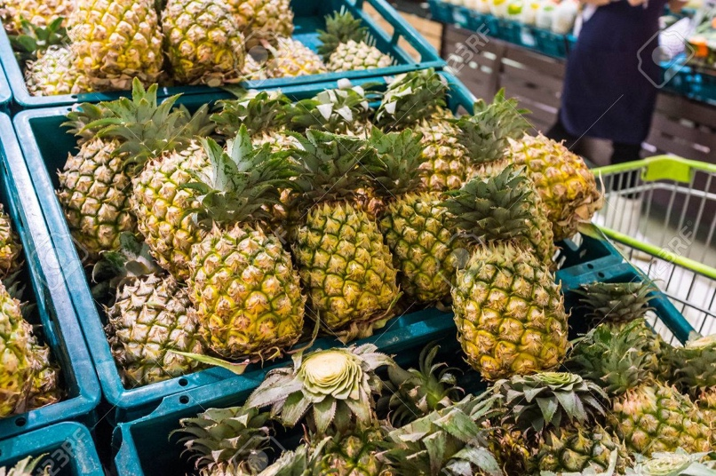

Step 2: Pick up, feel and squeeze pineapples. If you feel that a pineapple is very hard, it is most likely not ripe yet. If you feel that a pineapple is very soft, and squishy in some spots, it is overripened. Ripe pineapples should have firm shells but be slightly soft when they’re squeezed, when you have found a pineapple that fits these requirements move on to the next step.
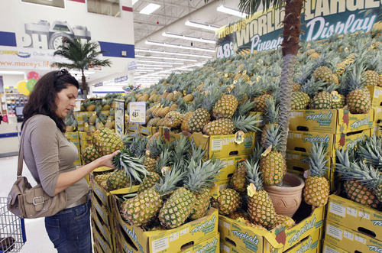

Step 3: Smell the bottom of the pineapple right near the base of the fruit. Smell is a great indicator of ripeness. If you don’t smell anything or not much of an aroma the fruit is most likely not ripe. However, if you smell a bitter or pungent aroma the fruit is most likely overripe. If you smell the bottom of the pineapple and see that it has a sweet and fruity smell, it is ripe, and you should buy it.
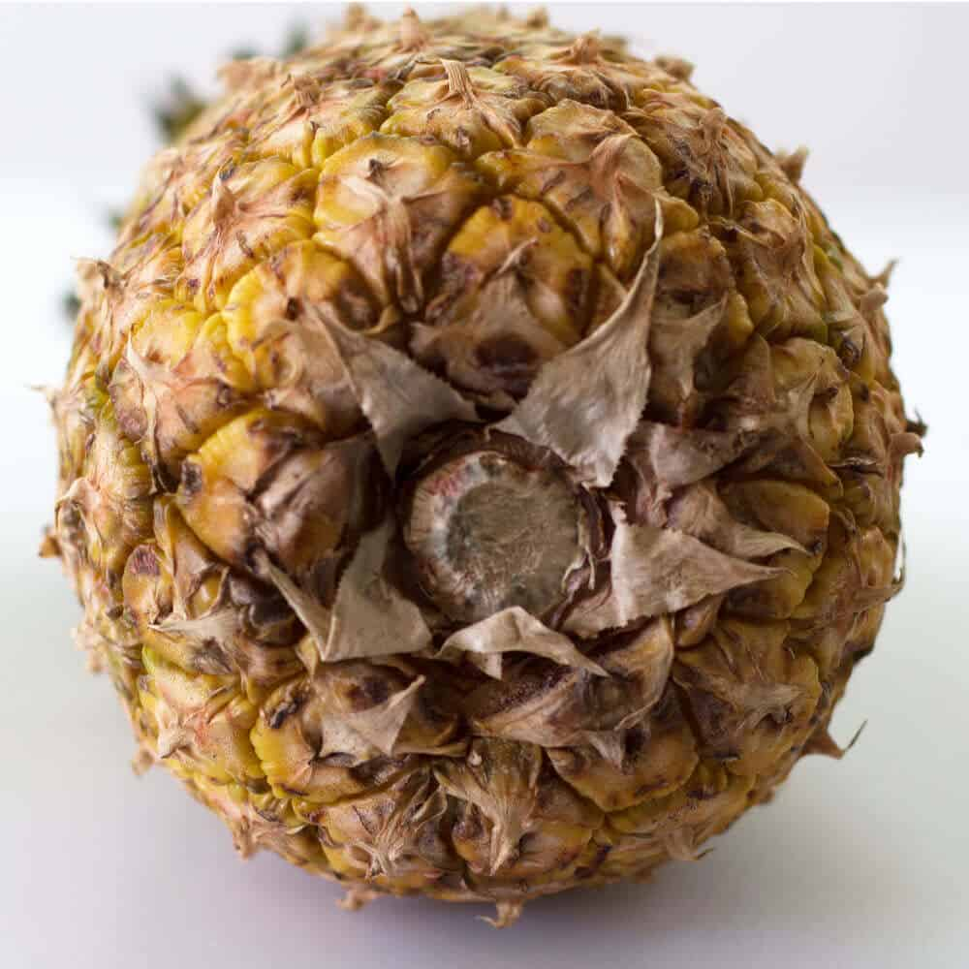

Steps (How to Cut a Pineapple)

Materials: Pineapple, Large Knife, Cutting Board

Step 1: Gather all your materials into one place. Make sure that it’s in a place where you have enough space to cut the pineapple.

Step 2: Slice off the Green crown and bottom. Place the pineapple horizontally on the cutting board. Grab a large knife with one hand and make sure that you’re holding the pineapple with your other hand. Slice off the top of the pineapple, then turn the pineapple around and slice off the bottom.
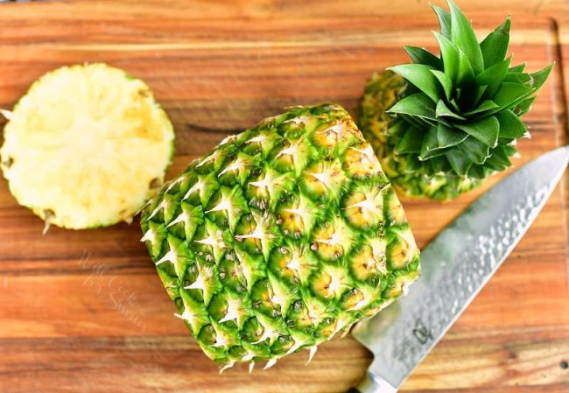

Step 3: Remove the Skin. After You’ve sliced off both the top and bottom of the pineapple, place it vertically on the cutting board. Hold the knife with one hand and secure the pineapple with the other hand. Try to cut the thick skin of the pineapple off without cutting off any of its fruit.
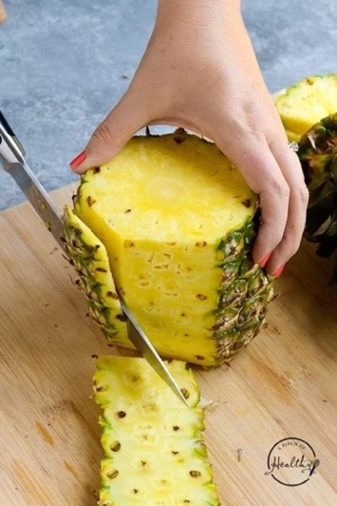

Step 4: Cut the pineapple into Quarters. After the skin is sliced off, keep the pineapple up vertically then take your knife and cut it in half. Then cut both halves of the pineapple in half to get 4 quarters of it.

Step 5: Remove the core of the Pineapple. You wouldn’t want to eat the thick, hard bitter core of the pineapple. After you’ve cut the pineapple into 4 quarters, take a quarter of the pineapple and try to slice off the core. (The core should be the lightest part of the pineapple and it’s pretty recognizable under light). It is best if you place the quarters horizontally.
.
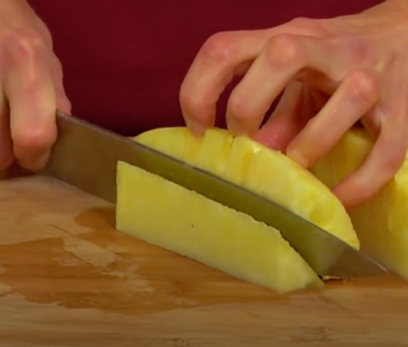

Step 6: Cut or use the pineapple whichever way you like and enjoy!!!
