How to drop a class on CUNYfirst:

Students may drop a class for several reasons, such as adjusting their schedules or choosing a different subject. Whatever the reason, it is important to drop a course correctly to avoid any issues with your advisor, credits, or tuition.

Step 1: Login to CUNYFIRST

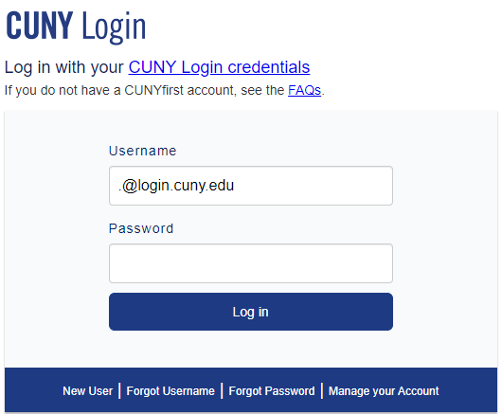

Step 2: After logging in, you will be at the homepage. The image below shows how the top left corner of the page looks. Click on “Student Center” under “CUNYFIRST MENU.”

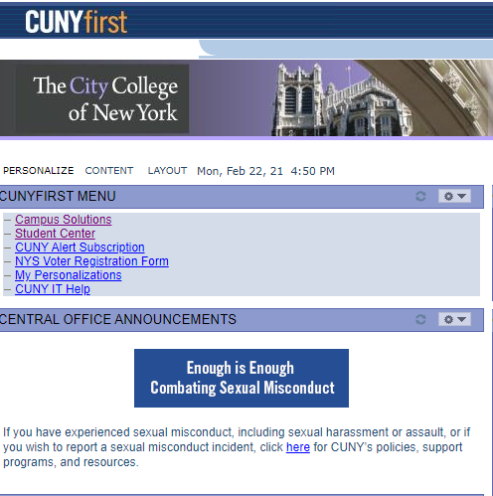
Step 3: Open the Student Center Portal and select the “other academic…” drop-down bar under the “Academics” section of the Student Center.
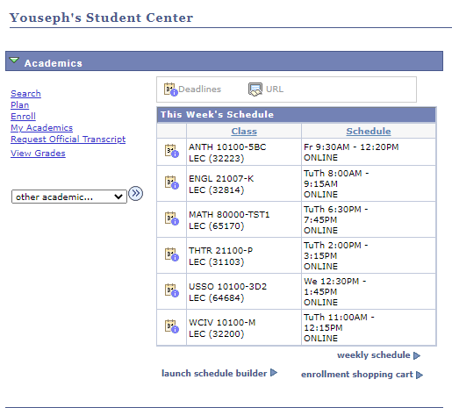
Step 4: Having selected the drop-down bar, select “Enrollment: Drop,” then click on the button with the double arrows to the right of the drop-down bar.

Step 5: You will be relocated to a page showing a list of your current classes. Choose the class you wish to drop by clicking on the empty checkbox to the left of the course name.
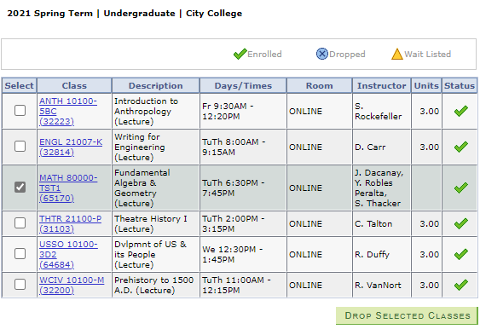

Step 6: After selecting the course you want to drop, click on the green box labeled “Drop Selected Classes.”

Step 7: You will be redirected to a page asking you to confirm if you want to drop the selected course. Confirm your decision, and your task is complete.

