Group 2- Meri Stojanova, Ramjit Pershad, George Ciobotu, Elbin Madera
How to withdraw money from an ATM

These is a set of simple instruction on how to withdraw money from an ATM.
- Insert the card in the ATM machine.
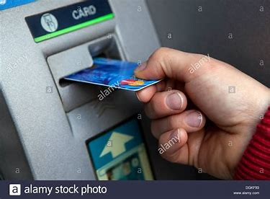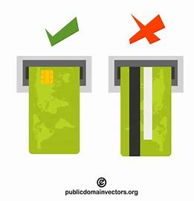

- Select the language you prefer.
- Enter your pin number using the keyboard.
- Select the correct option from the screen:
- Withdraw
- Deposit
- Account information
- More options
(We will select Withdraw)
- Select the account type:
- Checking account
- Savings account
- Enter the Correct amount and press on the Enter Button on the keyboard.
- Collect the cash.
- For addition transactions select YES, otherwise select NO.
- Select YES for a printed receipt, otherwise select NO.
- Do not forget to take your ATM card.

