Solar Panel Cost Analysis of a New York City Hospital
The City College of New York
ENGL 21007
Daniele Weisberg
10/26/2020

Table of Contents

Abstract 3
Introduction 3
Materials and Methods 4
Materials 4
Methods 4
Results 5
Discussion 5
Conclusion 5
References 6

Abstract
Solar panels are one of many ways cities are modernizing their electrical infrastructure to reduce costs and their carbon footprint. New York City is populated with over a million buildings, many with the potential to utilize their rooftops to harvest the sun’s green energy. While installations have been made over the past decade to reduce municipal and private electrical dependency, no building has had their system fully replaced. The hypothesis of this experiment was that a hospital, the New York Presbyterian, could be powered solely by solar panels installed on its roof, and the overall cost of purchasing the necessary materials, installation, and maintenance would end up saving a significant amount of capital versus continued private utility. Since the annual electrical expenditures resulted in $0 after the installation of the solar panels, the hospital would save an estimated $402 million after 20 years. While the upfront cost was high, the long term financial benefits greatly exceeded them.

Introduction
Climate change has grown into a priority global issue affecting the entire planet and its inhabitants. As America works out its place on the international stage in regards to the role it will play politically, states have begun taking action to counteract the environmental impact of relying on fossil fuels. In New York City, Mayor Bill de Blasio has been a large proponent on moving the metropolis towards green energy. In 2014, a roadmap titled “One City Built to Last” produced by the New York City Mayor’s Office of Sustainability, documented their plan to “reduce greenhouse gas emissions by 30 percent from a 2005 baseline by 2025 from almost a million buildings in New York City” (Solar Energy 2020). They also committed to reducing 80 percent of the city’s greenhouse gas emissions by 2050, the “80 x 50” plan (New York City's Roadmap to 80 x 50 2014). Among the various methods in the transition to green energy is the usage of solar panels to provide electricity. Installations have already been made on some public buildings, such as City Hall, a number of public schools, and Port Richmond’s Wastewater Treatment plant.
Some of the biggest commercial consumers of electricity are hospitals. Due to the nature of the services they provide and the fact that they run 24/7, they make ideal targets for clean energy reform. The average U.S. hospital uses approximately 27.5 kWh of electricity per square foot. With an average commercial energy price of $0.10 per kWh from a provider, such as Con Edison, the cost of power per square foot in a hospital is approximately $2.84 (DS&O Electric Cooperative Inc., 2010). The New York Presbyterian Hospital in the upper east side of Manhattan is one of the city’s largest at 500,000 square feet and 23 stories tall (Stoler, 2017). The annual electricity bill for the company is a large portion of its budget. In this experiment, we will test the hypothesis that purchasing, installing, and maintaining the necessary amount of solar panels on the roof of The New York Presbyterian hospital to cover its entire electricity usage would end up resulting in a smaller annual bill than what it currently pays from a private commercial provider.

Materials and Methods

Materials
- Solar panels (50k for The New York Presbyterian)
- Solar array mounting racks
- DC wiring
- Inverter system for AC circuits in the hospital
- Power or Kilowatt meter to measure the hospital’s electricity usage
- Computer with spreadsheet entry software to keep track of daily, monthly, and annual electricity usage

Methods
Since this particular hospital is located along the East River of Manhattan and not in immediate proximity to any taller buildings, solar panels could be installed at any position on the building’s roof without a lack of sunlight. Measurements of the building’s rooftop were taken (this experiment assumed that the entire roof was available for usage). Using the estimated average amount of electricity required by the solar panels to power the hospital non-stop for an entire year, and using 15 kW solar panels, we calculated the number of solar panels needed to be installed. This totaled to 50,000 solar panels utilizing the entirety of the hospital’s roof space.
15 kW solar panels models produce the highest wattage for most residential and commercial usage. In New York, after Federal ITC discounts, cost to purchase installation of a 15 kW system runs to approximately $40,000. Based on the number of solar panels necessary, the cost of purchasing and installing the solar panels was $28,502,000.
After consultations and approval from a structural engineer and a master electrician, the solar panels were installed. Solar array mounting racks were lined parallel to each other in rows across the rooftop. Each rack was securely anchored. Solar panels were then inserted into each rack and wired with the DC cables into their respective systems. The DC wiring was fed into the building and connected to the hospital’s power grid. Inverter systems were installed to direct AC current where needed. A Kilowatt meter was connected to the system within the hospital to monitor the amount of kilowatts the solar panels were providing in total. Since it's integral for a hospital to have power at all hours, an emergency shut-off switch was installed in the case of solar panels failing or not providing enough electricity. If activated, the hospital would revert back to its normal electrical utility provider. Using the meter, daily kilowatt production from the solar panels were tracked on a data monitoring software program. Data was collected over the course of a year from when the installations were complete and running.

Results
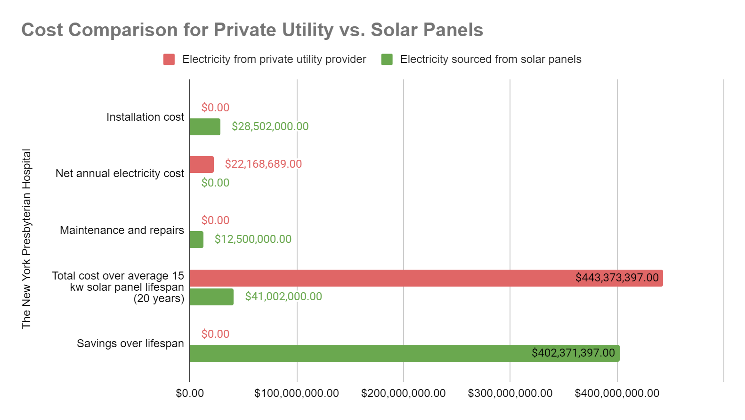

Figure 1: Results from the experiment. The bar chart illustrates initial installation and proceeding maintenance costs for the average lifespan for the solar panels. The final comparison of the hospital continuing with private electricity versus solar panels shows substantial savings from switching to the latter.
From the data in figure 1, the upfront first-year cost of purchasing and installing the solar panels and equipment is a 28.6% increase in the hospital’s normal annual electrical budget. After the initial cost, there is no continued monthly or annual fee for utilizing the electricity from the solar panels (this experiment assumed The New York Presbyterian received enough sunlight throughout the year to be fully powered by the solar panels). The data takes into account potential wear and tear, maintenance, and small repairs for the solar panels over their estimated average lifespan of twenty years, estimated at $12.5 million (Thoubboron, 2019). Even with the mentioned costs for the solar panels, their total is drastically less than the hospital continuing to use its private electrical utility provider for twenty years and beyond.

Discussion
The experiment has shown that there is an extraordinary amount of money to be saved transitioning from private provided electricity to complete reliance on solar energy. While the average annual bill for the hospital at $22.1 million is less than the first-year costs of purchasing and installing the solar panels at $28.5 million, the difference is passed the following year and is immediately met by savings. Over the average lifespan of the solar panels, The New York Presbyterian Hospital would save an estimated $402 million, which includes maintenance and repairs and considers no catastrophic failures.
While the experiment was successful, there are specific conditions to take into account before applying the results and procedures to other hospitals and buildings. The New York Presbyterian Hospital was an optimal candidate for the trials because it was not surrounded by any nearby taller buildings, ensuring its roof was always exposed to the sun. 100% of the hospital’s roof was available for solar panel installation, which provided a great allowance for the quantity we were able to install. Finally, The New York Presbyterian Hospital’s budget was capable of accommodating such an experiment without accruing risks. Other hospitals in New York City may not meet any or all of these conditions, so their unique circumstances must be taken into account and adjusted before committing to similar procedures.

Conclusion

The experiment conducted at The New York Presbyterian Hospital illustrated the substantial savings that can be had by transitioning over to 100% solar energy. The money retained by having no monthly costs after the initial installation will allow the hospital to invest into other aspects of its business operations, while reducing its carbon footprint at the same time. As New York City moves towards its 80 x 50 goal, the results from this experiment serve as an encouragement to other hospitals and various businesses to assess their electrical usage and consider converting to solar energy for their power needs.

References
DS&O Electric Cooperative Inc. (2010). Managing Energy Costs in Hospitals. Retrieved
October, 2020, from https://www.dsoelectric.com/sites/dsoelectric/files/My%20Business/hospitals.pdf
Lewis, K., Swenson, A., & Olsen, J. (2012, August 17). U.S. Energy Information Administration
- EIA - Independent Statistics and Analysis. Retrieved October, 2020, from https://www.eia.gov/consumption/commercial/reports/2007/large-hospital.php
Matasci, S. (2020, September 28). How Much Does a 15kW Solar Panel System Cost in 2020?:
EnergySage. Retrieved October, 2020, from https://news.energysage.com/15-kw-solar-system-cost/
New York City Mayor's Office of Sustainability. (2014). New York City's Roadmap to 80 x 50.
Retrieved October, 2020, from https://www1.nyc.gov/assets/sustainability/downloads/pdf/publications/New%20York%20City's%20Roadmap%20to%2080%20x%2050_Final.pdf
Sendy, A. (2020, October 06). What equipment do you need for a solar power system? Retrieved
October, 2020, from https://www.solarreviews.com/blog/what-equipment-do-you-need-for-a-solar-power-system
Solar Energy. (2020). Retrieved October, 2020, from
https://www1.nyc.gov/site/sustainability/codes/solar-panels.page
Stoler, M. (2017, December 6). Building Today for the Future: How Healthcare is Spiking
Construction in the Tristate Area. Retrieved October, 2020, from https://www.friedmanllp.com/insights/building-today-for-the-future-how-healthcare-is-spiking-construction-in-the-tristate-area
Thoubboron, K. (2019, September 23). What Are the Costs of Solar After Installation?:
EnergySage. Retrieved October, 2020, from https://news.energysage.com/costs-of-solar-after-installation/

Audience Analysis

Reader’s Name: Dr. Steven J. Corwin
Reader’s Job Title: President/CEO of New York Presbyterian Hospital
Kind of Reader: Primary
Reader’s Level of Education: Excellent, Doctor
Reader’s Professional Experience: President/CEO of New York Presbyterian Hospital, Chairman of Health Care Systems Council of the American Hospital Association, Chairman of the Greater New York Hospital Association, Advisory Board Member of the New York Academy of Medicine, Cardiologist, Internist.
Reader’s Personal Characteristics: N/A
Reader’s Cultural Background: N/A
Reader’s Attitude Toward the Writer: Potentially positive: proposal to save hospital money
Reader’s Way of Reading the Document: Study it
Reader’s Skill Level: Excellent
Reader’s Physical Environment: Private office

Reflection Paper

For this assignment, my group and I came together to decide on an issue to conduct a simulated experiment relevant to our major, electrical engineering. We chose to investigate how to better utilize solar energy to completely replace a building’s dependency on private electricity, specifically a hospital. The medium for this lab report can be both a physical copy printed and sent to the specific audience, as well as a digital copy sent via email. The format of the document lends itself to either type. Even considering the Covid pandemic, hospital employees are considered essential workers, and the primary audience, Dr. Steven J. Corwin, may either be at his office or at home to receive the document. The genre, a lab report, is a carefully crafted argument designed to persuade its intended audience to accept the conclusions reached through a replicable experiment or series of tests. It started with the hypothesis that a hospital could be fully powered by solar panels, as well as run at a lower annual cost. The data from the experiment highlights the benefits of transitioning to solar panels in the long term. The purpose of this document was to persuade Dr. Steven J. Corwin to replace the New York Presbyterian Hospital’s electrical system with solar panels. The evidence demonstrated by the experiment illustrates how it would save the hospital money as well as reduce its carbon footprint. Dr. Corwin is the primary audience for this lab report as he would have the final say on whether the hospital would invest in installing the solar panels. The secondary audience for this document could be the hospital’s board of directors or administrators, who may have interests in the financial savings demonstrated in this report. The exigence of the lab report was the pressing issue of climate change. As the world’s population continues to grow and more resources are required, it becomes ever more important that industries and people begin to transition to green energy. While the report’s main findings were in regards to financial savings, the goal was to use the economic benefits to persuade the audience to embrace clean energy. This coincides with my stance that increasing the usage of solar energy, especially in densely populated cities such as New York City, is of the utmost importance. Even if the lab report’s findings were to have gone against the hypothesis, the benefits to the planet and its inhabitants would outweigh whatever costs the green energy would require.
Learning Outcomes: I accomplished the fourth learning outcome by collaborating with my peers when we decided on what topic to investigate. We challenged each other's ideas and went over multiple revisions to make sure the lab report was properly testing a specific hypothesis. I met the eighth learning outcome by researching credible solar panel articles across the internet and incorporating them into my lab report in a way that they provided substance. I met the sixth learning outcome by explaining in the introduction the importance of climate change and the action that many cities are already taking against it. I accomplished the first and third writing goals by illustrating in a clear enough manner, for someone who is not an electrical engineer, why it is feasible to operate their building solely on solar panels. I kept within the scope of the lab report genre to persuade my audience based on the data found and the resulting conclusions.

