How to add contacts on iPhone?

These are instructions for those who have an Apple iPhone. Below are the steps with pictures to help you guys understand and learn on how to save contacts. Hopefully this will help!

Step 1: Click on the phone application on the bottom of your home screen.
Step 2: You should then see “contacts” on the bottom middle portion of your screen.

Picture 1 Picture 2
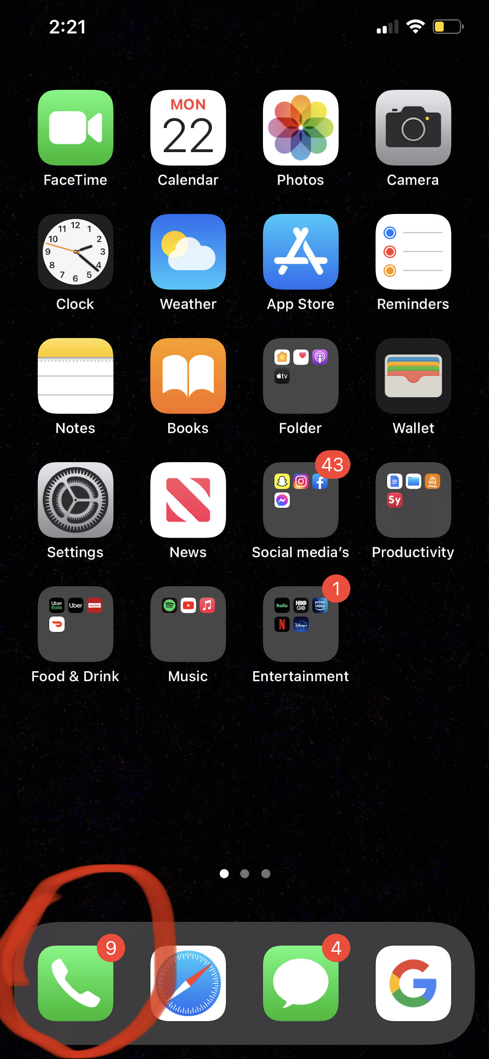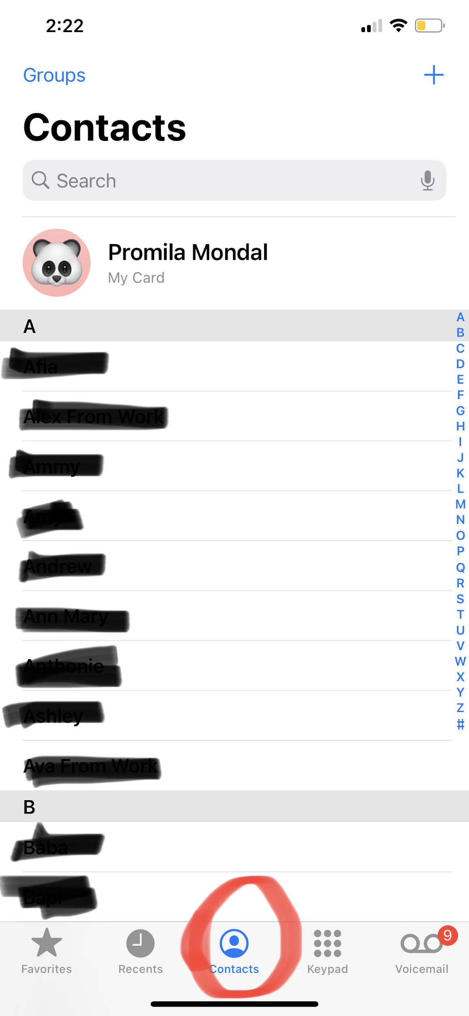

Picture 1 is showing where to find the application “phone” on home screen
Picture 2 is showing where to find the “contact” after clicking on the phone application

Step 3: There should be a + sign in the top right to add a new person’s contact information
---->
Step 4: After pressing the + sign, you should be able to add the person’s contact information such as first and last name and phone number.

Picture 3 Picture 4
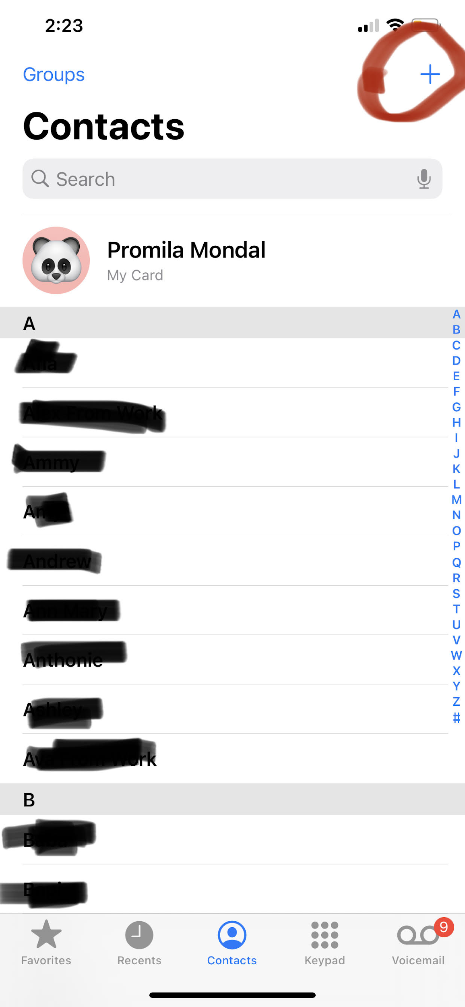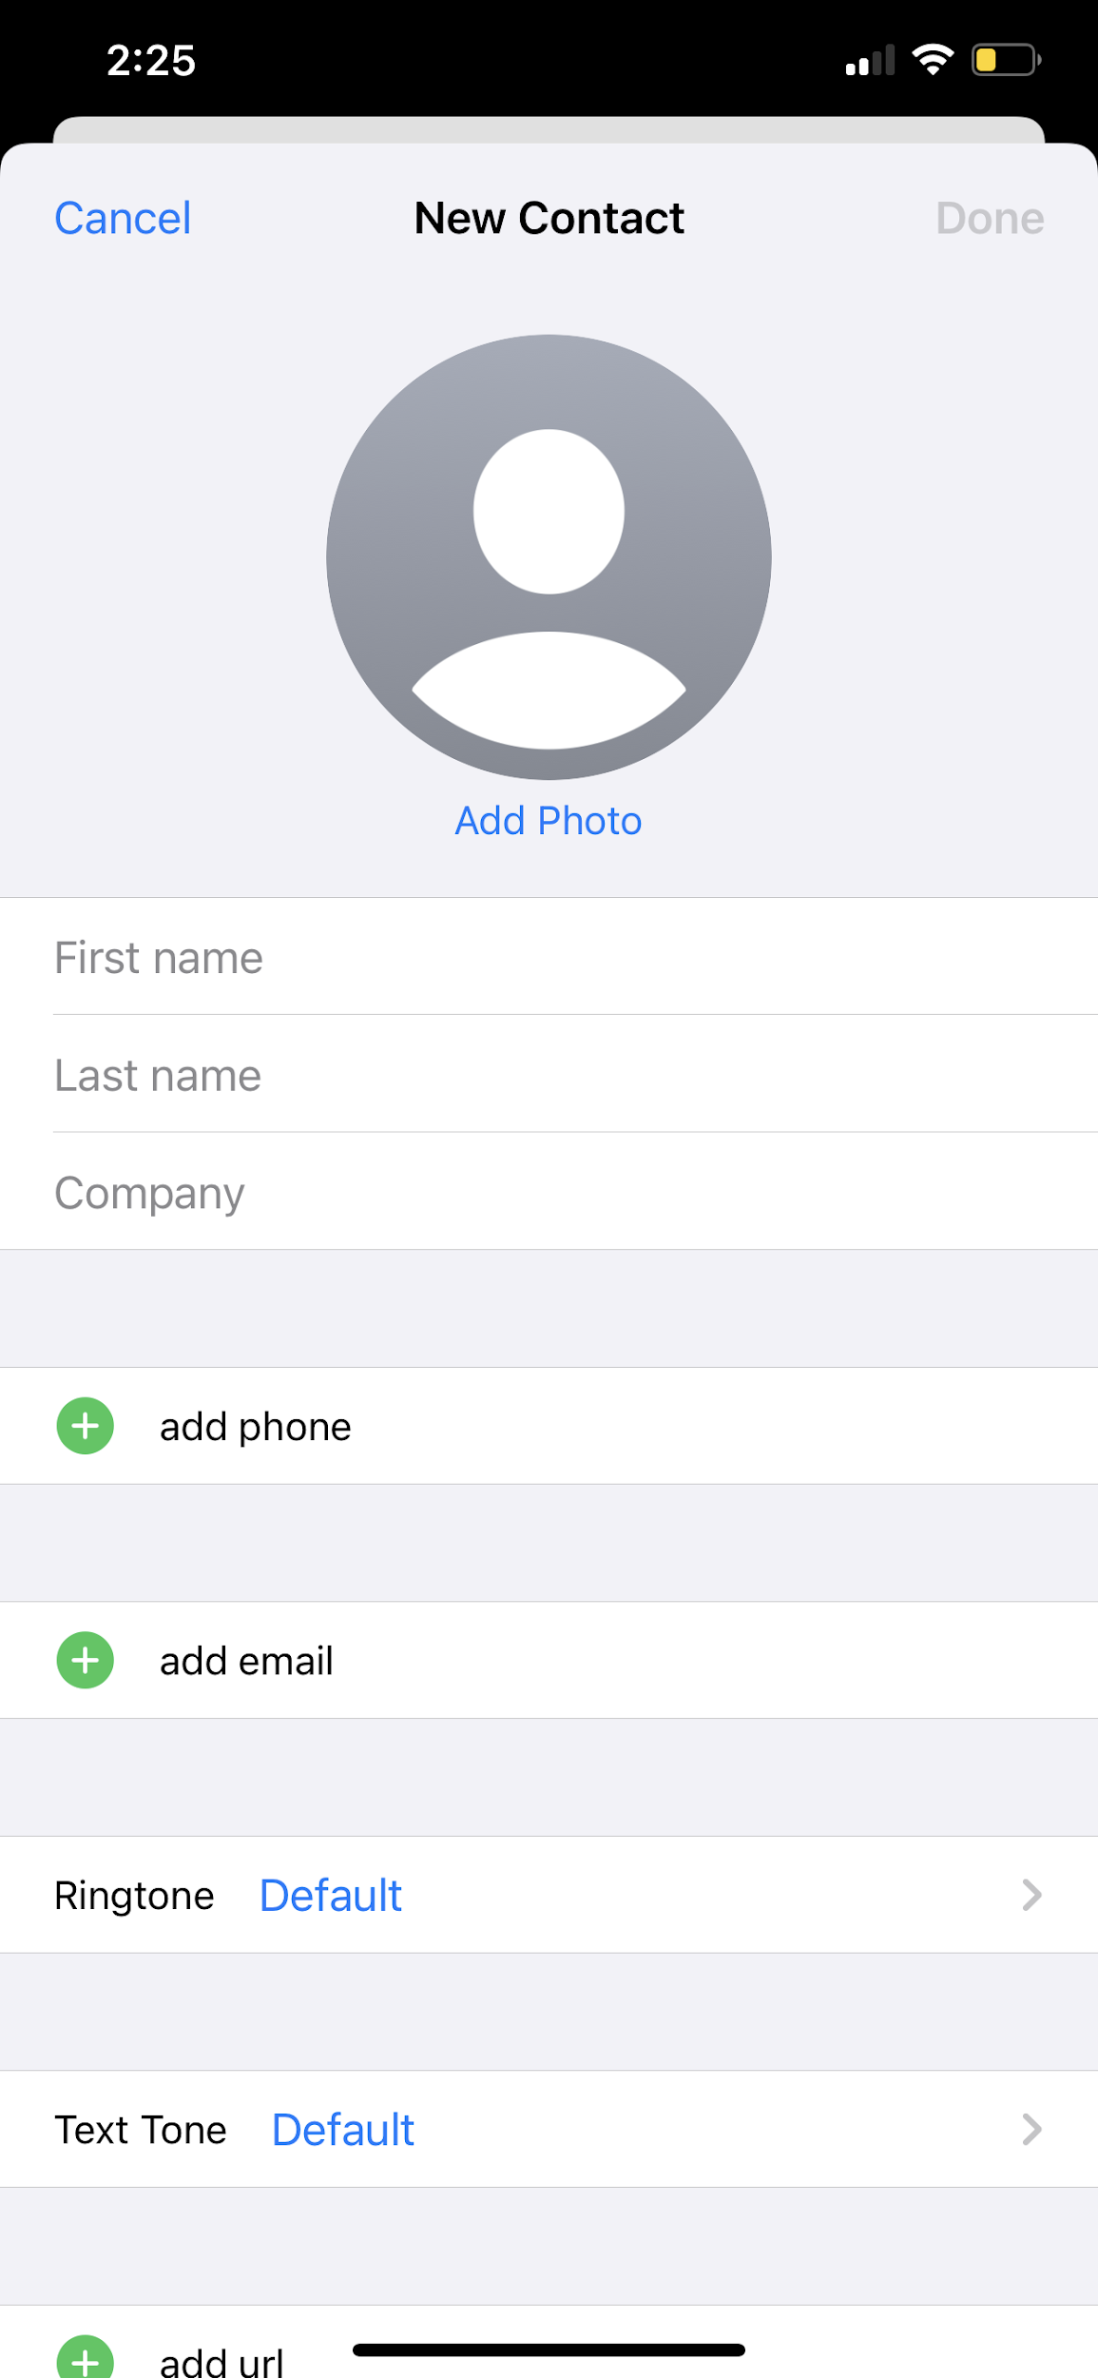

Picture 3 is showing where to find “+ sign” which is used for adding new contact
Picture 4 is showing the page you will get after pressing “+ sign”

------->
Picture 5 Picture 6

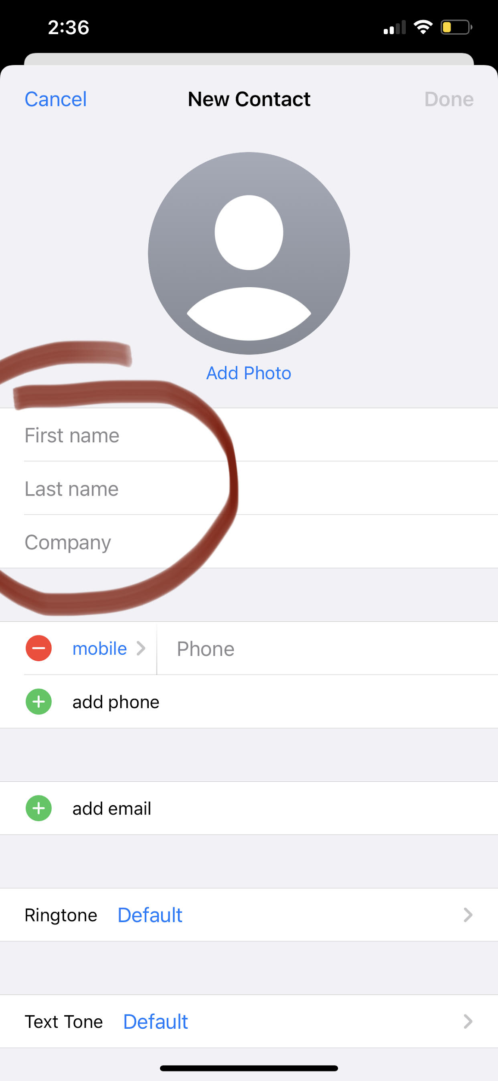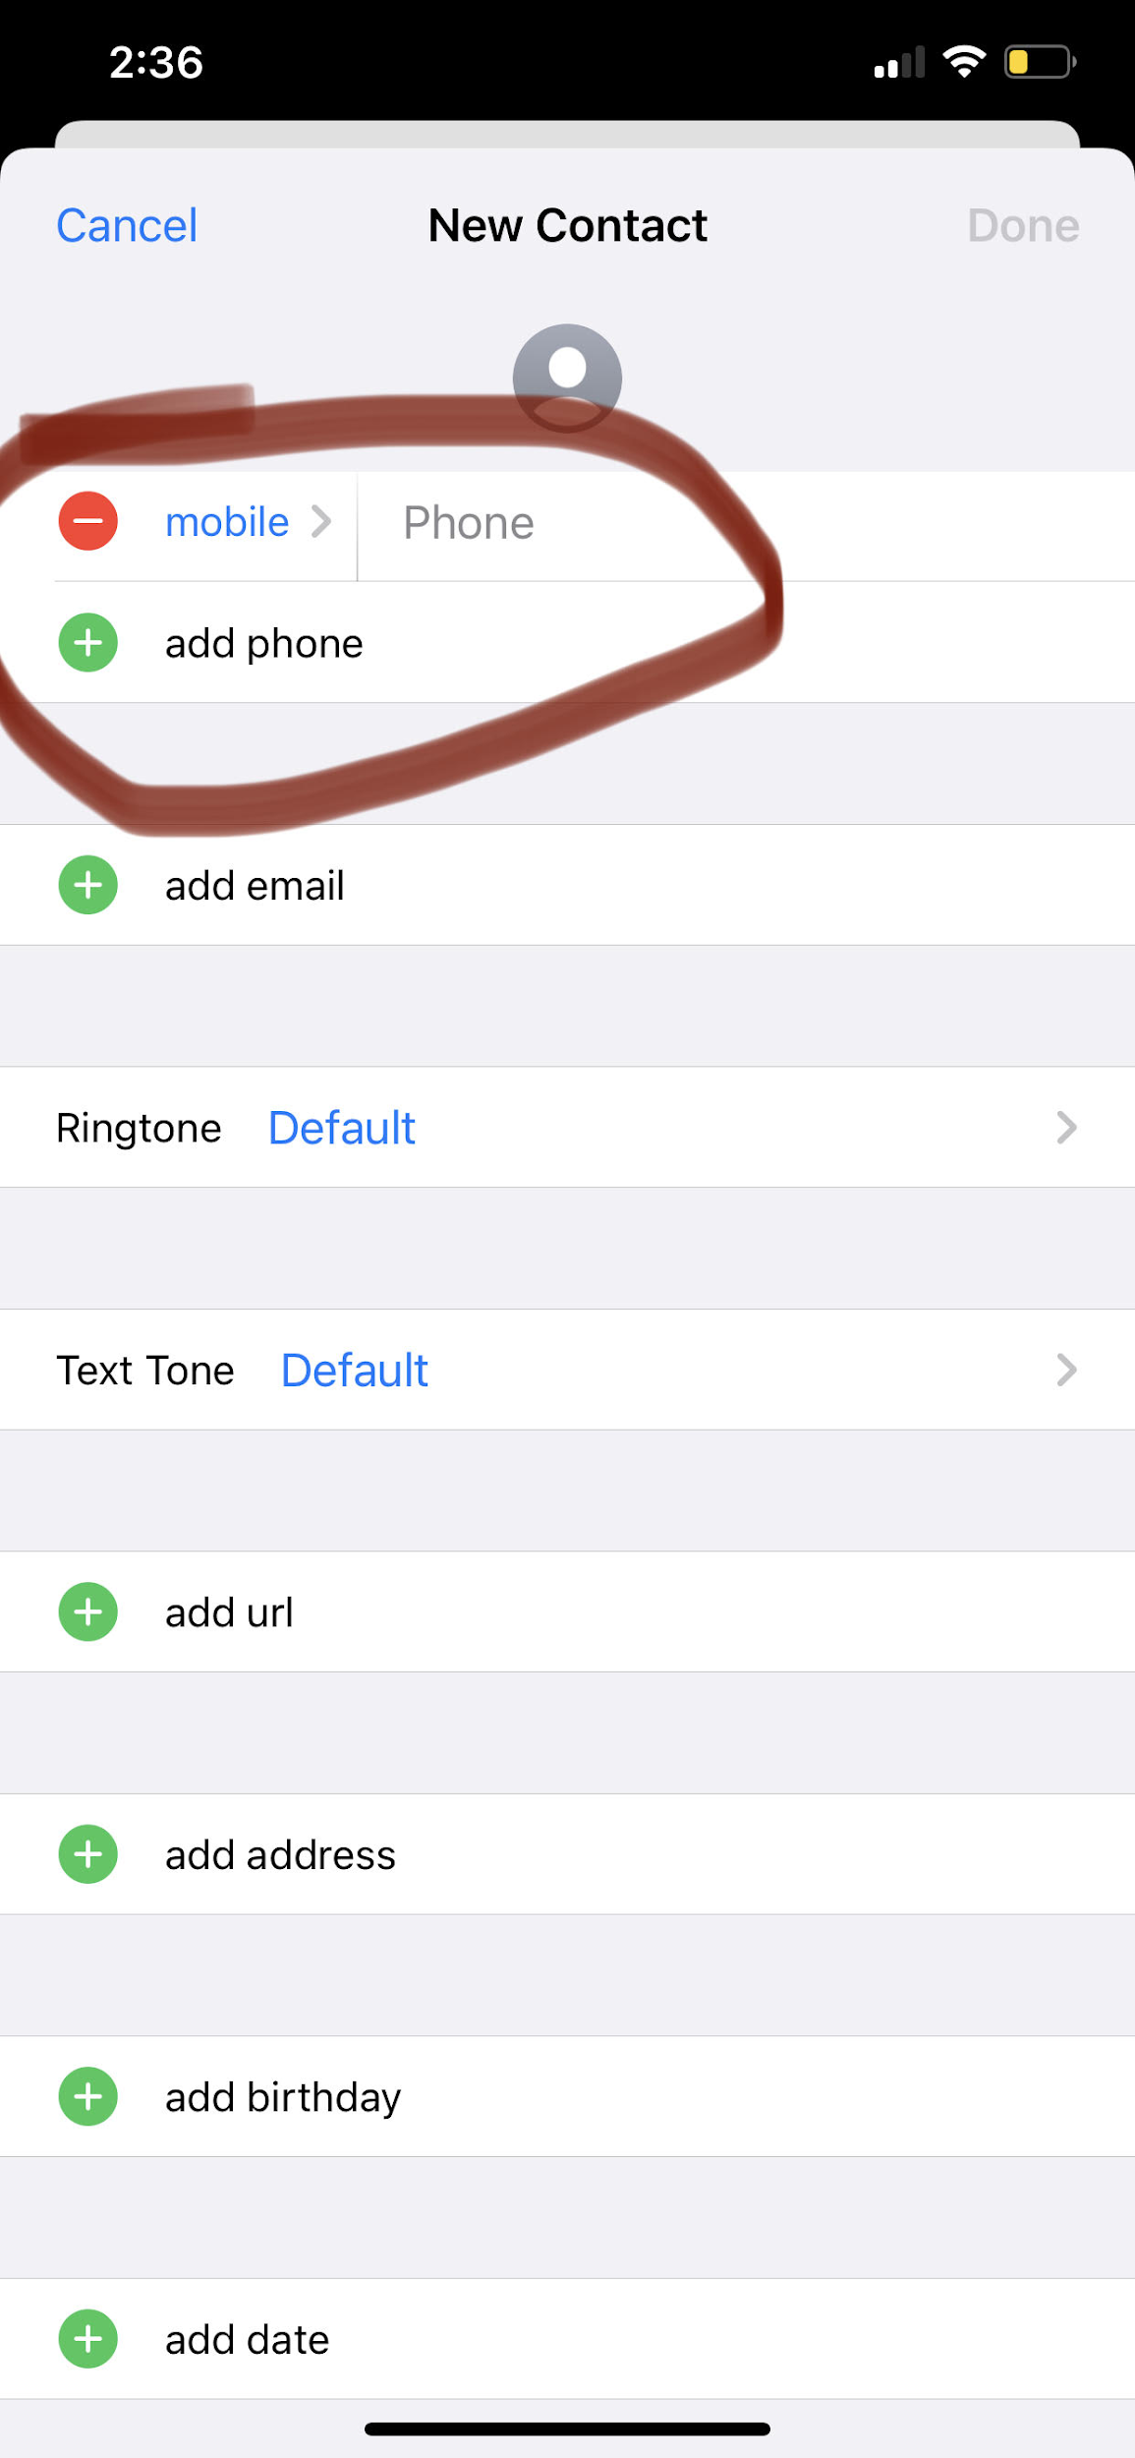

Picture 5 and 6 showing the page where you will write their name, information, phone number

------->

Step 5: Press the “Done” button on the top right afterwards to save the contact information on your phone.

Picture 7
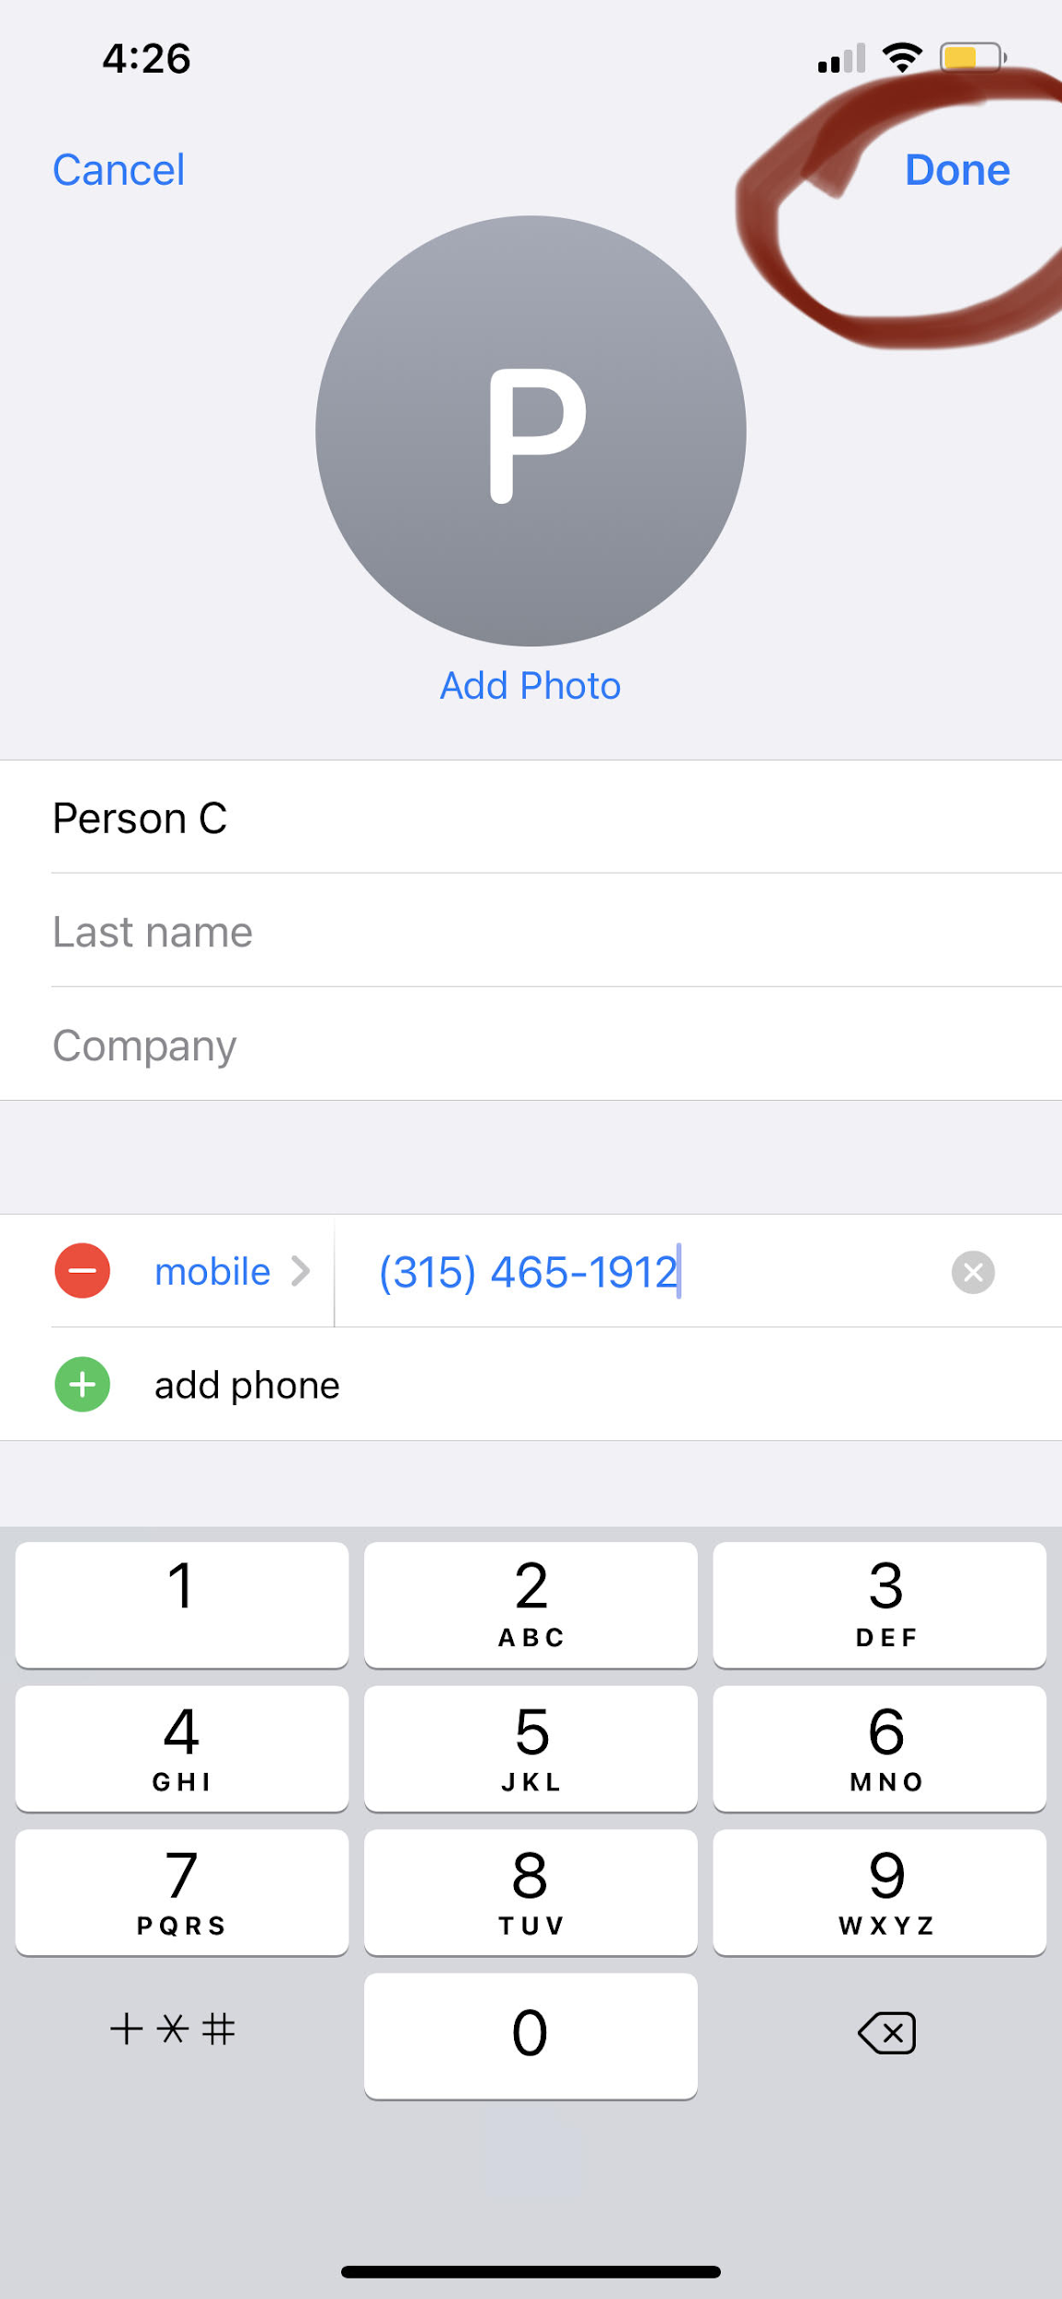
Picture 7 is showing where to find the “Done” button after you will put all the information

(Optional) Step 6: If you want, you can also add a photo from your gallery or take pictures using the camera option for the person so that you can easily recognize an individual besides via their name.
Picture 8: (Add Photo button) Picture 9: (camera button)
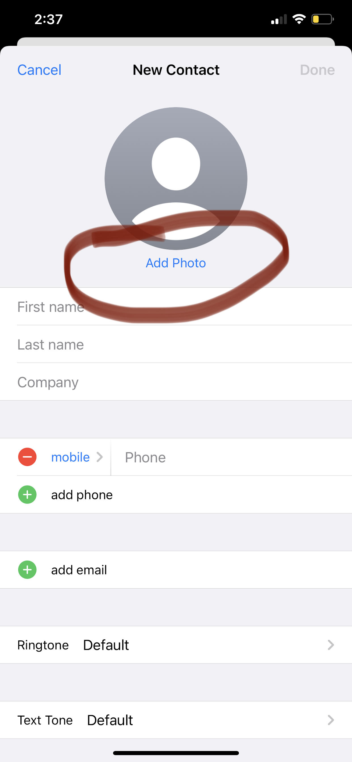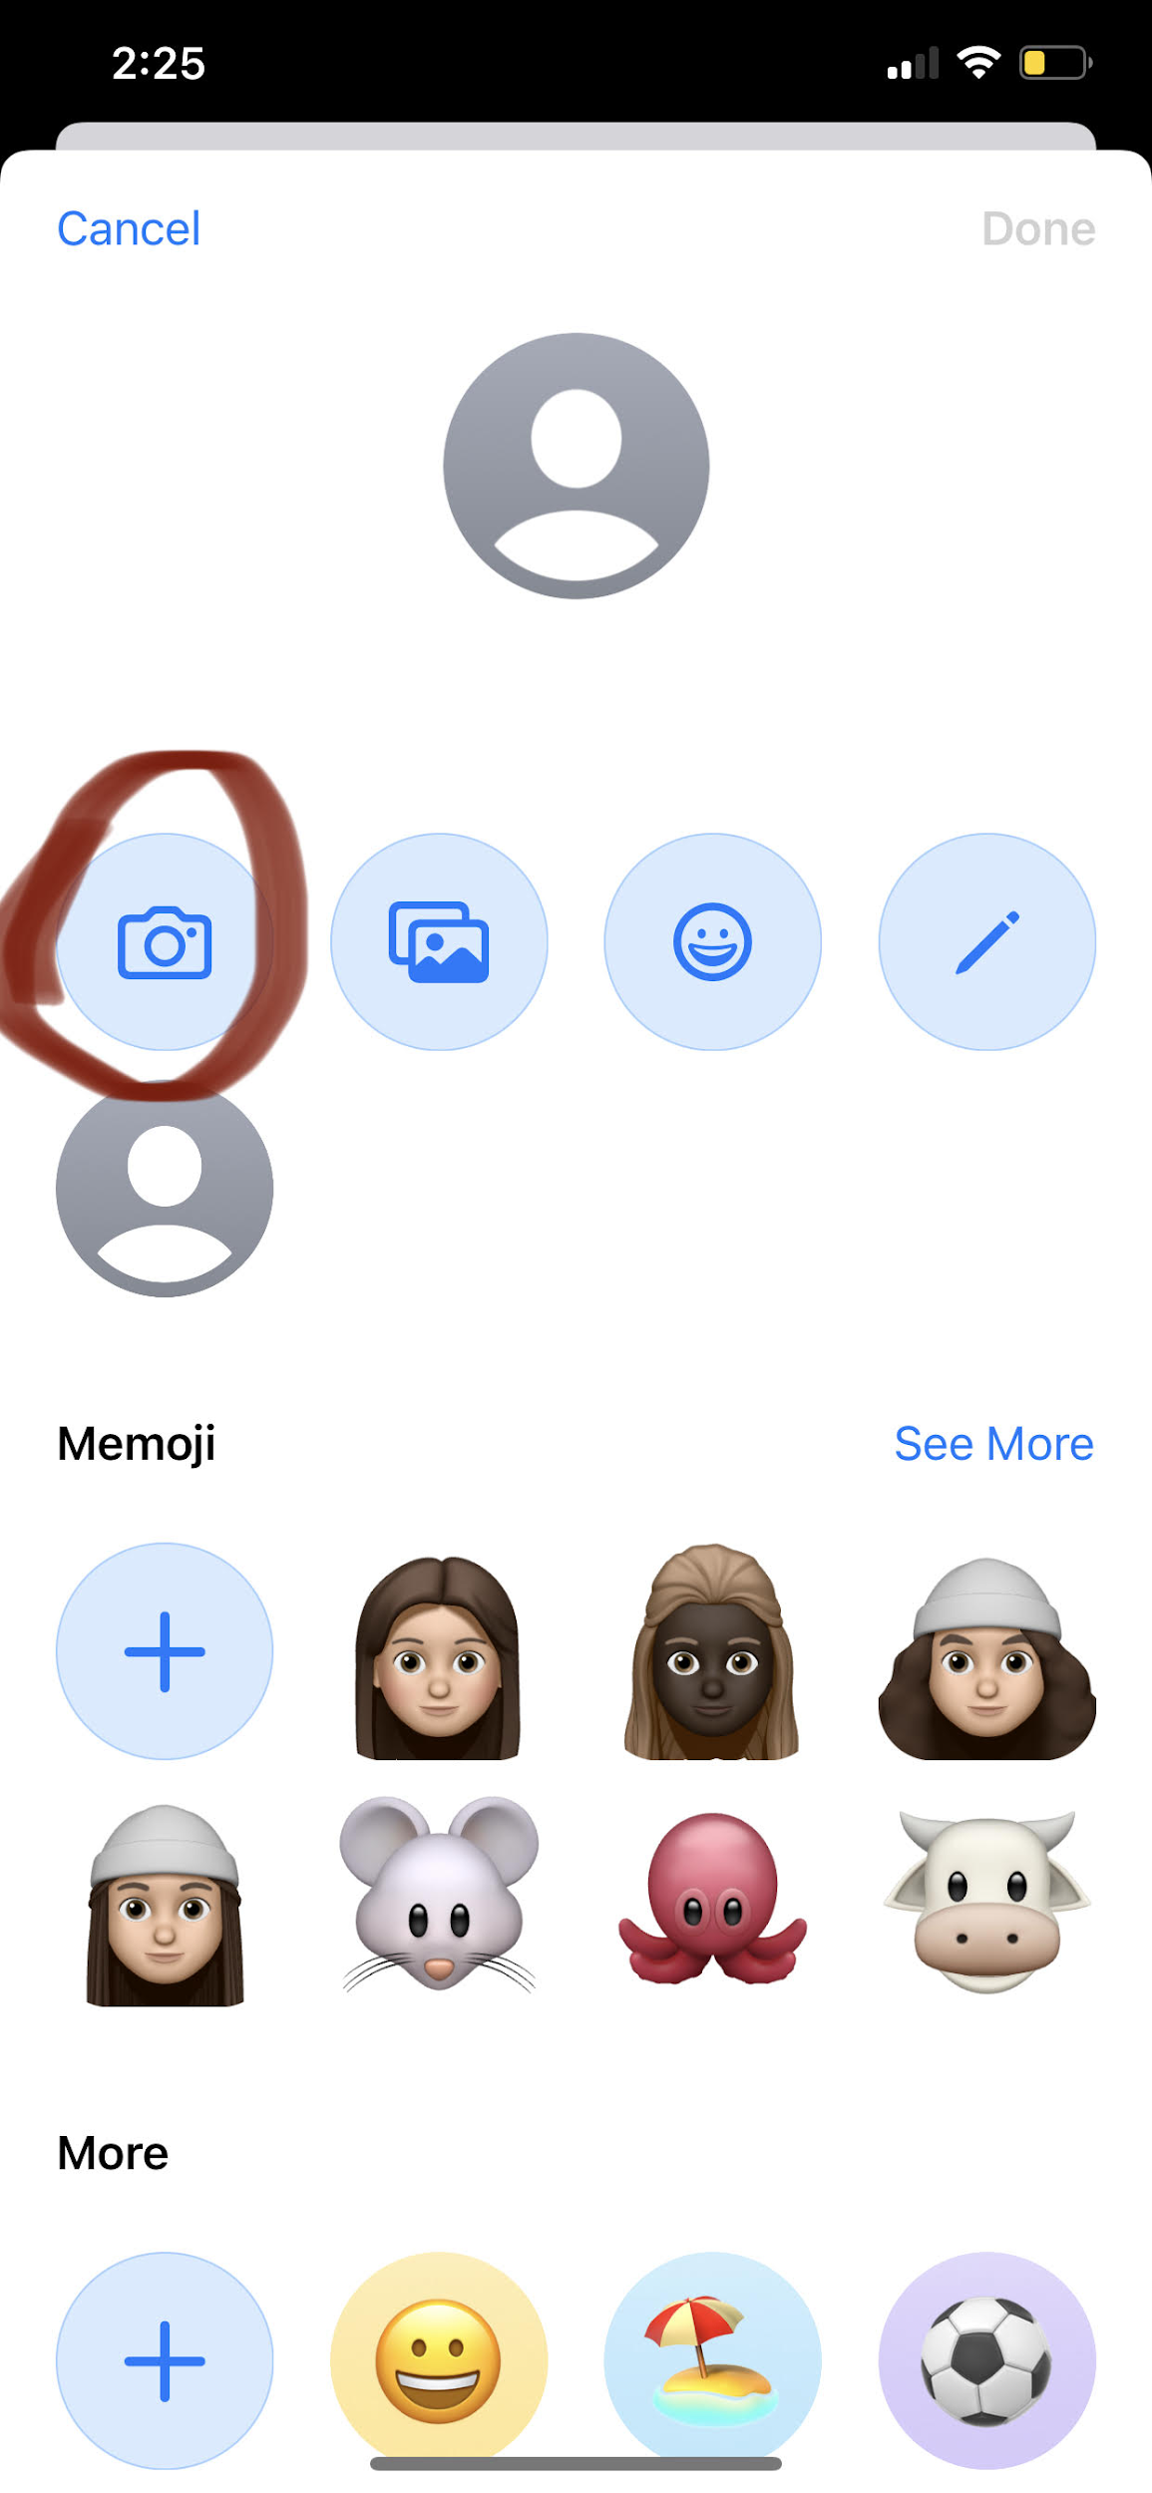
---->

Picture 10: (After pressing Camera roll) Picture 11: (Gallery button)
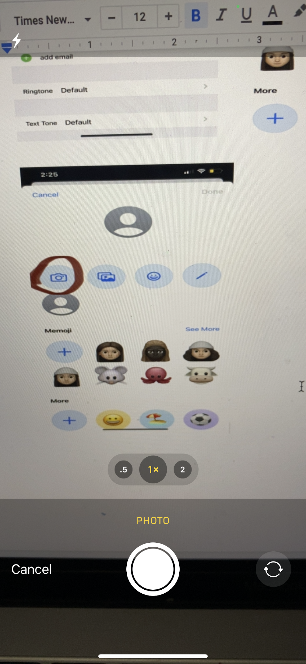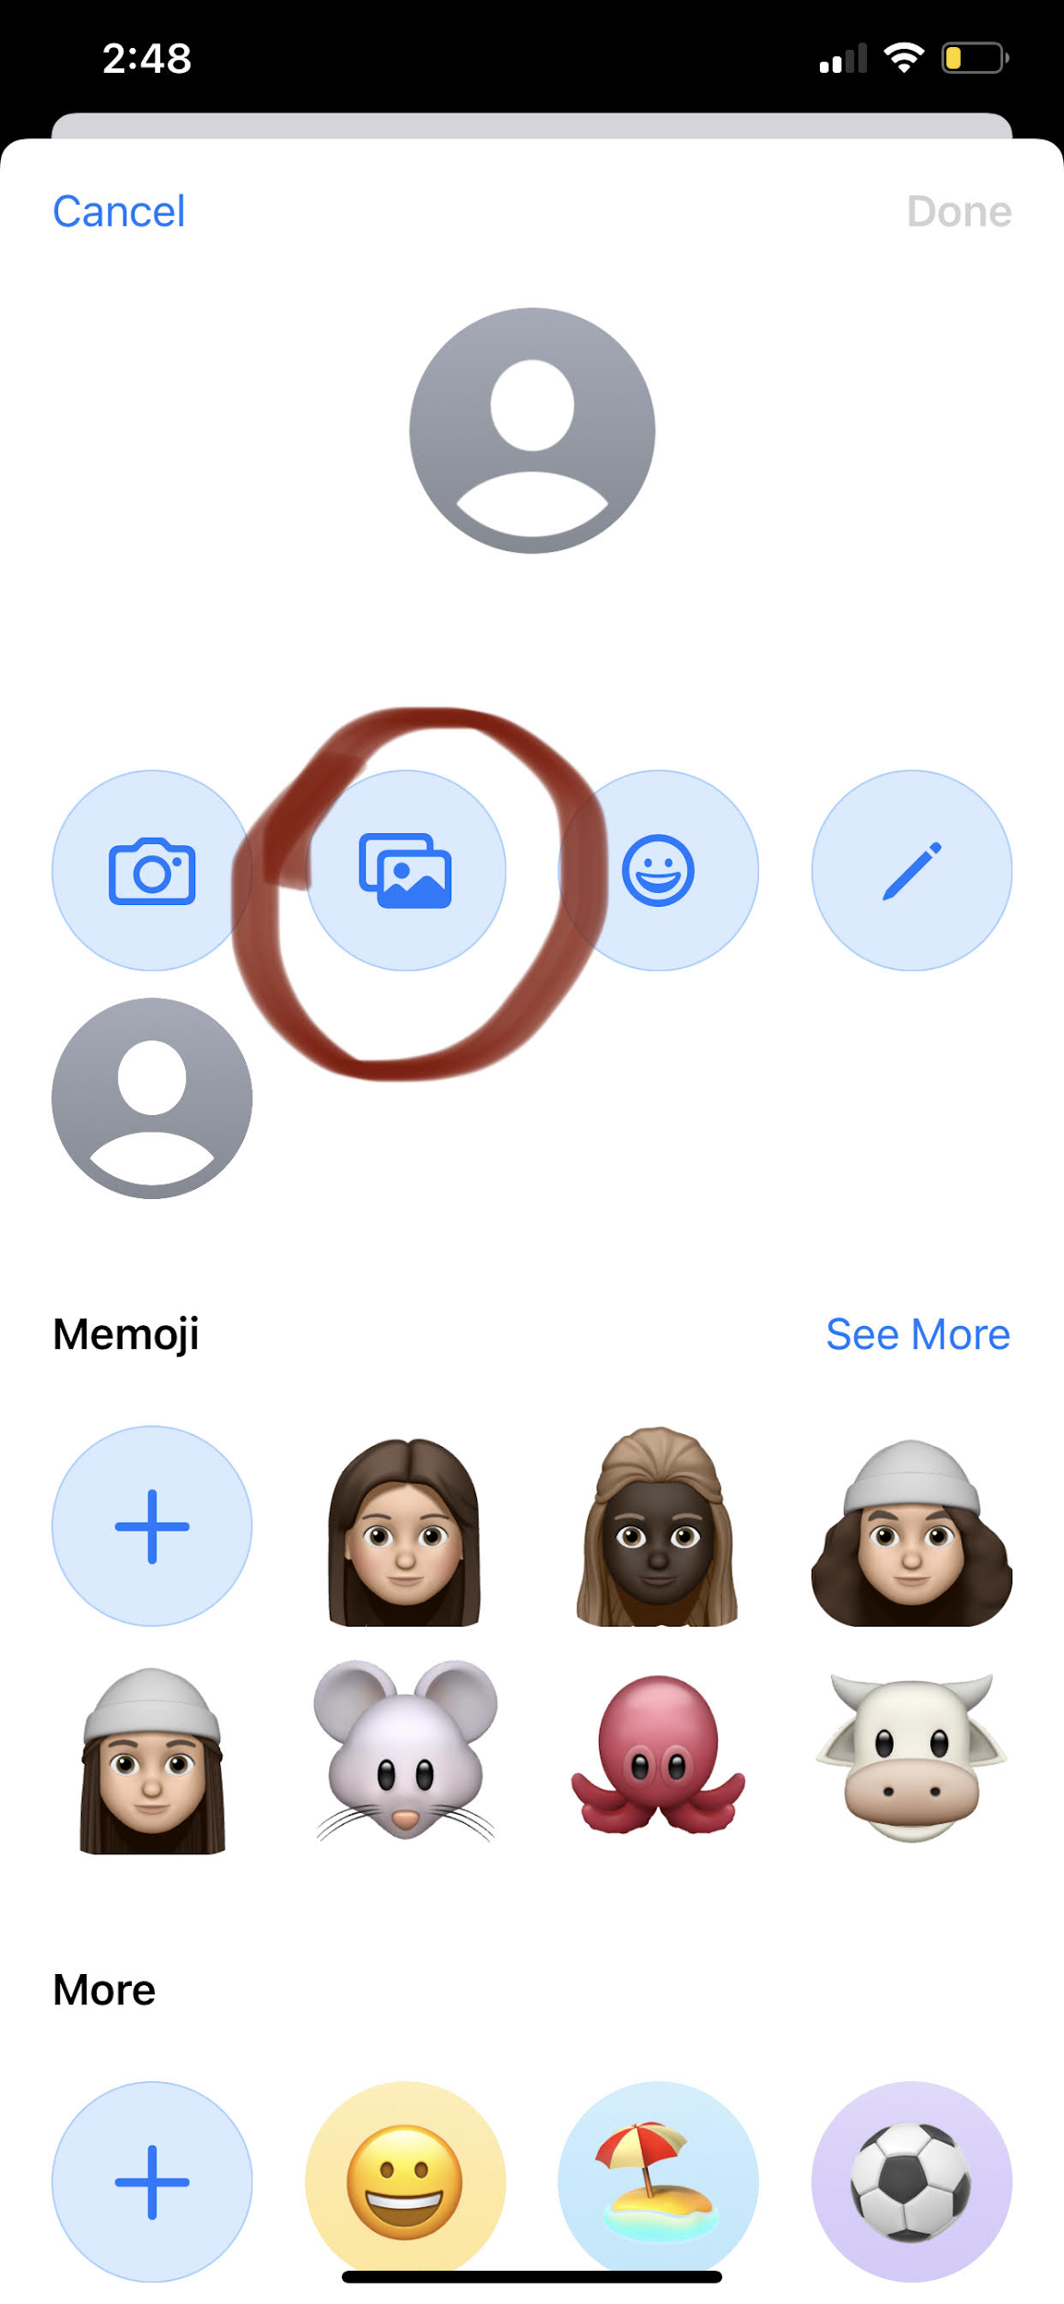
Picture 12: (after pressing gallery)
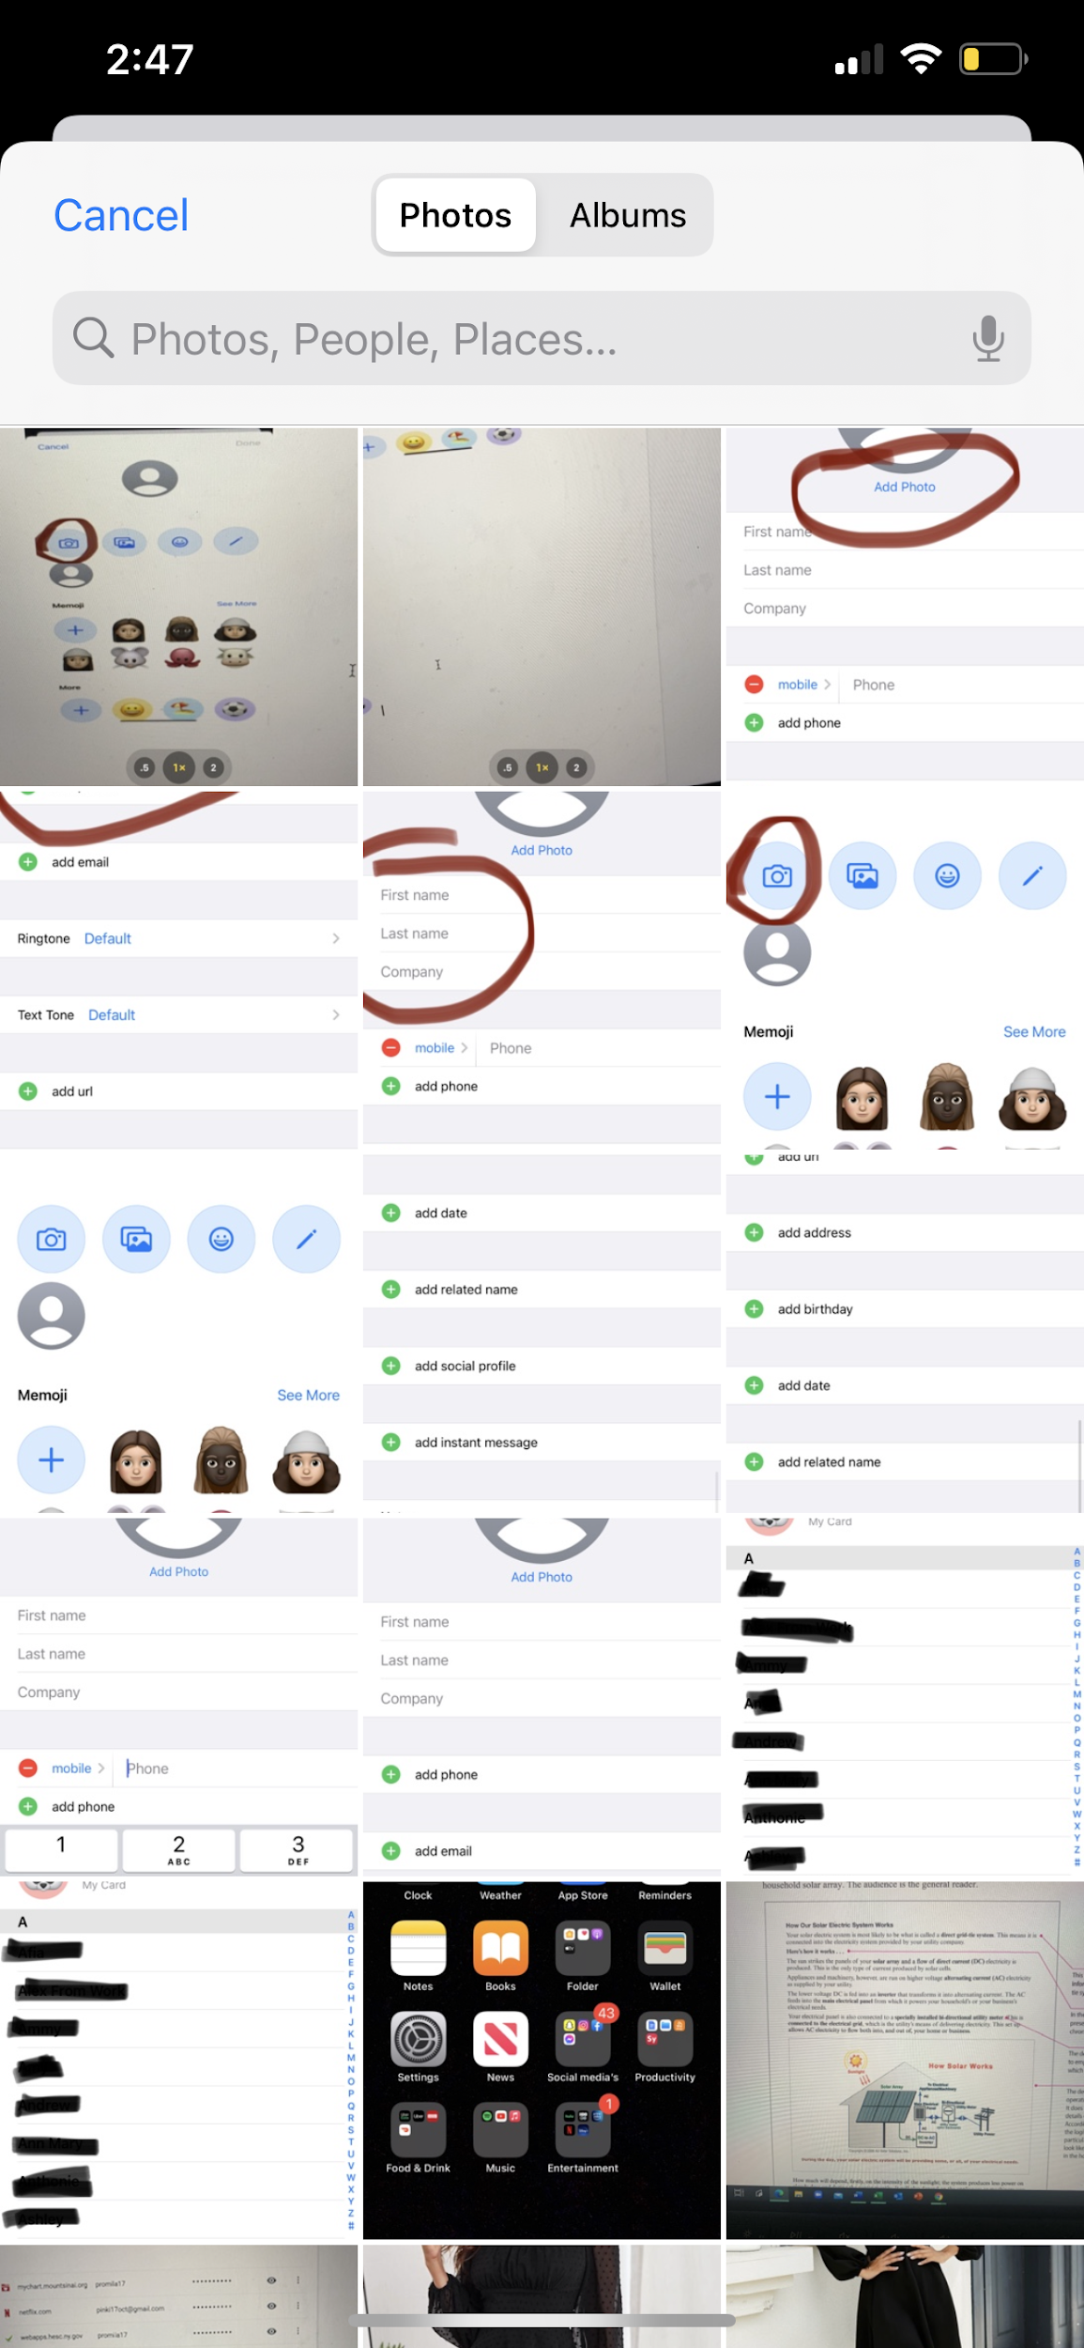
Picture 8,9,10,11,12 is showing how to add photo by using gallery or camera roll

Step 7: Enjoy knowing how to add contacts! Repeat steps to add more.

