How to diagnose your vehicle's fluids

Introduction
Owning a car is a responsibility that can be quite stressful, especially depending on the car’s age and previous usage. In order to ensure that your car is running optimally, it is mandatory that you run regular service checks. It can be quite a nuisance and costly if you are constantly going to a service shop for them to do it for you, however, there are certain things you can do for yourself, such as diagnosing motor oil, brake oils, and coolant levels. Below are some steps to keep in mind for whenever you decide to check your car and ensure it runs properly.

Procedure
Before starting it is important that your engine is off and the car is parked in a safe spot The Necessary tools are : napkins/pieces of absorbent paper or a cloth.
To check all the fluid, the first step, common to all of them, is to open the front hood/bonnet, then the three fluids will have different procedures.
Engine Oil
- Make sure the engine is not hot. Wait 10/15 minute after turning off the engine.
- Find the dipstick. ( located near the engine ,usually characterized by bright colors such as yellow, orange or red but can also be black.)
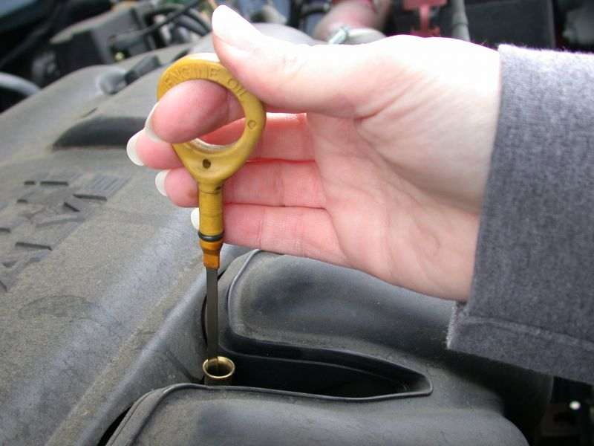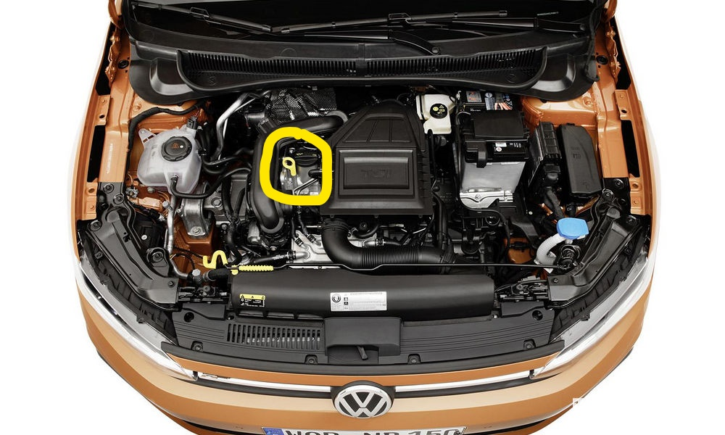
- Pull out the oil dipstick and clean it by wiping it with a napkin or a cloth.
- Put the oil dipstick back in place gently.
- Remove the dipstick once more to check the oil level. (Check the end of the dipstick to see where the oil layer ends, the tip will have notches or dots indicating the optimal range for the oil level. The outermost notch or point will indicate the minimum level while the innermost one will indicate the maximum level.)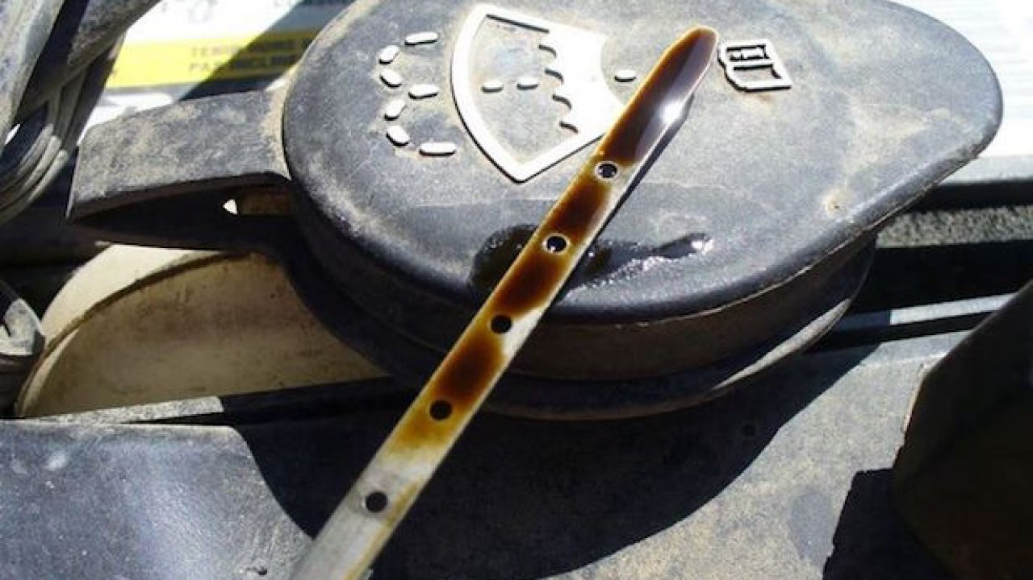
- Put the dipstick back in its place and top up the oil if necessary.( Check the other tutorial on ” How to Choose and Add the Right Oil to the Engine”) .

Brake Fluid
- Look for the brake pump. (In most cars, this is located at the rear of the engine compartment, at the driver's seat. Above the pump itself is a reservoir.)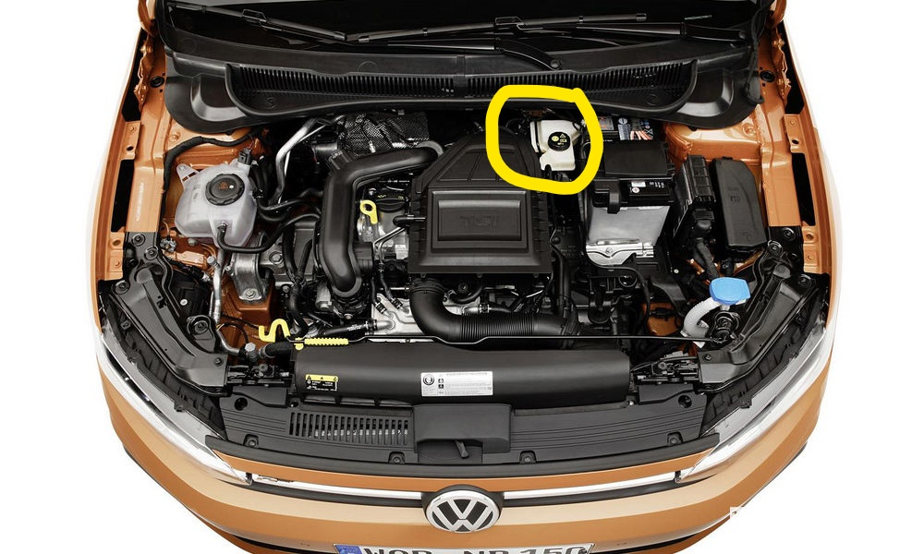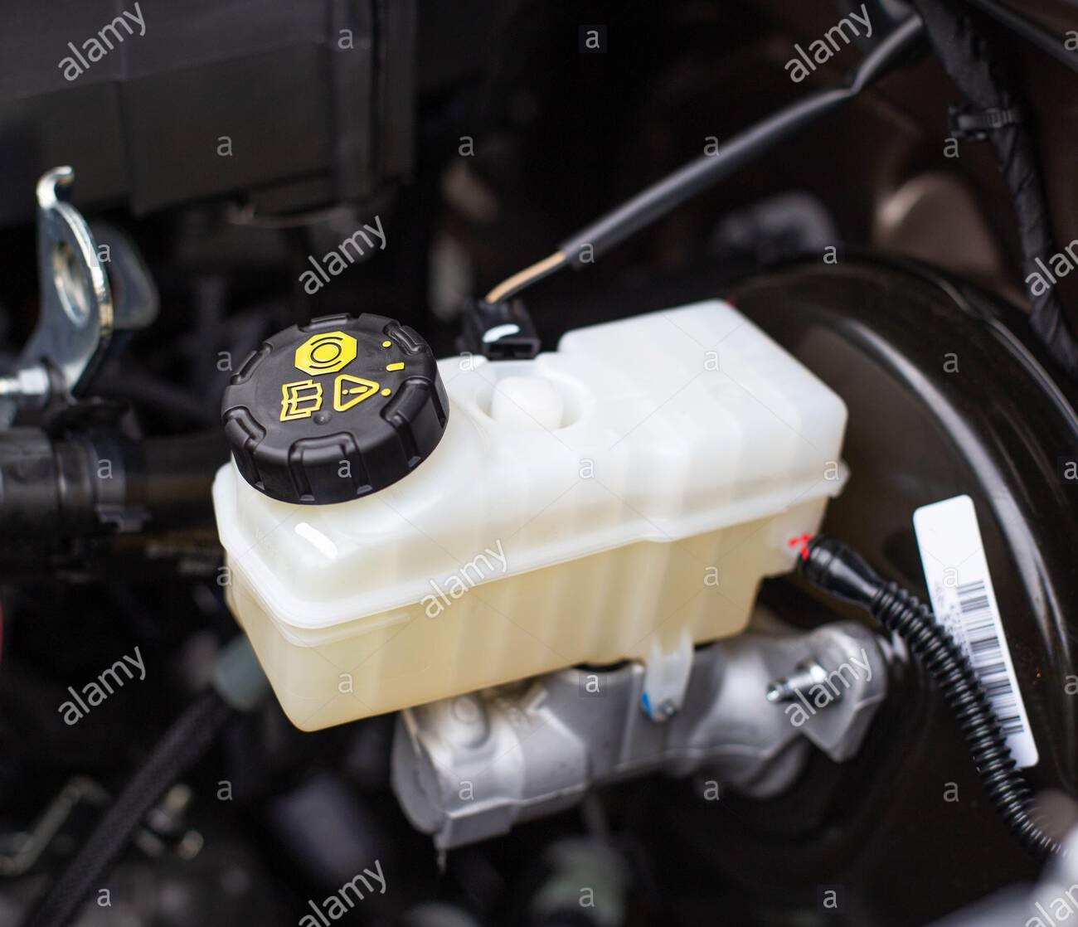
- Check the fluid level in the tank. ( the tank will have two lines, the lower one will indicate the minimum level while the higher one will indicate the maximum level. Most modern cars will also have the words Min and Max.)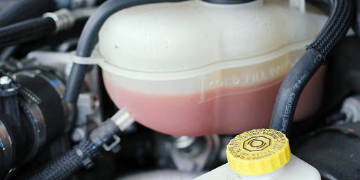

Radiator Coolant/Water
- Make sure the engine is not hot. Wait 10/15 minute after turning off the engine.
- Look for the radiator cap. (This is a cap near the top of the radiator. In more modern cars the cap is labeled.)
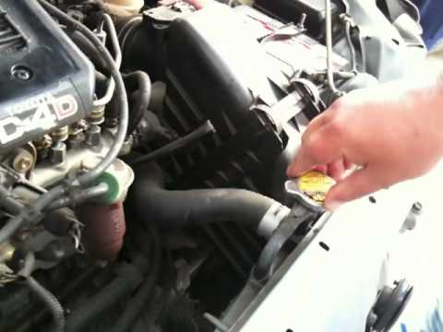
- Open the cap and check the fluid level in the radiator.( The coolant should almost reach the cap / top.)

