Memorandum

To: Noah Valenstein, Head of the Florida Department of Environmental Protection
From: Coastal Technologies
CC: Laura Moss, Indian River County Commissioner of District 5
Vero Beach Local Beneficiaries
Subject: Protecting Florida’s Shoreline using COASTALOCK Rip Raps
Date: April 29, 2021

The purpose of this memo is to introduce our company's proposal to install ECONcrete’s Coastalock rip rap along unprotected areas of the Florida State Road A1A and seek the county’s approval and funding for its installation. We have identified that in between 14069 Florida A1A, Vero Beach, Florida and 12720 Florida A1A, Vero Beach, Florida, there is a 0.75 mile stretch of road that is unprotected. Furthermore, about 250 ft away from the shoreline there are approximately 45 residential buildings that would benefit from preserving the shoreline.
About Us
Our company, Coastal Technologies is located in Fort Lauderdale, Florida, and our team specializes in installing rip rap rocks that protect homes in coastal communities and shorelines from erosion. Our team is made up of three civil engineers who are passionate about exploring new innovative coastal technologies and preserving beaches, marine life, and coastal cities.
Cost of COASTALOCK
COASTALOCK would be about 1% more expensive than conventional single-layer armor technologies for large-scale projects, and up to about 10% more expensive for small-scale projects.
The addition of ECOncrete can reduce mitigation penalties significantly, as they are often considered self-mitigating. Addition of COASTALOCK units, for example, could reduce penalties by up to 80%. Depending on project size, location, and environmental conditions, this may amount to savings in the tens of millions of dollars and can be equivalent to about 15% of project costs.

Benefits of ECONcrete’s Admix
ECONcrete’s Admix is an innovative combination of bio enhancing concrete admixtures that increases surface roughness of COASTALOCK. The unique 3D modular design of COASTALOCK enhances the growth of diverse marine plants and animals on the rip raps and shoreline. These organisms provide numerous biological and economic advantages. For example, it will enhance the ecosystem of sea-life by promoting the growth of oysters and moss on the COASTALOCK. As a result, the concrete will increase in strength due to properties of bio protection and will outlast normal concrete.

Why Does a Rip Rap Need to be Installed?
After Super storm Hurricane Sandy, Fort Lauderdale decided to utilize a secant-pile system that was scheduled for construction in 2019 to protect against future hurricanes and passively prevent erosion of the shoreline. However, the construction of the secant-pile system isn’t viable in the rough terrain between 14069 Florida A1A, Vero Beach, Florida and 12720 Florida A1A, Vero Beach, Florida. So, in order to preserve the unprotected areas of the Florida State Road A1A and the approximately 45 residential buildings against future damages from shoreline erosion and the impact of hurricanes; it is imperative to construct a sturdy rip rap.

Please find Coastal Technologies’ Code of Conduct and Mission Statement as well as the Engineering Proposal attached below. Feel free to contact us should you have any questions. We can be reached at office@coastaltechnologies.com. We look forward to hearing your position regarding the installation of the ECOncrete ripraps.

Attached: Code of Conduct, Mission Statement and Boilerplate, and Engineering Proposal

Sincerely,
Coastal Technologies
Fort Lauderdale, FL

Code of Conduct
Scope
Coastal Technologies expects all of our employees and board members to know and follow the code of conduct. Moreover, we also expect members who may be temporarily assigned to work with Coastal Technologies, such as interns or independent contractors, to follow the code in connection with their work with us.
Respect in the Workplace
Coastal Technologies has a commitment to creating and maintaining a respectful, safe, and inclusive working environment. We have a no tolerance policy in regards to harassment, discrimination, misconduct, or retaliation. If you find anyone violating this code, please report it by email either directly to your supervisor or the Human Resources department of Coastal Technologies.
Professionalism
All employees of Coastal Technologies are expected to be professional in the workplace in order to ensure that customer relations are maintained, employee interactions are positive, and that Coastal Technologies meets its goals and objectives. This includes punctuality and effective time management to meet deadlines, as well as maintaining a positive workplace attitude. Employees are also expected to dress appropriately by adhering to the company dress code. While in the office, Coastal Technologies expects employees to dress appropriately in business attire of a casual nature. Our work environment encourages employees to dress comfortably for work. At work sites, long pants and safety equipment including hard hats, safety glasses, earplugs, safety gloves and work boots should be worn. Long hair should be tied back, and jewelry should never be worn. Coastal Technologies employees should remain loyal to the company and avoid conflicts of interests by not accepting gifts from third parties or disclosing any sensitive information unless authorized by the head of the company.
Protection of Intellectual Property
All employees of Coastal Technologies are expected to keep sensitive information confidential and respect all copyright and other intellectual property laws in regards to Coastal Technologies intellectual property as well as other company’s.
Disciplinary Actions
Any employee who fails to follow the code of conduct will face disciplinary action up to and including termination. Legal action may be taken against those who conduct unlawful behaviors.

Mission Statement:
Our company, Coastal Technologies is located in Fort Lauderdale, Florida, and our mission is to install rip rap rocks all around the United States in order to protect homes in coastal communities and shorelines from erosion. If shorelines aren’t preserved properly, erosion can damage sea life and homes. It's important to preserve the shoreline for the future generations before it's too late. At Coastal Technologies, our motto is saving nature and lives one rock at a time.
Boilerplate:
At Coastal Technologies we are bringing erosion solutions to help people protect their homes and save money. Our company understands the importance of preventing erosion and will help solve the threats caused by erosion with the help of ECOncrete and their product COASTLOCK. Whether it’s a big body of water or small, big piece of land or small, Coastal Technologies can ensure that by installing rip raps we will help protect your property from erosion. Coastal Technologies travels across the US helping other coastal locations.

Protecting Florida’s Shorelines Using COASTALOCK Rip Raps
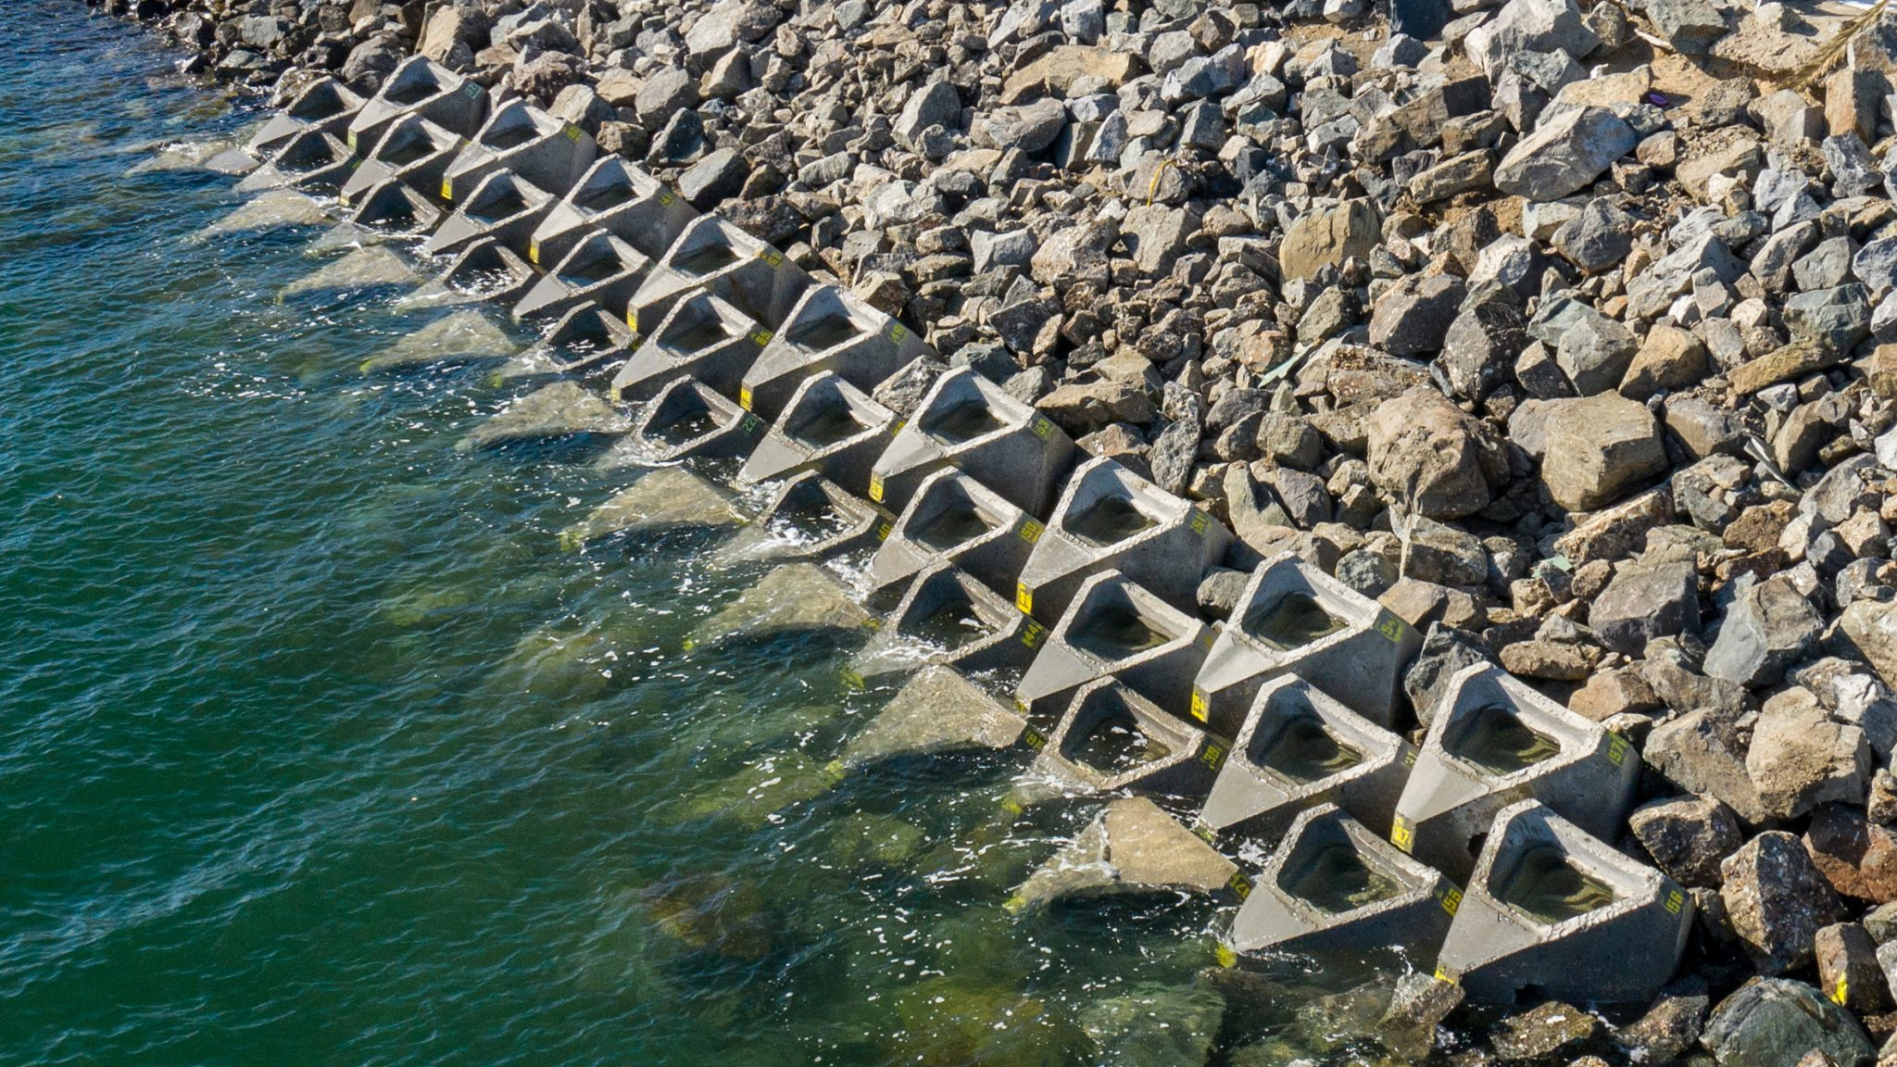
April 29, 2021
To: Noah Valenstein and Laura Moss
From: Coastal Technologies
Javier Tapia
Rebecca Rose Gindoff
Juan Tlatelpa

Table of Contents
1. Introduction 7
1.1 Problem Statement 7
1.2 Background 7
1.3 Needs Statement 8
1.4 Objective 8
2. Proposed Technical Approach 9
2.1 Requirements 9
2.2 Architecture Design 10
2.3 Implementation Design 10
2.4 Quality Assurance Plan 11
3. Expected Project Results 11
3.1 Measures of Success 11
3.2 Project Costs 12
4. Schedule 12
5. References 14
6. Appendix 15

1. Introduction
It is important that we do everything we can to stop Florida's coastal shoreline from eroding any more than it already has. In 2010, almost 500 of the 825 miles of beaches in Florida were considered either critically or no-critically eroded (Clark, 2017). With Florida's coastal shoreline eroding, property values are decreasing and lives are being put in danger. To stop this from happening, our team will be using ECOncrete Rip Raps and placing them along the shore in areas that have the most shoreline erosion. By doing this we will be protecting marine life, the beach, and the lives and properties of people in coastal cities.

1.1 Problem Statement
Coastal erosion along shorelines can damage sea life and homes. After Superstorm Hurricane Sandy destroyed segments of the Florida State Road A1A, Florida State decided to utilize a secant-pile system to rebuild the seawall that was destroyed. The construction of the new seawall was scheduled for 2019 with the purpose to protect the A1A against future hurricanes and passively prevent erosion of the shoreline and A1A highway (VanHoose, 2020). However, the construction of the secant-pile system prioritized the preservation of the A1A and undermined preservation of the local community’s shoreline. Although the construction of the new seawall isn’t viable in the rough terrain between 14069 Florida A1A, and 12720 Florida A1A, Vero Beach, Florida, a rip rap could be used to mitigate the effects of hurricanes. Therefore, in order to preserve the unprotected areas of the Florida State Road A1A and the approximately 45 residential buildings against future damages from shoreline erosion and the impact of hurricanes; it is imperative to construct a sturdy, long-lasting, and eco-friendly rip rap.

1.2 Background
In 2012 Hurricane Sandy hit Florida and caused over $12 million in damage to local beaches in Indian River County, Florida. Over 590,000 cubic yards of sand was lost, boardwalks and lifeguard posts were damaged, and cliff-like drop offs were left, slicing off sections of dune fronts (Bierschenk and Stephans, 2012). In 2016, Hurricane Matthew did nearly $13 million in damage to the shorelines of Indian River County, causing 16 miles of beach to be critically eroded (Hagan, 2016). Erosion is a significant problem in Indian River County because almost 99% of the county’s population resides in the coastal zone. Additionally, the beaches are the main source of income for the community and with each storm the beaches get smaller, and the water approaches properties farther inland (Indian River County, 2020).
One of Indian River County’s natural resources against protecting the main land from coastal erosion is their barrier island, Orchid Island. The 2020 IRC 2020 Comprehensive Plan for Coastal Management discusses the benefits of the barrier island as a habitat for several coastal communities of birds, fish, reptiles and mammals as well as for county residents and visitors, but also recognizes that the changing dimensions of the island due to coastal erosion is something that needs to be addressed. Along areas of Orchid Island, the County has installed coastal tropical hammocks, a 3,000 foot experimental Prefabricated Erosion Protection, as well as coastal armoring, but they are still in search of a solution that will both preserve the natural habitats and protect the coast from erosion in the still unprotected areas of Orchid Island (Indian River County, 2020).

1.3 Needs Statement
We have identified that in Indian River County, on Orchid Island, between 14069 Florida A1A, Vero Beach, Florida and 12720 Florida A1A, Vero Beach, Florida, there is a 0.75 mile stretch of road that is unprotected against coastal erosion. Furthermore, about 250 ft away from the shoreline there are approximately 55 residential buildings that would benefit from preserving the shoreline. We propose to install ECOncrete COASTLOCK rip raps to help mitigate the effects of future hurricanes, thereby protecting the shoreline from gradual erosion.

1.4 Objective
By installing ECOncrete COASTLOCK rip raps our objective is to reduce Florida’s shoreline erosion and preserve the beach while protecting the A1A highway and the residential buildings along the 0.75 mile stretch. We also aim to increase marine life by providing additional habitats within the rip raps.

2. Proposed Technical Approach
The proposed prevention plan is to install a rip rap designed by the company ECOncrete, named “COASTALOCK”, in order to mitigate the effects of future hurricanes on the A1A Florida State Highway and the local community. To begin the installation of the ECOncrete COASTLOCK rip raps our team of engineers will analyze the topography of the shoreline along the 0.75 mile stretch before installing the box water dams, compacting the sand, and laying down the geotextile fabric. Our team will then begin placing the COASTALOCK riprap blocks in order to protect the A1A highway and the residential buildings as well as increase marine life along the shore.

2.1 Requirements
General Requirements:
- ECOncrete COASTALOCK ripraps
- NOAQ Boxwall water dams
- Plate compactor
- Geotextile Filter Fabric
- Fabric staples
- Crane
- Shovel truck
- Warehouse space
Personnel Requirements:
- Civil Engineering Team: Will supervise the installation of the riprap and will lead the quality control management plan.
- Engineering Team: Will prepare the coastline for the installation of the rip rap.
- Crane Operator: Will install the riprap using lifting straps.
- Shovel Truck Operator: Will transport the riprap to and from the warehouse and worksite.

2.2 Architecture Design
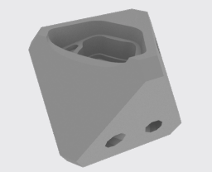
ECOncrete’s COASTALOCK is a single layer armor system designed to provide coastal defense, acting as gravity based units that provide shoreline stabilization and erosion control. The units are octahedral shaped for increased durability and to allow them to be easily combined for stability. COASTALOCK’s unique concrete mix and design encourage growth of marine flora and fauna, elevate biodiversity, and reduce the dominance of invasive species.
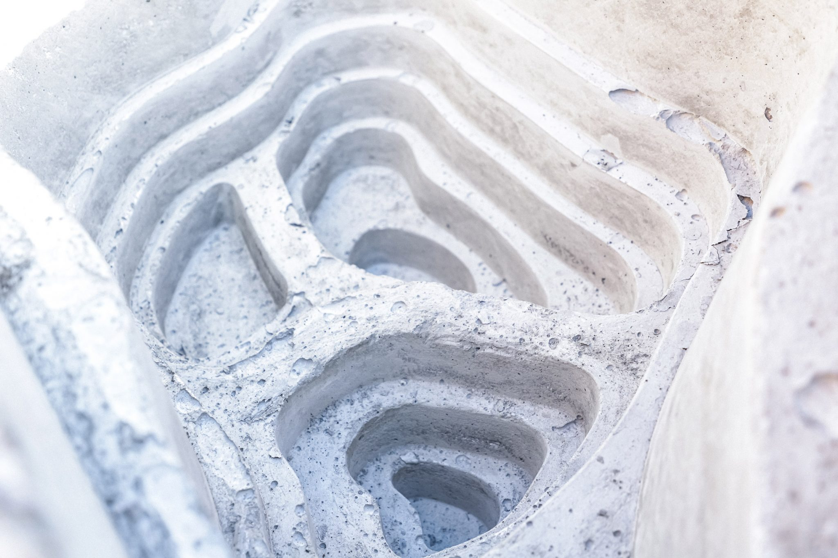
The interlocking COASTALOCK accommodates a few installation patterns which also create unique coastal habitats along the textured indented surfaces that have never before been available on armored waterfronts. These habitats help to compensate for the loss of natural intertidal habitats which has resulted from the construction of standard armor solutions. The COASTALOCK was designed for efficient storage in multiple layers as well as easy handling and positioning.

2.3 Implementation Design
The ECOncrete COASTALOCK is designed to be transported by a crane and placed using either a placement jig or lifting straps. We will be building a riprap using 3 layers of the COASTALOCK units. See Appendix for more details.
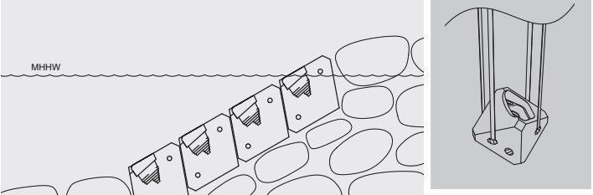

2.4 Quality Assurance Plan
To ensure the quality of the installation of the COASTALOCK riprap our team of engineers will identify the potential errors and develop ways to mitigate them. Our team will actively supervise the installation of the COASTALOCK riprap and guide the crane operator when any issue concerning structural integrity of the rip rap occurs. Furthermore, our team of engineers will deal with and document issues as they occur for future reference and we will use the information acquired for future projects.

3. Expected Project Results
By installing the ECOncrete COASTALOCK rip raps, we expect to:
- Preserve the Vero Beach coastline
- Protect the A1A Florida State Highway
- Protect residential buildings
- Increase marine life
- Save money in the long run

3.1 Measures of Success
To make sure that our project is successful we will be analyzing the site after the project has finished. Team members will visit the site every three days for three weeks, a total of 21 visits. Every time a team member goes they will analyze the rip raps to see if they move or get damaged, if and how much water passes through the rip raps and if sand is being lost. After the first three weeks, we will cut down the visits to once a month to continue ensuring the ripraps’ success. To help us we will be giving all residential buildings our email and phone number to contact us in case there is a problem with the ripraps.

3.2 Project Costs
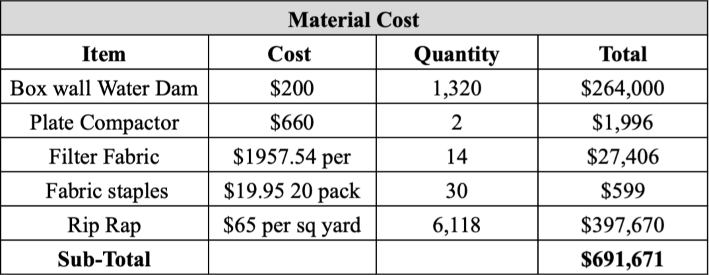

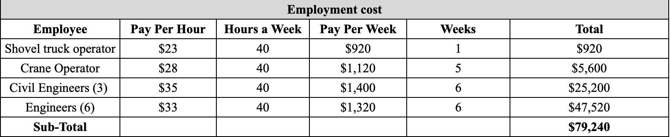

4. Schedule
Our company projects to complete the installation of the COASTALOCK riprap in about 5-6 weeks. To organize this project and create a timeline our team will install the rip rap in 5 different sections with structured steps.
Week 1: One team of engineers will analyze the topography of the coastline and adjust the slope of the beach with a shovel truck to ensure the surface is level and that the rip raps will be placed at the appropriate slope. Simultaneously, another team of engineers will install an array of temporary box wall water dams that will protect the 0.75 mile stretch of leveled and prepped sand from potential damage inflicted by the waves crashing.
Week 2 - 6: Will be used to complete task A, B, C in all 5 sections.
- Task A: Compact sand using a plate compactor. 264 yards by 5.2 yards of sand will be compacted. After that, we will go over it two more times taking a total time of 7 hours. (1 work day)
- Task B: Once the sand is compact we will lay down geotextile fabric and staple them using landscape fabric staples every 10 feet. (1 work day)
- Task C: With a crane we will place each COASTALOCK rip rap on the geotextile fabric. (3 work days)
- Repeat tasks A, B, C in sections remaining 4 sections.
After completing task C in section 5 we will be removing the temporary box wall water dams.

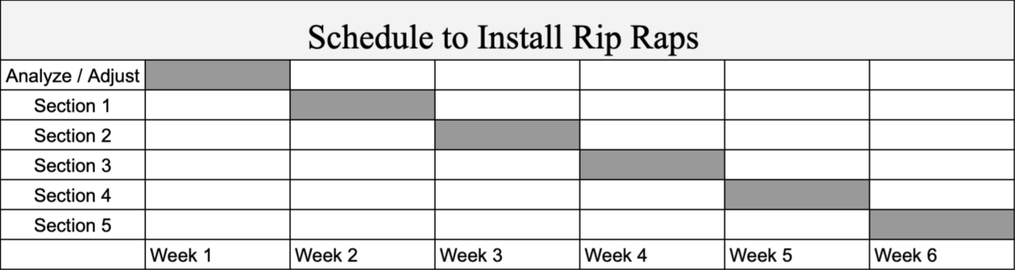

5. References
Bierschenk, E., & Stephens, H. (2012, November 1). Hurricane Sandy causes $12M of beach erosion in Vero Beach, Indian River County. The Palm Beach Post. https://eu.palmbeachpost.com/
Clark, R. (2017, January 12). State of the Beach/State Reports/FL/Beach Erosion - Beachapedia. Beachapedia. http://www.beachapedia.org/State_of_the_Beach/State_Reports/FL/Beach_Erosion#:%7E:text=According%20to%20the%20Coastal%20Hazards%20section%20of%20Florida%27s,from%20107.7%20in%202000%20to%2095.9%20in%202010.
Hagan, A. (2016, October 12). Erosion is a significant problem in Indian River County. WPTV.https://www.wptv.com/region-indian-river-county/erosion-a-significant-problem-in-indian-river-county
Indian River County Community Development Department. (2020). Indian River County 2020 Comprehensive Plan (Chapter 9). https://irccdd.com/Planning_Division/CP/Comprehensive_Plan_Ch9.pdf
VanHoose, J. (2020, September 17). RS&H-Designed SR A1A Project Brings More Resiliency to Flagler Beach. RS&H. https://blog.rsandh.com/news/rsh-designed- sr-a1a-project-brings-more-resiliency-to-flagler-beach

6. Appendix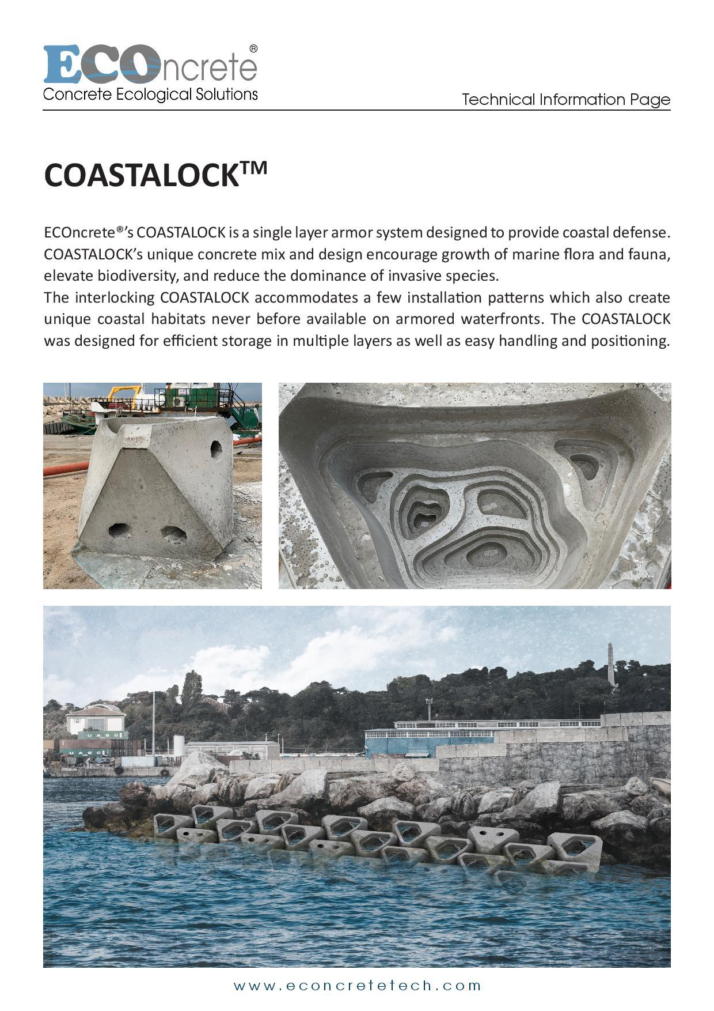
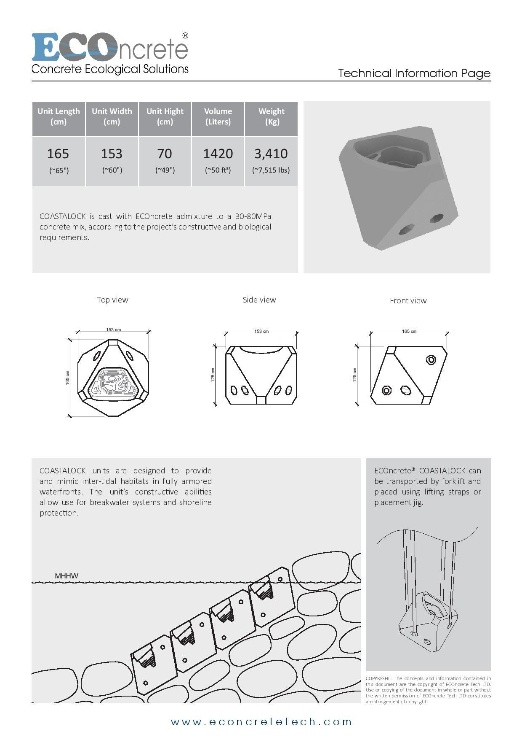
AUDIENCE PROFILE SHEET
Reader’s Name: Noah Valenstein
Reader’s Job Title: Head of the Florida Department of Environmental Protection
Type of Reader: Primary
Professional Experience: Noah Valenstein heads the Florida Department of Environmental Protection and currently serves as the state’s chief resilience officer. Noah has served as secretary since 2017, and he is the first DEP secretary to be appointed by two consecutive governors.
Job Responsibilities: The secretary, Noah Vakenstein, oversees all functions of the DEP. Which includes: ecosystem restoration, land and recreation, regulatory programs, and division of administrative services.
Personal Characteristics: According to Noah’s Twitter, he is a Floridian, father and husband. Noah prioritizes building relationships between diverse groups of stakeholders, from state and federal agencies to environmental and agricultural groups to local communities and businesses. At the state level, Noah has developed strong relationships with Florida’s leading environmental nonprofits.
Cultural Characteristics: Noah Valenstein is a white male, born in Florida, and approximately 35 years old. Noah’s political party is nonpartisan and this reveals that he is open minded and neutral.
Attitude Toward the Writer: Noah has developed strong relationships with Florida’s leading environmental nonprofits, including the Everglades Foundation, Everglades Trust, Save the Manatee Club, Audubon Florida and many others. Thus, we assume Noah will respect and possibly be inclined to support our cause.
Attitude Toward the Subject: Coastal Technologies is planning to install a rip rap to mitigate the effects of hurricanes and help the Highway A1A community with preserving their shoreline. Noah has already worked with other organizations to help Floridians and will think about how people will benefit from our proposal.
Expectations About the Subject: Upon reading our proposal Noah will expect for our rip rap installation and budget to be realistic and attainable. Whether or not Noah decides to support us his expectations are for us to follow our set budget and schedule.
Expectations About the Document: Noah Valenstein will expect for the document to be well written and with enough information to help him fully understand the subject. The document should include illustration and charts when needed and no important questions should be left unanswered.
Reasons for Reading the Document: The document is emailed to Noah Velenstein from Coastal Technologies and we are seeking his support.
Ways of Reading the Document: The document is an engineering proposal that must be studied in order to fully comprehend the subject.
Reading Skills: Noah Valentstein attended the University of Florida and obtained a Bachelor’s degree in Environmental Policy and received Honors. Also, he graduated from Florida State University and earned a Juris Doctor, which is the minimum required to practice law. So with this information we can infer that Noah won’t have any difficulty reading our engineering proposal.
Reader’s Physical Environment: The engineering proposal will be delivered to Noah via email. So, the reader’s physical environment will be at work or home depending on their work situation with COVID-19.
---------------------------------------------------------------------------------------------------------------------
AUDIENCE PROFILE SHEET
Reader’s Name: Laura Moss
Reader’s Job Title: Indian River County Commissioner District 5
Type of Reader: Primary
Professional Experience: Laura Moss was the Mayor of Vero Beach, Fl from 2016-2017 and Vice Mayor from 2019-present. She has served on the Vero beach City Council, Metropolitan Planning Organization, and the Affordable Housing Advisory Committee since 2016.
Job Responsibilities: Policymaking, budgeting, environmental and land use planning, as well as overseeing all boards related to Emergency Services, Utilities Services, Community Development, and Public Works which includes Coastal Engineering, in District 5 (Orchid Island).
Personal Characteristics: Professional, ambitious, educated, and “a woman of the people” according to TCPalm Endorsements. Prioritizes working as a community to improve quality of life and make our environment more sustainable, evident by the fact that she was awarded the President’s Award from Audubon Florida.
Cultural Characteristics: White female, in her upper sixties. Republican.
Attitude Toward the Writer: Coastal Technologies is working to install ripraps to ensure a better environment for the local community in Vero Beach. As County Commissioner Laura Moss has brought back Coffee with the Mayor because of her strong dedication to helping the Vero Beach community, she will be very interested in what Coastal Technologies has to say about coastal erosion and protecting the community.
Attitude Toward the Subject: Laura Moss when running for County Commissioner said her main priorities while in office are land development and environmental sustainability. Given this we believe Laura Moss will be inclined to support our plan and help with its implementation.
Expectations About the Subject: Upon reading our proposal Laura will expect Coastal Technologies to stick to their schedule as well as prioritize the community’s needs over the company’s.
Expectations About the Document: Laura will expect for the document to be well written and with enough information to help her fully understand the subject and why it is crucial to the environment and community. The document should include illustration and charts when needed and no important questions should be left unanswered.
Reasons for Reading the Document: The document is emailed to Laura Moss from Coastal Technologies seeking her support on a matter important to the people she represents.
Ways of Reading the Document: She will probably skip over the technical description because only the current problem and the benefits of the proposed solution are relevant to her.
Reading Skills: As she is a prominent political figure and former mayor, she has exceptional reading skills and should have no issues reading the documents, except potentially understanding all aspects of the technical descriptions, as engineering is not her specialty.
Reader’s Physical Environment: The engineering proposal will be delivered to Laura Moss via email. So, the reader’s physical environment will be at work or home depending on their work situation with COVID-19.
---------------------------------------------------------------------------------------------------------------------
AUDIENCE PROFILE SHEET
Reader’s Name: Highway A1A Local Community (Beneficiaries)
Reader’s Job Title: Working Class Community
Type of Reader: Secondary
Professional Experience: N/A
Job Responsibilities: N/A
Personal Characteristics: Care about protecting their homes and the community as a whole. Concerned about maintaining the sources of income for Vero Beach that the coast provides the coastal community.
Cultural Characteristics: N/A
Attitude Toward the Writer: Coastal Technologies is proposing a way to protect the shorelines and therefore the livelihoods and homes of the residents of Vero Beach, so interested in what Coastal Technologies has to offer.
Attitude Toward the Subject: The Highway A1A Local Community is concerned about coastal erosion and interested in proposed solutions that will protect their homes and livelihoods, so interested in the ripraps Coastal Technologies is proposing.
Expectations About the Subject: After reviewing the engineering proposal, they would expect the riprap construction to stick to the proposed schedule as well as benefit the community like the document says it will.
Expectations About the Document: The local community will expect for the document to be well written and with enough information to help them fully understand the subject and why it is beneficial to the community.
Reasons for Reading the Document: Concerns their homes, so will read it to decide if it is something they will support or fight against
Ways of Reading the Document: Those who read it/are interested in understanding the proposed solution will read it in its entirety to understand how it will affect their community
Reading Skills: Will differ amongst the community members, some may struggle reading the technical aspects
Reader’s Physical Environment: The community would receive this information via the community email list, so would most likely be reading it at home or somewhere on their mobile device.

Rose Gindoff - Reflection
For this project we decided to address coastal erosion in Vero Beach, Florida. Based on the research we did regarding current solutions and their faults, we decided the best solution would be to install ECOncrete COASTALOCK ripraps along the 0.75 mile stretch of shoreline in Vero Beach. This idea for the proposal compliments our area of study as we are all Civil Engineering students and coastal engineering is a division of Civil Engineering.
Collaboration was the most crucial part of this project. As this project was a culmination of all the work we have done so far in the semester, it included many aspects and required a lot of division of labor as well as communication. At first it was difficult to get in the flow of working together as none of our projects thus far had required as much collaboration, but once we got into the swing of things, we worked really well together. To complete the assignment we relied heavily on technology in order to communicate. Although this was due to our “new normal” of pandemic life and online learning, if we were working on a legitimate project as engineers, it would probably have looked very similar as engineers are often located in different areas. Because we have been a group this entire semester, we had figured out the best ways to communicate with each other, which made completing this project much easier than if we did not already have a preferred method of communication.
For the Asynchronous Assignment #4, I focused on the Code of Conduct and the Job Posting, but helped my group members Juan and Javier with the Mission Statement, Boilerplate, Applicant Pick, and Memo. For the actual Engineering Proposal, I focused on the problem, background and needs. I helped with the technical aspects as well, but Juan and Javier did the brunt of that work.
The genre of this assignment is an engineering proposal. An engineering proposal is a persuasive document that gives a detailed description of the project you wish to conduct. Our proposal meets all of the requirements because we start with the problem, providing accurate research about coastal erosion caused by hurricanes in Indian River County, Florida, we then introduce our design to the audience by giving a detailed technical description of our design as well as a budget.
The purpose of our engineering proposal is to persuade our audience to approve and fund our project to install ECOncrete ripraps along the coast of Florida in Indian River County. Our audience for this proposal is Noah Valenstein, Laura Moss, and the Highway A1A Local Community. We chose our three audiences based on their positions and their connection with the location. Noah Valenstein is Head of the Florida Department of Environmental Protection, Laura Moss is the County Commissioner for Vero Beach, and the local community will be directly affected by any construction done off of the A1A, so they deserve to know what is going on. Additionally, if we have the community’s approval, it will be easier to get approval from the local government.
Our exigence is the damage to marine life and homes along the shoreline caused by coastal erosion. As almost 99% of the county’s population resides in the coastal zone, coastal erosion is a large issue in Indian River County. Additionally, the beaches are the main source of income for the community and with each storm the beaches get smaller, and the water approaches properties farther inland.
For this assignment we chose two mediums to communicate with our audience. Although both are technically digital we will be emailing our audience our memo with the Engineering Proposal as an attachment as well as doing an oral presentation over Zoom. Our stance for this proposal is advocating for the installation of ECOncrete COASTALOCK ripraps to protect the shoreline.
With this assignment I have met multiple course learning outcomes. I was able to explore the collaborative aspect of the writing process throughout the entire project by working with my group mates. I was also able to formulate and articulate my stance through my writing, explore the use of genre, medium, and rhetorical situations within my writing, and practice using various online resources to find information for my engineering proposal as it required a substantial amount of research. I hope that we communicated the problem, objective, and proposed solution clearly and critically and that this document will be received positively by our audience.

Javier Tapia - Reflection
For this assignment we were told to compose an engineering proposal for a creative engineering innovation that would solve or mitigate problems related to natural disasters. So, our group decided to address the coastal erosion in Vero Beach, Florida caused by the Atlantic Hurricane season. To mitigate this, our group decided to investigate a modular riprap designed by the company ECOncrete named, “COASTALOCK”. Overall, the subject of our engineering proposal suited our group, because we all major in Civil Engineering
The engineering proposal was a conglomerate of the previous assignment and by far the most complex and time consuming. The difficult part of the project was finding time to work together, because we were all preoccupied during the mornings of weekends and this project required the most teamwork. Fortunately, all of our schedules aligned and we were able to complete the assignments during the afternoon. When choosing our topic, we decided that painting roads white was a good idea, however, Rose convinced us that relating white roads to global warming to forest fires wouldn’t be a solid connection. So, our group decided to investigate rip raps and how they can mitigate the effects of hurricanes. The benefit of teamwork in the engineering proposal is that bouncing ideas around and being open minded will facilitate the project. Thus, if it weren’t for Rose telling us that white roads aren't a good idea for the requirements of this project, we would have been stuck with a weak connection to natural disasters.
For the Asynchronous Assignment #4, Rose worked on the code of conduct and job positions. At first, we wanted to hire a hydraulic engineer and the group reconsidered to hire a crane operator. The reason for this change is that we realized that we had to hire one of our classmates. Then, Juan did the mission statement, and the boilerplate. At first, the boilerplate was too similar to the mission statement, so Rose and I gave Juan suggestions. Lastly, I did the applicant pick and the memo. For the applicant pick, I didn’t realize that we had to choose someone from outside the group. Then, Rose informed me and I quickly made adjustments.
For the engineering proposal, I focused on finding our subject and location. So, I suggested doing a modular riprap instead of a stone riprap. I then found a company, ECOncrete, with a product that we could use and easily install. So, I contacted the company and acquired a technical description of their product. After that, I suggest installing the riprap in the A1A highway, which was partially destroyed by Hurricane Sandy. So once we decided on the topic Juan discovered how to properly install rip raps, the materials and workers we would need, the cost, the measure of success, and the schedule. Meanwhile, Rose and I focused on the problem, background, needs, objective, the expected results, technical approach, and designs. As a team we all came together and organized all of the information in a proposal and presentation. Overall, COVID-19 put us in a virtual learning setting and like true engineers we were able to complete this project without ever speaking to each other, only text.
The genre of this assignment is an engineering proposal, because it follows the structure and composition of one . This includes an introduction, problem statement, background, needs statement, objective, proposed technical approach, and etc. Engineering proposals to offer to carry out research or provide a product or service in a persuasive manner. For this assignment our group uses digital medium to communicate the engineering proposal to our audience, in the form of email and a powerpoint presentation.
The purpose of our engineering proposal is to persuade our audience to approve and fund the installation of the COASTALOCK riprap, which will protect and preserve the unguarded portions of the Florida State Highway A1A and the local community. The goal of our engineering proposal was to seek funding from Noah Valenstein, the Head of the Florida Department of Environmental Protection.
Our targeted audience was Noah Valenstein, the Head of the Florida Department of Environmental Protection, Laura Moss, the Indian River County Commissioner of District 5, and the Vero Beach local community. Noah Valenstein’s job responsibilities were overseeing all functions of the DEP; which includes: ecosystem restoration, land and recreation, regulatory programs, and division of administrative services. We targeted Noah, because the DEP is a government funded institution responsible for land preservation and they had the money for our project. Secondly, Laura Moss was the major of Vero Beach and she also was responsible for improving the Vero Beach community.
The exigencies for this project is that natural disasters are unpredictable and wreak havoc on unprotected communities. So, in order to mitigate the effects of hurricanes on small communities, we decided to install a riprap to at least preserve the shoreline after a hurricane. For this engineering proposal the stance was to persuade the audience to give us funding and allow us to build a COASTALOCK riprap to protect unprotect areas of Vero Beach.
With this assignment I have met multiple course learning outcomes. I was able to explore the collaborative aspect of the writing process through working together on the engineering proposal as a group and dividing work and responsibilities amongst use. While writing the engineering proposal I was also able to formulate and articulate my stance through my writing, explore the use of genre, medium, and rhetorical situations within my writing, and practice using various online resources to find information for our engineering proposal. I was also able to work on my writing, editing, and revising by working with the help of my group and from the peer reviews from my other classmates.

Juan Tlatelpa - Reflection

For our engineering proposal as a group, we decided to address coastal erosion in Vero Beach, Florida. After doing research we decided to use an existing rip rap from ECOncrete, we would use their product the COASTALOCK riprap. Our proposal to stop erosion was to place these rip raps along the 0.75 mile stretch of shoreline in Vero Beach. This idea for the proposal compliments our area of study as we are all Civil Engineering students and coastal engineering is a division of Civil Engineering.
This was my first time writing an engineering proposal, it seemed like it was going to be a lot of work but as a group we managed to do it. At first it was hard to get the work done because we weren't exactly sure who was doing what since this was our first time actually working on a group assignment. Once we started communication and got in motion the assignment was basically done. All we had to do was lay everything out and go back to make edits. At the start of this assignment our group came up with an idea to paint roads in california to lower the temperature however, it had to be changed so we came up with the idea of installing rip raps to prevent Florida’s shoreline from further erosion.
For the Asynchronous Assignment #4, I worked on the mission statement, and boilerplate as Rose and Javier worked on the code of conduct, job posting, applicant pick, and memo. For the actual Engineering Proposal, I focused on finding how to properly install rip raps, the materials and workers we would need, the cost, the measure of success, and the schedule. Javier and Rose focused on the problem, background, needs, objective, the expected results, technical approach, designs and a lot of research. As a team we all came together and organized all of the information in a proposal and presentation.
The genre of this assignment is an engineering proposal since it follows the structure and composition of a proposal. An engineering proposal includes an introduction, problem statement, background information, needs, objective, proposed technical approach, requirements, architecture design, implementation design, quality assurance plan, expected results, measure of success, project cost, schedule. An engineering proposal is a plan to solve an ongoing problem and is used to persuade the reader to support it. By using an engineering proposal we are able to propose our plan to prevent Florida’s shoreline from further erosion.
My targeted audience for this assignment were Noah Valenstein, Laura Moss, and the Highway A1A Local Community. Noah Valenstein is the Head of the Florida Department of Environmental Protection. Laura Moss is the Indian River County Commissioner District 5 and the Highway A1A Local Community are the beneficiaries.

The purpose of this engineering proposal is to persuade my audience Noah Valenstein, Laura Moss, and the local community to approve and fund the COASTALOCK riprap, which will solve the problem with shoreline erosion and its potential effects. The proposal intends to inform how our team plans to solve it. We want to let our audience know how important solving this problem is and how it can affect them and future generations.

The exigence for this engineering proposal comes from previous problems Florida has faced due to hurricanes and erosion. This is a serious matter because as the shoreline is eroding the highway and residential buildings near the shoreline are at risk of being damaged or destroyed. Additionally, because of erosion and the amount of damage that could be done property values are dropping drastically. It may not seem like losing sand is a problem but if nothing is done to stop this everything can be lost and cost millions to repair.

For this assignment we chose two mediums to communicate with our audience. We will be emailing them our proposal and presentation that goes along with it. As well as presenting our proposal over ZOOM. Our stance for this engineering proposal is to persuade the audience to help us install ECOncrete COSTALOCK rip raps to protect the shoreline.

With this Engineering proposal, I have met multiple course learning outcomes. I was able to develop and engage in the collaborative and social aspects of the writing process by working with my classmates. I was also able to formulate and articulate my stance through writing which is to install rip raps to protect Florida’s shoreline. I was also able to work on my writing, editing, and revising by working on a first draft and going over it with the help of my group and other classmates. Additionally, I was able to practice finding different types of sources about previous problems Florida has faced with hurricanes and erosion.

