City College of New York

Engl 21007- K

Engl 21007- M

Writing for Engineers

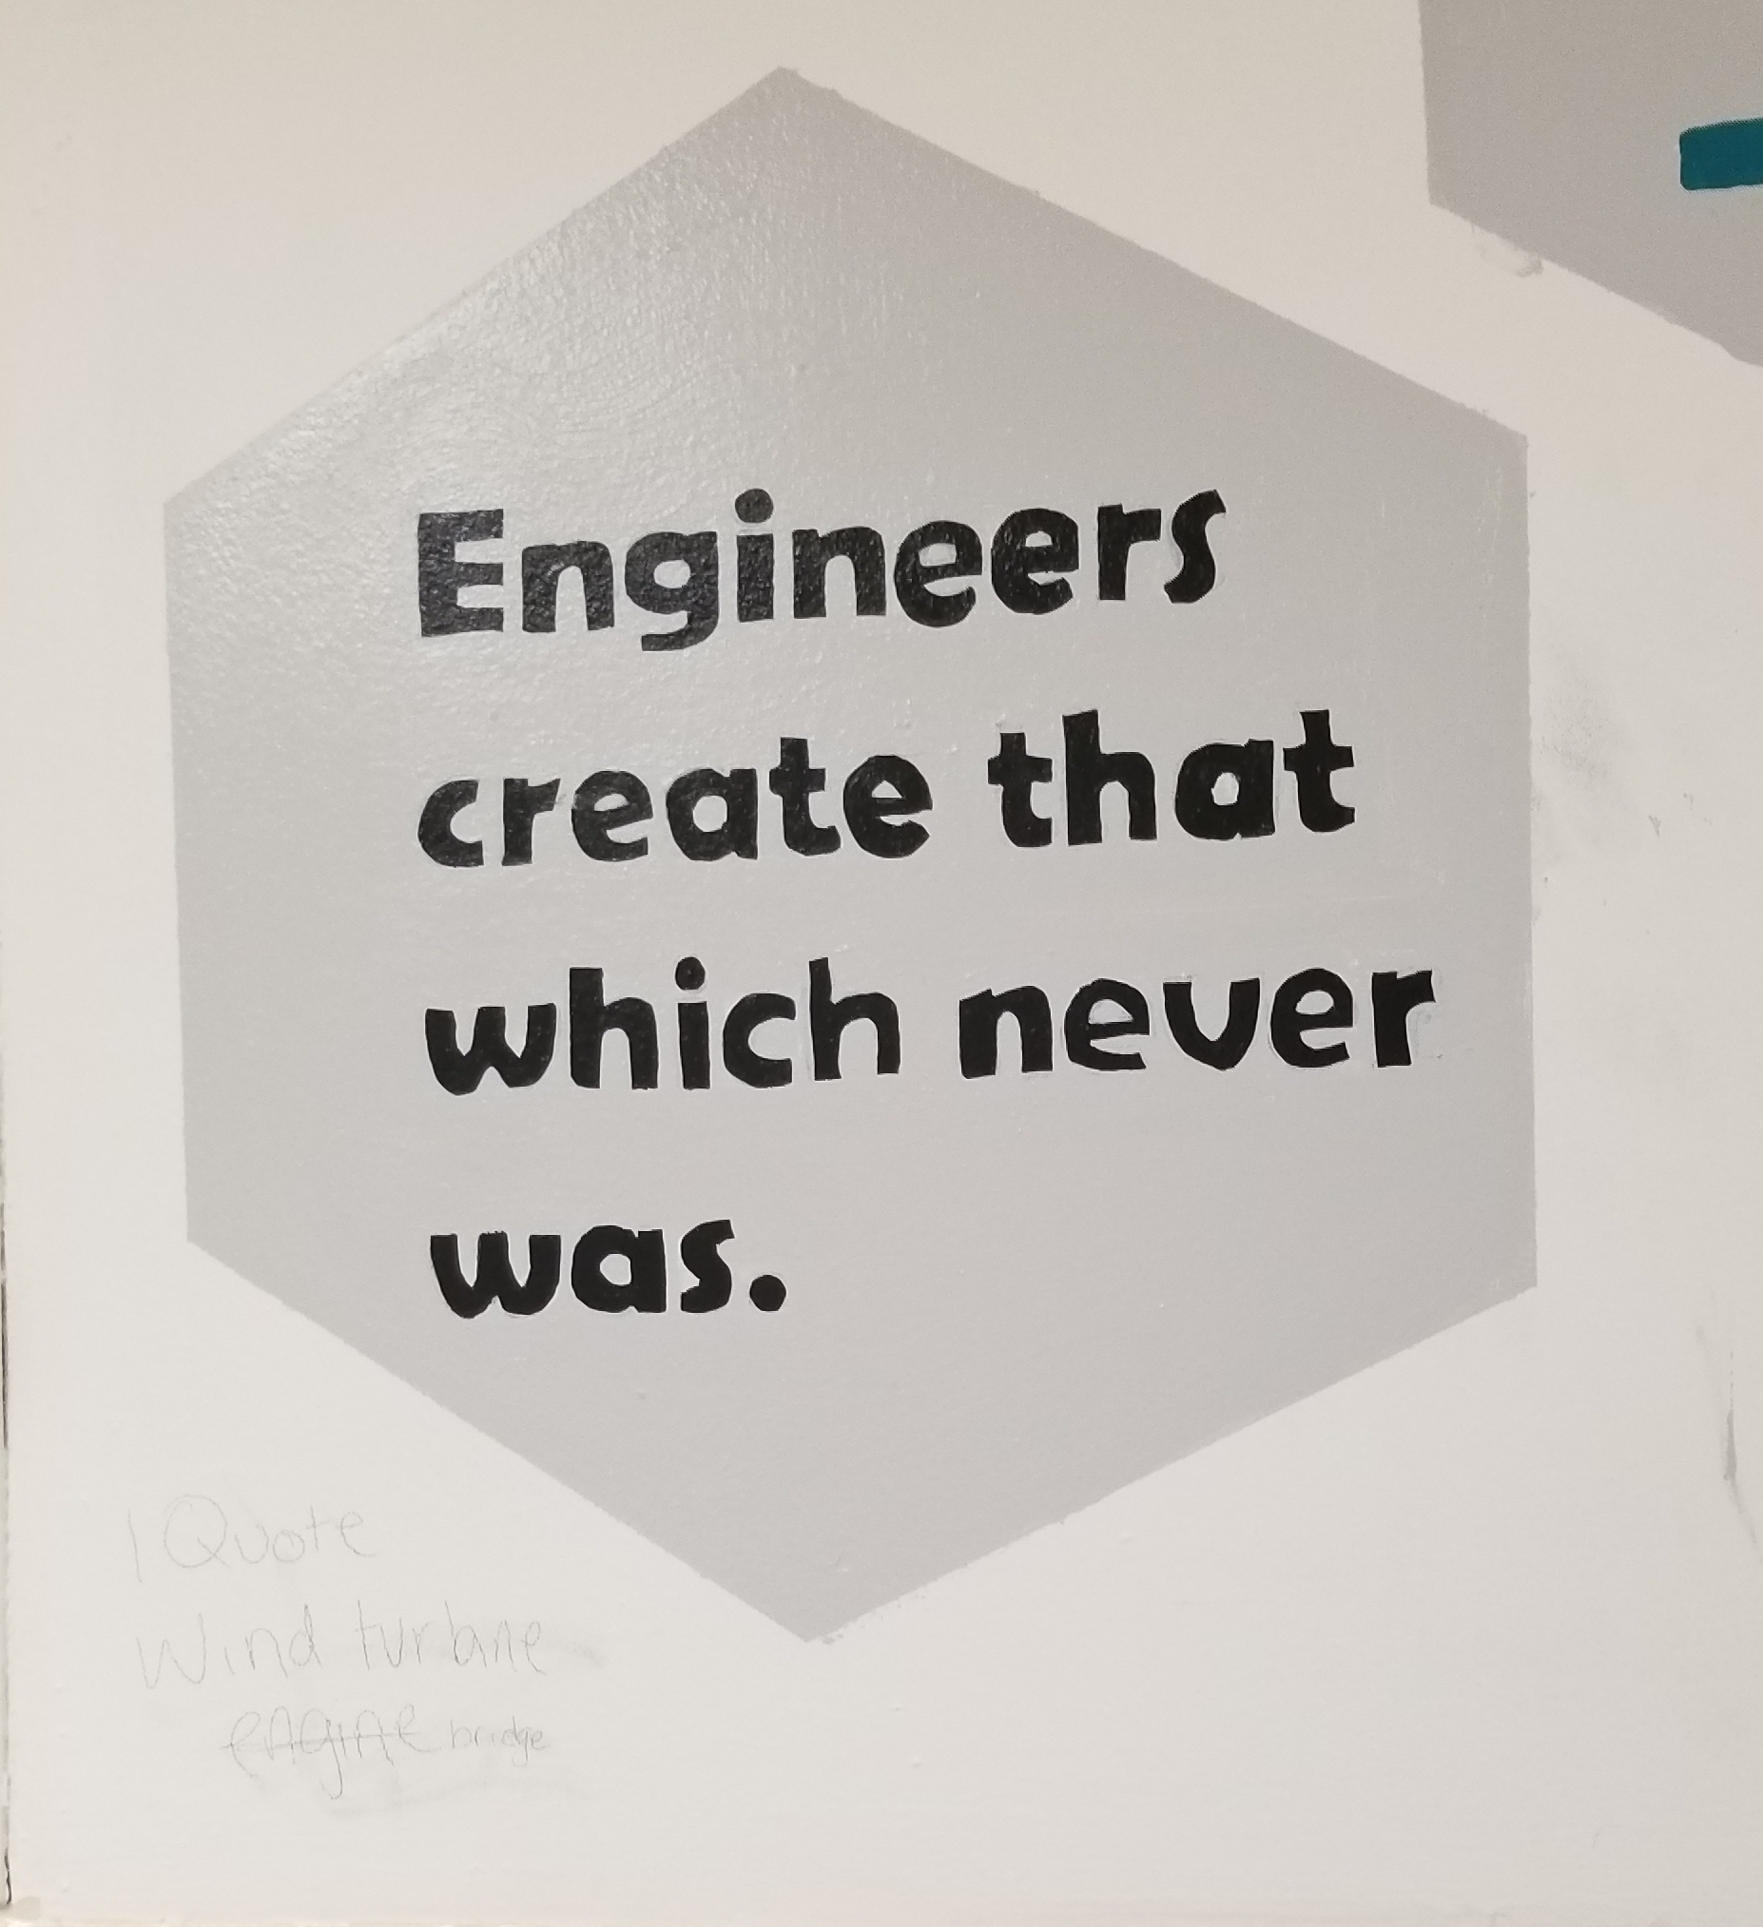 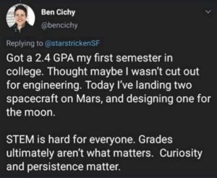

**Course:** Engl 210

**Classroom**: NAC 1/301 Y

**Schedule:** Tuesdays and Thursdays: Section K- 8:00am-9:15am; Section M- 11:00am-12:15pm

**Writing Instructor:** Danielle Carr

**Office Location:** NAC 6/335a

**Office Hours:** Tues 9:30-10:30am, Thurs 12:30pm-1:30pm, and by appointment

**Email:** dcarr@ccny.cuny.edu

**Phone:** 914-462-7330, and office extension x5407

Course Description:

This course will help you to hone the critical reading, thinking, research, and writing skills you will need to succeed in all of your writing courses, specifically your engineering courses. This course also prepares students to write as engineers in professional environments. Students will examine, analyze, and create various types of technical communication such as: e-mails, memos, letters, instructions, definitions, descriptions, designs, proposals, and presentations. Students will learn to synthesize information, find answers, and present ideas to various audiences they will research and encounter. Learning to write well will enable students to present themselves in the best possible light in all situations. Students will learn how to communicate knowledge, plans, and ideas in a professional manner. Our time in this course will focus on reading and listening, essential steps in the writing process, effective writing, synthesizing material from various sources, and the ability to locate and evaluate relevant library and online research. We will also examine how writing is impacted by the elements of the rhetorical situation. By the end of the course, students should be confident in utilizing this knowledge in the construction and completion of a writing portfolio and self assessment.

How This Course Works:

Welcome back to in person classes! For the past two years, we have been conducting classes in a digital, synchronous setting through Zoom which has taught students such necessary skills as communication, teamwork, and distance communication all things that engineers use throughout their careers. However, for the spring 2022 semester, we will be returning to the “traditional classroom experience,” and working on learning these essential engineering tools in person. For students, this means that our class meetings will take place synchronously, in person, in a set classroom at a set time. In addition, there will also be a number of designated “hybrid” days that the class will meet asynchronously, where there will be no “formal face to face (f2f) meeting,” but there will be an assignment due and that will count as a both attendance and classwork grade for the day. You will be notified in advance of these days. This class is also heavy on group work. Groups will be determined by the instructor and will remain throughout the semester (barring any unusual occurrences). Students are expected to communicate with their group mates often and be cooperative and demonstrate proper group work behavior. Students will still be responsible for attending all scheduled f2f classes, on time and for the duration of the class meeting, handing in all work ON TIME and properly done, on Blackboard. There will be NO print media submitted for class assignments due to Covid-19 protocols. Students will also be responsible for posting homework, projects, and presentations in specific folders and also posting responses to these assignments. I will let you know when these postings are due, keep in mind they are mandatory as they are part of your homework and participation grades. Asynchronous assignments will also have time sensitive deadlines. These responses can transfer to discussions held in class, so they must be thought provoking and thorough. Overall, it is extremely important for students to attend all class meetings, as these meetings are when students will learn the required genre work for the class and discuss the assignments for the course. There will also be in person peer review workshops for draft work on larger assignments.

Course Learning Outcomes:

Over the course of the semester, you will

* acknowledge your and others' range of linguistic differences as resources, and draw on those resources to develop rhetorical sensibility
* enhance strategies for reading, drafting, revising, editing, and self-assessment
* negotiate your own writing goals and audience expectations regarding conventions of genre, medium, and rhetorical situation
* develop and engage in the collaborative and social aspects of writing processes
* engage in genre analysis and multimodal composing to explore effective writing across disciplinary contexts and beyond
* formulate and articulate a stance through and in your writing
* practice using various library resources, online databases, and the Internet to locate sources appropriate to your writing projects
* strengthen your source use practices (including evaluating, integrating, quoting, paraphrasing, summarizing, synthesizing, analyzing, and citing sources)

What You’re EXACTLY Doing in This Course:

In this course you will learn to read, write, and speak thoughtfully and critically within your discipline. You will produce various written works in discipline specific genres and give presentations surrounding engineering topics of your choosing. Hopefully this rhetoric and writing practice strengthens your writing skills throughout your academic and scientific career.

Also, to simulate the engineer’s “experience,” you will spend much of the semester in pre-determined (by me) groups, in which you will consider the topic, direction, and composition of your projects together. However, MOST of the time, you will compose and submit individual assignments.

Required Textbook(s): *Technical Communication* by Mike Martel, 13th edition, Bedford/Saint Martin’s

* Supplemental Readings will be made available on Blackboard, CUNY Commons course site, or as handouts and distributed in class.
* OER textbooks (which, from time to time we might reference), include <https://digitalcommons.kennesaw.edu/opentc/>

<https://open.umn.edu/opentextbooks/textbooks/412>

CUNY Commons Course Website- <https://engl210ccny.commons.gc.cuny.edu/> Which will house various documents/files necessary for coursework

Semester Calendar

Tuesday, February 1- **First Day of Classes!**

Thursday, February 3

Tuesday, February 8- **No Class Meeting! Classes Follow a Friday Schedule**

Thursday, February 10

Tuesday, February 15

Thursday, February 17

Tuesday, February 22

Thursday, February 24

Tuesday, March 1

Thursday, March 3

Tuesday, March 8

Thursday, March 10

Tuesday, March 15

Thursday, March 17

Tuesday, March 22

Thursday, March 24

Tuesday, March 29

Thursday, March 31

Tuesday, April 5

Thursday, April 7

Tuesday, April 12

Thursday, April 14

Tuesday, April 19- **No Classes! Spring Break**

Thursday, April 21- **No Classes! Spring Break**

Tuesday, April 26

Thursday, April 28

Tuesday, May 3

Thursday, May 5

Tuesday, May 10

Thursday, May 12

Tuesday, May 17- **Last Day of Classes!**

**Class Policies**

Lateness and Absences

* According to the CUNY CCNY Undergraduate Bulletin: http://www.ccny.cuny.edu/registrar/upload/2013-2015-Undergraduate-Bulletin.pdf (page 215)

Students are expected to attend every class session of each course in which they are enrolled and to be on time. An instructor has the right to drop a student from a course for excessive absence. Students are advised to determine the instructor’s policy at the first class session. They should note that an instructor may treat lateness as equivalent to absence. No distinction is made between excused and unexcused absences. ***Each instructor*** retains the right to establish his or her own policy, but students should be guided by the following general College policy: **In courses designated as clinical, performance, laboratory or field work courses, the limit on absences is established by the individual instructor. For all other courses, the number of hours absent may not exceed twice the number of contact hours the course meets per week. When a student is dropped for excessive absence, the Registrar will enter the grade of "WU.”**

In other words: each student can miss up to THREE classes. FOUR absences results in a failure of the course. Students are expected to be in class ON TIME and remain for the duration of class. IF there is an unavoidable issue which prevents the student for remaining in the class for the entire period (as in necessity for lateness or early departure) please let the instructor know prior to arrival via email. If attendance/lateness is going to be a problem, consider switching from this section.

Food and Drink 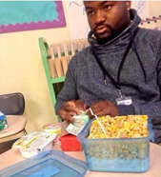 🡨----------------- Don’t let this be you!!!

Eating/Drinking is allowed in class but do not let it be a distraction to you or your classmates. Also, **clean up after yourselves!** Classrooms are communal spaces and NOT your personal bedrooms, hotel rooms, or kitchens. They need to be kept clean by ALL who use them. We do not want to invite any four or more legged creatures into our learning environment!

Electronic Devices 

If it beeps, vibrates, rings, plays music, or has a screen, mute it before you enter class. Cell phone use is prohibited during class. Silence your cell phone, put it away before you enter the room and keep it away for the duration of class. If there is an emergency, quietly step out of the room to handle it. Tablets and computers can be used as note-taking devices or E-book readers if that is how students wish to transcribe information or read text. However, those devices can only be used SOLELY for that purpose, no web surfing, social media, or any other recreational use during class time. When those devices are not needed, they should be “sleeping,” face down, and out of reach.

“Don’t Yuck My Yum” 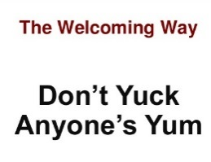

Each and every one of us, including myself, comes from a diverse background, environment, and has a unique life experience and skill set which contributes to our worldview and opinion. As members of a classroom community, school community, and society, etc., it is our duty to remember this and respect all viewpoints, even if we don’t agree with them. Remember, there are constructive ways to criticize.

Assignments and Due Dates 

Assignments are due on the due date on blackboard unless previously arranged with the instructor. Because of Covid-19 protocols, there will be no print media submissions this semester. Everything will be submitted and returned on Blackboard with instructor and/or peer comments. In the case that any student will be absent on a due date, plan to submit work early! All assignments will be submitted on Blackboard either on the discussion board or a specific area designated for that assignment. IF you miss that deadline, you MUST email me for permission to submit assignments via email. Things get lost in email. If you submit the assignment and I don’t know it’s coming, I’m not looking for it, and it could be buried under something else, and therefore your grade could end up ZERO due to non-submission. Therefore, ASK FOR permission BEFORE e-mailing late assignments. Work submitted after the due date will be deducted by half a letter grade every day that it’s late. First draft due dates are listed on the weekly assignment schedule, final draft due dates are due **1-2** class meetings after you receive your essays back with either my or peer comments. The exact dates will be announced in class.

Academic Integrity

Plagiarism is the unacknowledged use of another person's words or ideas. You can use other people’s ideas as much as you want and/or need to. Just make sure to **properly** give credit where credit is due. Words copied verbatim from another source must be quoted and the source must be cited. When you paraphrase words/ideas from another source, you must acknowledge the original author unless the ideas are common knowledge (information found in three or more different places). If you collaborate with another author to produce written work, you must acknowledge that person's contribution. “Borrowed” material must be *properly* cited in APA format, as is the citation method that will be studied in this class during the semester. Anything incorrectly cited is considered plagiarism and is graded as an F. If there is any further question about the parameters of academic dishonesty reference page 230 of the CUNY Policy on Academic Integrity appears on page 230 of the City College of New York Undergraduate Bulletin 2013-2015.

* http://www.ccny.cuny.edu/registrar/upload/2013-2015-Undergraduate-Bulletin.pdf

All writing submitted for this course is expected to be your own. If a student’s submission contains any forms of plagiarism, he/she is at minimum subject to a failing grade for the project and/or course, and worst case scenario, academic suspension or expulsion. Part of the function for this course is to teach students how maintain academic integrity and to cite sources **properly** according to the standards of the American Psychological Association (APA)in order to avoid cases of inadvertent plagiarism, As part of this course, we will discuss strategies for adhering to standard conventions for responsible source use and for maintaining academic integrity and how to avoid inadvertently plagiarizing someone else’s work.

You can learn more about plagiarism at the following link: www.wwnorton.com/college/english/write/writesite/research/plagiarism_tutorial.aspx

Here are four practices defined as plagiarism in the CUNY Policy on Academic Integrity:

* Copying another person’s actual words without the use of quotation marks and footnotes attributing the words to their source.
* Presenting another person’s ideas or theories in your own words without acknowledging the source.
* Using information that is not common knowledge without acknowledging the source.
* Failing to acknowledge collaborators on homework and laboratory assignments.
* *Submitting downloaded term papers or parts of term papers, paraphrasing, or copying information from the internet without citing the source, and “cutting and pasting” from various sources without proper attribution.
* *Using other student’s content without permission. Student samples are **not** appropriate fodder for submissions!

If you need ANY help at all *outside* of the classroom pertaining to anything at all, from writing issues and tutoring, to feeling overwhelmed, or *anything* in between, utilize these resources…

**The Writing Center**

<http://www.ccny.cuny.edu/writing/>

The CCNY Writing Center offers a supportive learning environment where students can have one-on-one tutoring sessions with writing consultants. It is a great resource for you to obtain extra help as you write and revise your papers. They DO NOT proofread your papers, but offer assistance on improving certain aspects of them. They also offer ESL tutoring. To set up an appointment or semester-long sessions, contact them in person at the Writing Center, which is located in the NAC, 3rd floor plaza or call (212) 650-8104. They will be partially open starting 9/8, and fully operational starting 9/15. I strongly advise you contact them as soon as possible, even if you don’t have anything specific you need assistance with yet.

**Gateway Advising Center**, NAC 1/220

<http://www.ccny.cuny.edu/gateway/>

Students without a declared major can receive academic advising, especially if you have questions about your course of study, core requirements, etc.

**AccessAbility Center Tutoring Services,** NAC 1/218

<http://www.ccny.cuny.edu/accessability/>

Provides one-on-one tutoring and workshops to all registered students with learning or physical disabilities.

**SEEK Peer Academic Learning Center,** NAC 4/224

Phone: 212-650-5786**;** Email: seekpals@ccny.cuny.edu

Offers counseling and peer tutoring for students in need of academic and financial support who have registered for the SEEK Program.

**Campus Counseling Center,** Marshak J-15

Phone: 212-650-8222, Email: [counseling@ccny.cuny.edu](mailto:counseling@ccny.cuny.edu)

<http://www.ccny.cuny.edu/counseling/>

The Counseling Center offers short term individual and group counseling to help students deal with their personal and adjustment issues that may interfere with their ability to progress academically to their fullest potential.

**Instructor, see front page for contact information and location**

If there’s something you feel I can’t help you with during class time, please do NOT hesitate to reach out and contact me. I frequently answer email and I love hard working students.

Grading Breakdown

Students will be assigned a grade for the writing section based on their completion of their assignments, participation, and attendance according to the following breakdown:

**Attendance and Participation, (online and f2f),**

**Coursework and in class writing 15% 94%-100% A 70%-72% C-**

**-Diagnostic Essay (letter to professor) 90%-93% A- 66%-69% D+**

**Lab Report 15% 86%-89% B+ 60%-65% D**

**Technical Description 15% 85%-83% B 0%-59% F**

**Group Project 20% 80%-82% B-**

**--Proposal 10% 76%-79% C+**

**--Presentation 10% 73%-75% C**

**Self Assessment/Portfolio 20%**

**Memo- 15%**

**Required Assignments**

In addition to smaller assignments that will be assigned throughout the course of the semester, the bulk of the coursework will focus on 4 major assignments given with the goals of reinforcing lessons, meeting course learning outcomes, and increasing writing, analytical, and rhetorical skills. These will be done in a series of drafts with scaffolding assignments in order to both lead up to the assignments and provide students opportunities to submit their best work. All assignments must follow genre conventions and APA requirements and have 12 pt. New Times Roman with 1-inch margins. Spacing will be determined by the genre conventions of each assignment.

* Diagnostic Writing Assignment- 500 word minimum
  + Write a professional letter to me about your life, your experiences, your achievements, your talents. What is your major in college and how does your major connects to your professional goal(s)? Include where you are from and how you want me to see you. Write about your challenges as well as your successes. How do you imagine your future place in the world of engineering? What are some of the engineering challenges you would like to be involved with? How do you plan to impact change in your world with your degree? Must include at least ONE page on an “artifact,” an item that is most important to your area/concentration. For example, computer engineers could discuss a mouse or a keyboard; mechanical engineers could do a caliper. Students must describe the item in detail and discuss the significance of the item. You will (eventually) bring in this item (or a photo) and discuss it with the class. This item CANNOT be your cellphone or computer unless you are/have built the Iphone 25 or Samsung S25.
    - This is a formal letter, addressed to me (see address below), and must be signed at the end by you. See the Kennesaw website, chapter 2.1, and Markel 377-378 for letter templates. My address:

Danielle Carr

City College of New York- English Department

1. Convent Ave

New York, NY 10031

* Memo (15%) - 1-2 pages (500 words), 1 page reflection paper, 1 audience analysis sheet. Students will write a memo to an appropriate audience of the City College of New York, addressing a problem of your choosing on campus. This problem can be related to renovating or improving areas of the campus (cafeterias, dorms, classrooms, parking etc.). Be creative. The idea is to define a problem and offer a specific solution to address this problem. Remember, your audience does not know about this specific problem so you will have to provide the context. Important details can be bulleted for easy reading. No cost estimates are required for this memo. Basically, it will be a memo that requires a follow-up meeting for further discussion. *This is a single draft submission.*
* Technical Description (15%)- minimum of 4 pages of text, 2 page reflection paper, and 1 audience analysis sheet
  + Students will write a description of a simple technological item, more than likely, the item selected and included in the letter to the instructor assignment.
  + Or, choose one that you are particularly interested in and explain its purpose, as it relates to your concentration. Think carefully about your choice. Descriptions of objects, mechanisms, and processes appear in virtually every kind of technical communication. In addition, instructions are also frequently used.
  + Research and APA citations will be required for this assignment.
* Lab Report (15%) - min 4-5 pages of text, min 2 pages reflection paper, and 2 audience analysis sheets
  + Students will compose a lab report based on a lab experiment specific to their chosen area/concentration of engineering. The lab report must have all of the elements of the lab report listed from the discussion/powerpoint from class (the appendix/acknowledgements are not mandatory, but the other elements are). The lab report also requires research, a minimum of three sources must be cited both in text and listed on the reference page according to APA standards.
* Multimodal Engineering Proposal + Presentation (20%) - Proposal Minimum 5 pages. Self-Reflection 1-2 pages. Presentation, minimum 10 minutes. Each person will write his or her own reflection paper which must include their role in the project (exactly WHAT they did), how they liked (or disliked) working in teams, analysis of the rhetorical elements and how the project met specific course learning outcomes. You will also grade each other’s performance with templates.
  + The assignment is a group/oral report of a proposal for a creative engineering innovation. The following areas of the United States (USVI, Puerto Rico, parts of Florida, and Houston), not to mention islands such as Dominica, islands of the BVI, St Maarten, Barbuda, Cuba, etc were drastically affected by hurricanes Maria and Irma. Most recently the Bahamas was affected by hurricane destruction and Puerto Rico is suffering from massive, random earthquakes. These areas are undergoing massive rebuilding projects, changing infrastructure, and considering ways to update aspects of the islands so that such immense damage does not occur in the wake of other hurricanes. Power grids, computer systems, roads, bridges, buildings, to name a few things, have been destroyed. Hospitals, airports, etc are being severely impacted. Despite the amount of human suffering that has occurred in the wake of these natural disasters, these natural disasters actually make for an engineer’s dream: how can you positively impact these areas in their times of great need? Rebuilding and upgrading to better than once was will take years, especially if hurricanes of such magnitude return to the Caribbean.
    - You are not limited to this part of the world. If you find a recent natural disaster in another part of the world where your team’s expertise could be of service, clear it with the instructor first.
  + Your task is to consider this in light of your engineering concentration (civil, electrical, computer, mechanical, chemical, etc) and develop a thing/idea that is designed to assist the rebuilding process in some way. Your design might have something to do with infrastructure: bridges, roads, sidewalks, etc. Your idea might have to do with solar panels and electrical grids, water collection (as islands are notoriously yet ironically always short on water), anything, there is no limit to idea but money must be considered (you need a budget, hurricane repair is ALREADY expensive). These are just some ideas you are not required to use them.
  + You will need to do some research to see what problems have surfaced where (as far as issue/island/location) on your own, which you will incorporate into your project (that’s going to be the history/background part).
  + The project requires a brief technical description of your thing/idea, a brief literature review, the proposal, powerpoint, resumés, job postings, and an audience analysis- who are you presenting this to? Who are you impacting/helping with your idea/thing? How will this impact your content?
    - Project objectives:
      * Innovation
      * Process
      * Group work
      * Oral presentation
      * Overall thoroughness and logic of proposal structure
* Final portfolio and self-reflection (20%)
  + A rhetorical analysis of the student’s work that should include references to elements of the rhetorical situation: genre, audience, purpose, exigence, stance, and media/design, in digital format, on the CUNY Commons.
* **Reflection paper- typically 1-2 pages, but depends on the assignment. All major writing assignments will require a written self-reflection component, which we will discuss in class.
  + Students must make use of the terms introduced in the rhetorical situation and describe how each assignment has helped them to achieve the course learning project. These must be attached to the final draft of all major assignments.

On draft work:

“Almost all good writing begins with terrible first efforts. You need to start somewhere. Start by getting something -- anything -- down on paper. A friend of mine says that the first draft is the down draft -- you just *get it down*. The second draft is the up draft -- you *fix it up*. You try to say what you have to say more accurately. And the third draft is the dental draft, where you check every tooth, to see if it's loose or cramped or decayed, or even, God help us, healthy.”

– Anne Lammott, *Bird by Bird: Some Instructions on Writing and Life*

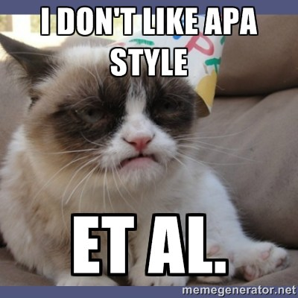 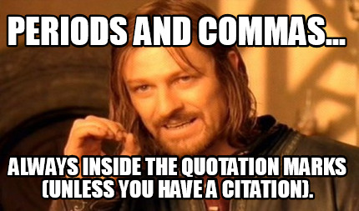

*** All written assignments must be typed using Microsoft Word in 12 point, Times New Roman font, double spaced, with one inch margins, as per APA guidelines and follow the appropriate genre conventions. For this course we will be referring to the Purdue OWL website to learn and practice using the APA format. <https://owl.english.purdue.edu/owl/resource/653/01/>

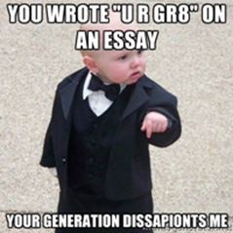 *** Also, while the course objectives do not state that I am trying to create professional grammarians, ***ALL*** writing for this course ***MUST*** be written in Standard English and not in text slang or colloquial spelling. You are assessed for grammar, so if that is not your strong suit, spend time with grammerly.com or the campus writing center.

Weekly Assignment Schedule

|  |  |  |
| --- | --- | --- |
| **Date** | **In Class** | **Homework** |
| **Week 1** |  |  |
| Tuesday 2/1 | Review syllabus, ice breaker, assign and explain diagnostic essay assignment, discuss “Theme for English B.” | Read Markel Ch 5. Complete introduction letter, due 2/2, post on BB. Complete bio info on BB discussion page. |
| Thursday 2/3 | Discuss elements of Rhetorical situations, genre, stance, exigence, purpose, media/design, and audience. In class writing assignment on rhetorical situation and audience analysis. | Note the groups on BB. Read Markel Ch 3, 8, 9, 10, 14- pgs 377-385, and both links on the course site pertaining to writing emails to Professors, and the handout on exigence on the course site under miscellaneous section |
| **Week 2** |  |  |
| Tuesday 2/8 | **NO CLASS! Classes follow a Friday Schedule!** | Read Markel 386-395 |
| Thursday 2/10 | How do engineers communicate? Discussion on emails and memos, major assignment #1- memo, reflection papers, and audience analysis. | Genre analysis homework on memo. Compose an email to a professor/instructor outside of this class with a request. CC me on it, and forward me any responses. Take a screen shot of the email and post it on BB. Each group must post its discussion point for the memo assignment AND compose a response on each group’s memo topic post. Due Sun 2/13. Memo due Thurs 2/17, single draft submission. |
| **Week 3** |  |  |
| Tuesday 2/15 | Continue Discussion | Read Ch 20, Memo: Thurs 2/17 |
| Thursday 2/17 | In class assignment and discussion on descriptions and instructions. | **Group homework:** Markel 591 #10- no limitations on choice. One per group. **Solo homework:** Markel 591 #7. Post by 2/21. Presentations on 2/22. |
| **Week 4** |  |  |
| Tuesday 2/22 | Instructions Presentations | Read Markel Ch 6. Compose BB post on technical description item, due Sun 2/20, comment on classmates. Genre analysis on tech description due Mon 2/21. |
| Thursday 2/24 | Discuss assignment #2- technical description | Draft work due 3/1 on BB, prepare for peer review workshop. Final due 3/3. |
| **Week 5** |  |  |
| Tuesday 3/1 | Discuss APA citations and quotations.  Peer review- tech description | final draft due 3/3 |
| Thursday 3/3 | **Final draft of tech description due. Asynch #1 no f2f class. ethics in tech writing Markel Ch 2** | Read Markel Ch 19 |
| **Week 6** |  |  |
| Tuesday 3/8 | Discuss lab reports | Genre analysis on lab reports |
| Thursday 3/10 | **\*\* library class** | Post lab report decisions on bb, comment on other groups, due Sun 3/13 |
| **Week 7** |  |  |
| Tuesday 3/15 | Continue discussion on lab reports | Draft work due 3/24, final draft due 3/29 |
| Thursday 3/17 | **Asynch #2 no f2f class** | Prepare “the extension” from asynch #2, post presentations on 3/21, presentations are due 3/22, one per group |
| **Week 8** |  |  |
| Tuesday 3/22 | Lab report presentations | Draft work due 3/24, prepare for in person workshop |
| Thursday 3/24 | In person peer review | **Final draft due Tues 3/29**, Read Markel 10, 15, 16 |
| **Week 9** |  |  |
| Tuesday 3/29 | Discussion- genre of technical proposal | Read student samples- genre analysis, Continue research |
| Thursday 3/31 | Discussion of genre analysis, continue with discussion on proposal | Compose brief abstract on projects, post on BB, comment on other groups. Due 4/3- 8pm |
| **Week 10** |  |  |
| Tuesday 4/5 | Discussion- job posting, resumé and large group project | post resumé, develop a job posting for your team/project, post it on bb, then pick from the “pool of applicants” on BB in the resume area. |
| Thursday 4/7 | instructor meetings/work day | Read Markel Ch 21 |
| **Week 11** |  |  |
| Tuesday 4/12 | Discussion on powerpoints |  |
| Thursday 4/14 | **Asynch #3 & #4, no f2f** | Continue working on projects |
| **Week 12** |  |  |
| Tuesday 4/19 | **No Classes- Spring Break!** | Draft work due 4/26 for in person peer review |
| Thursday 4/21 | **No Classes- Spring Break!** | Final drafts due 4/28, presentations begin on 4/28 |
| **Week 13** |  |  |
| Tuesday 4/26 | In person peer review | Final drafts due 4/28, presentations begin on 4/28 |
| Thursday 4/28 | **In class presentations** |  |
| **Week 14** |  |  |
| Tuesday 5/3 | **In class presentations**/ discussion of final project (return to CUNY commons sites) | Watch video lecture on building skeleton sites  Post skeleton sites on BB |
| Thursday 5/5 | Discussion of content | Group compositions on content, post to BB, Watch video lecture on editing |
| **Week 15** |  |  |
| Tuesday 5/10 | Continue working on projects, **\*possibly asynch day** |  |
| Thursday 5/12 | Continue working on projects |  |
| **Week 16** |  |  |
| Tuesday 5/17 | **Last Day of Classes!**  **-**Continue working on projects | Enjoy your summer!  **Final project due Tues 5/24** |