Project Survival Pods
Proposal, Technical Project Plan X
to be presented on 11/14/18
Group 2: Nikolas Arsenlis, Prahllad Shaha, and Evert Magana

160 Convent Ave, New York, NY 10031
(212) 650-7000
LCCCompany@citymail.cuny.edu

TABLE OF CONTENTS
1. Introduction 3
1.1 Problem Statement 3-4
1.2 Background 5
1.3 Needs Statement 5
1.4 Objective 6
2. Proposed Technical Approach 6-7
2.1 Requirements 7-8
2.2 Architecture 8-10
2.3 Implementation Design 11
2.4 Quality Assurance Plan 11-13
3. Expected Project Results 13-14
3.1 Measures of Success 14
3.2 Costs 14-15
Schedule 13
Reference Page 16

1. Introduction
The worst problem during a tsunami is getting people to safety and this was observed after the earthquake and tsunami that devastated Japan in 2011. A magnitude of 9.0 earthquake hit Japan and once the visible tsunami, which was 30 feet at one point, hit Japan, the area was devastated and the people did not know what to do. Many perished from this tsunami where warning signs were headed and nobody knew where find shelter as it hit. This is a major problem and the new and improved Survival Pod can solve this by cutting the death rate and injury rate dramatically. All a citizen has to do is go outside into their designated capsule, jump in and relax. The spherical airplane-grade aluminum is virtually indestructible where it will withstand the initial impact of a natural disaster, as well as sharp object penetration, heat exposure, blunt object impact, and rapid deceleration. This proposal will be sent to the Japanese Federal Government and the citizens of Japan so that they are aware that this will benefit both parties in the future and save lives.

1.1 Problem Statement
The problem is that when a natural disaster occurs, such as the 2011 tsunami in Japan, the loss of life is tremendous and so if the government can federally fund this project then this number would decrease dramatically. Is money equal to the loss of a life? This project can benefit a country by showing their interest of the citizens and show their protection. The 2011 Tohoku earthquake and tsunami resulted in 15,885 deaths, 6,148 injuries, and 2,623 people missing. As of 2017, residents are still recovering where there are still about 150,000 evacuees who lost their homes. More than 120,000 buildings were destroyed, 278,000 were half destroyed and 726,000 were partially destroyed. The estimated cost of the damage is about $199 billion dollars and an economic cost of $235 billion dollars (Oskin, 2017, pg. 1). The major issues during a tsunami is that people do not pay attention to warning signs, they don’t even know the damages of a tsunami, or they are physically unable to evacuate from their homes. During a natural disaster, such as this one, people are scrambling to find shelter and to try to survive. Many are successful, but many aren’t.
According to the LCC Company Website (2018), “The Survival Capsule is a patent-pending, personal safety system (PSS) desgined as a spherical ball to protect against tsunami events, tornadoes, hurricanes, earthquakes, and storm surges. Using the PSS, as opposed to a municipal safety system like aa safe house, allows individual groups and families to be more in control of their survival in an emergency situation” (Survival Capsule LCC, 2018). The proposed project is to implement Survival Pods in which people could jump in and float on top of the water without hurting themselves while being connected to the earth surface. This technical proposal is mostly written to the government to federally fund these Survival Pods so that human lives could be saved.
The Federal government of Japan would, in turn, lose some money but in the long run this could benefit them. After other countries see how Survival Pods help people get to safety in coastal regions, they will jump on board. At that point if the government buys stock in the company, they will regain that money back and will profit from this in less than 5-10 years. Investing in installing these capsules in coastal areas would allow for Japanese citizens to support the government in a more positive manner.

1.2 Background
The idea for the Survival Capsules was first brought about by Julian Sharpe in 2010 in Oregon. Throughout the years this capsule has made its way into competitions and testing sites to ensure the products credibility. In 2012, the Prototype Exposition Capsule was built and prepared for the Yokohama Exposition. In 2013, the Test Capsule was build and tested at a laboratory in Seattle and then appeared at the Yokohama Disaster Preparedness Expo. Then, the first Production Capsule was shipped to Japan and was put through water floatation trials in Tokyoe Bay with Max Gross Weight. Julian Sharpe and Scott Hill, alongside other engineers, perform structural analysis and converged on the functioning design. Today, Survival Capsules can be sold to anyone with one of its first buyers, Jeanne Johnson.

1.3 Needs Statement
As someone who lives one of New York’s coastal areas, I know how important the implementation of Survival Pods is. After the Indian Ocean earthquake and tsunami, the Japanese earthquake and tsunami in 2011, and Hurricane Sandy, people are nervous about their safety. The Survival Pods can help this dramatically because these virtually indestructible balls can protect us from anything. The people reading this proposal also thinks about their safety because they might have been affected after 2011 in Japan. Currently people tried to use rafts or stand on top of buildings, but as you can see in the figure 1 below it is a terrible and sad sight. In use, people can walk outside of these pods without a scratch on their heads.
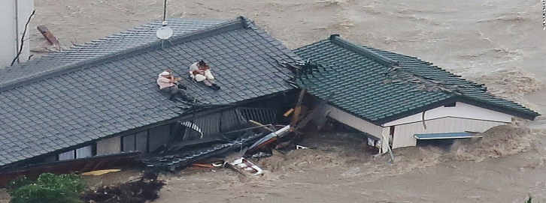 Figure 1

1.4 Objective
In implementing this project in coastal areas around Japan and eventually other countries, the team hopes to decreases the number of lives lost after a tsunami hits. The team wants to create an implement as many Survival Pods necessary to ensure that people will know what to do during a tsunami and to ensure their safety. In turn, the team hopes that funding of this project can ensure that the safety of the country comes first.

2.0 Technical Approach
The group of engineers that will be creating these survival pods are mechanical engineers, aerospace engineers, and electrical engineers. The mechanical and aerospace engineers will build the Survival Capsule and test its durability and performance in the field. They will creating the aluminum coating of the survival pods, the inner heat and cooling system, the water-resistant interior, and will put in the harness seats. They will be given a median salary from $85,000 to $120,000, based on how long they are working for the company.
Then, the electrical engineers and software engineers will install the GPS system inside the capsule, the lighting for the capsule, any other electrical features, and complete the coding for the system. According to Sharpe, Acklen, and Hill (2018), “The capsule design benefits from analytical methods, technology and testing approaches which we use on a daily basis to achieve our aerospace design, analysis and certification commitments. In this case numerous MSC Software programs were used such as PATRAN, NASTRAN, and DYTRAN” (Sharpe, Acklen, and Hill, 2018, Pg. 4). Their median salary will be from $75,000 to $100,000, based on their experience level and their commitment to the company.
Once the capsules are produced, manufacture, and tested the company ships them out to anyone who purchases one. Once purchased, a team of engineers brings it to their location and installs it so that if a natural disaster hits, they will be ready. The product is simple to install and the company has built thousands of capsules to this date in a matter of a couple years

2.1 Requirements

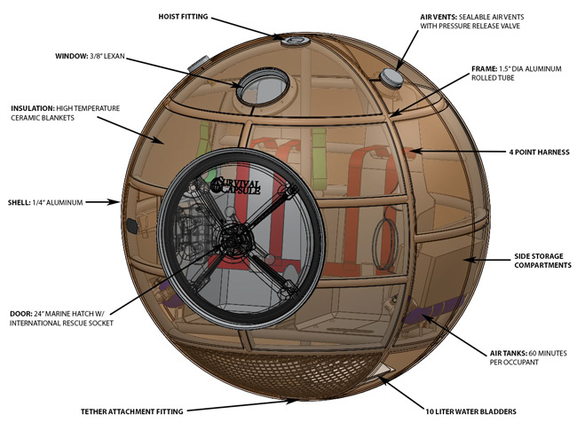
Figure 3
Building requirements and Research requirements
- - Research tsunami damage and effects to understand what needs to be completed
- Research durability of materials and how to fit multiple people inside a survival pod
- - Research costs and time scheduling for completion of the project
- - Build the aluminum structure for the exterior
- - Bolt the as many seats down that fit inside the pod
- - Make sure that the door is sealed shut where no water can get in or out
- - Insulate and build the mini-HVAC system inside the survival pod
- - Install the GPS tracking system and the lights inside
- - Test prototypes of the survival pods
Personnel Requirements
- A group of mechanical engineers, aerospace engineers, electrical engineers, and software engineers that can all work as one big unit
- Researchers to figure out the best materials for the pods and figure out how to make the project as cheap as possible, but still know that safety is our number 1 priority
Other Requirements
- Warehouse to build the survival pods
- Outdoor area: swimming pool to test the buoyancy of the pods

2.2 Architecture Design
The Survival Capsules LCC Company, after the Japanese Earthquake and Tsunami in 2011, started creating Survival Capsules that hold either multiple people at a time when a natural disaster strikes. There are five capsules that are in circulation: SC2001 (holds 2 adults), SC4001 (holds 4 adults), SC6001 (holds 6 adults), SC8001 (holds 8 adults), and SC10001 (holds 10 adults) that range at various prices. These survival capsules are better than any raft on the market where they were designed by aircraft engineers and extremely tested so they can endure anything. The inner capsule looks like a car where there are seatbelts and big chairs to sit in. There is also storage space for the storage of food, water, perishables, and clothes. The structure looks like a miniature submarine which is thermally insulated that includes an external GPS tracking system with an option to place a small toilet on the inside. The capsule includes air ventilation compartments, unit color so it is visible by search helicopters, a watertight marine door, and a marine standard window. Underneath the Survival Pods there is a wire attached from the ground to the pod so that it doesn’t float away on impact from the tsunami. According to Sharpe, Acklen, and Hill, “The capsule is tethered on a winch system installed in the ground thus allowing the capsule to self-adjust to water height. The capsule on the other hand when installed with the tether system, varies position with water height and is highly adaptable to changing water depth” (Julian Sharpe Aaron Acklen, and Scott Hill, 2018, Pg. 3).
The Survival Pods are hemispherical shells spun from flat circular blanks that are formed over a die. The capsule floor is light weight and perforated to allow moisture drainage. The capsules are made of aircraft grade aluminum and can go up to 8 feet in diameter or 2.44 meters. It weighs about 80 kg = 176.37 pounds and has a withstand load of 22.4 tons. With the price of aluminum being at $.89 per pound, the aluminum exterior of each pod would cost around $157.00.
Optional Features vs. Standard Features
Standard Features | Optional Features
- Safety Seating with Four-Point Harness Straps | - Surround Sound Music System
- Storage Space (sufficient for five day’s supply per person) | - Additional Storage
- Multiple Counter Sunk Hoisting Points | - Multiple Capsule Stacking System
- Water Storage (bladder or tank) | - Dry Powder Seat Toilet
- Basic Internal Light | - Additional Internal Lighting
- GPS (Global Positioning System) | - Solar Panel Array
- Air Ventilation Vents  - Capsule Storage Stand  - Basic, High-Visibility Unit Color  - Air Supply Tanks (one for each occupant)  - Hard Restraint Support  - Solid, Watertight Marine Door (opens from inside and outside  - Marine Standard Window | - Additional Internal Insulation (acoustic and thermal)  - Ground and Rooftop Tether System  - Color Options
“This was according to LCC Company Products Website that lists these under the products section” (LCC Company, 2018, pg. 1).
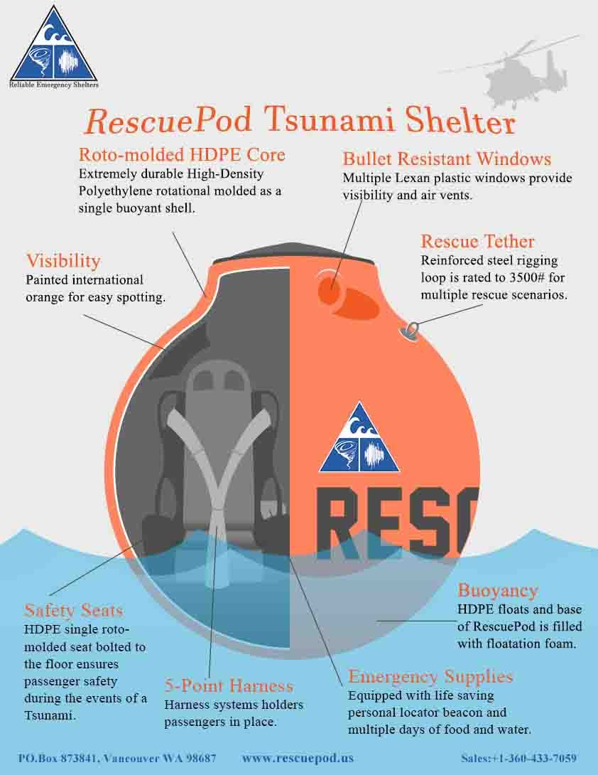 Figure 2

2.3 Implementation Design

1) Our team engineers will be consulting with the environmental engineers about the effects the tsunamis and hurricanes in the area. They will be able to give us a good idea of the conditions we will be dealing with and they will also let us know if this is a good area to place the capsules we would like to implement.

2) We will need to survey the areas that we feel will need the capsules the most. This will include how many people inhabit the area and how many people live in each household so that we can place the amount of capsules accordingly. Our capsules can hold a maximum of 10 people so knowing the number of people in the area is critical.

3) Once we know how many capsules we will need, we will have a team go and set up the capsules in their respected areas to ensure the safety of all the people within the area. This team will also hold public instruction tutorials once set up is complete to inform the people how to use it.

2.4 Quality Assurance Plan
To ensure the safety of the capsule we would like to implement, we have a variety of engineers to test and approve of every component of the capsule. Our group of engineers have years of experience in their field and their skills will be essential to making sure every component of the capsule is safe to use in a natural disaster.
Our mechanical and aerospace engineers that are building the capsule will test the materials used thoroughly to make sure it can withstand the natural conditions the capsule will be placed in. We have chosen to use aluminum for the coating of the capsule because of its durability and ability to withstand heavy weather conditions. The assistance of an aerospace engineer is a big advantage because they have knowledge of materials in extreme conditions. Our mechanical engineers will be testing the interior conditions of the capsule making sure the H-VAC systems are up to par. These components will be tested to ensure the safety of the people inside the capsule. Rescuing people from their homes is one part, the second part includes the safety of people inside the capsule for the duration it takes for the rescue teams to arrive.
Our electrical engineers will be testing out all the electrical components of the capsule. This includes lighting inside and outside the capsule. One of our concerns is making sure the people inside the capsules have enough lighting for the time they will be in the capsule and also the lighting outside the capsule so that it can be found by rescue teams. We want to avoid the risk of a power outages of the capsule so we will be testing the lighting by leaving it on for a couple of days in a testing area to ensure the lighting lasts as long as it needs to. The lighting outside is crucial to finding the capsules at any time of day. Even though the capsule will be a bright vibrant color, the lighting will complement its visibility through the debris.
Our software and computer engineers are in charge of making sure the GPS system works according to plan. Each capsule will include a GPS tracking device so that rescue teams will be able to locate them. Along with the GPS systems, these engineers are in charge of the coding component of the capsule. Software systems are prone to malfunction so we have implemented a backup system in case of a system failure. Although it is unlikely that the primary systems will fail, our team of engineers have thought of every scenario possible incase anything were to go wrong while people wait for rescue teams to arrive.

Schedule for Survival Pods
Date | Task
12/01/18 | The LCC Company will met up with the Japanese Federal Government and their environmental/human safety department
12/25/18 | Get all of the necessary permits to start finalizing and installing Survival Pods in homes and in commercial areas
1/30/19 | Brief the team of engineers about the task at hand and begin production and testing immediately
3/30/19 | Being testing the porotypes and fixing any last minute problems before getting it patented and approved
4/30/19 | Set up a meeting between the 2 parties to show our progress in such a short amount of time to begin installation
6/25/19 | Begin installation in coastal Japanese cities and suburbs to see the impact of the Survival Pods on Human Life
11/12/19 | After hurricane, earthquake, and tsunami season we see the real impact

3. Expected Project Results
- We expect that our Survival Capsules will decrease the death toll of each natural disaster dramatically
- We expect that our team of engineers will ensure the safety of any civilian that will enter the pods
- We expect that our project will be implemented during the next natural disaster
- We expect that our team of engineers will make around 500,000 pods per year and our stock’s will increase so profit could be made

3.1 Measures of Success
Unfortunately, in order to measure the success of our survival capsule, we will have to wait until after a natural disaster occurs. This will let us know how the capsule withstood the weather conditions it was up against. If any component of our capsule were to fail, we can make improvements to that specific component. We will also be able to measure our success by counting the number of lives we have saved. Although some homes may be destroyed, the life of the citizens is what we value the most. Our team of engineers have researched and tested every component of the capsule to ensure absolute safety of the citizens. Many lives have been lost in previous natural disasters and our goal is make sure everyone is accounted for and safe.

3.2 Costs
Requirements | COST
Mechanical Engineers (4) | $85,000-$120,000 Per Year
Electrical Engineers (3) | $75,000-$100,000 Per Year
Software Engineer (2) | $75,000-$100,000 Per Year
Aerospace Engineers (2) | $85,000-$120,000 Per Year
Aluminum Exterior Frame | $157 Per Survival Pod
Seats | $70 Per Seat With Harnesses Included
GPS and Lighting | $100 Per Pod
Insulation and H-VAC System  Working Facility and Testing Area  Other Interior Additions | $600 Per Pod  $50,000 to Build a Warehouse  $500 Per Pod

Notes:
- Price of aluminum is $.89 per pound. Each Survival Pod exterior frame weighs about 176.37 pounds. Multiply these two and each pod exterior aluminum frame costs about $157 dollars.
- The starting price for a 2 person pod is $13,500 dollars increasing in $4,000 dollars per upgrade for a larger capsule, which includes installation.
- The above costs would add up to $1,016,427 which would include the salaries of the engineers per year. This cost would increase because in a years’ time span, the company could make 500,000 pods.

References
Doughton, S. (2017, March 5). Tsunami pod can save lives — at a price. In Times Colonist. Retrieved November 13, 2018, from https://www.timescolonist.com/islander/tsunami-pod-can-save-lives-at-a-price-1.10936007
Lumb, D. (2015, July 2). Can This Capsule Help You Survive A Tsunami?. In Fast Company . Retrieved November 13, 2018, from https://www.fastcompany.com/3047684/can-this-capsule-help-you-survive-a-tsunami
Nakayama, E., Sushida, T., & Hagiwara, I. (2016, March). Mathematical Modeling and Simulation for Origami Tsunami Pod [Electronic version]. Josai Mathematical Monographs, 9, 3-19.
Oskin. (September 13, 2017). Japan Earthquake & Tsunami of 2011: Facts and Information. Retrieved November 13, 2018 from https://www.livescience.com/39110-japan-2011-earthquake-tsunami-facts.html
Ripley, W., & McKirdy, E. (2015 , September 11). Japan flooding: 3 deaths, levee breaks, many missing. In CNN. Retrieved from https://www.cnn.com/2015/09/10/asia/japan-floods/index.html
Sharpe, J. (2014). Tsunami Survival Capsule Design and Development Program Utilizing
MSC Software to Support Analytical Correlation against Test Results. [online] MSC
Software. Available at: http://pages.mscsoftware.com/rs/mscsoftware/images/Paper_Survival%20Capsule%20Paper05052013.pdf [Accessed 14 Nov. 2018].

Szondy, D. (2014, May 22). Gizmag checks out Survival Capsules' tsunami survival pods. In New Atlas . Retrieved November 13, 2018, from https://newatlas.com/survival-capsule-tsunami/32010/

