City College of New York

Engl 21007- L

Spring 2023

Writing for Engineers

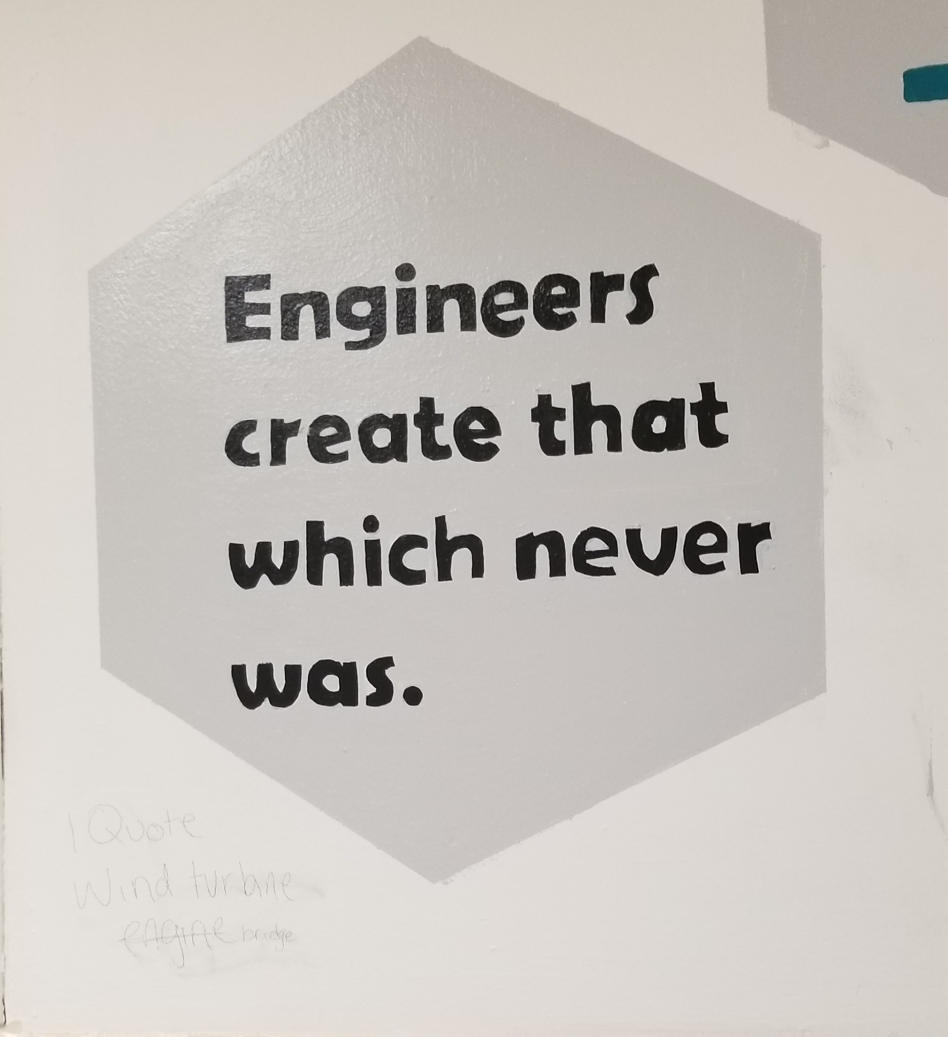 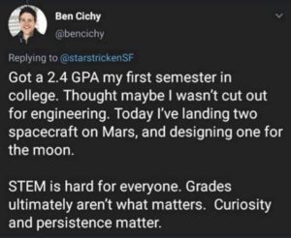

**Course:** Engl 210

**Classroom**: NAC 1/301 Y (ALC- active learning classroom)

**Schedule:** Tuesdays and Thursdays: Section L 9:30am- 10:45am

**Writing Instructor:** Danielle Carr

**Office Location:** NAC 6/335a

**Office Hours:** Thurs 11:00am-12:15pm, and by appointment

**\*\*Email:** [dcarr@ccny.cuny.edu](mailto:dcarr@ccny.cuny.edu) **(please take note of this!)**

**Phone:** office extension x5407

Course Description:

This course will help you to hone the critical reading, thinking, research, and writing skills you will need to succeed in all of your writing courses, specifically your engineering courses. This course also prepares students to write as engineers in professional environments. Students will examine, analyze, and create various types of technical communication such as: e-mails, memos, letters, instructions, definitions, descriptions, designs, proposals, and presentations. Students will learn to synthesize information, find answers, and present ideas to various audiences they will research and encounter. Learning to write well will enable students to present themselves in the best possible light in all situations. Students will learn how to communicate knowledge, plans, and ideas in a professional manner. Our time in this course will focus on reading and listening, essential steps in the writing process, effective writing, synthesizing material from various sources, and the ability to locate and evaluate relevant library and online research. We will also examine how writing is impacted by the elements of the rhetorical situation. By the end of the course, students should be confident in utilizing this knowledge in the construction and completion of a writing portfolio and self assessment.

How This Course Works:

Welcome back to in person classes! For the past two years, we have been conducting classes in a digital, synchronous setting through Zoom which has taught students such necessary skills as communication, teamwork, and distance communication all things that engineers use throughout their careers. However, for the spring 2023 semester, we will be returning to the “traditional classroom experience,” and working on learning these essential engineering tools in person. For students, this means that our class meetings will take place synchronously, in person, in a set classroom at a set time. In addition, there will also be a number of designated “hybrid” days that the class will meet asynchronously, where there will be no “formal face to face (f2f) meeting,” but there will be an assignment due and that will count as a both attendance and classwork grade for the day. You will be notified in advance of these days. This class is also heavy on group work. Groups will be determined by the instructor and will remain throughout the semester (barring any unusual occurrences). Students are expected to communicate with their group mates often and be cooperative and demonstrate proper group work behavior. Students will still be responsible for attending all scheduled f2f classes, on time and for the duration of the class meeting, handing in all work ON TIME and properly done, on Blackboard. There will be NO print media submitted for class assignments due to Covid-19 protocols. Students will also be responsible for posting homework, projects, and presentations in specific folders and also posting responses to these assignments. I will let you know when these postings are due, keep in mind they are mandatory as they are part of your homework and participation grades. Asynchronous assignments will also have time sensitive deadlines. These responses can transfer to discussions held in class, so they must be thought provoking and thorough. Overall, it is extremely important for students to attend all class meetings, as these meetings are when students will learn the required genre work for the class and discuss the assignments for the course. There will also be in person peer review workshops for draft work on larger assignments.

Course Learning Outcomes:

Over the course of the semester, you will

* acknowledge your and others' range of linguistic differences as resources, and draw on those resources to develop rhetorical sensibility
* enhance strategies for reading, drafting, revising, editing, and self-assessment
* negotiate your own writing goals and audience expectations regarding conventions of genre, medium, and rhetorical situation
* develop and engage in the collaborative and social aspects of writing processes
* engage in genre analysis and multimodal composing to explore effective writing across disciplinary contexts and beyond
* formulate and articulate a stance through and in your writing
* practice using various library resources, online databases, and the Internet to locate sources appropriate to your writing projects
* strengthen your source use practices (including evaluating, integrating, quoting, paraphrasing, summarizing, synthesizing, analyzing, and citing sources)

What You’re EXACTLY Doing in This Course:

In this course you will learn to read, write, and speak thoughtfully and critically within your discipline. You will produce various written works in discipline specific genres and give presentations surrounding engineering topics of your choosing. Hopefully this rhetoric and writing practice strengthens your writing skills throughout your academic and scientific career.

Also, to simulate the engineer’s “experience,” you will spend much of the semester in pre-determined (by me) groups, in which you will consider the topic, direction, and composition of your projects together. However, there will be numerous opportunities for students to compose and submit individual assignments.

Required Textbook(s): *Technical Communication* by Mike Martel, 13th edition, Bedford/Saint Martin’s

* Supplemental Readings will be made available on Blackboard, CUNY Commons course site, or as handouts and distributed in class.
* OER textbooks (which, from time to time we might reference), include <https://digitalcommons.kennesaw.edu/opentc/>

<https://open.umn.edu/opentextbooks/textbooks/412>

<https://mcmassociates.io/textbook/>

CUNY Commons Course Website- <https://engl210ccny.commons.gc.cuny.edu/> Which will house various documents/files necessary for coursework

Important Dates!

Thursday, January 26- **First Day of Classes!**

Tuesday, February 21- **No Class Meeting! Classes Follow a Monday Schedule**

**Thursday, March 30- **Deadline for submission for PSA Sustainability Project**

Thursday, April 6- **No Classes! Spring Break**

Tuesday, April 11- **No Classes! Spring Break**

Thursday, April 13- **No Classes! Spring Break**

Tuesday, May 16- **Last Day of Classes!**

**\*\***Tuesday, May 23- **Final Submission for Self Assessment Date!**

**Class Policies**

Lateness and Absences

* According to the CUNY CCNY Undergraduate Bulletin: http://www.ccny.cuny.edu/registrar/upload/2013-2015-Undergraduate-Bulletin.pdf (page 215)

Students are expected to attend every class session of each course in which they are enrolled and to be on time. An instructor has the right to drop a student from a course for excessive absence. Students are advised to determine the instructor’s policy at the first class session. They should note that an instructor may treat lateness as equivalent to absence. No distinction is made between excused and unexcused absences. ***Each instructor*** retains the right to establish his or her own policy, but students should be guided by the following general College policy: **In courses designated as clinical, performance, laboratory or field work courses, the limit on absences is established by the individual instructor. For all other courses, the number of hours absent may not exceed twice the number of contact hours the course meets per week. When a student is dropped for excessive absence, the Registrar will enter the grade of "WU.”**

In other words: each student can miss up to THREE classes. FOUR absences results in a failure of the course. Students are expected to be in class ON TIME and remain for the duration of class. IF there is an unavoidable issue which prevents the student for remaining in the class for the entire period (as in necessity for lateness or early departure) please let the instructor know prior to arrival via email. If attendance/lateness is going to be a problem, consider switching from this section. **This section is designated IN PERSON! Students are expected to attend and participate IN SEAT!** The instructor will determine and notify students of any hybrid/remote meetings throughout the semester.

Food and Drink 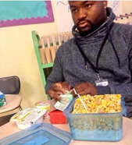 🡨----------------- Don’t let this be you!!!

**Due to the location of our classroom- NAC Library, ALC 1/301y1, students are only allowed to bring and drink WATER in the classroom. These are the rules of the NAC library. No other food/drink is permitted in these rooms!**

Electronic Devices 

If it beeps, vibrates, rings, plays music, or has a screen, mute it before you enter class. Cell phone use is prohibited during class. Silence your cell phone, put it away before you enter the room and keep it away for the duration of class. If there is an emergency, quietly step out of the room to handle it. Tablets and computers can be used as note-taking devices or E-book readers if that is how students wish to transcribe information or read text. However, those devices can only be used SOLELY for that purpose, no web surfing, social media, or any other recreational use during class time. When those devices are not needed, they should be “sleeping,” face down, and out of reach.

“Don’t Yuck My Yum” 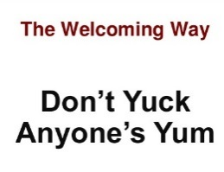

Each and every one of us, including myself, comes from a diverse background, environment, and has a unique life experience and skill set which contributes to our worldview and opinion. As members of a classroom community, school community, and society, etc., it is our duty to remember this and respect all viewpoints, even if we don’t agree with them. Remember, there are constructive ways to criticize.

Assignments and Due Dates 

Assignments are due on the due date on blackboard unless previously arranged with the instructor. Because of Covid-19 protocols, NO homework assignments will be accepted in print media. Digital media, Blackboard submissions ONLY! Or email, if instructed to do so. Everything will be submitted and returned on Blackboard with instructor and/or peer comments. Students will be instructed of the designated submission areas on Blackboard for their homework and these areas will be set by a timer, signaling a deadline. After the deadline is met and passed, (for example: Tues, 2/7/23, 11:59pm), the submission areas will “LOCK” and be inaccessible to students. If in the case you are locked out of your homework submission due to lateness, DO NOT send me a random email, “throwing” your homework at me! This is one of my huge pet peeves. Send an e-mail requesting permission to submit late work and then wait for a response. Should you receive a positive response for email submission, send a properly composed email with a label of the homework assignment. DO NOT send a blank email with some random file attachment and no message. This is the way that homework gets “lost” in cyber space/email threads. Wait for a response from me stating “received/confirmed” so that you know I received your homework. If you submit the assignment and I don’t know it’s coming, or send some random blank email, with some random file attachment, and I’m not looking for it, and it could be buried under something else, and as a result, your grade could end up ZERO due to non-submission. Therefore, ASK FOR permission BEFORE e-mailing late assignments. Work submitted after the due date will be deducted by half a letter grade every day that it’s late. *If and only if it is accepted.

*In the case that any student will be absent on a due date, plan to submit work early! Ask permission to submit work early via email and then wait for instructions on how/where to submit early. First draft due dates are listed on the weekly assignment schedule, final draft due dates are due **1-2** class meetings after you receive your essays back with either my or peer comments. The exact dates will be announced in class and are always listed on the syllabus.

***Homework Submissions***

**\*\*POST HOMEWORK IN A WORD.DOC OR GOOLEDOCS ONLY, NOT A .PAGES FILE OR .PDF SOME OTHER FORMAT.**

**----All homework submissions will be through Canvas- NO pdfs! NO .pages files! MS Docs or googledocs submissions ONLY! Any googledocs submissions MUST be unlocked for access and for editing! **Any file that is uploaded to Canvas that is unable to be read or accessed will be graded a ZERO!**

Academic Integrity

Plagiarism is the unacknowledged use of another person's words or ideas. Students can use other people’s ideas as much as heshe wants and/or needs to. They just need to make sure to **properly** give credit where credit is due. Words copied verbatim from another source must be quoted and the source must be cited. When you paraphrase words/ideas from another source, you must acknowledge the original author unless the ideas are common knowledge (information found in three or more different places). If you collaborate with another author to produce written work, you must acknowledge that person's contribution. “Borrowed” material must be *properly* cited in APA format. That is the preferred citation method for Engl 21007 and will be studied and used extensively in this class during the semester. Anything incorrectly cited is considered plagiarism and is graded as an F. If there is any further question about the parameters of academic dishonesty reference page 230 of the CUNY Policy on Academic Integrity appears on page 230 of the City College of New York Undergraduate Bulletin 2013-2015.

* http://www.ccny.cuny.edu/registrar/upload/2013-2015-Undergraduate-Bulletin.pdf

All writing submitted for this course is expected to be your own. If a student’s submission contains any forms of plagiarism, he/she is at minimum subject to a failing grade for the project and/or course, and worst case scenario, academic suspension or expulsion. Part of the function for this course is to teach students how maintain academic integrity and to cite sources **properly** according to the standards of the American Psychological Association (APA)in order to avoid cases of inadvertent plagiarism. As part of this course, we will discuss strategies for adhering to standard conventions for responsible source use and for maintaining academic integrity and how to avoid inadvertently plagiarizing someone else’s work.

You can learn more about plagiarism at the following link: www.wwnorton.com/college/english/write/writesite/research/plagiarism_tutorial.aspx

Here are four practices defined as plagiarism in the CUNY Policy on Academic Integrity:

* Copying another person’s actual words without the use of quotation marks and footnotes attributing the words to their source.
* Presenting another person’s ideas or theories in your own words without acknowledging the source.
* Using information that is not common knowledge without acknowledging the source.
* Failing to acknowledge collaborators on homework and laboratory assignments.
* *Submitting downloaded term papers or parts of term papers, paraphrasing, or copying information from the internet without citing the source, and “cutting and pasting” from various sources without proper attribution.
* *Using other student’s content without permission. Student samples are **not** appropriate fodder for submissions!

If you need ANY help at all *outside* of the classroom pertaining to anything at all, from writing issues and tutoring, to feeling overwhelmed, or *anything* in between, utilize these resources…

**The Writing Center**

<http://www.ccny.cuny.edu/writing/>

The CCNY Writing Center offers a supportive learning environment where students can have one-on-one tutoring sessions with writing consultants. It is a great resource for you to obtain extra help as you write and revise your papers. They DO NOT proofread your papers, but offer assistance on improving certain aspects of them. They also offer ESL tutoring. To set up an appointment or semester-long sessions, contact them in person at the Writing Center, which is located in the NAC, 3rd floor plaza or call (212) 650-8104.

**Gateway Advising Center**, NAC 1/220

<http://www.ccny.cuny.edu/gateway/>

Students without a declared major can receive academic advising, especially if you have questions about your course of study, core requirements, etc.

**AccessAbility Center Tutoring Services,** NAC 1/218

<http://www.ccny.cuny.edu/accessability/>

Provides one-on-one tutoring and workshops to all registered students with learning or physical disabilities.

**SEEK Peer Academic Learning Center,** NAC 4/224

Phone: 212-650-5786**;** Email: seekpals@ccny.cuny.edu

Offers counseling and peer tutoring for students in need of academic and financial support who have registered for the SEEK Program.

**Campus Counseling Center,** Marshak J-15

Phone: 212-650-8222, Email: [counseling@ccny.cuny.edu](mailto:counseling@ccny.cuny.edu)

<http://www.ccny.cuny.edu/counseling/>

The Counseling Center offers short term individual and group counseling to help students deal with their personal and adjustment issues that may interfere with their ability to progress academically to their fullest potential.

**Instructor, see front page for contact information and location**

If there’s something you feel I can’t help you with during class time, please do NOT hesitate to reach out and contact me. I frequently answer email and I love hard working students.

Grading Breakdown

Students will be assigned a grade for the writing section based on their completion of their assignments, participation, and attendance according to the following breakdown:

**Attendance and Participation, (online and f2f),**

**Coursework and in class writing 15% 94%-100% A 70%-72% C-**

**Memo- 15% 90%-93% A- 66%-69% D+**

**Lab Report/PSA-Sustainability 15% 86%-89% B+ 60%-65% D**

**Technical Description 15% 85%-83% B 0%-59% F**

**Group Project 20% 80%-82% B-**

**--Proposal 10% 76%-79% C+**

**--Presentation 10% 73%-75% C**

**Self Assessment/Portfolio 20%**

**\*\*Extra Credit is offered at the end of the semester and is optional for students to complete to pick up their grades. For those who choose to complete the extra credit assignment, the points awarded will be distributed amongst already existing grades as a “grade boost,” instead of as a whole other graded assignment, so as not to disrupt the gradebook weight.**

**Required Assignments**

In addition to smaller assignments that will be assigned throughout the course of the semester, the bulk of the coursework will focus on the composition of 4 major, scaffolded assignments given with the goals of reinforcing lectures/discussions, meeting course learning outcomes, and increasing writing, analytical, and rhetorical skills. These will be done in a series of drafts with built in scaffolded assignments in order to both lead up to the assignments and provide students opportunities to submit their best work. **All assignments must follow genre conventions, APA requirements, and have 12 pt. New Times Roman with 1-inch margins. Spacing will be determined by the genre conventions of each assignment.**

* Diagnostic Writing Assignment- 500 word minimum
  + Write a professional letter to me about your life, your experiences, your achievements, your talents. What is your major in college and how does your major connects to your professional goal(s)? Include where you are from and how you want me to see you. Write about your challenges as well as your successes. How do you imagine your future place in the world of engineering? What are some of the engineering challenges you would like to be involved with? How do you plan to impact change in your world with your degree? In this letter, answer the following questions- describe what you think, “writing for engineers” means. Do you think Engineers need to know how to write? Why or why not? What do you think this course will encompass? Do you find writing difficult? Who do you think composes the engineer’s audience when they write? The letter MUST also include substantive and relevant information on an “artifact,” an item that is most important to your area/concentration. For example, computer engineers could discuss a mouse or a keyboard; mechanical engineers could do a caliper. Students must describe the item in detail and discuss the significance of the item. You will discuss this item with the class. This item CANNOT be your cellphone or computer unless you are/have built the Iphone 25 or Samsung S25.
    - This is a formal letter, addressed to me (see address below), and must be signed at the end by you. It must follow the appropriate letter genre conventions. Markel 377-378 for letter templates.
    - My address:

Danielle Carr

City College of New York- English Department

1. Convent Ave

New York, NY 10031

* Memo (15%) - 1-2 pages (500 words), 1 page reflection paper, 1 audience analysis sheet. Students will write a memo to an appropriate audience of the City College of New York, addressing a problem of your choosing on campus. This problem can be related to renovating or improving areas of the campus (cafeterias, dorms, classrooms, parking etc.). Be creative. The idea is to define a problem and offer a specific solution to address this problem. Remember, your audience does not know about this specific problem so you will have to provide the context. Important details can be bulleted for easy reading. No cost estimates are required for this memo. Basically, it will be a memo that requires a follow-up meeting for further discussion. *This is a single draft submission. No draft work required.*
* Technical Description (15%)- minimum of 4 pages of text, 2 page reflection paper, and 1 audience analysis sheet
  + Students will write a description of a simple technological item, more than likely, the item included in the letter to the instructor assignment.
  + Or, choose one that you are particularly interested in and explain its purpose, as it relates to your concentration. Think carefully about your choice. Descriptions of objects, mechanisms, and processes appear in virtually every kind of technical communication. In addition, instructions are also frequently used.
  + Research and APA citations will be required for this assignment.
* Lab Report/ PSA/ Sustainability (15%) -, min 2 pages reflection paper, and 2 audience analysis sheets
  + Students will compose a lab report based on a lab experiment specific to their chosen area/concentration of engineering. The lab report must have all of the elements of the lab report listed from the discussion/powerpoint from class (the appendix/acknowledgements are not mandatory, but the other elements are). The lab report also requires research, a minimum of three sources must be cited both in text and listed on the reference page according to APA standards.
* Multimodal Engineering Proposal + Presentation (20%) - Proposal Minimum 5 pages. Self-Reflection 1-2 pages. Presentation, minimum 10 minutes. Each person will write his or her own reflection paper which must include their role in the project (exactly WHAT they did), how they liked (or disliked) working in teams, analysis of the rhetorical elements and how the project met specific course learning outcomes. You will also grade each other’s performance with templates.
  + The assignment is a group/oral report of a proposal for a creative engineering innovation. The following areas of the United States (USVI, Puerto Rico, parts of Florida, and Houston), not to mention islands such as Dominica, islands of the BVI, St Maarten, Barbuda, Cuba, etc were drastically affected by hurricanes Maria and Irma. Most recently the Bahamas was affected by hurricane destruction and Puerto Rico is suffering from massive, random earthquakes. These areas are undergoing massive rebuilding projects, changing infrastructure, and considering ways to update aspects of the islands so that such immense damage does not occur in the wake of other hurricanes. Power grids, computer systems, roads, bridges, buildings, to name a few things, have been destroyed. Hospitals, airports, etc are being severely impacted. Despite the amount of human suffering that has occurred in the wake of these natural disasters, these natural disasters actually make for an engineer’s dream: how can you positively impact these areas in their times of great need? Rebuilding and upgrading to better than once was will take years, especially if hurricanes of such magnitude return to the Caribbean.
    - You are not limited to this part of the world. If you find a recent natural disaster in another part of the world where your team’s expertise could be of service, clear it with the instructor first.
  + Your task is to consider this in light of your engineering concentration (civil, electrical, computer, mechanical, chemical, etc) and develop a thing/idea that is designed to assist the rebuilding process in some way. Your design might have something to do with infrastructure: bridges, roads, sidewalks, etc. Your idea might have to do with solar panels and electrical grids, water collection (as islands are notoriously yet ironically always short on water), anything, there is no limit to idea but money must be considered (you need a budget, hurricane repair is ALREADY expensive). These are just some ideas you are not required to use them.
  + You will need to do some research to see what problems have surfaced where (as far as issue/island/location) on your own, which you will incorporate into your project (that’s going to be the history/background part).
  + The project requires a brief technical description of your thing/idea, a brief literature review, the proposal, powerpoint, resumés, job postings, and an audience analysis- who are you presenting this to? Who are you impacting/helping with your idea/thing? How will this impact your content?
    - Project objectives:
      * Innovation
      * Process
      * Group work
      * Oral presentation
      * Overall thoroughness and logic of proposal structure
* Final portfolio and self-reflection (20%)
  + A rhetorical analysis of the student’s work that should include references to elements of the rhetorical situation: genre, audience, purpose, exigence, stance, and media/design, in digital format, on the CUNY Commons.
* **Reflection paper- typically 1-2 pages, but depends on the assignment. All major writing assignments will require a written self-reflection component, which we will discuss in class.
  + Students must make use of the terms introduced in the rhetorical situation and describe how each assignment has helped them to achieve the course learning project. These must be attached to the final draft of all major assignments.

On draft work:

“Almost all good writing begins with terrible first efforts. You need to start somewhere. Start by getting something -- anything -- down on paper. A friend of mine says that the first draft is the down draft -- you just *get it down*. The second draft is the up draft -- you *fix it up*. You try to say what you have to say more accurately. And the third draft is the dental draft, where you check every tooth, to see if it's loose or cramped or decayed, or even, God help us, healthy.”

– Anne Lammott, *Bird by Bird: Some Instructions on Writing and Life*

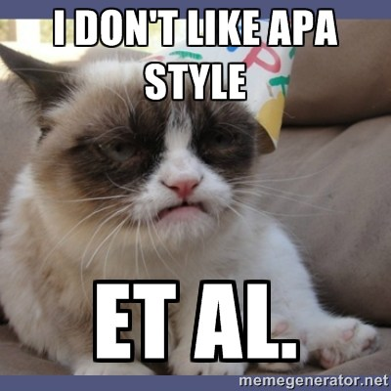 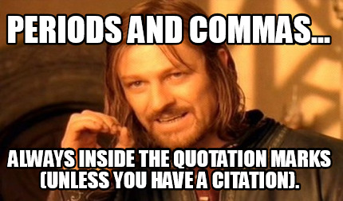

*** All written assignments must be typed using Microsoft Word in 12 point, Times New Roman font, double spaced, with one inch margins, as per APA guidelines and follow the appropriate genre conventions. For this course we will be referring to the Purdue OWL website to learn and practice using the APA format. <https://owl.english.purdue.edu/owl/resource/653/01/>

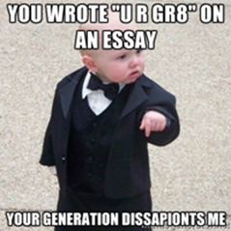 *** Also, while the course objectives do not state that I am trying to create professional grammarians, ***ALL*** writing for this course ***MUST*** be written in Standard English and not in text slang or colloquial spelling. You are assessed for grammar, so if that is not your strong suit, spend time with grammerly.com or the campus writing center.

Weekly Assignment Schedule

|  |  |  |
| --- | --- | --- |
| **Date** | **In Class** | **Homework** |
| **Week 1** |  |  |
| Thurs 1/26 | Review syllabus, ice breaker, assign and explain diagnostic essay assignment, discuss “Theme for English B.” | **Read** Markel Ch 1, 5, & pgs 377-378, exigence handout and Professor’s PPT on exigence (course website, miscellaneous)  **Compose** introduction letter/diagnostic essay, due 1/30, post on BB. |
| **Week 2** |  |  |
| Tues 1/31 | Discuss elements of Rhetorical situations, genre, stance, exigence, purpose, media/design, and audience. In class writing assignment on rhetorical situation and audience analysis. | Note the groups on BB. **Read** Markel Ch 3, 8, 9, 10, 14- pgs 377-395, **(with *special* attention to pgs 386-391)** and both links on the course site pertaining to writing emails to Professors |
| Thurs 2/2 | **Discussion:** How do engineers communicate?  Assignment #1- memo | 1. Genre analysis homework on memo. 2. Compose an email to a professor/instructor outside of this class with a request. CC me on it, and forward me any responses. Take a screen shot of the email and post it on BB (for grading) 3. **Group work:**  Each group must post its discussion point for the memo assignment AND compose a response on each group’s memo topic post. |
| **Week 3** |  |  |
| Tuesday 2/7 | **Discussion:** Reflection papers and audience analysis | Memo due Mon 2/13-single draft submission. |
|  |  |  |
| Thursday 2/9 | Continue Discussion | **READ** Markel ch 6 & 20  Watch video lecture on tech description:  **Memo due Mon Thurs 2/13-single draft submission. |
| **Week 4** |  |  |
| Tuesday 2/14 | Discussion: Definitions, Descriptions, Instructions, audience and APA | Compose BB post on technical description item, comment on THREE different classmates’ posts. ALL due Wed 2/15, 9pm |
| Thursday 2/16 | Continue discussion- technical description & assignment #2  **In class assignment and discussion on descriptions and instructions. | **Solo homework:**  Genre Analysis on tech description  Markel 591 #7.  *Post by 2/20 11:59pm  **Group homework: Part 1:** Markel 591 #10- no limitations on choice. Record submissions. Post on BB. One post per group. Due 2/22, 9pm  **Part 2:** Complete rubric/report on group presentations on instructions. One rubric/report per group  *Due 2/22 9pm. |
| **Week 5** |  |  |
| Tuesday 2/21 | **NO CLASS! Classes follow a Friday Schedule!** | **See above!** |
| Thursday 2/23 | **Library workshop with Professor Trevar Riley Reid** | Compose **complete** tech description draft, post by Due Mon 2/27, 10pm. |
| **Week 6** |  |  |
| Tuesday 2/28  **\*Potential Asynch Class** | **(*Potential Virtual)** Peer review workshop | Complete peer review work by Wed 3/1, noon. Post on BB.  *Final draft due Sun 3/5 11:59pm on BB |
| Thursday 3/2  **\*Potential Asynch Class** | **Complete Asynch #1**- Ethics in Technical Communication- complete by 11:59pm | **Read** Markel Ch 19 and sample lab report  **\*\*Final draft tech description due sun 3/5, 11:59pm on BB** |
| **Week 7** |  |  |
| Tuesday 3/7 | Discussion: Lab reports and Sustainability | Pg 548 “Exercises” #1- **Choose TWO labs instead of 3-4.**  Due Wed 3/8, 11:59pm |
| Thursday 3/9 | Discussion: assignment #3- lab reports & PSA | **Part 1 Group work:** Choose sustainability topic and organization from the list, create a post that explains the topic, the organization, and the reason for your team’s selection, post on spread sheet and BB. One post per group AND Comment on other teams’ posts.   * **Posts due Sun 3/12, 8pm, responses due Mon 3/13, 8pm**   **Part 2: * Group Lab presentations**   * Directions: each team will choose one lab. they will answer the questions from the markel 548 on that one lab (1. compare and contrast the basic elements of the reports. 2. In what ways do they follow a similar format? 3. If the reports differ in format, why do you think the authors chose to present information in the manner they did? 4. field any other questions/comments the class might have about the lab on display.) this is an oral assessment. each group is required to present/discuss the lab to the class on the specified date. for clarification of what the presentation looks like, several groups dissected the lab according to the genre conventions that markel discusses. * **Post due 3/15, present (record)- 3/16**   **Group work:** Lab report presentations due 3/15 on BB, present on 3/16. |
| **Week 8** |  |  |
| Tuesday 3/14 | Continue discussion on lab reports & assignment #3- lab reports and PSAs | Lab report presentations due 3/15 on BB, present on 3/16. |
| Thursday 3/16 | In class presentations | Continue research on PSA, watch Canva video |
| **Week 9** |  |  |
| Tuesday 3/21 | Continue discussion | **Read** assigned links and Markel Ch 21 |
| Thursday 3/23 | Discussion- technical proposal genre | **Read** Markel 10, 15, 16 |
| **Week 10** |  |  |
| Tuesday 3/28 | Continue Discussion- assignment #4, in class workshop- edit/discuss PSA | **PSA Final draft due Thurs 3/30**, **3/31- follow submission directions!** |
| Thursday 3/30 | PSA Presentations | Compose brief abstract on projects, post on BB, comment on other groups. One post per group. **Post due Sun 4/2- 8pm, responses Mon 4/3, 8pm** |
| **Week 11** |  |  |
| Tuesday 4/4 | **Asynch #3 & #4, no f2f**   * Complete by 11:59p | Continue to work on project |
| Thursday 4/6 | **No Classes- Spring Break!** | Same |
| **Week 12** |  |  |
| Tuesday 4/11 | **No Classes- Spring Break!** | Same |
| Thursday 4/13 | **No Classes- Spring Break!** | Watch video lecture on resume & powerpoint. Prepare project progress report for in class student meetings on Tues 4/18 |
| **Week 13** |  |  |
| Tuesday 4/18 | **\*In class group meetings with instructor. Begin draft work!** | **Solo homework:** post resumé, according to Markel text/video lecture  **Group homework:**  post resumé, develop a job posting for your team/project, post it on bb, then pick from the “pool of applicants” on BB in the resume area. Discuss WHY you made your selection. One post per group. |
| Thursday 4/20 | **In person peer review workshop** | Final drafts due 4/25, presentations begin on 4/25 |
| **Week 14** |  |  |
| Tuesday 4/25 | **In class presentations** |  |
| Thursday 4/27 | **In class presentations** | Watch video lecture on building skeleton sites  Post skeleton sites on BB |
| **Week 15** |  |  |
| Tuesday 5/2 | discussion of final project (return to CUNY commons sites) | Genre analysis on project |
| Thursday 5/4 | Discussion: Project content  *In class group work- content creation & rhetorical situation assessment analysis | Group compositions on content, post to BB, Watch video lecture on editing |
| **Week 16** |  |  |
| Tuesday 5/9 | Presentations | Continue project  Watch video on revision |
| Thursday 5/11 | Continue working on projects  **Potential Asynch Class**   * **Read** Markel ch 3, pg 61 #3, **AND** ch 10, pgs 249- 251 #’s 1,2,3,4,7,9,10,11 A; 12, 18, 19, 20, 21, 28,230, 32, 38 B | Continue project |
| **Week 17** |  |  |
| Tuesday 5/16 | **Last Day of Classes!**  **-Peer review workshop on projects.**  **\*Possibly remote, live synchronous meeting** | Enjoy your summer!  **Final project due Tues 5/23, 5pm!** |